**1.INTRODUCTION**

**1.1.INTRODUCTION:**

The “Enhancing Coffee Shopping Experience with Web Technologies” project is an advanced e-commerce platform meticulously designed to provide a superior and immersive shopping experience for coffee enthusiasts. This platform integrates state-of-the-art web technologies to ensure exceptional performance, scalability, and maintainability. The front-end development leverages React for a dynamic and responsive user interface, paired with Redux for efficient state management. The backend is robustly built using Node.js, and MongoDB is employed for scalable and flexible database management. The architecture is thoughtfully designed to facilitate seamless interactions between the front-end and back-end components, ensuring a smooth and responsive user experience. Key features of the platform include an extensive product catalog, secure user authentication, a dynamic shopping cart with a streamlined checkout process, comprehensive order management, advanced search and filtering capabilities, and a responsive design that ensures optimal user experience across all devices. This project exemplifies the integration of modern web technologies to create a high-performance, user-friendly platform for coffee enthusiasts and sellers alike.

**1.2.PROBLEM STATEMENT:**

This application is a smart web application designed to enhance the shopping experience for coffee, tea, and cold drink enthusiasts, as well as streamline the operations for sellers and administrators. The main aim of the application is to provide a unified platform where users can easily browse and purchase their favorite beverages, and sellers can efficiently manage their product listings and orders.

In this application, sellers will register and log in to the platform to upload product details, manage inventory, and process orders. The application will support various product categories, allowing sellers to specify product information such as price, description, and availability. Sellers will also be able to view and update their products, ensuring that the latest information is always available to customers.

Customers must register and log in to the application to explore the wide range of products available. They can add items to their cart, proceed to checkout, and make secure payments. The application will also feature user authentication to ensure secure transactions and personal data protection. Additionally, customers can view detailed product information, search and filter products, and track their orders.

Administrators will oversee the entire application, providing support and ensuring the smooth operation of the platform. They will have the ability to manage user accounts, monitor transactions, and handle any issues that arise. This comprehensive approach ensures a seamless and enjoyable experience for both customers and sellers, ultimately driving satisfaction and growth for the coffee, tea, and cold drinks marketplace.

**1.3.NEED OF THE PROJECT:**

The need for this project arises from the increasing demand for a convenient and user-friendly platform to enhance the shopping experience for coffee, tea, and cold drink enthusiasts, as well as to streamline operations for sellers and administrators. It addresses the following key requirements:

1. **Enhanced Shopping Experience**: Consumers seek an easy-to-navigate platform where they can browse a wide variety of beverages, view detailed product information, and make secure purchases with minimal effort.
2. **Seller Efficiency**: Sellers require a streamlined system to manage their product listings, inventory, and orders. The platform provides tools for sellers to easily upload, update, and monitor their products, ensuring efficient operations.
3. **Secure Transactions**: With the rise of online shopping, ensuring secure transactions is paramount. The application incorporates robust user authentication and payment processing mechanisms to protect user data and financial information.
4. **Comprehensive Product Management**: The project offers a detailed product management system where sellers can categorize their products, add descriptions, set prices, and manage stock levels, ensuring that customers always have access to accurate and up-to-date information.
5. **Customer Convenience**: Customers need a platform that allows them to create accounts, track orders, and manage their shopping carts. The application simplifies these processes, enhancing customer satisfaction and loyalty.
6. **Administrative Oversight**: Administrators play a crucial role in maintaining the platform's integrity. They require tools to manage user accounts, oversee transactions, and provide support to both sellers and customers, ensuring the platform runs smoothly and efficiently.
7. **Scalability and Growth**: The project is designed to be scalable, accommodating future growth in user base and product offerings. This ensures that the platform can evolve to meet increasing demand without compromising performance.
8. **Economic and Technical Feasibility**: The project conducts a thorough feasibility analysis to ensure it is economically viable and technically feasible within budget constraints. This includes assessing the financial impact and ensuring the technical infrastructure can support the system without incurring excessive costs.

**2.REQUIREMENTS**

**2.1 LITERATURE SURVEY:**

In conducting the literature survey for the coffee-tea and cold drinks online shop project, the primary focus lies in the analysis of existing e-commerce platforms and industry practices. E-commerce platforms like Amazon, Starbucks, and Teavana will be studied to understand key features, user interfaces, and functionalities that enhance the shopping experience for beverages. Additionally, examining these platforms will provide insights into effective product catalog management, secure transaction processes, and efficient inventory control.

Furthermore, the literature survey will delve into modern web development technologies and methodologies, such as the use of Node.js for server-side scripting, Express for building web applications, and MongoDB for handling large-scale data storage. It will also explore the benefits of using React for creating dynamic and responsive user interfaces, along with Redux for state management. Reviewing academic and industry publications on these technologies will offer a comprehensive understanding of their implementation and best practices.

Another critical aspect of the literature survey involves the exploration of user authentication and security practices. This includes studying the implementation of JSON Web Tokens (JWT) for secure user sessions and bcrypt for password hashing. By analyzing the security measures used in successful e-commerce platforms, the project will ensure robust protection of user data and transactions.

Moreover, the survey will investigate the integration of payment gateways, focusing on how platforms like Stripe facilitate secure and efficient payment processing. This involves reviewing documentation and case studies on payment gateway integration to understand the challenges and solutions associated with handling online transactions.

Lastly, the literature survey will consider the scalability and maintainability of web applications. It will explore mono repo architectures and modular design principles that enable efficient code management and application scalability. By synthesizing these insights, the project will be equipped with a robust understanding of industry standards, user expectations, and best practices to develop a highly effective and user-friendly online shop for coffee, tea, and cold drinks.

**2.2.EXISTING SYSTEM:**

In the existing system, many e-commerce platforms for beverages such as Amazon, Starbucks, and Teavana offer a wide range of features aimed at enhancing the shopping experience. These platforms are equipped with comprehensive product catalogs, secure transaction processes, and efficient inventory management. However, despite these features, they often lack the tailored experience that specialized beverage shops require. For instance, while Amazon provides an extensive selection of products, it does not focus specifically on coffee, tea, and cold drinks, which can lead to a less personalized shopping experience. Additionally, larger platforms may not offer the same level of support and customization for smaller sellers who specialize in these beverages.

Moreover, the existing systems often use a mix of outdated and modern technologies, which can lead to inconsistencies in performance and user experience. Security measures, while generally robust, may not always be optimized for the specific needs of beverage transactions. Authentication processes can be cumbersome, and integrating new security features such as JSON Web Tokens (JWT) and bcrypt for password hashing may be challenging. Furthermore, the user interfaces on these platforms, though functional, might not be as dynamic and responsive as those built using modern frameworks like React. This can result in a less engaging shopping experience, particularly on mobile devices.

**2.3.PROPOSED SYSTEM:**

The proposed system aims to address the shortcomings of the existing platforms by creating a specialized e-commerce solution tailored for coffee, tea, and cold drink enthusiasts. This system will leverage modern web development technologies such as Node.js for server-side scripting, Express for building robust web applications, and MongoDB for efficient data storage and retrieval. The front-end will utilize React to create dynamic, responsive, and user-friendly interfaces, along with Redux for state management. This combination ensures that the platform is both scalable and maintainable, capable of handling a growing user base and an expanding product catalog.

Additionally, the proposed system will incorporate advanced security measures to protect user data and transactions. By implementing JSON Web Tokens (JWT) for secure user sessions and bcrypt for password hashing, the platform will ensure that user authentication is both secure and efficient. The integration of payment gateways like Stripe will facilitate seamless and secure transactions, enhancing the overall user experience. Furthermore, the platform will offer comprehensive product management tools for sellers, enabling them to easily upload, update, and monitor their products. This ensures that customers always have access to accurate and up-to-date information, improving their shopping experience and satisfaction. By focusing on the specific needs of the beverage market, the proposed system will provide a superior, tailored shopping experience that meets the expectations of both consumers and sellers.

**2.4 FEASIBILITY STUDY:**

The feasibility of the coffee-tea and cold drinks online shop project is analyzed in this phase to ensure that the proposed system is practical and viable for implementation. This involves developing a general plan for the project, estimating costs, and understanding the major requirements to ensure the proposed system is not burdensome to the stakeholders.

The feasibility study focuses on three key considerations:

economical feasibility,

technical feasibility,

and social feasibility.

**ECONOMICAL FEASIBILITY**

This study examines the economic impact the system will have on the organization. It is essential to ensure that the development and implementation costs are within the budget constraints. The expenditures must be justified by the benefits the system brings. In this project, most of the technologies used, such as Node.js, Express, React, and MongoDB, are open-source and freely available, minimizing the cost. The only significant expenses are associated with customized components and potential hosting services. Thus, the project is economically feasible as it leverages cost-effective technologies and minimizes unnecessary expenditures, ensuring the system is affordable and financially viable for the organization.

**TECHNICAL FEASIBILITY**

This study assesses the technical requirements and feasibility of the system. The proposed system must not demand excessively high technical resources, which could strain the organization's capabilities. The use of modern, widely-adopted technologies such as Node.js, Express, React, and MongoDB ensures that the technical requirements are modest and manageable. These technologies are known for their scalability, performance, and ease of use, reducing the learning curve for developers. Additionally, the use of JWT for secure authentication and bcrypt for password hashing ensures robust security measures are in place. The system is designed to be user-friendly, requiring minimal changes to the existing infrastructure and ensuring seamless integration. Overall, the technical feasibility of the project is high, as it leverages reliable, scalable, and well-supported technologies.

**SOCIAL FEASIBILITY**

This aspect of the study evaluates the level of acceptance and usability of the system by the end users. It is crucial to ensure that users are comfortable with the new system and perceive it as beneficial. The proposed system focuses on providing a seamless and intuitive user experience, with a responsive design that works well across various devices. Training and support will be provided to help users become familiar with the system, ensuring they can use it efficiently. By involving users in the development process and addressing their feedback, the project aims to build confidence and encourage acceptance. The user-centric design and comprehensive support mechanisms will ensure that users feel empowered rather than threatened by the new system, leading to higher acceptance and satisfaction levels.

Overall, the feasibility study indicates that the proposed coffee-tea and cold drinks online shop project is economically, technically, and socially feasible. By addressing these key considerations, the project is well-positioned for successful implementation, offering a cost-effective, technically sound, and user-friendly platform for beverage enthusiasts and sellers.

**2.4. HARDWARE AND SOFTWARE REQUIREMENTS:**

**HARDWARE REQUIREMENTS:**

* **Main Processor:** 2GHz dual-core processor
* **RAM:** 4 GB (min)
* **Hard Disk:** 80 GB
* **Network:** Broadband internet connection

**SOFTWARE REQUIREMENTS:**

* **Programming Language:** JavaScript
* **Backend Framework:** Node.js 14.x or later
* **Frontend Framework:** Create React App with React 17.x or later
* **State Management:** Redux 4.x or later
* **Database:** MongoDB 4.x or later
* **Authentication Library:** bcrypt 5.x or later, JSON Web Tokens (JWT) 8.x or later
* **Styling Framework:** Tailwind CSS 2.x or later
* **Package Manager:** npm 6.x or later / yarn 1.x or later
* **Development Tools:** Visual Studio Code or any other modern code editor
* **Web Server:** Express.js 4.x or later
* **Operating System:** Windows 10 64-bit / macOS Catalina 10.15 or later / Ubuntu 18.04 LTS or later
* **Version Control System:** Git 2.x or later
* **Browser:** Latest version of Google Chrome / Mozilla Firefox
* **Cloud Service (optional):** Cloudflare for security and performance optimization

**3. SYSTEM ANALYSIS**

**3.1 SOFTWARE REQUIREMENT SPECIFICATION:**

A Software Requirements Specification (SRS) plays a critical role in the development of a software project like the Coffee-Tea and Cold Drinks Online Shop. Here's how an SRS contributes to the success of the project:

1. **Clear Project Understanding**: The SRS document serves as a comprehensive and structured description of the project's requirements. It helps all stakeholders, including developers, testers, project managers, and clients, gain a clear understanding of what the software should do.
2. **Scope Definition**: The SRS clearly defines the scope of the project by detailing the functionalities and features that need to be implemented. It helps in avoiding scope creep, ensuring that the project stays on track.
3. **Basis for Development**: Developers use the SRS as the foundation for coding the software. It provides them with detailed information on what needs to be built, including user interfaces, data handling, and interactions.
4. **Quality Assurance**: Testers refer to the SRS to create test cases and ensure that the software meets the specified requirements. This helps in identifying and fixing bugs and issues early in the development process.
5. **Alignment with Client Expectations**: The SRS is typically reviewed and approved by the client or stakeholders. It ensures that the client's expectations and requirements are documented and understood, reducing the likelihood of misunderstandings and disputes later in the project.
6. **Change Control**: If there are changes or updates required during the project, the SRS serves as a reference point. Any proposed changes can be evaluated against the documented requirements to assess their impact and feasibility.
7. **Project Management**: Project managers use the SRS to create project plans, allocate resources, and track progress. It helps in setting milestones and monitoring whether the project is on schedule and within budget.
8. **Risk Mitigation**: The SRS can highlight potential risks and challenges associated with the project, allowing the project team to proactively address them.
9. **Legal and Regulatory Compliance**: In some cases, software projects need to adhere to specific legal or regulatory requirements. The SRS can document these requirements and ensure that the software is compliant.

In the context of the Coffee-Tea and Cold Drinks Online Shop application:

* The SRS outlines the detailed requirements for each module (User, Admin, Product Management, Order Management), specifying what actions each type of user can perform, how data is handled, and what the user interfaces should look like.
* It defines the expected behavior of the system, such as user registration and login, product uploading, order processing, and payment handling.
* It acts as a reference document that guides the development team throughout the project, ensuring that the final software product aligns with the client's needs and expectations.
* It provides a basis for testing by specifying the criteria that need to be met for each requirement.

Overall, the SRS is an essential document that serves as the blueprint for the entire software development project, ensuring that the final product is of high quality, meets user needs, and is delivered on time and within budget.

**3.1.1 FUNCTIONAL REQUIREMENTS:**

1. **User Registration and Authentication:**
   * Users (sellers and administrators) should be able to register and create accounts.
   * Users should be able to log in securely with their credentials.
2. **Seller-Specific Functionality:**
   * Sellers should be able to upload products with details such as name, category, price, and description.
   * Sellers should have the ability to edit, update, or remove their products.
   * Sellers should be able to view their uploaded products and manage inventory.
3. **Admin-Specific Functionality:**
   * Admins should be able to manage user accounts, including approving new seller registrations.
   * Admins should be able to view and manage all products listed on the platform.
   * Admins should be able to resolve disputes and handle issues related to product listings or user accounts.
4. **Product Management:**
   * The system should allow for categorization of products (e.g., coffee, tea, cold drinks).
   * Users should be able to browse products by category.
   * Users should be able to search for products using keywords.
5. **Cart and Checkout:**
   * Users should be able to add products to their cart.
   * Users should be able to view and update their cart.
   * Users should be able to proceed to checkout and complete the payment process.
   * The system should generate a QR code for UPI payments during checkout.
6. **Order Tracking:**
   * Users should be able to view the status of their orders.
   * Sellers should be able to update the status of orders (e.g., processing, shipped, delivered).
7. **Notifications:**
   * The system should notify users about order status updates, new products, and other relevant information.
8. **User Profiles:**
   * Users should have customizable profiles that showcase their preferences and purchase history.
9. **Reporting and Analytics:**
   * Generate reports and analytics on sales, user activity, and system performance.

**3.1.2 NON-FUNCTIONAL REQUIREMENTS:**

1. **Performance:**
   * The system should respond quickly to user requests, even during peak usage.
   * It should handle a large number of concurrent users efficiently.
2. **Security:**
   * Implement robust security measures to protect user data and privacy.
   * Secure user authentication and authorization mechanisms.
3. **Reliability:**
   * Ensure high system availability and minimize downtime.
   * Implement backup and recovery procedures to handle data loss scenarios.
4. **Scalability:**
   * The system should be able to scale horizontally to accommodate growing user and data loads.
5. **Usability:**
   * The user interface should be intuitive and easy to navigate.
   * Accessibility features should be included to cater to users with disabilities.
6. **Compatibility:**
   * Ensure that the system is compatible with a wide range of web browsers and devices.
7. **Data Integrity:**
   * Implement data validation and error handling to maintain data accuracy.
   * Use proper data encryption for sensitive information.
8. **Compliance:**
   * Comply with relevant laws and regulations regarding user data protection and online transactions.
9. **Database Management:**
   * Efficiently manage the MongoDB database to handle data storage and retrieval.
   * Optimize database queries for performance.
10. **Documentation:**
    * Maintain thorough documentation for system setup, configuration, and usage.
11. **Cost-Efficiency:**
    * Ensure that the system development and maintenance costs remain within budget constraints.
12. **Load Testing:**
    * Conduct load testing to ensure the system can handle expected levels of traffic and usage.
13. **Disaster Recovery:**
    * Establish a disaster recovery plan to mitigate data loss in case of unforeseen events.

**4.SYSTEM DESIGN**

**4.1 USER’S DIAGRAM SYSTEM ARCHITECTURE**

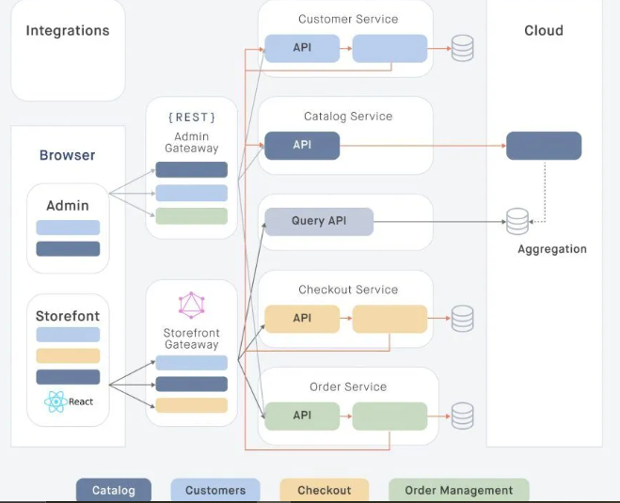

FIG. 4.1 USER’S DIAGRAM

The image provided represents a system architecture that can be adapted to explain the architecture of your project, which includes user, seller, and admin interactions, a frontend built with React, a backend using Node.js and Express.js, and MongoDB as the database.

**System Architecture Breakdown**

1. **User Interaction**:
   * The browser acts as the interface where users (customers), sellers, and admins interact with the system.
   * For your project, this would mean customers (students and companies) and admins access the system through a web interface built with React, utilizing the Storefront Gateway for customers and Admin Gateway for admins.
2. **Microservices**:
   * The diagram shows different services like Customer Service, Catalog Service, Checkout Service, and Order Service, each with its own API and database interactions.
   * In your project:
     + **Customer Service** can represent user-related functionalities such as user registration, login, and profile management.
     + **Catalog Service** can correspond to product-related functionalities where sellers upload, update, and manage their products.
     + **Checkout Service** relates to the payment processing and order management functionalities.
     + **Order Service** manages the orders placed by users, tracking their status and ensuring fulfillment.
3. **Data Flow and Storage**:
   * The backend services communicate with databases to store and retrieve data. These interactions are depicted by the arrows pointing to and from the databases.
   * For your project, MongoDB would handle data storage, and the backend services (implemented with Node.js and Express.js) would manage the data transactions. This includes user data, product details, order information, and payment transactions.
   * The diagram also highlights an aggregation layer which could be a part of your data analytics and reporting functionality, providing insights into user activities, product performance, and sales trends.

**Additional Components**

1. **Security and Middleware**:
   * The system should include security measures such as JWT (JSON Web Tokens) for authentication and authorization, ensuring secure user sessions.
   * Middleware like authToken in your Express.js routes would handle these security aspects, validating user tokens for protected routes.
2. **Scalability and Maintenance**:
   * The architecture supports scalability with each service being independent and capable of horizontal scaling. This is crucial for handling increased load, such as more users, products, or orders.
   * Tools like nodemon facilitate efficient development and maintenance by automatically restarting the server on code changes.

By mapping this architecture to your project, it provides a robust, scalable, and maintainable structure ensuring efficient management of users, products, orders, and payments while maintaining security and performance.

**4.2: UML DIAGRAMS:**

UML stands for Unified Modeling Language. UML is a standardized general-purpose modeling language in the field of object-oriented software engineering. The standard is managed and was created by the Object Management Group (OMG).

The goal is for UML to become a common language for creating models of object-oriented computer software. In its current form, UML comprises two major components: a Meta-model and a notation. In the future, some form of method or process may also be added to or associated with UML.

The Unified Modeling Language is a standard language for specifying, visualizing, constructing, and documenting the artifacts of software systems, as well as for business modeling and other non-software systems. UML represents a collection of best engineering practices that have proven successful in the modeling of large and complex systems.

The UML is a very important part of developing object-oriented software and the software development process. The UML uses mostly graphical notations to express the design of software projects.

**Goals:**

The primary goals in the design of the UML are as follows:

1. **Provide users a ready-to-use, expressive visual modeling language** so that they can develop and exchange meaningful models.
2. **Provide extendibility and specialization mechanisms** to extend the core concepts.
3. **Be independent of particular programming languages and development processes**.
4. **Provide a formal basis for understanding the modeling language**.
5. **Encourage the growth of the object-oriented tools market**.
6. **Support higher-level development concepts** such as collaborations, frameworks, patterns, and components.

**UML Diagrams for the Project:**

1. **Use Case Diagram**:
   * Depicts the interaction between users (students, companies, admin) and the system.
   * Illustrates the various functionalities available to each user type.
2. **Class Diagram**:
   * Shows the structure of the system by depicting the system’s classes, their attributes, and the relationships among the classes.
3. **Sequence Diagram**:
   * Represents the sequence of interactions between objects and classes in the system over time.
   * Useful for understanding how the functionalities (e.g., user registration, job posting, application submission) are carried out in the system.
4. **Activity Diagram**:
   * Describes the workflow of various activities in the system.
   * Helps in visualizing the dynamic aspects of the system, like the process flow for job application and approval.
5. **Component Diagram**:
   * Illustrates the organization and dependencies among software components, such as React components, Node.js modules, and MongoDB collections.
6. **Deployment Diagram**:
   * Displays the physical deployment of artifacts on nodes.
   * Shows how the software is deployed across servers and cloud services, indicating components like web servers, databases, and user interfaces.

By utilizing UML diagrams, the project achieves a clear and structured representation of its architecture and design, facilitating better understanding and communication among stakeholders and ensuring the successful implementation of the system.

**CLASS DIAGRAMS**

Class diagrams to describe the structure of the system. Classes are abstractions that specify the common structure and behavior of a set Class diagrams describe the system in terms of objects, classes, attributes, operations and their associations.

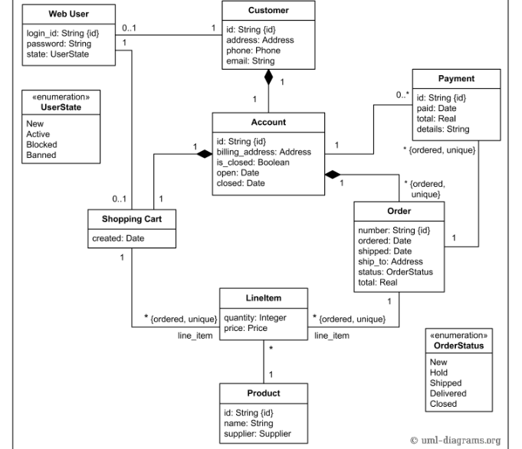

4.2 Class Diagram

**USE CASE DIAGRAMS**

Use cases are used during requirements elicitation and analysis to represent the functionality of the system.The Unified Modeling Language will result in lower overall costs, more reliable and efficient software, and a better relationship with all parties involved. Software documented with UML can be modified much more efficiently.

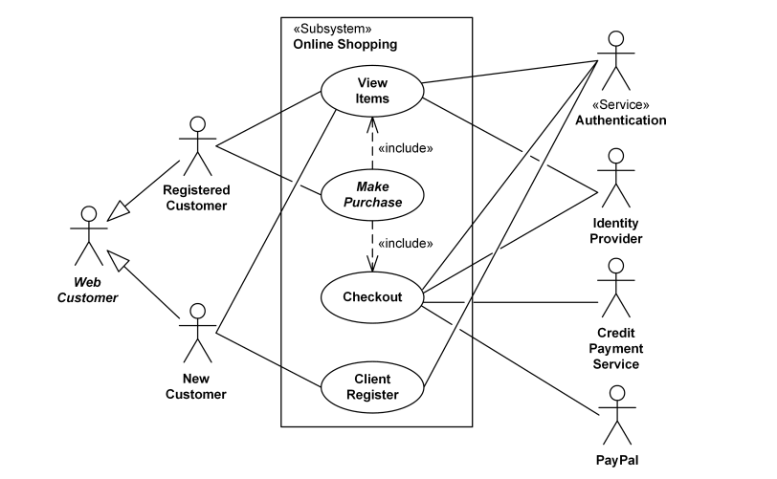

**SEQUENCE DIAGRAMS**

Sequence diagrams are used to formalize the behavior of the system and to visualize the communication among objects. They are useful for identifying additional objects that participate in the use cases. A Sequence diagram represents the interaction that take place among these objects.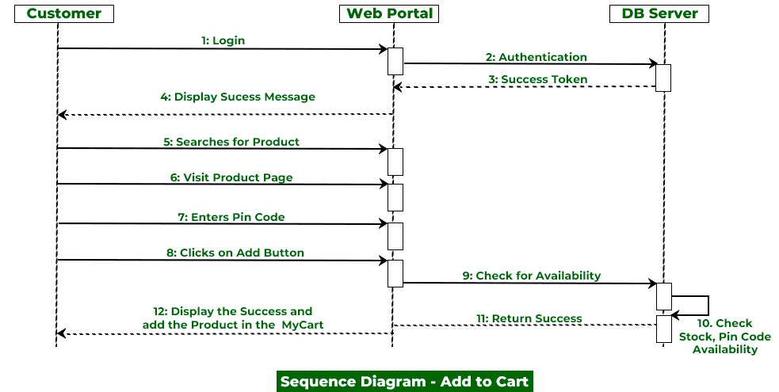

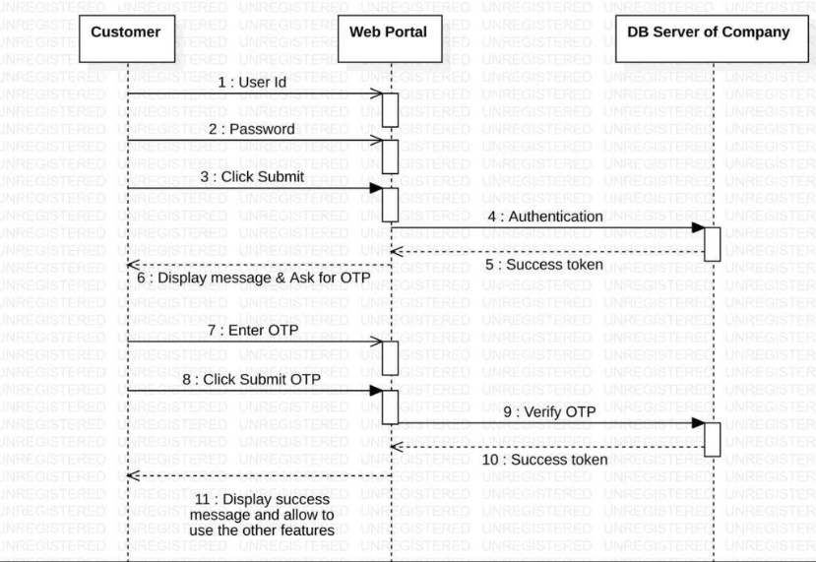

4.4.2 Authentication Sequence Diagram

**ACTIVITY DIAGRAMS**

An activity diagram describes a system in terms of activities. Activities are states that represents the execution of a set of operations. Activity diagrams are similar to flowchart diagram and data flow.

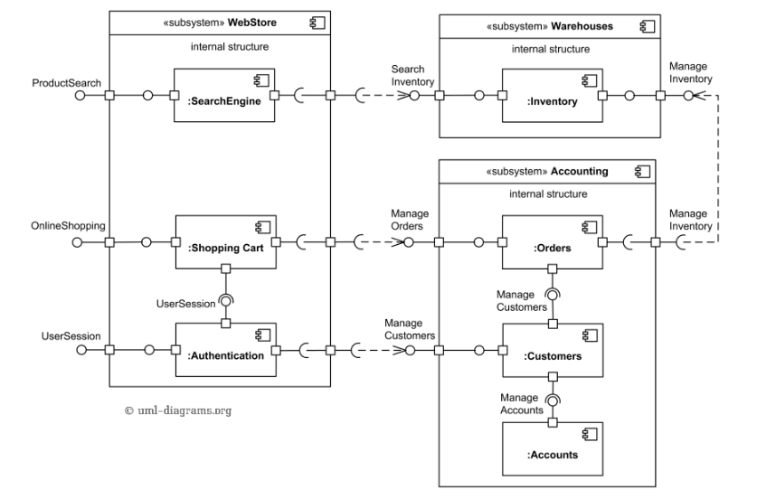

4.5 Activity Diagram

**ER DIAGRAMS**

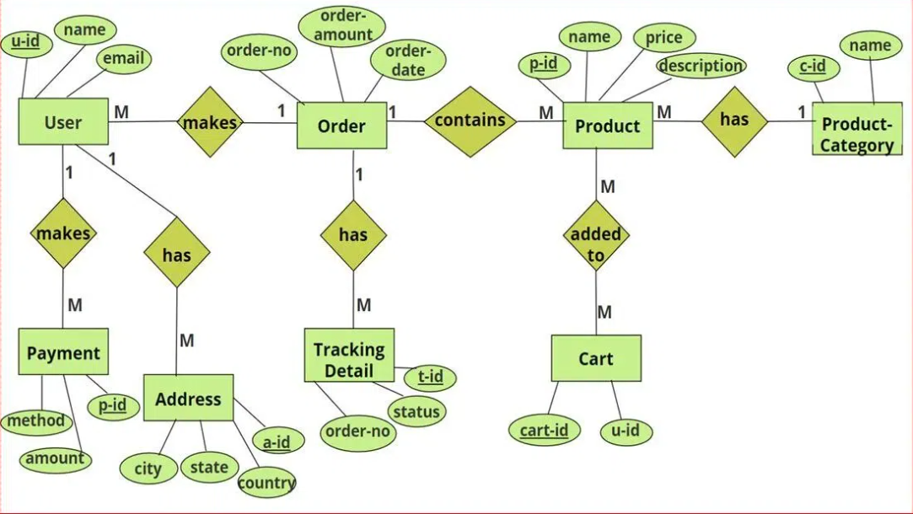

An Entity-Relationship (ER) diagram is a visual representation used in database design to illustrate the structure and relationships of data within a system. It depicts entities, which represent objects or concepts with distinct attributes, and the relationships that connect these entities. The diagram typically includes entities as rectangles, attributes as ovals, and relationships as diamonds, with lines connecting them to show how entities are related. ER diagrams help in identifying and organizing the data requirements, ensuring a clear understanding of the database schema, and facilitating communication between stakeholders. By mapping out entities, their attributes, and their relationships, ER diagrams serve as a foundational tool for designing and optimizing relational databases, ultimately guiding the creation of a coherent and efficient data model.

**5.SYSTEM IMPLEMENTATION**

**5.1 TECHNOLOGY:**

**Javascript Platform:**

JavaScript has emerged as a powerful and versatile language for web development, seamlessly bridging the gap between frontend and backend technologies. On the frontend, JavaScript enables dynamic, interactive user experiences by manipulating the Document Object Model (DOM) and handling user events in real-time. Frameworks and libraries such as React, Vue.js, and Angular enhance its capabilities, allowing developers to build responsive and visually appealing interfaces with reusable components. These tools streamline the development process, improve maintainability, and ensure a smoother user experience.

**Advantage Javascript Platform:**

On the backend, JavaScript continues to shine through Node.js, a runtime environment that allows developers to execute JavaScript code server-side. Node.js provides a non-blocking, event-driven architecture, making it well-suited for handling concurrent requests and building scalable applications. With the vast ecosystem of npm packages, developers can integrate a wide array of functionalities and streamline development workflows. The ability to use a single language across both frontend and backend reduces context switching, promotes code consistency, and enhances collaboration within development teams. Overall, JavaScript's versatility and extensive ecosystem make it an excellent choice for building full-stack web applications.

**Javascript API Features**:

➢ Essentials: Includes objects, strings, threads, numbers, I/O, data structures, system properties, date/time, etc.

➢ Networking: Supports URLs, TCP, UDP sockets, and IP addresses.

➢ Internationalization: Helps in creating localized programs for global users.

➢ Security: Provides both low-level and high-level security features.

➢ Software Components: JavaBeans can be integrated into existing component architectures.

➢ Object Serialization: Allows lightweight persistence and communication via RMI.

**MongoDB:**

* A NoSQL database designed for handling large volumes of unstructured or semi-structured data.
* Utilizes a document-oriented data model where data is stored in flexible, JSON-like documents, allowing for a more dynamic schema.
* Supports operations such as INSERT (adding new documents), FIND (querying documents), UPDATE (modifying documents), and DELETE (removing documents).
* Ideal for applications requiring high scalability, real-time analytics, and rapid development, offering advantages such as horizontal scaling and built-in support for complex queries and indexing.

**HTML (Hypertext Markup Language):**

● Standard markup language for creating web pages and web applications.

● Uses tags to structure content and define elements on web pages.

● Provides a basic structure for web documents, including text, images, links, and multimedia.

● Requires browsers to interpret and render web content as intended.

**(Cascading Style Sheets):**

● A style sheet language used for controlling the presentation and layout of web documents.

● Separates content (HTML) from its visual representation (CSS).

● Allows developers to define styles, fonts, colors, and positioning for web elements. ● Enhances consistency and maintainability of web design.

**5.2 IMPLEMENTATION:**

**TECHNOLOGY STACK’S PREREQUISITES:**

**1.Frontend:**

* + **React:** For building user interfaces.
  + **Redux:** For state management.
  + **Tailwind CSS:** For styling the application.

1. **Backend:**
   * **Node.js:** JavaScript runtime for building the backend.
   * **Express:** Web framework for handling API requests.
   * **MongoDB:** NoSQL database for data storage.
   * **bcrypt:** Library for hashing passwords.
   * **JSON Web Tokens (JWT):** For secure user authentication.
2. **Development Tools:**
   * **Visual Studio Code:** Code editor.
   * **Git:** Version control.
   * **npm or yarn:** Package management.
3. **Deployment and Performance:**
   * **Cloudflare:** For security and performance optimization.

This setup ensures a robust and scalable platform that enhances the online coffee shopping experience, providing a seamless and secure interface for both customers and sellers.

**Frontend Documentation :**

**Create react app:**

**Create React App** is a tool that sets up a modern web application by running a single command. It allows developers to quickly bootstrap a React project with no build configuration required. This project was initialized using Create React App, which provides a robust and well-configured environment for development. With features like live reloading, easy environment setup, and a pre-configured Webpack setup, Create React App simplifies the development process, allowing developers to focus more on writing code rather than managing configurations.

### **State Management**

Effective state management is crucial for building complex applications with dynamic user interfaces. In this project, state management is handled using a combination of React's Context API and Redux Toolkit. React's Context API is used for managing global states that need to be accessed throughout the application, such as user authentication status and theme settings. This approach simplifies the passing of data through the component tree without having to pass props manually at every level.

### **Redux Toolkit**

**Redux Toolkit** is used for more sophisticated state management needs. It is a powerful library that simplifies the process of managing state in React applications. Redux Toolkit provides a standardized way to write Redux logic and includes useful tools like createSlice for creating reducers and actions, configureStore for setting up the store, and createAsyncThunk for handling asynchronous actions. In this project, Redux Toolkit manages various parts of the application state, including user information, product data, and shopping cart details, ensuring a predictable state container that helps in debugging and testing.

### **Component-Based Architecture**

The frontend is designed using a component-based architecture, which enhances reusability, maintainability, and scalability. Each component encapsulates a piece of the user interface and its associated logic. For example, components like SignUp, SignIn, UserProfile, and ProductList are responsible for specific parts of the UI. This modular approach allows for easier updates and maintenance as each component can be developed, tested, and debugged independently.

### **Routing with React Router**

**React Router** is employed to handle the routing within the application. It provides a declarative way to navigate through different views or pages in the app. React Router's dynamic routing capabilities allow the application to render components based on the URL, enabling a seamless and intuitive navigation experience for users. Routes are defined in a centralized file, making it easy to manage and extend the navigation structure as the application grows.

### **Tailwind CSS**

For styling, **Tailwind CSS** is used, which is a utility-first CSS framework. Tailwind CSS allows developers to apply styles directly in the HTML through utility classes, resulting in a highly customizable and responsive design. This approach speeds up the development process and ensures consistency across the UI. Tailwind's configuration file allows for easy theme customization and extending the default styles to meet the specific needs of the project.

### **Integration with Backend APIs**

The frontend interacts with the backend through a series of well-defined APIs. Each component that requires data from the server or needs to send data to the server does so through these APIs. For instance, the SignUp and SignIn components interact with the authentication endpoints, while the ProductList and ProductDetails components interact with the product-related endpoints. This separation of concerns ensures that the frontend remains focused on rendering the UI and handling user interactions, while the backend handles data processing and business logic.

### **React Toastify for Notifications**

**React Toastify** is used for displaying notifications within the application. It provides an easy way to show alerts and notifications in response to user actions, such as successful sign-ups, logins, or errors. React Toastify's customizable toasts enhance user experience by providing immediate feedback, making the application more interactive and user-friendly.By leveraging these tools and technologies, the frontend of this project achieves a robust, scalable, and maintainable architecture, ensuring a high-quality user experience.

### **React Reusable Components**

**React reusable components** are a fundamental concept in React development that promote modularity, maintainability, and efficiency. By creating components that can be reused across different parts of the application, developers can avoid redundancy and simplify updates. Reusable components encapsulate specific functionality or UI elements, allowing them to be used in various contexts without duplicating code. This modular approach not only makes the codebase cleaner and easier to manage but also ensures consistency in design and behavior throughout the application. For instance, a button component can be designed once and reused with different props to perform various actions, enhancing development speed and reducing potential errors.

### **useState Hook**

The **useState hook** is a vital React feature introduced with React Hooks in version 16.8, allowing functional components to manage local state. It simplifies the state management process by providing a way to declare state variables directly within a functional component. The useState hook returns an array with two elements: the current state value and a function to update it. This enables dynamic interaction within the component, as state changes trigger re-renders to reflect the updated state. For example, managing form inputs, toggling visibility of elements, or keeping track of counters can be efficiently handled using the useState hook, resulting in more concise and readable code compared to class components.

### **useEffect Hook**

The **useEffect hook** is another essential React feature that allows developers to perform side effects in functional components. Introduced alongside React Hooks, useEffect replaces lifecycle methods such as componentDidMount, componentDidUpdate, and componentWillUnmount in class components. This hook takes a function as an argument, which contains the side-effect logic, and an optional dependency array that determines when the effect should re-run. Common use cases for useEffect include data fetching, subscriptions, and manual DOM manipulations. By using useEffect, developers can handle asynchronous operations and ensure that side effects are executed at the right times, keeping the component logic organized and clear.

**Backend Documentation**

### **Backend Development**

The backend development of this project focuses on creating a robust, scalable, and secure server-side infrastructure to support the coffee-tea and cold drinks online shop. Built using Node.js, the backend leverages Express, a minimalist web framework, to handle routing, middleware, and HTTP requests efficiently. The backend is responsible for managing user authentication, product data, orders, and payments. It ensures that all client requests are processed accurately and securely, providing a seamless experience for both the seller and admin sides of the application.

MongoDB is used as the primary database, providing a flexible and scalable solution for storing user and product data. Mongoose, an Object Data Modeling (ODM) library, is employed to define schemas and interact with the database, ensuring data integrity and consistency. The application uses bcrypt for hashing and securely storing user passwords, while JSON Web Tokens (JWT) are used for managing authentication and authorization. Additionally, Nodemon is utilized during development to automatically restart the server on file changes, enhancing the development workflow. This comprehensive setup ensures that the backend is not only efficient and performant but also secure and maintainable, capable of handling the demands of a modern e-commerce platform.

### **JavaScript**

**JavaScript** is a versatile, high-level programming language that is widely used for both client-side and server-side development. In the context of backend development, JavaScript allows developers to write server-side code using Node.js, creating dynamic and scalable web applications. Its asynchronous, event-driven architecture makes it suitable for handling multiple simultaneous connections, which is essential for building real-time applications. JavaScript's extensive ecosystem, including numerous libraries and frameworks, provides developers with the tools needed to efficiently build and maintain server-side logic and functionality.

### **Express**

**Express** is a minimalist web application framework for Node.js, designed to build robust and scalable web applications. It provides a simple, yet powerful, set of features to develop both web and mobile applications. Express facilitates the management of routes, handling HTTP requests and responses, and setting up middleware for various functionalities such as logging, authentication, and error handling. Its flexibility and ease of use make it a popular choice for building RESTful APIs and single-page applications. Express's middleware architecture allows developers to add functionality in a modular way, promoting maintainable and scalable code.

### **Nodemon**

**Nodemon** is a development tool that automatically restarts a Node.js application when file changes are detected in the directory. It improves the development workflow by eliminating the need to manually stop and restart the server after every code change. Nodemon watches for changes in the files and automatically restarts the server, ensuring that the latest code is always running. This leads to faster development cycles and enhances productivity. Nodemon is particularly useful during the development phase, allowing developers to focus on writing code without worrying about the server state.

### **JSON Web Token (jsonwebtoken)**

**JSON Web Token (JWT)** is a compact, URL-safe means of representing claims to be transferred between two parties. In backend development, JWT is commonly used for authentication and authorization purposes. It allows secure transmission of information between the client and server as a JSON object. JWTs are signed using a secret or a public/private key pair, ensuring the integrity and authenticity of the token. Express applications often use the jsonwebtoken library to generate, sign, and verify tokens. This enables secure, stateless authentication mechanisms, reducing the need for server-side sessions and improving scalability.

### **Mongoose**

**Mongoose** is an Object Data Modeling (ODM) library for MongoDB and Node.js. It provides a schema-based solution to model application data, offering a straightforward way to interact with MongoDB. Mongoose translates data between the database and JavaScript objects, ensuring that the application data follows defined schemas. It offers built-in type casting, validation, query building, and business logic hooks, which simplify database operations. By abstracting MongoDB’s native driver, Mongoose makes it easier to work with MongoDB, enabling developers to focus on building application logic rather than dealing with complex database operations.

### **bcrypt**

**bcrypt** is a library for hashing passwords, ensuring secure storage of user credentials. It is designed to be computationally intensive to protect against brute-force attacks. In the context of backend development, bcrypt is used to hash passwords before storing them in the database and to compare hashed passwords during the authentication process. The bcryptjs library in Node.js provides both synchronous and asynchronous methods for hashing and verifying passwords. By using bcrypt, developers can enhance the security of their applications, protecting user data against unauthorized access and ensuring that passwords are securely managed.

**PROJECT STRUCTURE:**

In a React and Node.js web development project, the structure is typically organized to enhance modularity and maintainability. The frontend, built with React, usually features a directory structure that includes folders for components, containers, and assets. Components are often broken down into reusable units, while containers manage state and handle business logic. Assets such as stylesheets and images are organized to keep the project tidy and scalable. The React application is often configured with tools like Webpack and Babel for efficient bundling and transpilation.

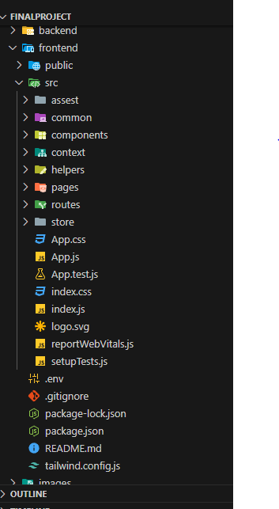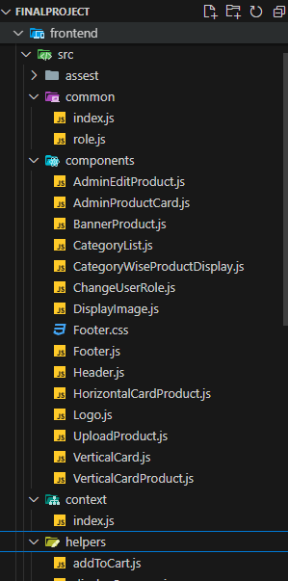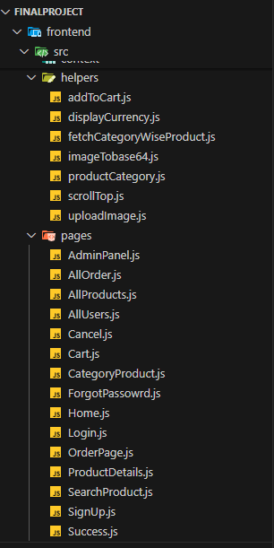

Above fig are representation of frontend file structure.

On the backend, Node.js serves as the runtime environment, and the project structure often includes folders for routes, controllers, models, and middleware. Routes define the API endpoints, controllers handle request processing and business logic, models represent the database schemas, and middleware is used for tasks like authentication and error handling. This separation of concerns ensures that each part of the application is modular and easy to maintain. Together, React and Node.js provide a cohesive framework for building full-stack applications with a clear separation between frontend and backend responsibilities.

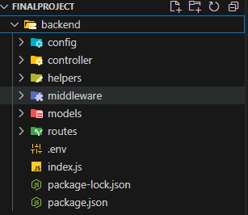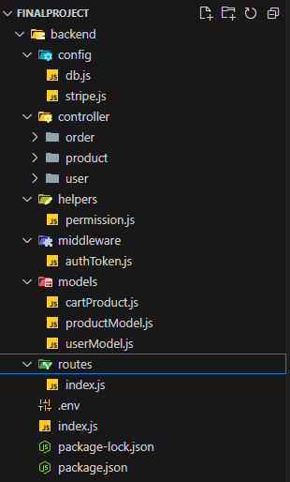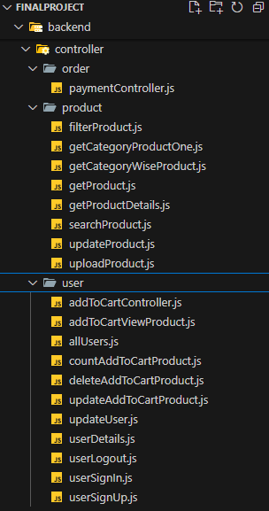

**5.3 Sample Code**

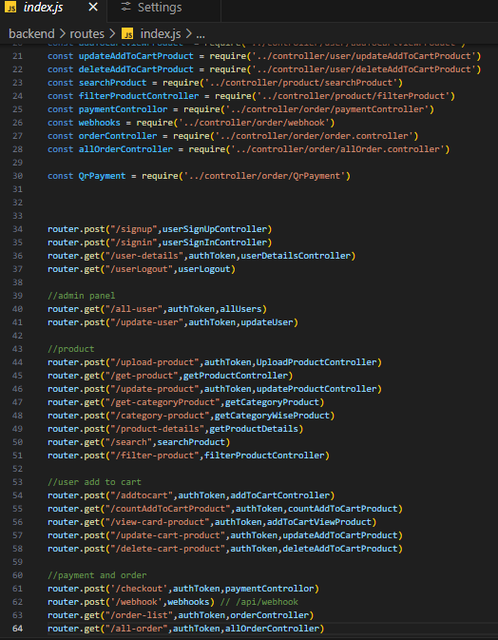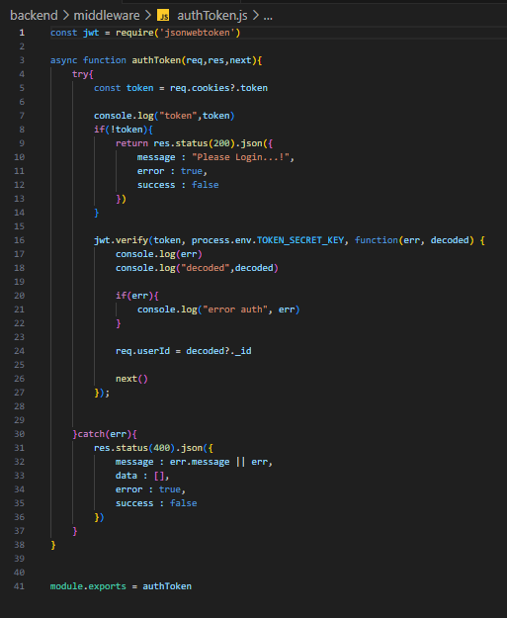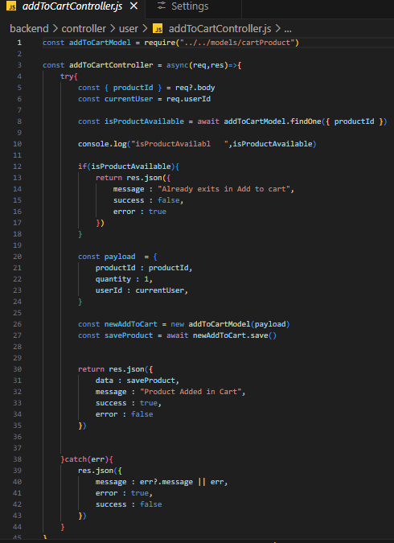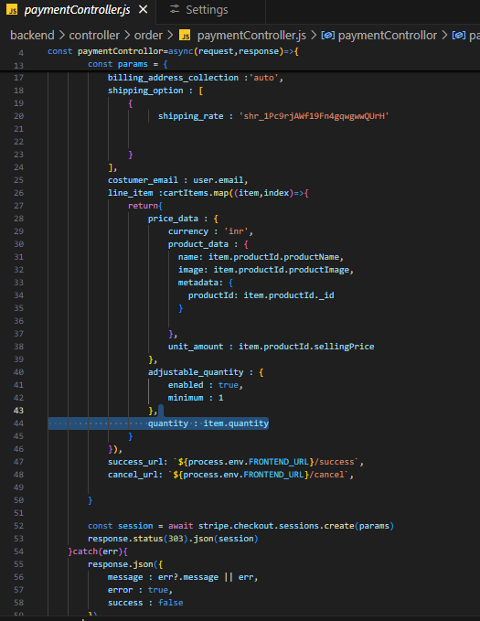

**Frontend::**

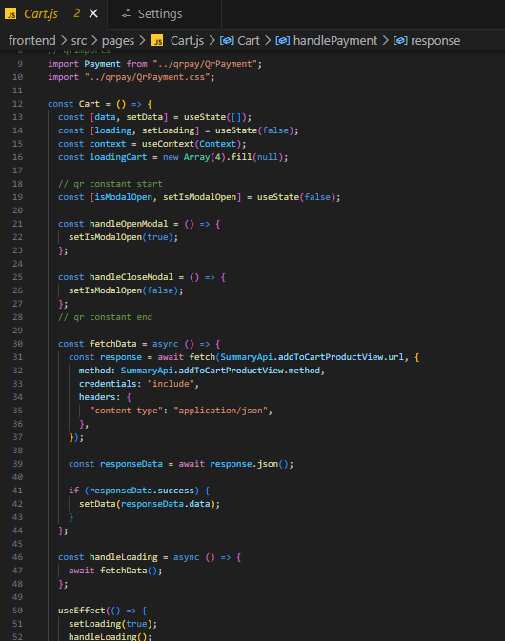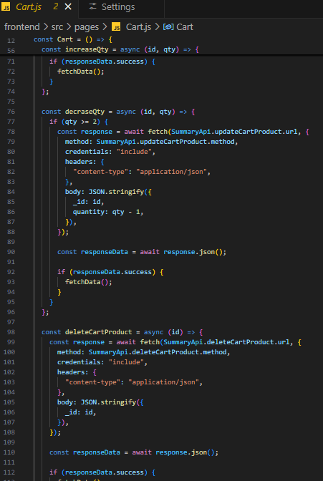

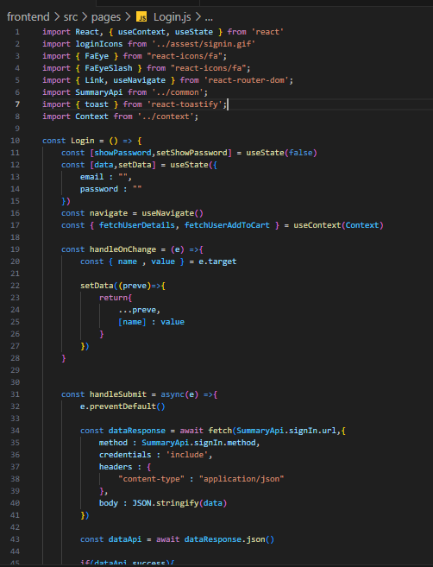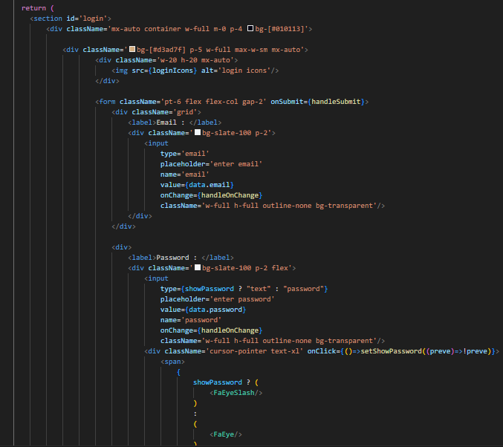

**6.1: OUTPUT SCREEN**

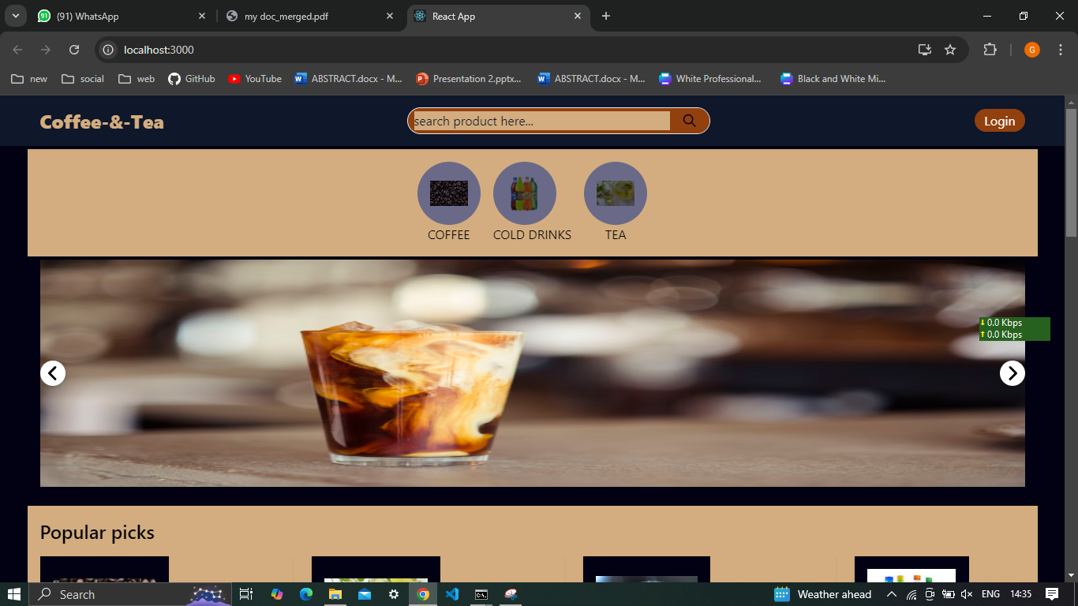**1.Landing-page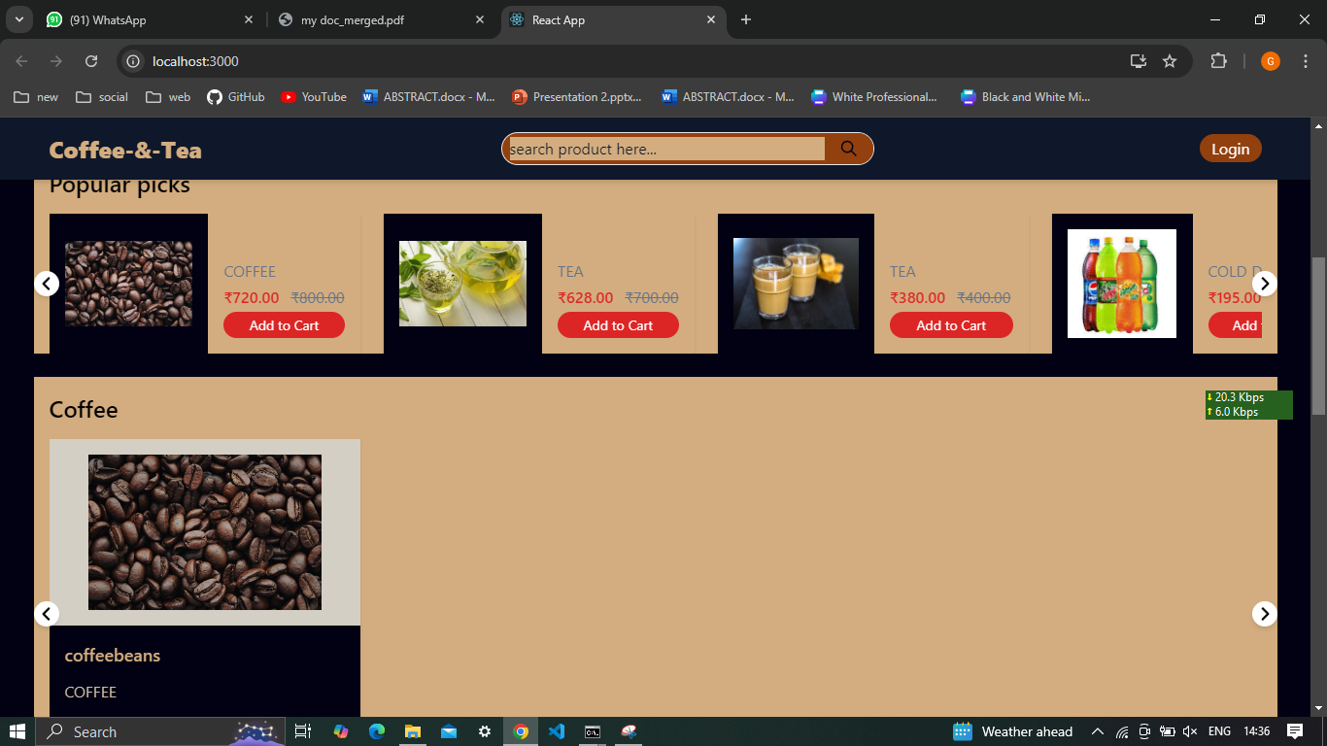2.product-page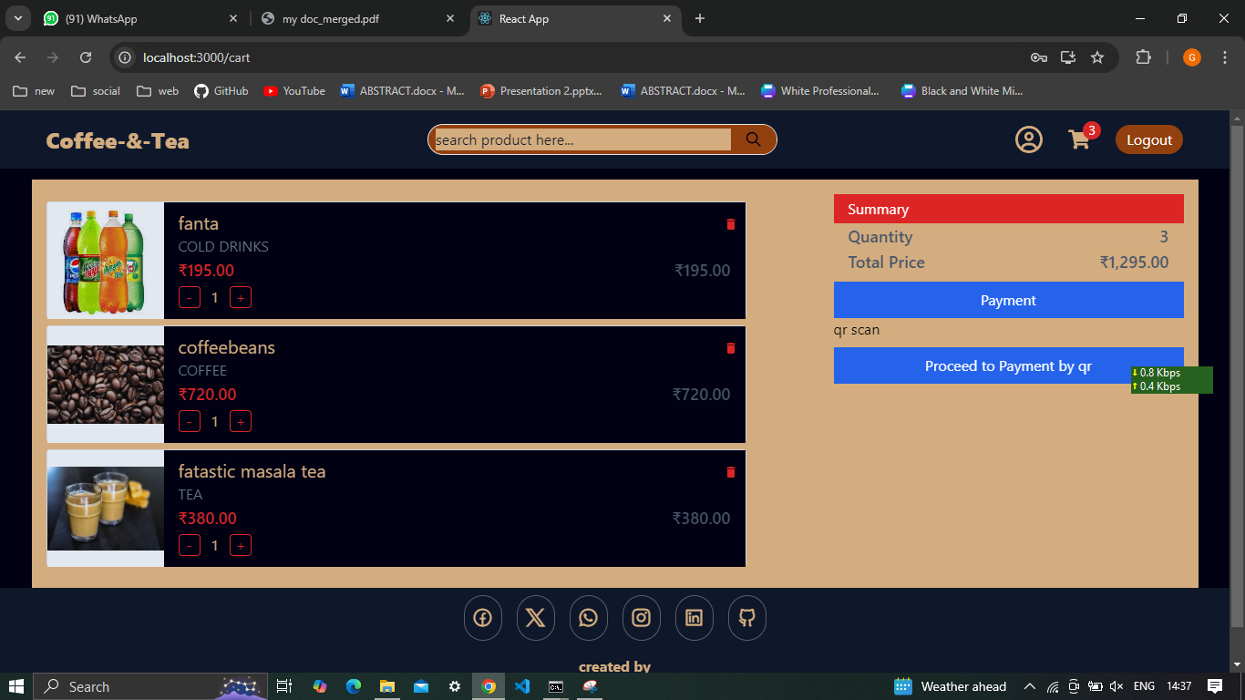3.cart-page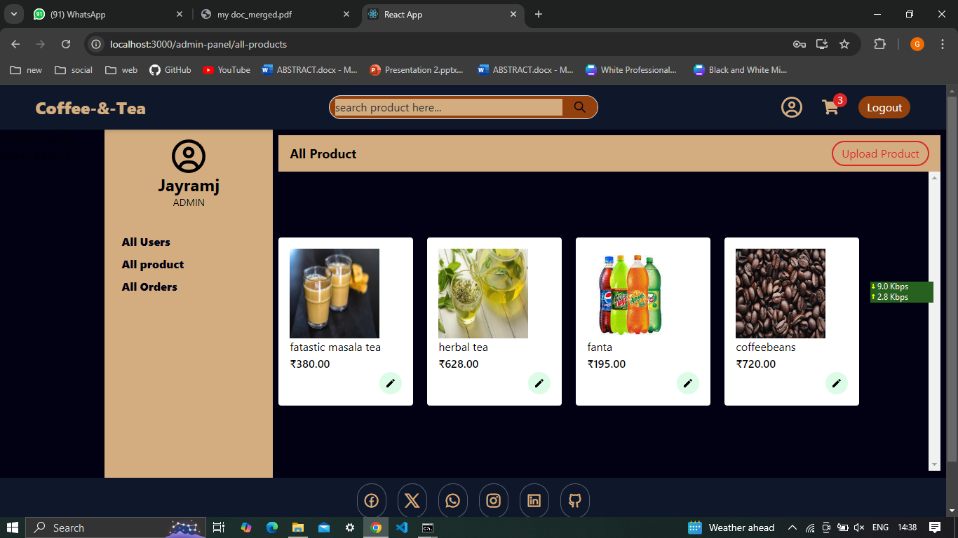4.all-product-page(admin panel)**

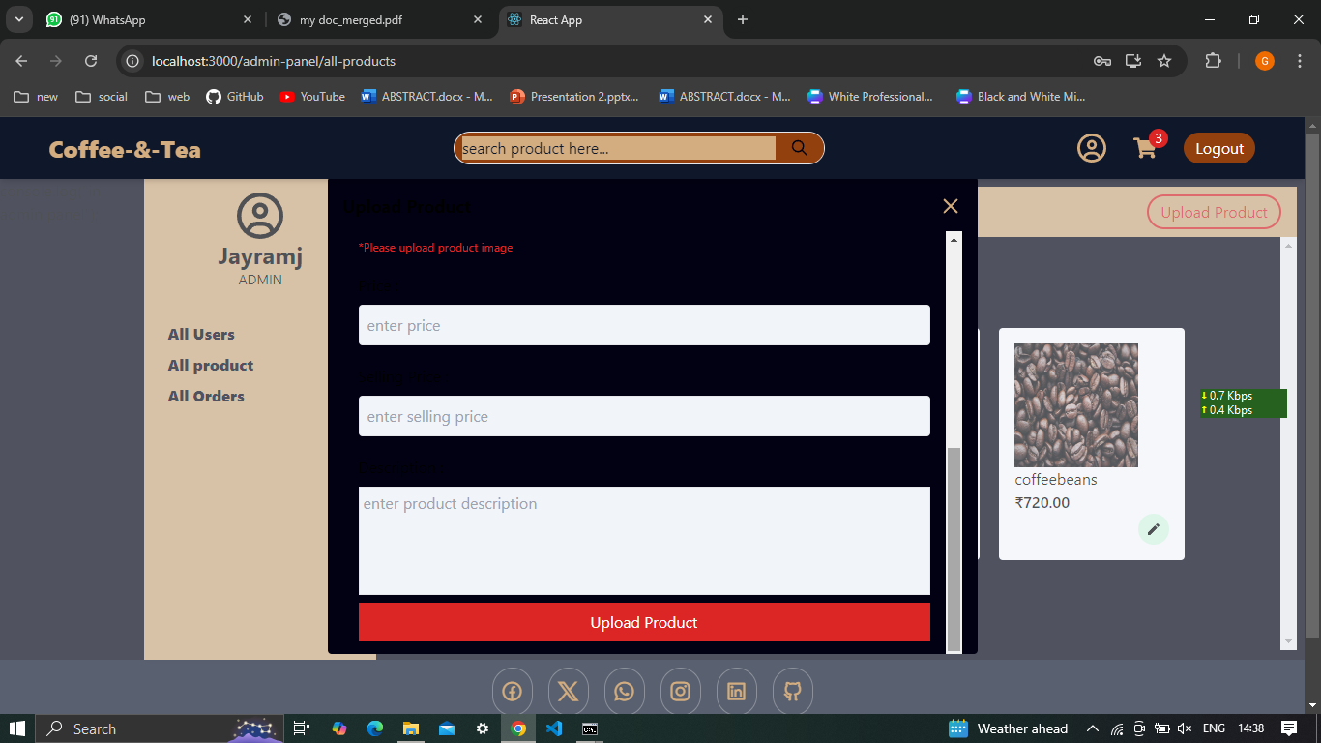**5.product-upload-page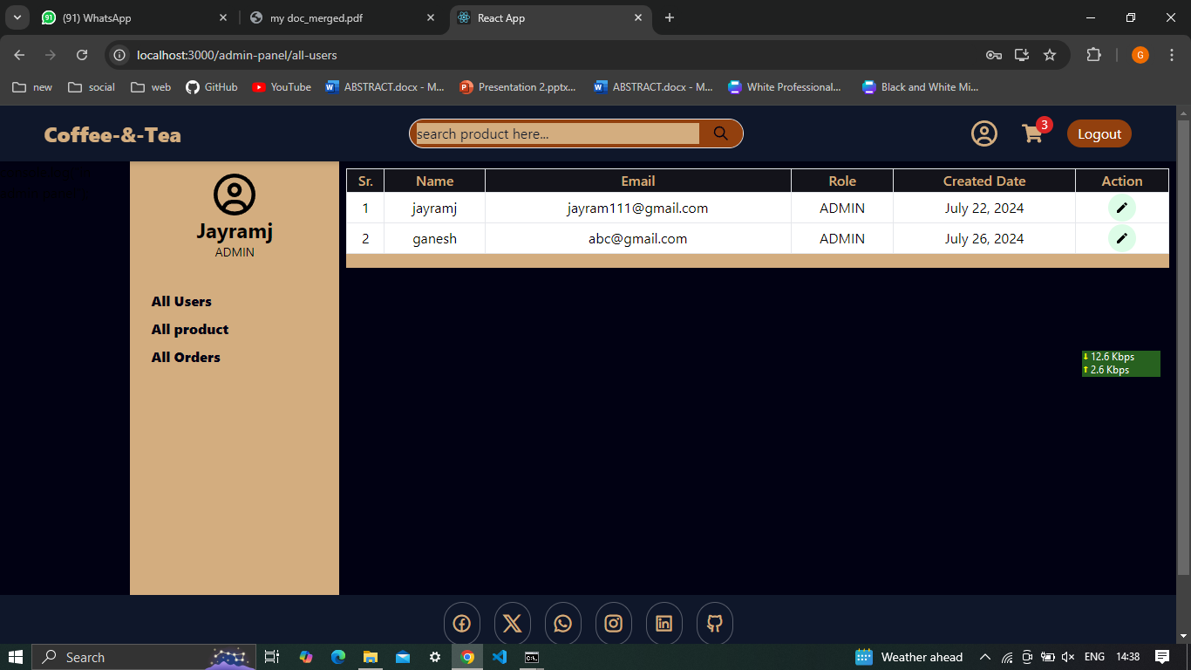6.user-management page(admin panel)**

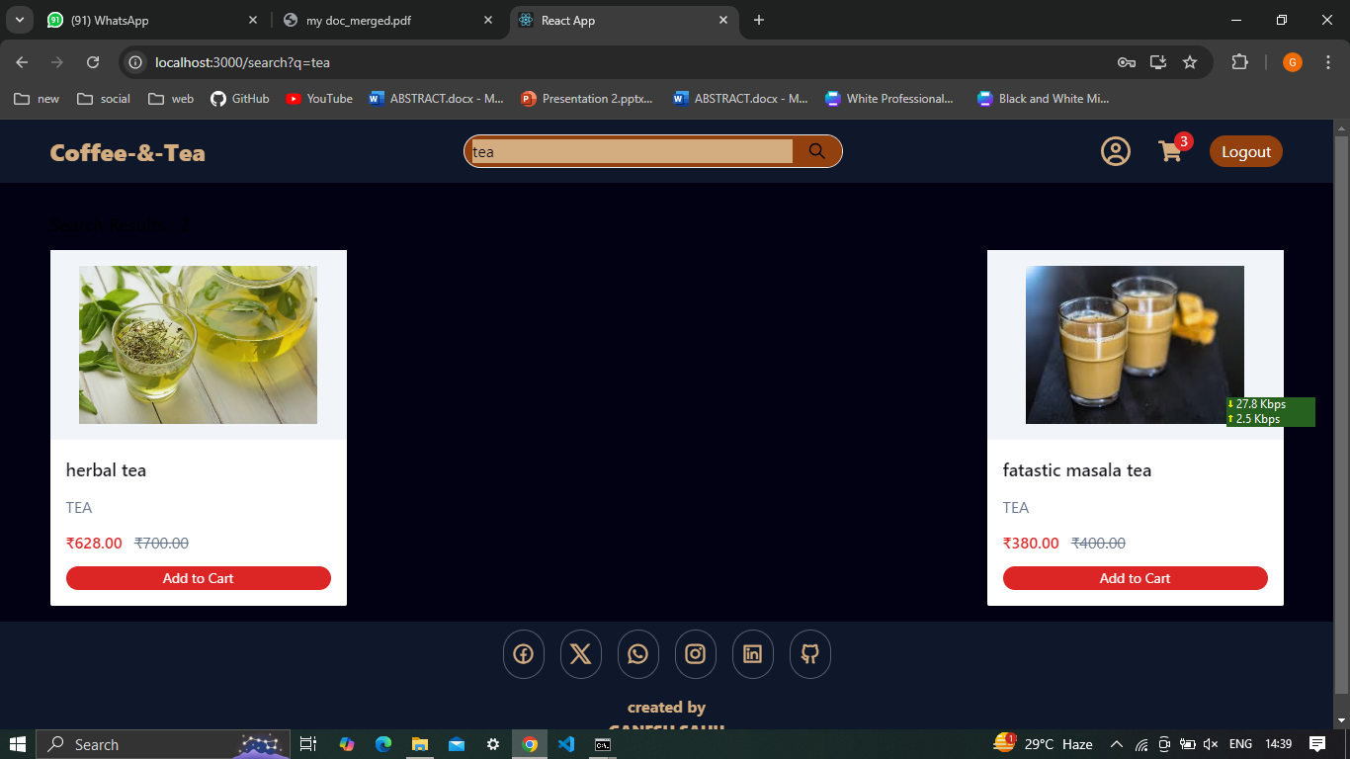**7.product-search-page**

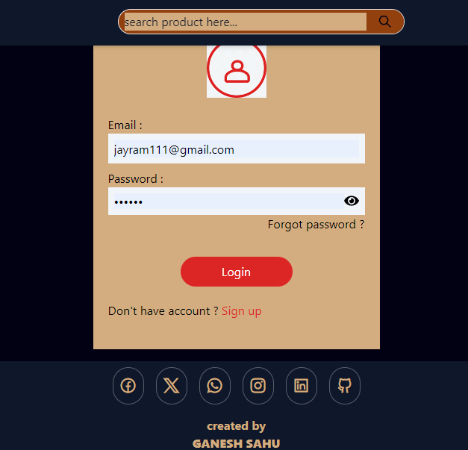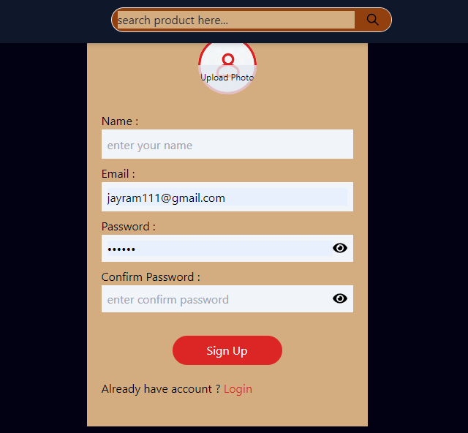

**8.login and sign-up page.**

**7: SYSTEM TESTING**

**7.1 TESTING METHODOLOGIES**

The following are the Testing Methodologies:

* Unit Testing
* Integration Testing
* User Acceptance Testing
* Output Testing
* Validation Testing

**UNIT TESTING:**

Unit testing focuses on verifying the smallest unit of software design, typically a module or function. This type of testing aims to ensure that each module operates correctly in isolation by exercising all possible execution paths and error handling scenarios. During unit testing, each module is tested individually against its design specifications to confirm proper functionality. This testing phase helps identify and address issues at a granular level before the modules are integrated into a larger system.

**INTEGRATION TESTING:**

Integration testing addresses the challenge of combining individual units into a cohesive system. It involves testing the interactions between integrated modules to ensure they work together as intended. The primary objective is to verify that the integrated components function correctly and meet design specifications. Integration testing can be approached in various ways:

1. TOP-DOWN INTEGRATION: This approach integrates modules from the top of the control hierarchy, starting with the main module and progressively incorporating subordinate modules. Testing proceeds by replacing individual stubs with actual modules as integration progresses downward.
2. BOTTOM-UP INTEGRATION: This method begins with integrating and testing the lowest-level modules first. It involves combining these modules into clusters, which are then tested using a driver program. As testing advances, clusters are integrated into higher levels of the program structure, eliminating the need for stubs.

**OTHER TESTING METHODOLOGIES:**

USER ACCEPTANCE TESTING: This testing method ensures that the system meets user needs and expectations. It involves continuous feedback from prospective users throughout development, making adjustments based on their input. The goal is to deliver a user-friendly system that aligns with user requirements and facilitates ease of use.

**OUTPUT TESTING:** After validation testing, output testing checks if the system produces the required outputs in the correct format. This includes both on-screen and printed formats, based on user specifications. Proper output testing ensures that the system delivers accurate and appropriately formatted data.

**VALIDATION CHECKING:** Validation testing verifies that the system meets the defined requirements for various data fields. This includes text fields, which must adhere to character limits and data type constraints, and numeric fields, which should only accept numeric values. Validation ensures that the system handles data correctly and produces expected results.

**PREPARATION OF TEST DATA:**

Test data preparation is crucial for effective system testing. Various types of test data are used to evaluate the system’s performance and uncover any defects. Artificial test data, generated specifically for testing purposes, helps cover all possible input scenarios and validate system functionality. Effective test data preparation and execution ensure thorough evaluation and refinement of the system.

**USER TRAINING:**

User training is essential for effective system adoption. It involves educating users about the system’s functionality and ensuring they can utilize it efficiently. Training sessions are designed to be intuitive, considering the users’ familiarity with computers and aiming for straightforward operation.

**MAINTENANCE:**

Maintenance involves addressing code and design errors and adapting the system to meet evolving needs. By accurately defining user requirements during development, maintenance efforts can be minimized. Future enhancements and feature additions are planned based on technological advancements and user feedback, ensuring the system remains relevant and functional.

**TESTING STRATEGY:**

A comprehensive testing strategy integrates test planning, case design, execution, and evaluation. It encompasses both low-level tests to verify individual code segments and high-level tests to validate overall system functions against user requirements. Effective testing is critical for ensuring software quality and meeting user expectations before system deployment.

**SYSTEM TESTING:**

Software once validated must be combined with other system elements (e.g. Hardware, people, database). System testing verifies that all the elements are proper and that overall system function performance is achieved. It also tests to find discrepancies between the system and its original objective, current specifications and system documentation.

**UNIT TESTING:**

In unit testing different are modules are tested against the specifications produced during the design for the modules. Unit testing is essential for verification of the code produced during the coding phase, and hence the goals to test the internal logic of the modules. Using the detailed design description as a guide, important Conrail paths are tested to uncover errors within the boundary of the modules. This testing is carried out during the programming stage itself. In this type of testing step, each module was found to be working satisfactorily as regards to the expected output from the module. In Due Course, latest technology advancements will be taken into consideration. As part of technical build-up many components of the networking system will be generic in nature so that future projects can either use or interact with this. The future holds a lot to offer to the development and refinement of this project.

**8.CONCLUSION**

In conclusion, the coffee-tea and cold drinks online shop project exemplifies the integration of contemporary web technologies to create a high-performance, user-friendly e-commerce platform. By leveraging a modern tech stack that includes Node.js, Express, MongoDB, React, and various supporting libraries and tools, this project ensures robust functionality, scalability, and security. The use of reusable components in React and efficient state management with Redux enhances the front-end experience, making it intuitive and responsive for users. Meanwhile, the backend, powered by Express and secured with JWT and bcrypt, provides a reliable foundation for handling authentication, data management, and business logic.

This project demonstrates the importance of modular design and reusable components in building maintainable and scalable applications. The thorough integration of front-end and back-end technologies ensures a seamless flow of data and interactions, creating a smooth user experience. With features such as secure user authentication, dynamic product catalogs, a streamlined checkout process, and real-time data updates, the platform is well-equipped to meet the needs of coffee enthusiasts and sellers alike.

Overall, this documentation serves as a comprehensive guide to the development and architecture of the project. It highlights the key components, technologies, and methodologies used, providing valuable insights into the creation of a modern e-commerce application. This project not only showcases technical proficiency but also emphasizes the importance of thoughtful design and careful planning in delivering a successful web application. As the project evolves, the foundational principles and technologies outlined here will continue to guide its growth and enhancement, ensuring its relevance and effectiveness in the competitive landscape of online retail.

**BIBILIOGRAPHY**

1. Roger S Pressman, “Software Engineering – A Practitioner’s approach” McGraw – Hill International Editions, Fifth Edition, 2001.

2. Henry F Korth, S. Sudharshan, “Database System Concepts” McGraw – Hill International Editions, Fourth Edition, 2002.

3. George Koch, Kevin Loney, “Oracle – The Complete Reference”, Tata McGraw Hill, Third Edition, 2001.

4. James Jawroski, “Mastering Java Script”, Tmh 3/e, 2000.

1. Websites:

- [Node.js Official Website](https://nodejs.org)

- [Express.js Official Documentation](https://expressjs.com)

- [React.js Official Documentation](https://reactjs.org)

- [MongoDB Official Documentation](https://docs.mongodb.com)

- [Mongoose Documentation](https://mongoosejs.com)

- [Tailwind CSS Documentation](https://tailwindcss.com)

- [Redux Toolkit Documentation](https://redux-toolkit.js.org)

2. GitHub Repositories:

- [Node.js GitHub Repository](https://github.com/nodejs/node)

- [Express.js GitHub Repository](https://github.com/expressjs/express)

- [React.js GitHub Repository](https://github.com/facebook/react)

- [Mongoose GitHub Repository](https://github.com/Automattic/mongoose)

- [Tailwind CSS GitHub Repository](https://github.com/tailwindlabs/tailwindcss)

- [Redux Toolkit GitHub Repository](https://github.com/reduxjs/redux-toolkit)

These references provide comprehensive information and resources that were instrumental in the development of this project. They cover the essential concepts, best practices, and advanced techniques needed to build a modern web application using the technologies and frameworks mentioned in this documentation.

**GLOSSARY**

1. **Enhanced Performance:**
   * **Fast Load Times:** The proposed system leverages modern web technologies such as React and efficient backend services with Node.js, ensuring fast load times and a smooth user experience.
   * **Low Latency:** Optimized server interactions and efficient data management with MongoDB reduce latency, providing a responsive platform.
2. **Superior Scalability:**
   * **Scalable Architecture:** The use of a mono repo architecture and scalable database solutions ensures the platform can handle increasing numbers of users and an expanding product catalog without performance degradation.
   * **Flexible Component Scaling:** The architecture allows for independent scaling of components, ensuring optimal performance under varying loads.
3. **Improved Maintainability:**
   * **Modern Codebase:** Utilizing contemporary development practices and tools, the proposed system ensures a clean and maintainable codebase, facilitating easier updates and maintenance.
   * **Reduced Downtime:** Efficient maintenance practices and streamlined deployment processes minimize downtime during updates.
4. **Comprehensive Features:**
   * **Detailed Product Catalogue:** The proposed system offers a rich product catalog with detailed information, user reviews, and ratings, helping users make informed purchasing decisions.
   * **Efficient Order Management:** Comprehensive order management tools allow users and sellers to efficiently track orders, manage shipments, and handle returns.
   * **Advanced Search and Filtering:** Enhanced search functionality and filtering options improve product discovery, making it easier for users to find what they are looking for.
5. **Robust Security:**
   * **Advanced Security Measures:** Implementation of modern security practices, including bcrypt for password hashing and JSON Web Tokens (JWT) for secure user sessions, ensures robust protection against common vulnerabilities.
   * **Secure Authentication:** Enhanced authentication mechanisms protect user accounts from unauthorized access, ensuring user data is secure.
6. **Feasibility Analysis:**

An assessment of the practicality and viability of the software project, including financial and technical considerations.

1. **Frameworks and Methodologies:**

Structured approaches and tools used for evaluating the feasibility of software projects, such as cost-benefit analysis and risk assessment.

1. **Functionalities:**

Specific actions and operations performed on the online recruitment platforms, like job posting, searching, and application submission.

**9. Industry Standards:**

Accepted practices and benchmarks followed in the field of online recruitment platforms and career services.

**10.Customer Engagement and Retention:**

* + **Personalized Recommendations:** Features such as personalized recommendations based on user behavior enhance customer engagement.
  + **Loyalty Programs:** Implementation of loyalty programs rewards frequent shoppers, encouraging repeat business.

**11.Accessibility:**

* + **Inclusive Design:** Adherence to web accessibility standards ensures the platform is usable by all, including those with disabilities.

**12.Analytics and Reporting:**

* + **Data-Driven Insights:** Detailed analytics and reporting tools provide sellers and administrators with valuable insights into sales and user behavior, aiding in informed decision-making and continuous improvement of the platform.