

**PIMPRI CHINCHWAD EDUCATION TRUST'S PIMPRI CHINCHWAD COLLEGE OF ENGINEERING**

**DEPARTMENT OF COMPUTER ENGINEERING**

**Mini Project Report**

**TITLE: “Hotel Management System”**

**SUBJECT: Database Management System**

**YEAR: TE Computer (2015 Course)**

**Submitted By:**

**Jitendra Joshi**

**Ganesh Shinde**

**TECOA139**

**TECOA164**

**Under the guidance of –**

**Mrs. Prof. Madhura Kalbhor.**

1



PIMPRI CHINCHWAD COLLEGE OF ENGINEERING DEPARTMENT OF COMPUTER ENGINEERING

**CERTIFICATE**

This is to certify that, the project entitled

**“HOTEL MANAGEMENT SYSTEM**”

is successfully carried out as a mini project successfully submitted by following students of “PCET's Pimpri Chinchwad College of Engineering,

Nigdi, Pune-44**”.**

**Under the guidance of Mrs. Prof. Madhura Kalbhor.**

In the partial fulfillment of the requirements for the T.E. (Computer Engineering)

**JITENDRA S. JOSHI TECOA139**

**GANESH D. SHINDE TECOA164**

**Project Guide:**

**Mrs. Prof. Madhura Kalbhor.**

2

**ABSTRACT**

In this project we are creating Software for any Hotels such that using that Software we can either take orders Online from Customers. And for Offline Orders, the waiter will take order from customer present in hotel and forward the order details to chef. The Whole Process is interconnected using software when certain order is arrived chef will know that order has received via online or offline and further chef can process for making food. When Order completed or placed Bill will be processed to customer.

It will be easy for hotel to maintain customer records and how many orders are coming daily.

3

**INDEX**

|  |  |  |  |  |
| --- | --- | --- | --- | --- |
| **Chapter** |  | **Content** | **Page No.** |  |
|  |  |  |  |  |
|  | **1.1** | **- Introduction** | **5** |  |
| **1** | **1.2** | **– Problem Statement** | **5** |  |
| **1.3** | **- Scope** |  |
|  | **5** |  |
|  |  |  |  |
|  |  |  |  |  |
|  | **2.1** | **– Project Design** | **6** |  |
| **2** | **2.2** | **– Technical Details** | **7** |  |
| **2.3** | **– Detailed Design of Modules** | **8** |  |
|  |  |
|  | **2.4** | **– Schemas of All Tables** | **9** |  |
|  | **3.1 – Results & Discussion** | | **10** |  |
| **3** | **3.2 – Source Code** | | **10** |  |
|  | **3.3 – Screen-Shots including GUI** | | **11** |  |
|  |  | |  |  |
| **4** | **4.1 – Conclusion** | | **15** |  |
|  |  |  |  |  |

**FIGURE INDEX**

|  |  |  |
| --- | --- | --- |
| **Figure No.** | **Figure Name** | **Page No.** |
|  |  |  |
| **1** | **FlowChart** | **6** |
|  |  |  |
| **2** | **Login and Signup(Customer)** | **11** |
|  |  |  |
| **3** | **Customer and Staff login** | **12** |
|  |  |  |
| **4** | **Waiter and Chef** | **13** |
|  |  |  |
| **5** | **Database Structure** | **14** |
|  |  |  |
| **6** | **Final Bill Screen** | **14** |
|  |  |  |

4

**Chapter 1**

**1.1 INTRODUCTION**

**1.2 Problem Statement:**

* A Single Hotel Management System for both Online as well as Offline Orders

**1.3 Objectives of Project:**

* The main objective of this project is that there will be interconnection between Customer and Hotel.
* Developing a platform for Customers to Place Order Online selecting items present in Hotel Menu.
* Developing a platform for Waiter to Place Order Offline selecting items present in Hotel Menu.
* Developing a platform for Chef to check the orders arrived.

**1.4 Scope:**

* Scope of project is for managing orders received from customers.
* Can be used for any Hotel just by changing its menu.

5

**Chapter 2**

**2.1 PROJECT DESIGN**

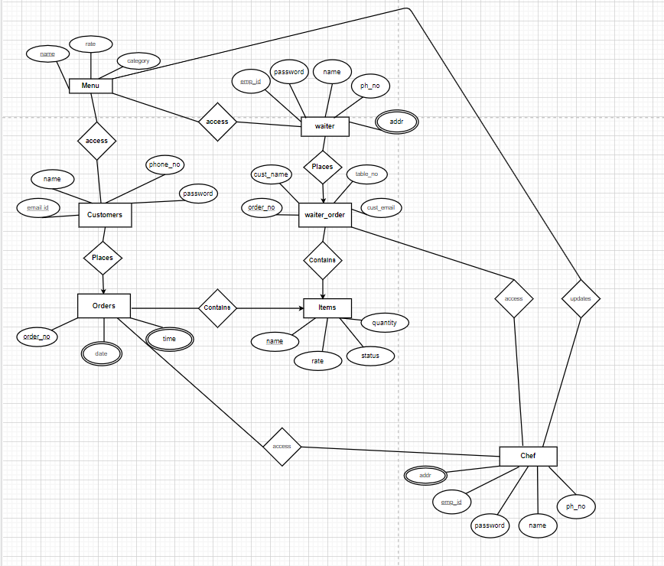

**Fig:Flowchart of System**

6

**2.2 Technical Details:**

**Platform used:**

Visual Studio Code, DB Browser for SQLite, SQLite Database.

**Backend Language:** Python, SQLite

**Frontend Language:**

Tkinter Python.

**Python libraries used:**

* Tkinter
* SQLite
* DateTime
* OS

7

**2.3 Detailed design of modules / functionality with explanation:**

**Module 1: Customer Side**

Signup: Name, MobileNo, Email, Pass

Scope of customer:- Customer can only place order for parcel.(read access to menu table/database, write access to Order table)

**Module 2: Waiter Side**

Sign in for waiter

Take details of customer: Name, Email, MobileNo(optional)

Place order.

Access to table same as customers.

**Module 3: Chef Side**

Sign in for chef.

Update menu (DML operation for menu)(Write access of menu table/database)

Update Order Table (Tracking of order)

8

**2.4 : Schemas of All Tables**

**Menu**(name varchar primary key, integer rate, category varchar);

**Customer**( email_id varchar primary key , name varchar, phone_no integer, password varchar);

**Orders**( order_no varchar primary key , date varchar, time varchar, cust_id varchar references Customer(email_id ) );

**Items**( name varchar, rate integer, quantity integer, order_no varchar references Orders( order_no), status varchar, category varchar, primary key(name,order_no) )

**waiter_order**( order_no varchar primary key , table_no integer, date varchar, time varchar, cust_name varchar, cust_email varchar)

**waiter_Items**( name varchar, rate integer, quantity integer, order_no varchar references waiter_order( order_no), status varchar, category varchar, primary key(name,order_no) )

**Record_Order**(order_no varchar primary key);

**Record_Items**( name varchar, rate integer, quantity integer, category varchar, order_no varchar references Record_Order(order_no));

**2.5 : Hours Estimation**

**Front End** :- 14 hours

**Back End** :- 12 hours

9

**Chapter 3:**

**RESULTS & DISCUSSION**

**3.1 Source code: –**

**Github Repo Link :-**

https://github.com/JitendraJoshi2000/Hotel-Mangement-DBMS-Mini-Project

10

**OUTPUTS:**

**Login Screen for Customer :-**

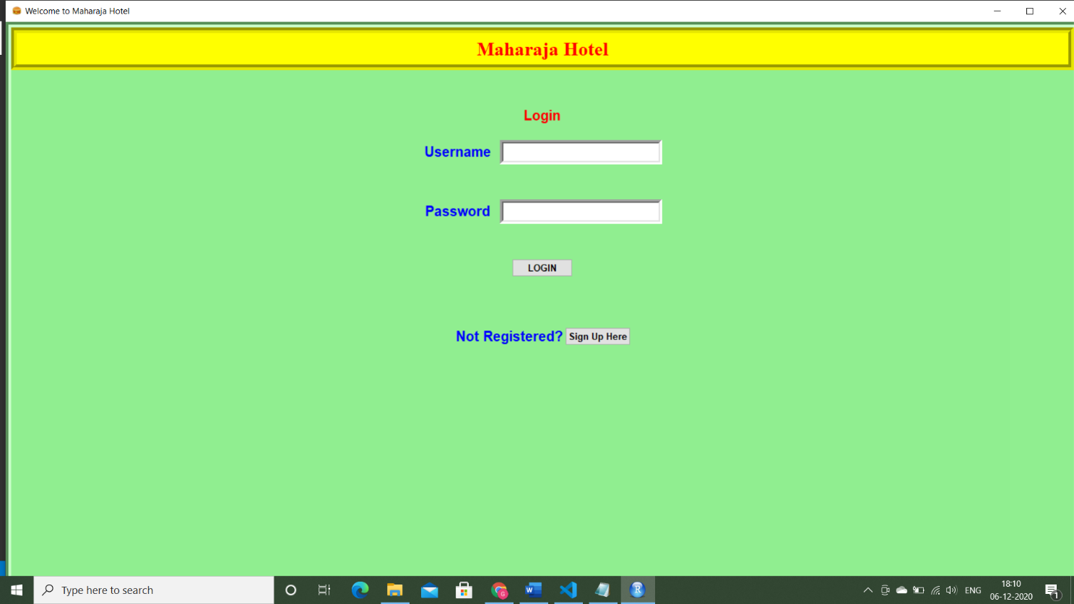

**SignUp Screen for Customer :-**

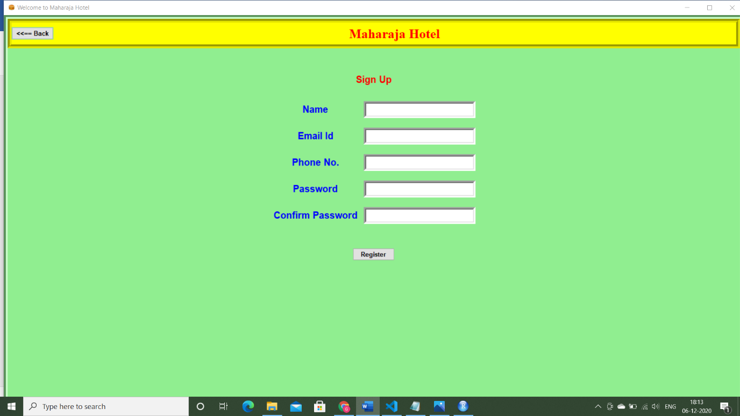

11

**Customer Side Screen :-**

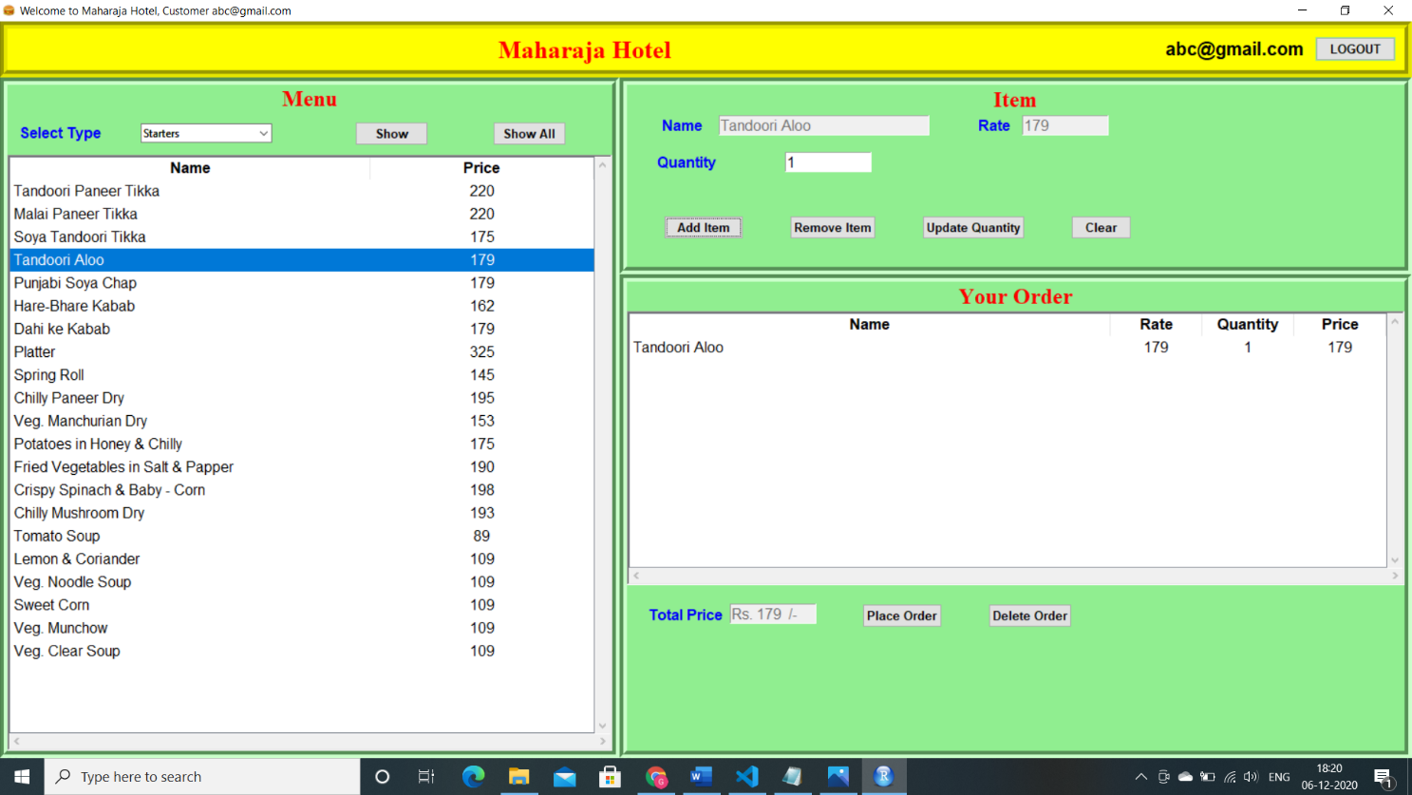

**Staff Login Screen :-**

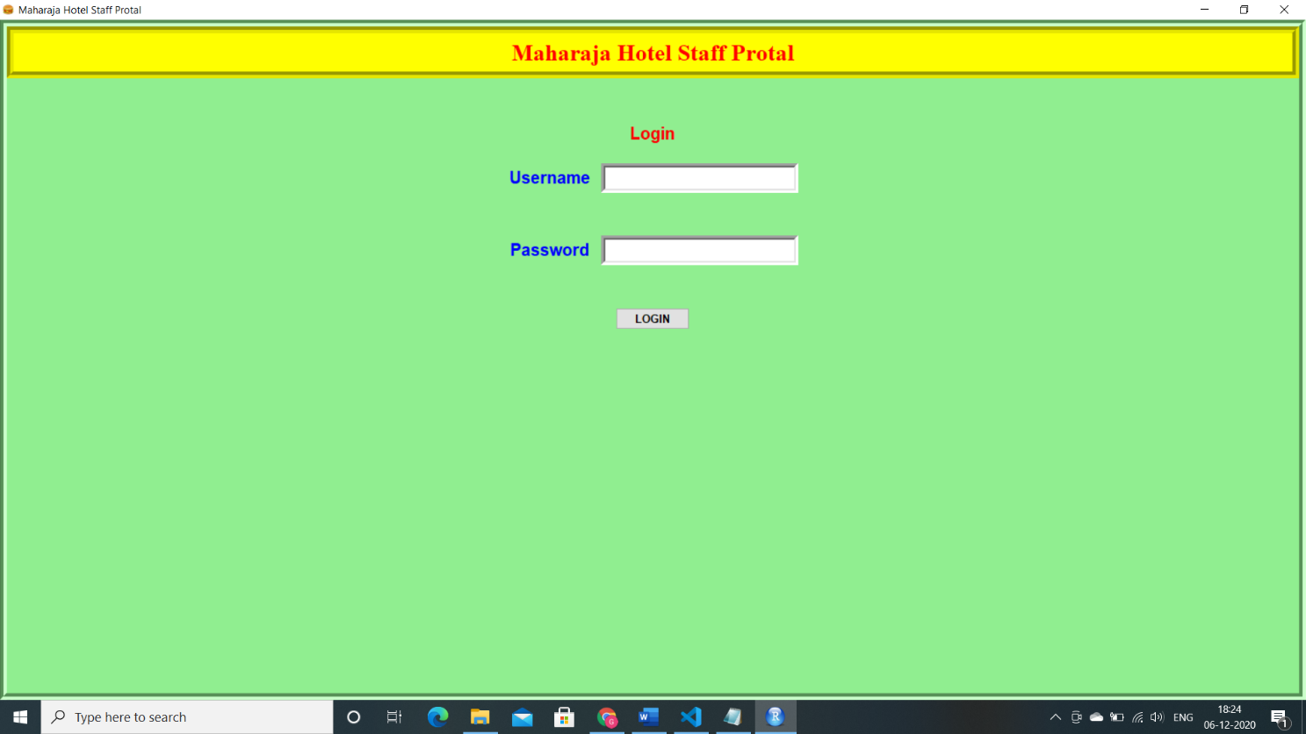

12

**Waiter Screen :-**

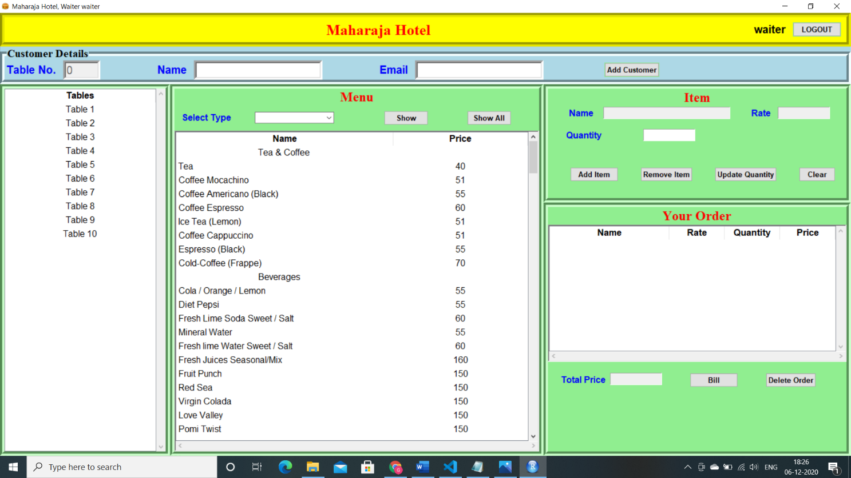

**Chef Screen :-**

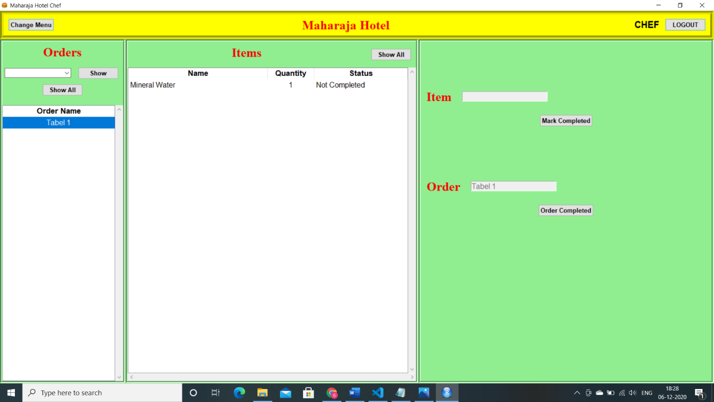

13

**Database Structure :-**

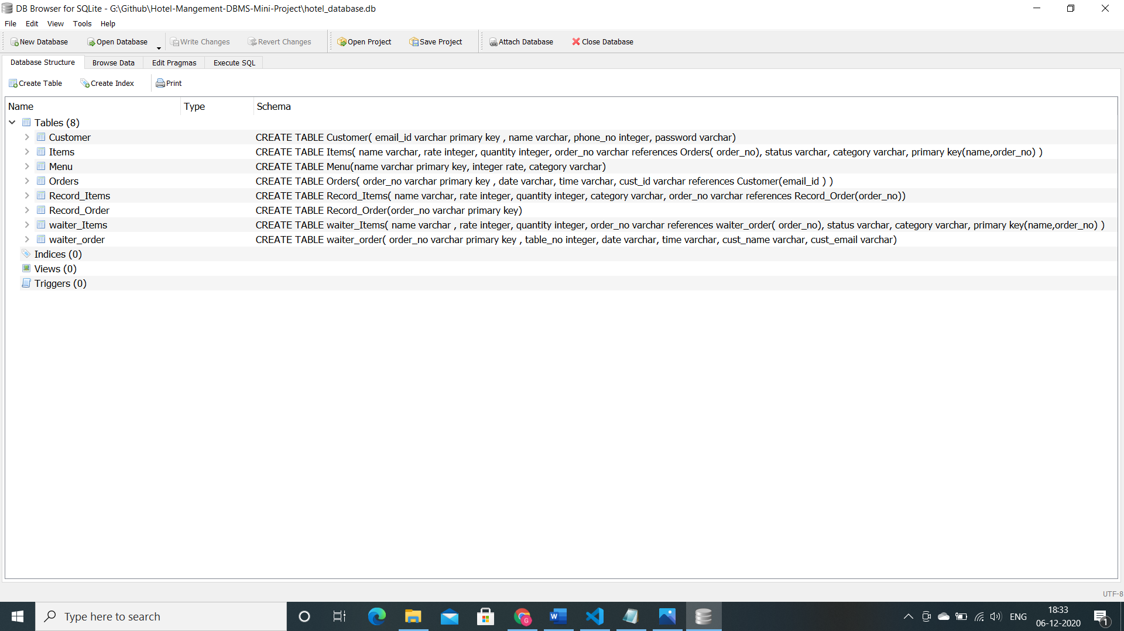

**Bill Screen :-**

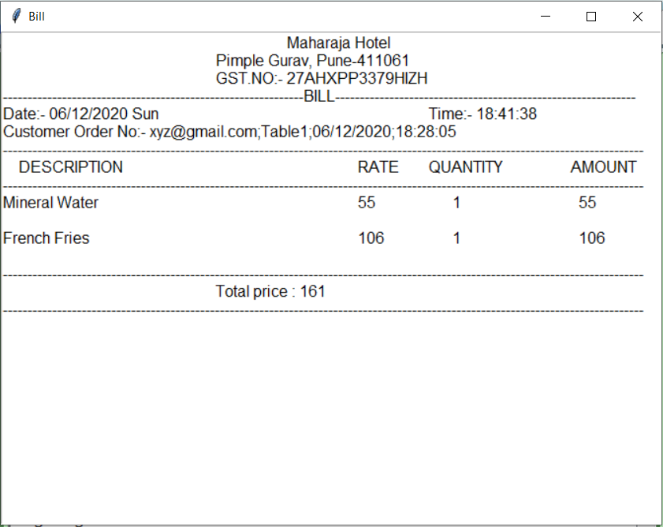

14

**Chapter 4**

**CONCLUSION**

**Through this project skills that we have** **acquired are:**

* Team work &Time management.
* We are now comfortable with SQLite Database and python language.
* We are able to develop new Software for Hotel Management System.

15