**ASSIGNMENTS**

1. LINKEDIN PROFILE

URL:  https://www.linkedin.com/in/salomon-ak-116120289

1. BRAND LOGO

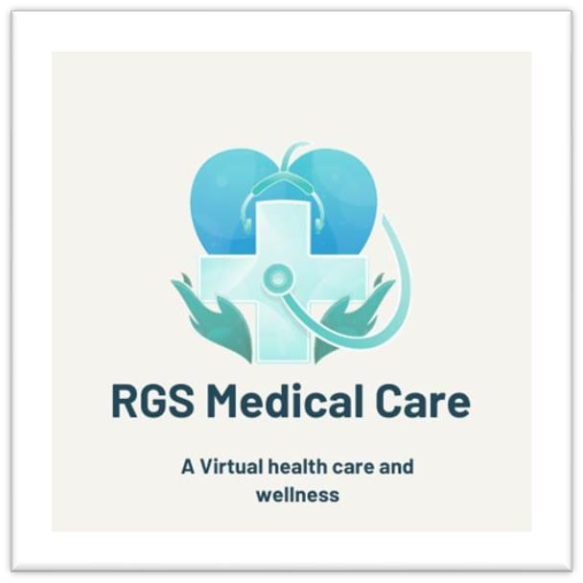

1. BLOGGER WEBSITE

URL: <https://www.blogger.com/profile/11149661092624526286>

4.EMAIL NEWSLETTER

URL: <https://breaktime123.blogspot.com/2023/09/email-newsletter-break-time.html?m=1>

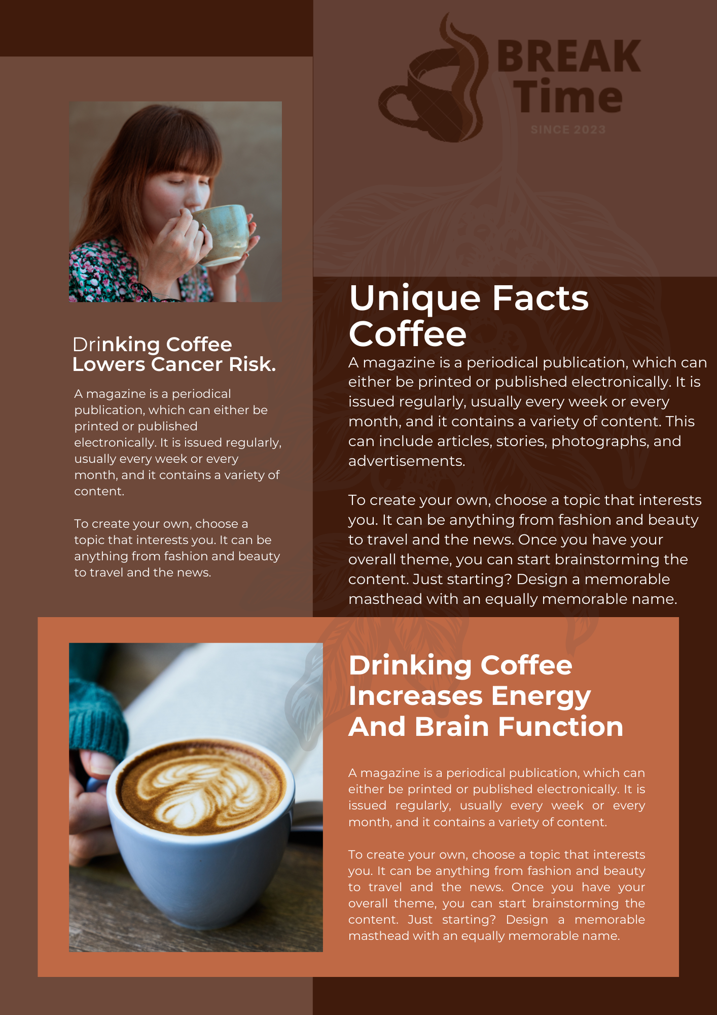

5.INFOGRAPHICS

URL: <https://www.blogger.com/blog/post/edit/2128751250764579777/8071747427524129125>

