CI/CD Report

Continuous Integration and Deployment using git action

* This workflow is designed to start a test run whenever a new push is detected in github to ensure the new changes doesn’t break the existing features
* The below screenshot shows the workflow execution and the relevant artifacts uploaded and can be downloaded to check the results.

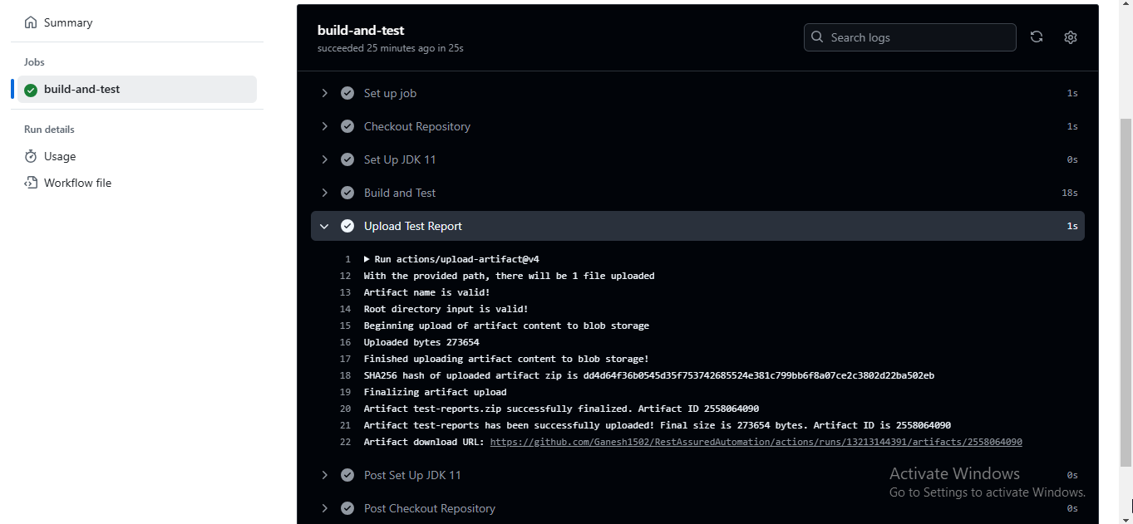

**Downloaded Artifact Report:** This shows the test results, where the tests are executed and the VM details