Test Report

HTML Report:

* Shows the total scenarios executed
* Number of cases passed and failed

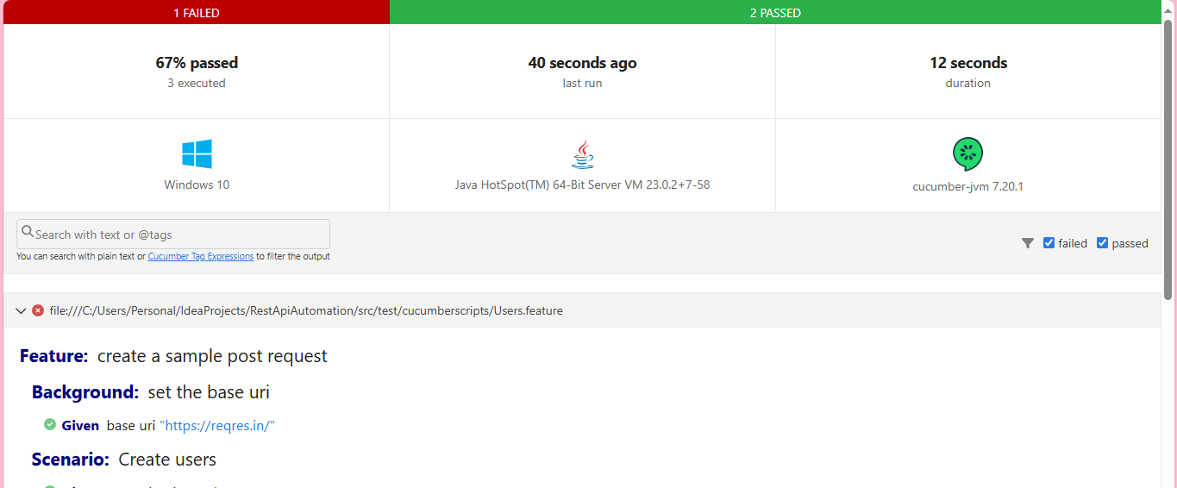

* Shows the step where the test case failed

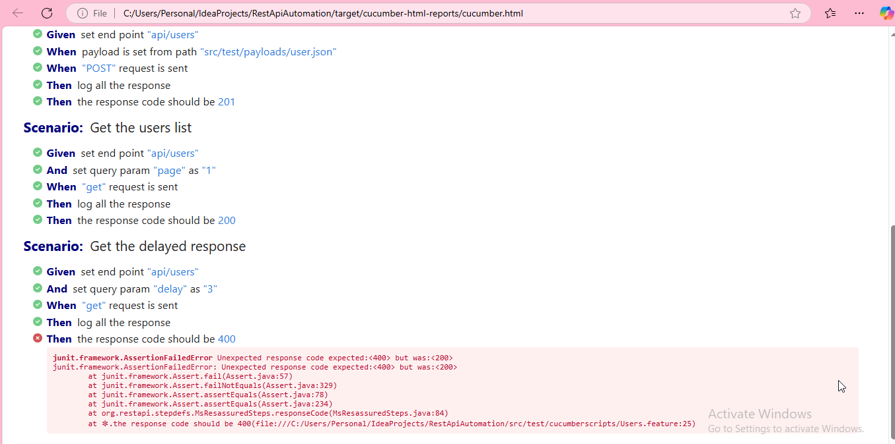

The Run will log the request and response in the console which will allow us to analyze the failures by referring the payloads and response

