भारतीय सूचना प्रौद्योगिकी संस्थान धारवाड़
Indian Institute of Information Technology Dharwad (IIIT Dharwad)
[Institute of National Importance by an Act of Parliament]

Course Project — Problem Statement
EC466 — Software Defined Networks
Session: Aug – Nov 2026 · Credits: 3-1-0-0-4
SELF-X: A Self-Improving Multi-Agent Large Language Model (LLM) Framework for Autonomous Software-Defined Network (SDN) Flow Management
Two-Timescale Edition — Multi-Agent LLM Governance + Lyapunov Drift-Plus-Penalty Control

Course & Evaluation Details
Field | Detail
Course Code | EC466
Course Name | Software Defined Networks
Session | Aug – Nov 2026
Credits | 3-1-0-0-4
Instructor / Coordinator | Asst. Prof. Jagadeesha R Bhat (jagadeesha@iiitdwd.ac.in)
Instructor Office | F323, E-Block, 2nd Floor
Course Assessment | Assignments 30% · Course Project 50% · Viva/Oral 20%
Team ID | SDN_07
Project Theme | SELF-X
Document Status | Revision 2.0 — responds to Version 1.0 instructor feedback

Team Members
S.No | Name | Registration No.
1 | Ganesh Reddy J | 23BDS024
2 | M Jagadeswar | 23BDS033
3 | Harsh Raj | 23BDS076
4 | C Sai Aravind | 23BDS075
5 | Koushik C | 23BCS073
6 | Dhruv R Katti | 23BEC015

Document: Problem Statement — Revision 2 (Submission Ready, EC466 Project) Version: 2.0
Companion figures: SELF-X Architecture (Fig. 1) · Self-Improvement Loop with Safety Gate (Fig. 2) · Two-Timescale Control (Fig. 3)
What changed in this revision
This revision responds directly to instructor feedback on Version 1.0. It (i) sharpens the objectives and deliverables into measurable, dated targets; (ii) replaces the generic “combination of existing ideas” novelty claim with an explicit, side-by-side differentiation against four closely related 2024–2026 works; and (iii) adds a genuinely new technical contribution — a Lyapunov drift-plus-penalty fast-timescale controller governed by the multi-agent LLM layer — together with a staged ablation study that isolates the causal contribution of each design element.

1. Abstract
Modern software-defined networks (SDNs) centralise intelligence in a controller that must continuously install, update, and delete flow rules across many OpenFlow switches while balancing latency, throughput, packet loss, energy, and resource cost — objectives that routinely conflict. Static rule engineering is brittle, and single-objective deep reinforcement learning (DRL) controllers are rigid once the traffic mix, topology, or reward drifts.
Four recent works sit closest to this problem, and none of them solves it as posed. Araujo et al. (2024) [12] apply a single reflexive LLM agent to dynamic SDN management, with no multi-agent decomposition, no self-improvement, and no formal guarantees. Li et al. (2026) [13] internalise experience into an LLM policy’s weights via reward-free preference fine-tuning, but for RAN slicing, as a single agent, with no connection to real OpenFlow control. Jamshidi et al. (2026) [11] separate a fast, per-switch PPO mitigation layer from a slow multi-agent LLM governance layer for SDN-IoT security — the closest architectural relative — but their fast layer is a trained RL policy with no analytic stability bound, and self-improvement edits a policy constitution rather than the agents’ own weights. Boussaoud et al. (2025) [14] specialise two RL agents (classification and decision) for SDN congestion control, but use no LLM reasoning and no continual self-improvement.
SELF-X closes this gap with a genuinely two-timescale design: a multi-agent LLM orchestrator (six agents) governs, at a slow timescale (30–120 s), a fast-timescale (100 ms–1 s) Lyapunov drift-plus-penalty (DPP) controller that installs OpenFlow rules under a provable time-average queue-backlog bound — without requiring the fast layer to be trained via RL. The LLM layer self-improves through self-critique, experience replay, and safety-gated LoRA fine-tuning of its own weights, promoting only policy updates that pass a non-regression stress test. We evaluate SELF-X with a six-stage ablation (static rules → single LLM agent → +reflection → +LoRA → +multi-agent → +Lyapunov DPP) against the strongest prior designs on a Mininet/Ryu testbed, targeting a ≥20% latency reduction over static control and an empirically validated backlog bound, feasible within the Aug–Nov 2026 course timeline.

2. Related Work & Differentiation
The instructor feedback on Version 1.0 was direct: combining several existing techniques (multi-agent orchestration, reflection, LoRA fine-tuning, reward-based control) does not by itself constitute novelty, and the problem statement did not explain how SELF-X differs from the nearest published systems. Table 1 makes that comparison explicit across the four works closest to this problem, each read in full before this revision was written.
Dimension | Jamshidi et al. 2026 [11] | Araujo et al. 2024 [12] | Li et al. 2026 [13] | Boussaoud et al. 2025 [14] | SELF-X (this work)
Domain / control point | SDN-IoT security defense | Dynamic SDN / 5G-core mgmt. | 6G RAN slicing (PRB alloc.) | SDN congestion / routing | SDN OpenFlow flow mgmt.
Fast-timescale mechanism | Per-switch PPO agents (trained RL) | None — single reflexive agent | None — single Actor-Reflector | DQN decision agent (trained RL) | Lyapunov drift-plus-penalty (no RL training)
Slow-timescale mechanism | Multi-agent LLM edits policy constitution Π | None (no timescale split) | None (no timescale split) | None (no LLM at all) | Multi-agent LLM tunes V, w, action mask
Self-improvement target | RL constraints/action-mask, not weights | None (reflection only) | LLM policy weights via KTO | None beyond offline RL training | LLM policy weights via safety-gated LoRA
Formal stability guarantee | None (empirical stress-test only) | None | None | None | Yes — analytic backlog bound B+V·C
Multi-agent specialization | Yes (governance side only) | No — single agent | No — single agent | Yes (2 RL agents) | Yes — 6 LLM agents
Safety-gated deployment | Yes (non-regression + hard-safety) | No | No | No | Yes (adapted to weight updates)
Table 1 — SELF-X positioned against the four closest 2024–2026 works, dimension by dimension.
Reading the table row by row: no prior work pairs a formally-guaranteed fast-timescale controller with a self-improving multi-agent LLM slow-timescale governor at the granularity of individual OpenFlow flow-mods. Jamshidi et al. [11] come closest in structure (fast/slow split, safety-gated deployment) but their fast layer is a black-box PPO policy that must be trained per-deployment and offers no analytic bound on queue behaviour; their self-improvement also edits an RL policy’s admissible-action constitution, not an LLM’s own parameters. Li et al. [13] internalise experience into model weights — the mechanism SELF-X borrows and adapts for its slow-timescale agents — but do so for a single Actor-Reflector agent with no multi-agent specialisation and no downstream real-time controller to govern. Araujo et al. [12] and Boussaoud et al. [14] establish, respectively, that a reflexive single LLM agent and a two-agent MARL design are each individually viable for SDN control, which is precisely why SELF-X’s ablation study (Table 2) uses configurations resembling each of them as intermediate stages rather than as unrelated prior art.

3. Problem Statement
PROBLEM
A centralised SDN controller must make flow-management decisions that satisfy multiple, often conflicting objectives (low latency, high throughput, bounded packet loss, low energy and resource cost) while reacting to rapidly changing traffic. Hand-crafted policies are brittle, and single-learner DRL agents cannot generalise or self-correct when the reward signal, topology, or workload drifts — and neither approach offers a formal guarantee on network stability that holds independently of how well the learned policy happens to perform. How can a controller autonomously learn, decompose, and refine its own flow-management policy over time — without human re-engineering — while (i) guaranteeing a provable bound on queue backlog and multi-objective cost, and (ii) deploying every self-generated policy update through an auditable, fail-closed safety gate?

4. Motivation / Need
As traffic becomes bursty, dynamic, and application-driven, static rule engineering fails to keep latency, throughput, and energy in balance, and DRL controllers that retrain on a fixed reward remain rigid when the traffic mix or topology changes. The 2026 research landscape — NetSoft 2026 (“Autonomous and Reliable Softwarized Networks in the Age of Distributed Intelligence”), NFV-SDN 2026, and the GLOBECOM 2026 “Agentic AI” workshop — identifies agentic, self-adaptive intelligence as the key enabler for next-generation autonomous networks [3–7], but, as Section 2 shows, none of the concrete systems published so far combines formal control-theoretic guarantees with continual, weight-level self-improvement at OpenFlow granularity. That combination is the gap SELF-X targets.

5. Proposed System Architecture
SELF-X layers a self-improving multi-agent LLM framework above an SDN controller, now explicitly organised around two control timescales (Figure 1). At the slow timescale, an LLM orchestrator decomposes a global intent (e.g. “minimise average latency under SLA”) into sub-tasks for five specialist agents (flow-sizing, routing/traffic-engineering, anomaly, security, slicing), which reason over recent trajectories stored in episodic and semantic memory and emit a structured update ΔΠ — a Lyapunov penalty weight V, per-objective weights w, and an admissible action mask. At the fast timescale, a Lyapunov drift-plus-penalty controller consumes ΔΠ and the live queue backlog Q(t) to greedily select, every control interval, the per-flow action (reroute, rate-limit, admit, or drop) that a provable bound guarantees keeps the network stable, then installs it via the OpenFlow southbound API. A telemetry plane closes the loop, feeding monitoring, evaluation, and reward signals back into the agentic layer.
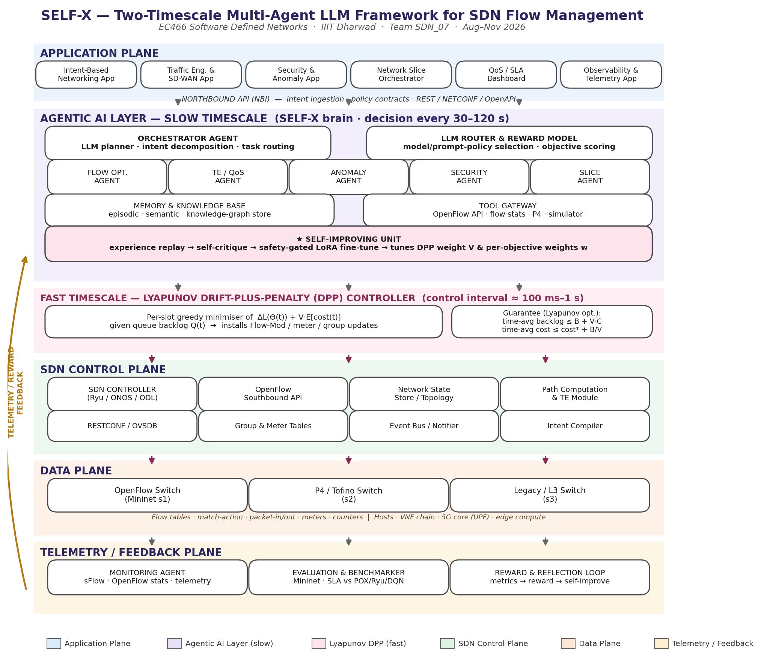
Figure 1 — SELF-X architecture: Application, Agentic AI (slow timescale), Lyapunov DPP (fast timescale), SDN Control, Data, and Telemetry planes.

6. Two-Timescale Control Formulation
This section gives SELF-X its concrete technical novelty relative to Table 1: a fast-timescale controller with an analytic stability guarantee, governed — not replaced — by the self-improving LLM layer.

6.1 System model
Let Q(t) = (Q₁(t), …, Qₙ(t)) be the vector of per-flow / per-switch backlog queues at control slot t, with dynamics Qᵢ(t+1) = max[Qᵢ(t) − μᵢ(t), 0] + λᵢ(t), where λᵢ(t) is the arrival rate and μᵢ(t) the service (departure) rate chosen by the fast-timescale action a(t). Define the quadratic Lyapunov function L(Q(t)) = ½Σᵢ Qᵢ(t)² and the conditional Lyapunov drift Δ(Q(t)) = E[L(Q(t+1)) − L(Q(t)) ∣ Q(t)]. Let cost(t) = wlat·latency(t) + wloss·loss(t) + wen·energy(t) + wres·resource(t) be the multi-objective cost, with weights w set by the slow-timescale LLM layer.

6.2 Drift-plus-penalty control law
Following standard Lyapunov optimisation theory [15], the fast-timescale controller acts every slot to greedily minimise the drift-plus-penalty expression Δ(Q(t)) + V·E[cost(t) ∣ Q(t)], where V ≥ 0 is a trade-off parameter set by the LLM governance layer. This per-slot minimisation decomposes into an independent, polynomial-time-solvable decision per flow (which path, rate, or admission action minimises weighted backlog growth plus cost), so no RL training is required for the fast loop to run or for its guarantee to hold. The standard result bounds the long-run time-average queue backlog and cost as:
time-avg backlog ≤ (B + V·C) / ε and time-avg cost ≤ cost* + B / V
for constants B, C, ε determined by the arrival/service process, where cost* is the optimal achievable time-average cost. Increasing V trades a larger (but still bounded) backlog for cost closer to optimal — an O(1/V), O(V) trade-off the LLM layer tunes explicitly rather than discovering by trial-and-error reward shaping.

6.3 What the LLM layer governs
The slow-timescale agents never touch the drift-plus-penalty math directly. Instead, based on reflection over recent SLA violations and reward trends, they propose a structured update ΔΠ = (V, w, action mask) — in the spirit of the policy-constitution deltas of Jamshidi et al. [11], but here governing a provably-stable analytic controller rather than an opaque RL policy. ΔΠ is deployed only if it passes a non-regression stress campaign (Section 13), so the network’s worst-case behaviour stays bounded by the Lyapunov guarantee regardless of what the LLM proposes within the validated range — giving SELF-X a safety property none of the four related works establish analytically for flow-level SDN control.
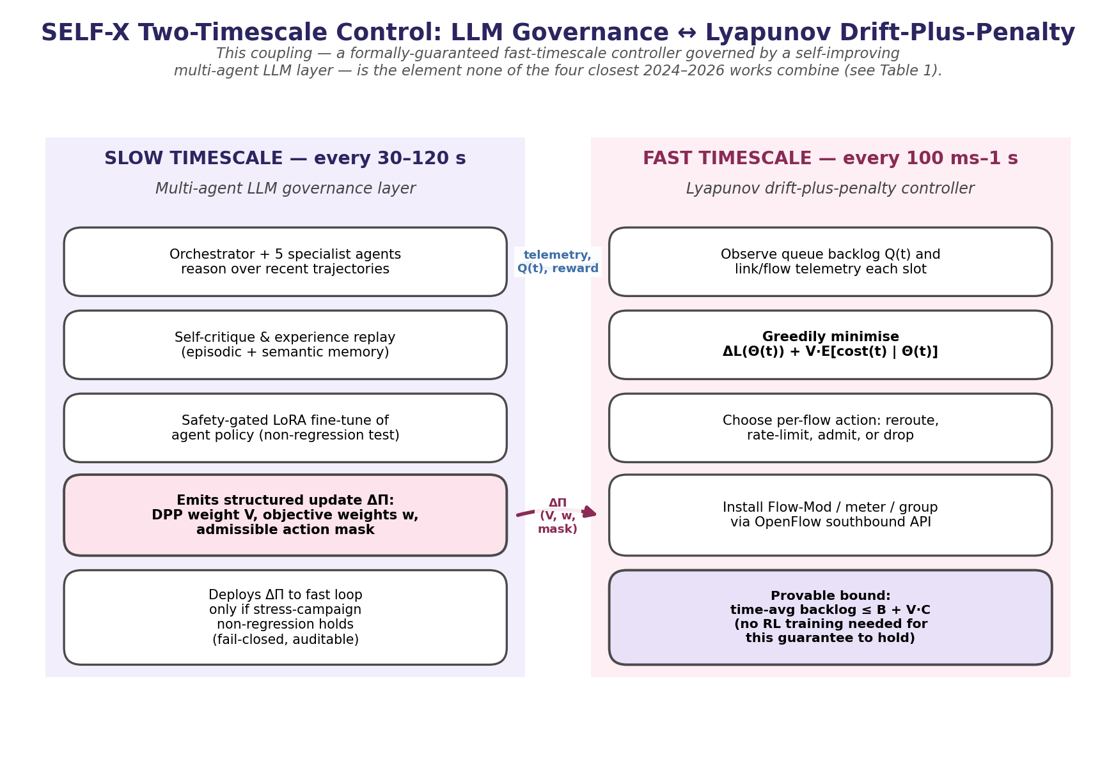
Figure 2 — The two-timescale coupling: multi-agent LLM governance (slow) ↔ Lyapunov drift-plus-penalty controller (fast).

7. Objectives
- Multi-agent architecture. Implement the 6-agent orchestrator + specialist LLM layer with a tool gateway wired to a Ryu/ONOS OpenFlow 1.3 controller and Mininet testbed. By Sep 28 (Wk 4).
- Formal fast-timescale control. Derive and implement the Lyapunov DPP controller and empirically validate that the time-average backlog bound B+V·C holds in ≥95% of ≥1000 control intervals across 3 traffic profiles. By Oct 12 (Wk 6).
- Slow–fast coupling and safety gate. Implement the ΔΠ update channel and the non-regression stress-test gate that must pass before any update is promoted to the fast loop. By Oct 26 (Wk 8).
- Self-improvement. Implement self-critique, experience replay, and safety-gated LoRA fine-tuning, and demonstrate a statistically significant (paired t-test, p < 0.05) improvement in cumulative multi-objective reward across ablation stages A1→A5. By Nov 9 (Wk 10).
- Benchmarking. Compare SELF-X against the 6 baselines in Table 3 on ≥3 topologies and 2 traffic generators, reporting latency, throughput, loss, convergence time, and control-plane overhead. By Nov 9 (Wk 10).
- Generalisation. Evaluate zero-shot transfer of the trained governance policy to an unseen topology and traffic mix, targeting retention of ≥90% of the performance gain observed during training. By Nov 16 (Wk 11).

8. Proposed Methodology / Approach
- Build Mininet topologies (linear, leaf-spine, and one held-out topology for generalisation testing) with Open vSwitch and OpenFlow 1.3.
- Select Ryu (and ONOS for cross-checking) as the controller beneath the SELF-X agent layer.
- Define a flow-management task set: elephant-flow rerouting, QoS/rate limiting, congestion avoidance, and anomaly-driven rule flush.
- Implement the fast-timescale Lyapunov DPP controller as a standalone module first, and validate its backlog bound empirically before coupling it to the LLM layer (de-risks the hardest technical component early, per the timeline in Section 15).
- Implement specialist agents using an LLM backend with ReAct-style tool calling over the OpenFlow/RESTCONF gateway; implement the ΔΠ emission and the non-regression safety gate.
- Instrument the reward signal (queue, port, and flow stats) and an experience-replay memory; implement self-critique and safety-gated LoRA fine-tuning on high-reward trajectories.
- Run the staged ablation (Table 2) and the full baseline comparison (Table 3) under identical topologies and traffic seeds for a fair, reproducible comparison.

8.1 Staged Ablation Design
This operationalises the instructor’s first suggested direction directly: rather than reporting only the full pipeline’s numbers, SELF-X is built up one design element at a time, so each stage’s contribution to reward, latency, and stability can be measured in isolation rather than asserted.
Stage | Configuration | Isolates / measures | Closest prior baseline
A0 | Static Ryu/POX (hand-crafted rules) | Non-learning floor | Classical SDN control
A1 | Single non-specialist LLM agent, no reflection | Raw LLM reasoning benefit | Araujo et al. [12]
A2 | A1 + self-critique / reflection (no weight update) | Value of verbal reflection alone | Reflexion-style reflection [17]
A3 | A2 + safety-gated LoRA self-fine-tuning | Value of internalizing experience into weights | Li et al. [13] (KTO fine-tuning)
A4 | A3 + multi-agent decomposition (6 specialists) | Value of task specialization | Boussaoud et al. [14] (2-agent MARL)
A5 | A4 + Lyapunov DPP fast timescale (full SELF-X) | Value of the formally-guaranteed fast loop | Jamshidi et al. [11] (two-timescale, but RL-based fast loop)
Table 2 — Six-stage ablation: each stage adds exactly one design element, mapped to its closest literature analogue.

9. Expected Deliverables
Each deliverable below carries an explicit, checkable acceptance criterion and a due date within the Aug–Nov 2026 session — directly addressing the feedback that deliverables lacked sharpness.
ID | Deliverable | Acceptance criterion | Due
D1 | Mininet topology + traffic-generator suite | ≥3 topologies (linear, leaf-spine, unseen holdout); ≥2 traffic profiles (iperf3 + bursty/elephant-flow); reproducible via one run script | Oct 12
D2 | Lyapunov DPP fast-timescale controller module | Empirically validated backlog bound holds in ≥95% of ≥1000 control intervals across 3 traffic profiles | Oct 12
D3 | SELF-X codebase (orchestrator, 5 specialist agents, tool gateway, DPP module, safety gate) | Runs end-to-end on Mininet unattended for ≥30 min continuous operation | Oct 26
D4 | Self-improvement module (replay buffer, self-critique chain, LoRA fine-tuner, non-regression harness) | A fine-tune cycle is automatically promoted or rejected, with a logged ΔΠ audit trail | Nov 2
D5 | Ablation + benchmark harness (Tables 2 and 3) with plots | Produces the 6-stage ablation table and 6-baseline comparison across latency, throughput, loss, convergence time, backlog-violation rate | Nov 9
D6 | Final report, architecture doc, and viva/demo slides | Matches submitted problem statement scope; live Mininet demo | Course deadline (Nov 2026)
Table 4 — Deliverables with acceptance criteria and due dates.

10. Evaluation Metrics
- Average end-to-end latency, throughput (Mbps), packet loss (%), and flow-install convergence time.
- Controller CPU / control-channel overhead and number of packet-in messages.
- Stability-specific: empirical backlog-bound violation rate against the analytic bound B+V·C; distribution of Q(t) over time; convergence of V and w chosen by the LLM layer.
- Reward convergence and number of self-improvement (LoRA) iterations to reach target quality, with the ablation stages (Table 2) used to attribute gains to specific design elements.
- Generalisation: performance retention under the unseen topology and bursty workloads (Objective 6).

11. Novelty / Originality
The novelty claim is no longer “we combine several existing techniques.” It is specific: SELF-X is, to our knowledge, the first SDN flow-management system to couple a Lyapunov drift-plus-penalty controller — which needs no RL training and carries an analytic stability bound — with a multi-agent LLM layer that self-improves its own weights (via safety-gated LoRA) rather than only editing external policy constraints. Table 1 shows this combination does not exist in the four closest works: Jamshidi et al. [11] pair LLM governance with a trained (not analytically guaranteed) fast loop; Li et al. [13] self-fine-tune weights but for a single agent with no formal controller beneath it; Araujo et al. [12] and Boussaoud et al. [14] each address one half of the problem (LLM reasoning, or multi-agent specialisation) without the other. The ablation study in Table 2 is designed specifically to make this a testable claim rather than an assertion: each stage adds exactly one element identified in Table 1, so the reward and stability gains attributable to multi-agent decomposition, self-critique, weight-level fine-tuning, and the Lyapunov controller can be reported separately rather than only in aggregate.
This directly targets NetSoft 2026’s “agentic AI and multi-agent systems” and “self-organising, self-healing, self-optimising softwarized networks” themes, while adding the control-theoretic rigor those venues increasingly expect alongside agentic reasoning.

12. Benchmarking Against Existing Systems
SELF-X is compared against six baselines spanning the design space covered in Table 1, on a common Mininet topology and workload, using the metrics in Section 10:
S.No | Baseline / System | Compared against
1 | Static Ryu / POX controller | Non-adaptive floor (Baseline 1 / A0)
2 | Deep Q-Network (DQN) controller, same reward | Single-agent DRL floor
3 | Two-agent MARL (classification + decision, DQN) | Non-LLM multi-agent design [14]
4 | Single non-specialist reflexive LLM agent | LLM-agent-only design, no self-improvement [12]
5 | SELF-X without Lyapunov DPP (LLM decides flow actions directly) | Isolates the value of the formal fast-timescale controller
6 | SELF-X — full pipeline (multi-agent + self-improve + DPP) | Proposed system
Table 5 — Benchmark baselines, chosen to cover each design point in Table 1.

13. Self-Improving Agent (Upgrade), with Safety Gate
SELF-X is not a static prompt-based agent. Building on the fail-closed discipline of Jamshidi et al. [11] — but applying it to weight updates rather than only policy-constitution edits — the self-improving unit follows a five-stage closed loop:
- Observe: collect telemetry, packet stats, flow tables, and queue backlog Q(t).
- Reason: the LLM planner decomposes intent, selects tools, and sets the DPP weight V and objective weights w.
- Act: install OpenFlow rules, QoS actions, and path re-routing via the fast-timescale controller.
- Evaluate: compute the multi-objective reward from throughput, latency, loss, energy, and cost.
- Safety-gate & adapt: a candidate LoRA-fine-tuned policy or ΔΠ update is promoted only if it passes a non-regression and hard-safety stress campaign; otherwise it is rejected and rolled back, and the loop continues to accumulate replay data.
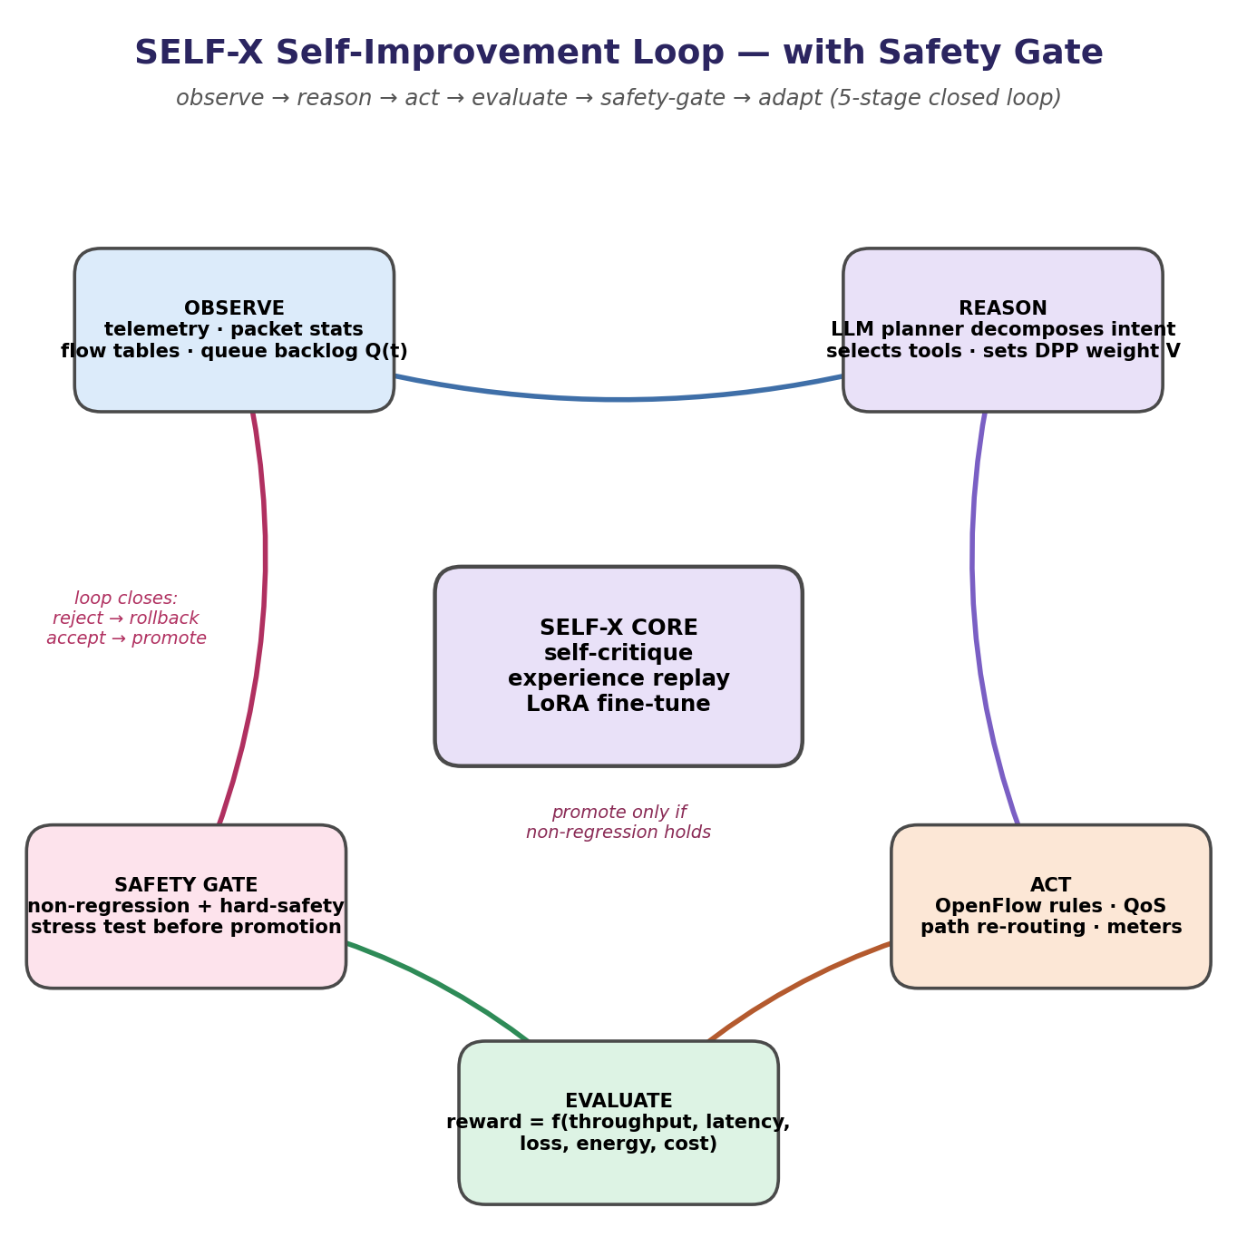
Figure 3 — SELF-X self-improvement loop: every candidate update is promoted or rejected by the safety gate before it can affect the live network.

14. Expected Outcome / Impact
A demonstrably self-improving SDN controller whose multi-agent LLM policy lowers end-to-end latency (targeting ≥20% versus static Ryu/POX, ≥10% versus DQN) while keeping queue backlog within an analytically derived, empirically validated bound — a concrete instance of an agentic, self-optimising softwarized network whose worst-case behaviour is provable rather than only observed.

15. Feasibility & Timeline to November 2026
The two riskiest components — the Lyapunov DPP controller and the LLM–DPP coupling — are scheduled first, so that if either needs rework there is buffer before the course deadline.
Weeks | Milestone
Wk 1–2 (Sep 1–14) | Lyapunov DPP formulation finalized; environment setup (Mininet, Ryu/ONOS, OpenFlow 1.3); static Ryu/POX and DQN baselines running
Wk 3–4 (Sep 15–28) | Orchestrator + 5 specialist agents + tool gateway wired to controller; single-agent reflexive LLM baseline (A1) working end-to-end
Wk 5–6 (Sep 29–Oct 12) | Self-critique/reflection loop (A2) implemented; DPP controller validated standalone against the analytic backlog bound (D1, D2)
Wk 7–8 (Oct 13–26) | Slow→fast update channel (ΔΠ) and safety gate implemented; LoRA self-fine-tuning pipeline (A3) online; full SELF-X integration (D3)
Wk 9–10 (Oct 27–Nov 9) | Multi-agent decomposition (A4) and full pipeline (A5) integrated; ablation + 6-baseline benchmark suite executed across topologies and traffic profiles (D4, D5)
Wk 11 (Nov 10–16) | Generalization / unseen-topology evaluation; statistical analysis; report and viva demo preparation (D6)
Table 6 — Weekly milestones, Sep–Nov 2026.

16. Alignment with 2026 Research Frontiers
This work targets the 2026 research frontier of autonomous, agentic-empowered softwarized networks: NetSoft 2026 — “Autonomous and Reliable Softwarized Networks in the Age of Distributed Intelligence”, whose scope explicitly lists agentic AI and multi-agent systems, generative AI, explainable and trustworthy AI for network autonomy, and self-organising/self-healing/self-optimising softwarized networks [3]; IEEE NFV-SDN 2026, which calls for agent-based SDN/NFV, AI/ML network automation, and self-healing operations [4]; and the GLOBECOM 2026 / ICC 2026 workshops on agentic-AI-empowered wireless communications and networking, network slicing, and O-RAN/edge convergence [5–6]. By pairing multi-agent LLM reasoning with a control-theoretically grounded fast loop, SELF-X addresses the scalability, interpretability, and provable-stability gaps that current agentic-SDN proposals — including the four surveyed in Table 1 — leave open.

17. Conclusion
This revised problem statement defines SELF-X as a two-timescale system: a self-improving multi-agent LLM layer that governs, rather than replaces, a Lyapunov drift-plus-penalty controller with a provable stability guarantee. Positioned explicitly against the four closest 2024–2026 works (Table 1), evaluated through a staged ablation that attributes gains to specific design choices (Table 2), and scheduled against a concrete Sep–Nov 2026 timeline (Table 6), the project is compelling because it sits at the convergence of agentic AI and control-theoretic networking — and it now specifies exactly which prior systems it improves on, how, and how that improvement will be measured.

18. References
[1] P. Goransson, C. Black, and T. Culver, Software Defined Networks: A Comprehensive Approach, 2nd ed., Morgan Kaufmann, 2016.
[2] W. Stallings, Foundations of Modern Networking: SDN, NFV, QoE, IoT and Cloud, 1st ed., Addison-Wesley Professional, 2015.
[3] IEEE NetSoft 2026, Call for Technical Session Papers — “Autonomous and Reliable Softwarized Networks in the Age of Distributed Intelligence.”
[4] IEEE NFV-SDN 2026, Call for Papers — Architectures, AI/ML in Cloud-Native Networks, Self-Healing, Network Slicing.
[5] IEEE GLOBECOM 2026, WS-13 — 2nd Workshop on Agentic AI Empowered Wireless Communications and Networking.
[6] IEEE ICC 2026 Workshops — Generative AI and Large Model Empowered Next-Generation Networks; Open Programmable and AI-Native Radio Access Network.
[7] IEEE INFOCOM 2026 Workshops — Cloud-Network Convergence; Generative AI for Next-Generation Networking; Next-Gen Open & Programmable RAN.
[8] N. McKeown et al., “OpenFlow: Enabling Innovation in Campus Networks,” ACM SIGCOMM CCR, vol. 38, no. 2, 2008.
[9] J. Wang et al., “A Survey on Large Language Models for Networking,” arXiv preprint, 2024.
[10] L. Yao et al., “Agent Networks: A Survey of Multi-Agent LLM Systems,” arXiv preprint, 2024.
[11] S. Jamshidi, N. Shahabi, F. Khomh, C. Fung, and M. Hamdaqa, “Multi-Agent LLM Governance for Safe Two-Timescale Reinforcement Learning in SDN-IoT Defense,” arXiv:2604.01127, 2026.
[12] A. S. Araujo, J. M. O. das Mercês, R. L. da Silva, A. V. de Alencar, I. F. Passos, M. P. Sousa, M. C. Dias, T. F. Meneses, and D. F. S. Santos, “An Agentic Approach For Dynamic Software-Defined Network Management Using Large Language Models,” in Proc. IEEE NFV-SDN, 2024, doi:10.1109/NFV-SDN61811.2024.10807498.
[13] Y. Li, H. Wang, G. Min, N. Georgalas, and W. Miao, “Adaptive RAN Slicing Control via Reward-Free Self-Finetuning Agents,” arXiv:2603.10564, 2026.
[14] K. Boussaoud, A. En-Nouaary, and M. Ayache, “Adaptive Congestion Detection and Traffic Control in Software-Defined Networks via Data-Driven Multi-Agent Reinforcement Learning,” Computers, vol. 14, no. 6, p. 236, 2025, doi:10.3390/computers14060236.
[15] M. J. Neely, Stochastic Network Optimization with Application to Communication and Queueing Systems, Morgan & Claypool, 2010.
[16] E. J. Hu et al., “LoRA: Low-Rank Adaptation of Large Language Models,” in Proc. ICLR, 2022.
[17] N. Shinn, F. Cassano, A. Gopinath, K. Narasimhan, and S. Yao, “Reflexion: Language Agents with Verbal Reinforcement Learning,” in Proc. NeurIPS, 2023.
— End of Problem Statement —

