Leakage-Governed Medical Insurance Claim Fraud Detection Using Classical Ensembles, Tabular Deep Learning, and Dual-Path Agentic Triage
B. Varshith (23bds011@iiitdwd.ac.in) | J. Ganesh Kumar Reddy (23bds024@iiitdwd.ac.in) | M. Jagadeeswar (23bds033@iiitdwd.ac.in)
Supervised by Prof. Ramesh Athe — Department of Computer Science & Engineering (DSAI), Indian Institute of Information Technology (IIIT) Dharwad, India

Abstract—Medical insurance fraud screening suffers when classifiers exploit upstream leakage, rely on single-feature shortcuts, or lack audit transparency. Across 4,500 medical claims (6.00% fraud prevalence), we evaluate a unified platform uniting five Classical ML learners, five PyTorch Deep Learning models (MLP, ResidualMLP, CNN1D, TabTransformer, and an unsupervised Autoencoder), and a Gemini 2.0 Flash Agentic/XAI layer. Auditing the workbook uncovered two structural traps: an upstream Cluster column concentrating 98.89% of frauds (267/270) in Cluster 1, and an amount boundary separating all frauds at ClaimAmount >= $7,465.07. Across a 32-run ablation matrix (Baseline, Cluster-free Intake, No-Amount, and Temporal Intake >= 2024-03-11), tree ensembles demonstrate decisive robustness: without Cluster, Random Forest achieves 1.0000 test PR-AUC and 0.9873 F1 (0 FP, bootstrap CI [0.9610, 1.0000]), holding 1.0000 F1 chronologically while linear and neural models drop 6.6–10.7 PR-AUC points. Removing ClaimAmount collapses all models to 0.1869–0.2404 PR-AUC. On the 29-feature full-stack contract, TabTransformer leads supervised neural models (0.9911 PR-AUC) while the unsupervised Autoencoder fails (0.0523 PR-AUC, 0.0299 F1). Exported browser weights match Python reference execution within 4.42e-7 max error across 10,800 scores with zero flips.
Index Terms—Healthcare Fraud Detection, Data Leakage, Random Forest, TabTransformer, Precision-Recall AUC, Agentic AI, Explainable AI.
I. INTRODUCTION
Automated healthcare claim triage operates under severe positive-class scarcity (6.00% in our operational dataset) where opaque predictions fail both deployment generalization and Special Investigation Unit (SIU) audit compliance [11, 13]. Prior evaluations frequently report optimistic random-split accuracy while overlooking upstream proxy leakage [17] and shortcut features [18]. This manuscript synthesizes our complete three-approach architecture: Classical Ensembles (Approach 1), five PyTorch neural paradigms (Approach 2), and Agentic Triage + Gemini Co-Pilot XAI (Approach 3) across both a live React/Node/FastAPI application (Track A) and a browser-native Claim Fraud Lab (Track B).
II. RELATED WORK
du Preez et al. [13] systematically reviewed 137 healthcare fraud publications, showing tree ensembles (Random Forests [1], XGBoost [2], LightGBM [3]) outperform linear and kernel models [4] on tabular claims while exposing weak temporal evaluation practices. Johnson and Khoshgoftaar [12] studied class-weighted Medicare neural models, while Huang et al. [6] and Gorishniy et al. [7] proposed TabTransformer and residual tabular MLPs [5]. Grinsztajn et al. [8] proved tree splits surpass neural models on ~10K tabular benchmarks under sharp feature boundaries. Saito and Rehmsmeier [16] proved PR-AUC dominates ROC-AUC under imbalance; Kaufman et al. [17] and Geirhos et al. [18] formalized leakage and shortcut failures; and SHAP [19], RAG [20], and cryptographic logs [14] frame auditability.
III. DATASET AUDIT & PROBLEM FORMULATION
Health Insurance Fraud Claims.xlsx holds 4,500 claims across 19 columns spanning 731 days (2022-07-09 to 2024-07-08) with zero missing entries, zero duplicates, and 270 frauds (6.00%). Six near-unique identifiers (ClaimID, PatientID, ProviderID, DiagnosisCode, ProcedureCode, ProviderLocation) are excluded. Cross-tabulation (Fig. 1) revealed upstream Cluster concentrates 267/270 frauds (98.89%) inside Cluster 1 (24.27% rate), while fraudulent ClaimAmount falls strictly in [$7,465.07, $9,978.43] versus [$100.12, $9,997.20] overall.
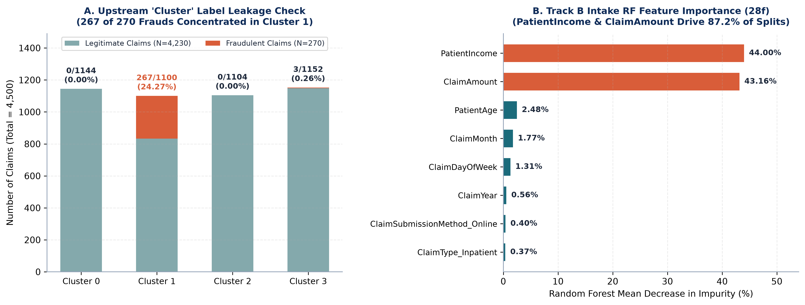
Fig. 1. (A) Upstream Cluster 1 leakage concentration; (B) Track B Intake RF split importance (PatientIncome 44.00%, ClaimAmount 43.16%).
Training-only ColumnTransformer standardizes numerics and one-hot encodes 7 categoricals across Baseline (29f), Cluster-free Intake (28f), No-Amount (27f), and Temporal Intake (>= 2024-03-11: Train 3,152 [199] / Val 677 [34] / Test 671 [37]). Supervised PyTorch models minimize weighted BCE (pos_weight = 15.67), while the Autoencoder minimizes legitimate-only MSE against the 95th validation percentile (0.128588). Track B fixes validation-F1 thresholds strictly prior to test evaluation.
IV. SYSTEM ARCHITECTURE (TRACK A & TRACK B)
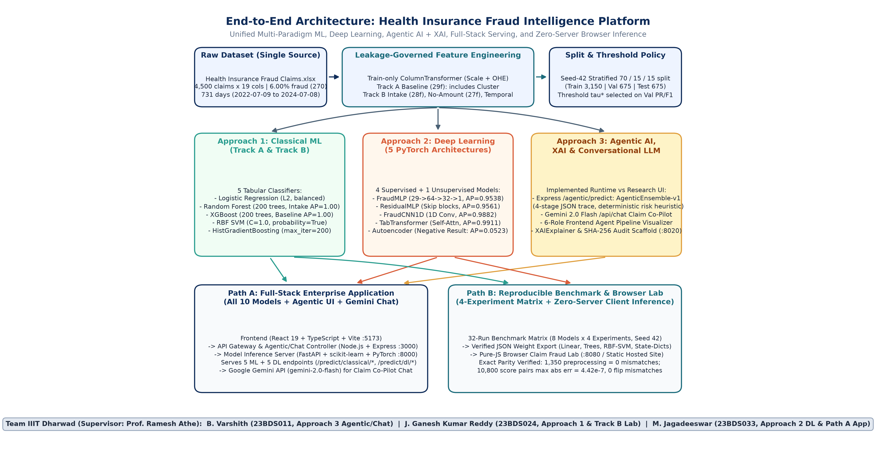
Fig. 2. Unified architecture linking Approaches 1–3, Full-Stack Path A (:5173/:3000/:8000), and Zero-Server Path B (:8080).
Path A serves 5 Classical ML and 5 PyTorch DL checkpoints from FastAPI (:8000) through Express (:3000) to React (:5173). Approach 3 provides /agentic/predict (AgenticEnsemble-v1 four-stage trace), Google Gemini 2.0 Flash /api/chat co-pilot, a 6-role UI workflow, and offline XAIExplainer SHA-256 logging (Fig. 3), while Path B exports verified model weights directly into zero-server browser JSON.
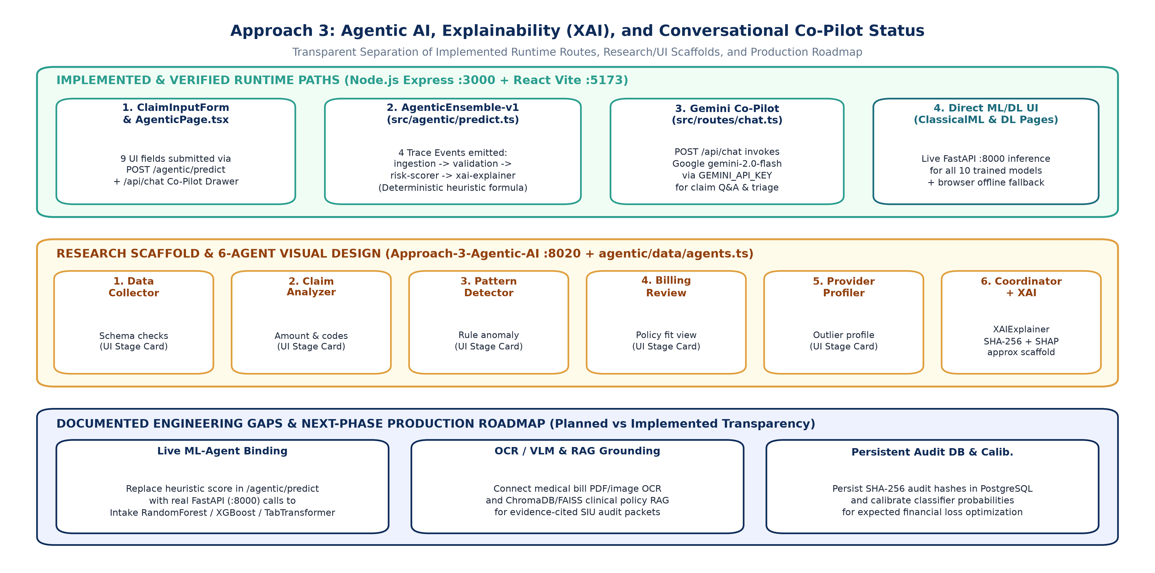
Fig. 3. Approach 3 separation of live Express/Gemini runtime APIs from the 6-role UI view and roadmap.
V. EXPERIMENTAL RESULTS & VERIFICATION
A. Track A 10-Model Benchmark & Autoencoder Study
Model | Fam. | Prec | Rec | F1 | ROC | PR-AUC
XGBoost | ML | 97.6 | 100 | 98.8 | 100.0 | 100.00
RandomForest | ML | 100 | 97.5 | 98.7 | 100.0 | 99.94
HistGradientBoost | ML | 100 | 97.5 | 98.7 | 98.5 | 97.65
TabTransformer | DL | 81.6 | 100 | 89.9 | 99.9 | 99.11
CNN1D | DL | 83.3 | 100 | 90.9 | 99.9 | 98.82
ResidualMLP | DL | 80.0 | 100 | 88.9 | 99.8 | 95.61
MLP | DL | 84.8 | 97.5 | 90.7 | 99.7 | 95.38
SVM (RBF) | ML | 74.5 | 95.0 | 83.5 | 99.6 | 92.52
LogisticReg. | ML | 62.5 | 100 | 76.9 | 99.5 | 91.86
Autoencoder | Unsup | 3.7 | 2.5 | 3.0 | 46.0 | 5.23
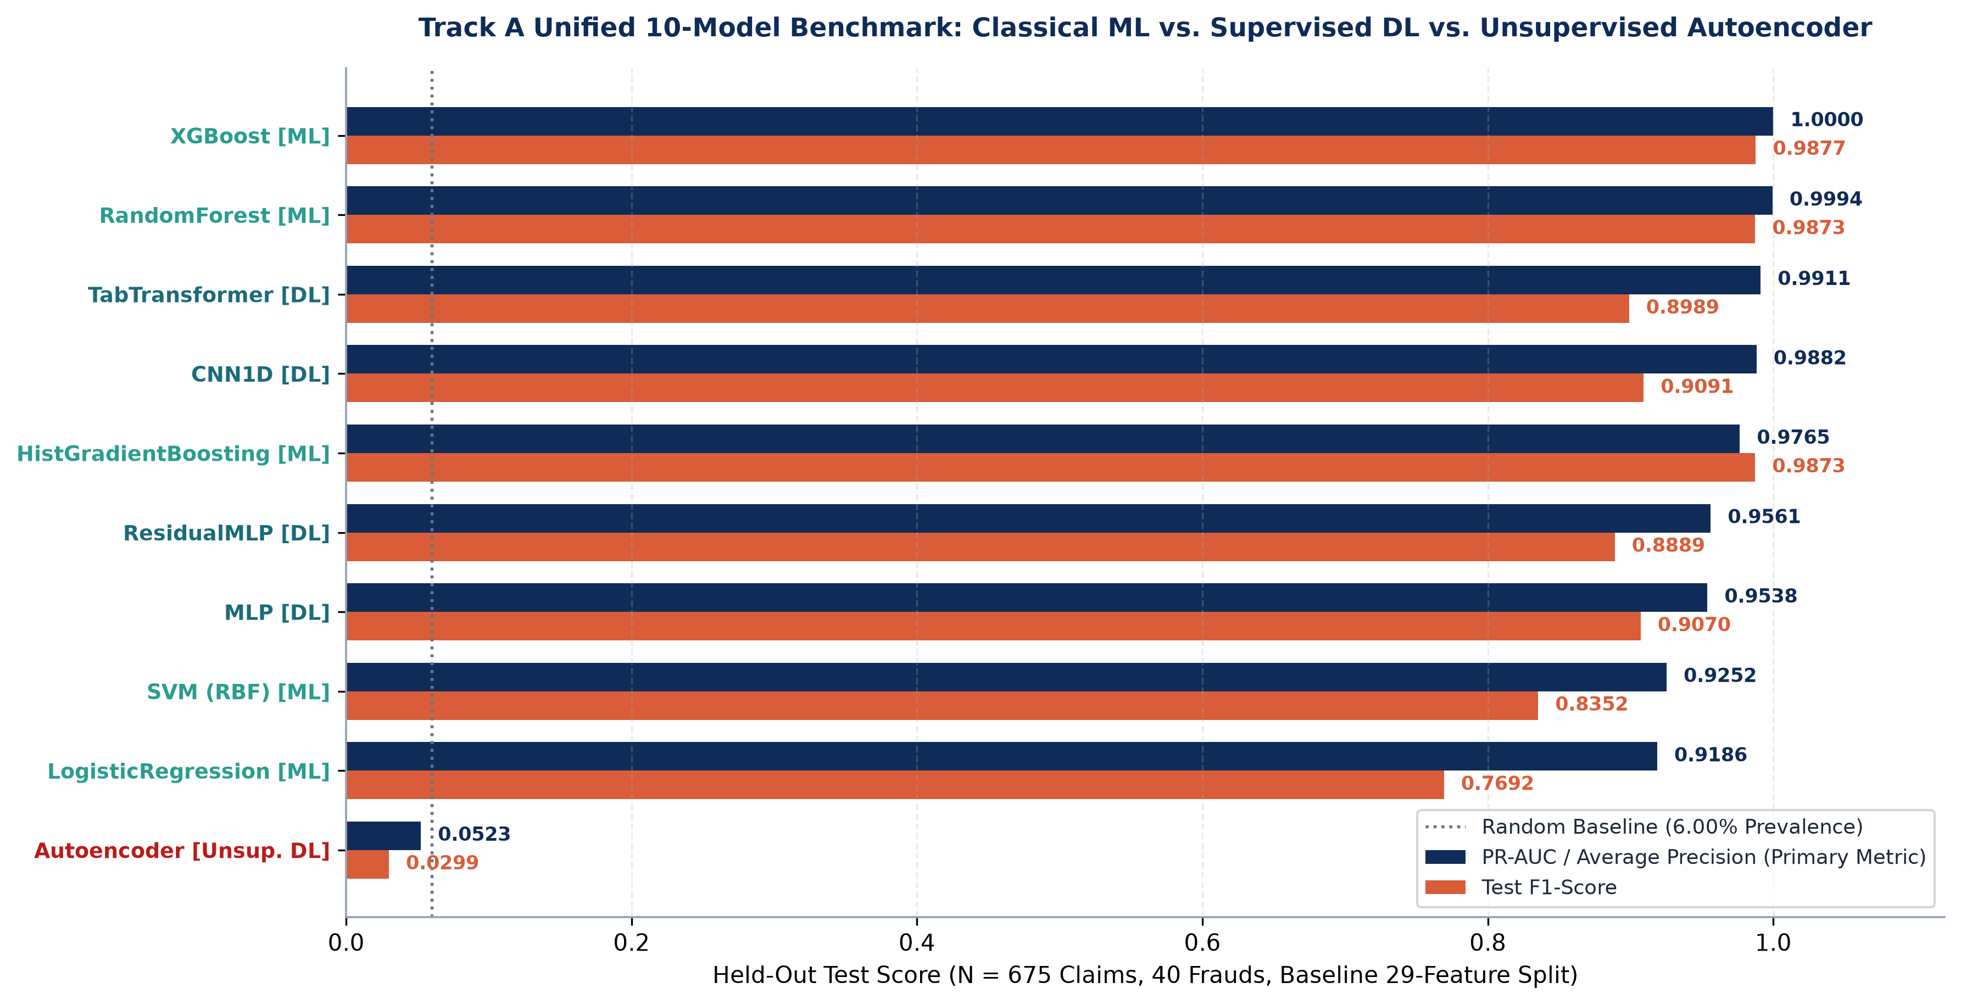
Fig. 4. Track A Test PR-AUC vs. F1 across 10 models (including the Autoencoder negative result at 5.23% PR-AUC).
B. Track B Four-Protocol Ablation, Error Audit & Parity
Model | Base (29f) | Intake (28f) | NoAmt (27f) | Temp (28f)
RandomForest | .9994/.975 | 1.00/.987 | .207/.364 | 1.00/1.00
XGBoost | 1.00/.988 | 1.00/.988 | .213/.352 | 1.00/1.00
GradientBoost | .977/.987 | .977/.987 | .240/.364 | 1.00/1.00
CNN1D | .988/.927 | .967/.877 | .229/.279 | .917/.811
ResidualMLP | .957/.929 | .877/.832 | .225/.344 | .798/.723
MLP | .954/.914 | .887/.822 | .230/.308 | .858/.696
LogisticReg. | .919/.784 | .853/.733 | .232/.319 | .880/.740
SVM (RBF) | .925/.897 | .818/.771 | .187/.304 | .840/.762
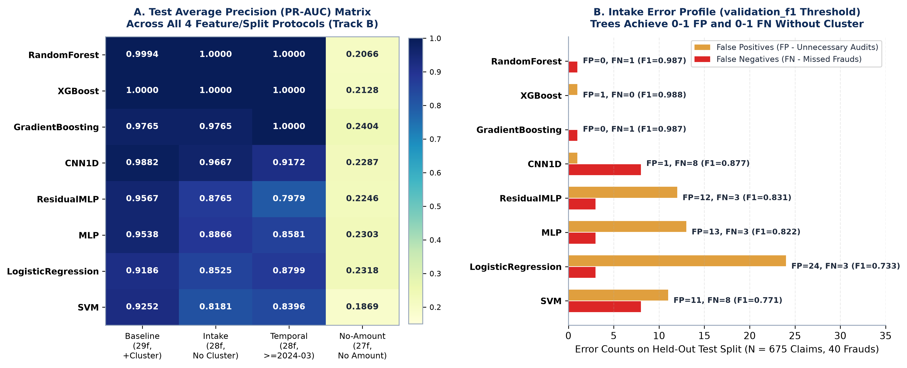
Fig. 5. Track B Test PR-AUC heatmap and Intake FP/FN error profile.
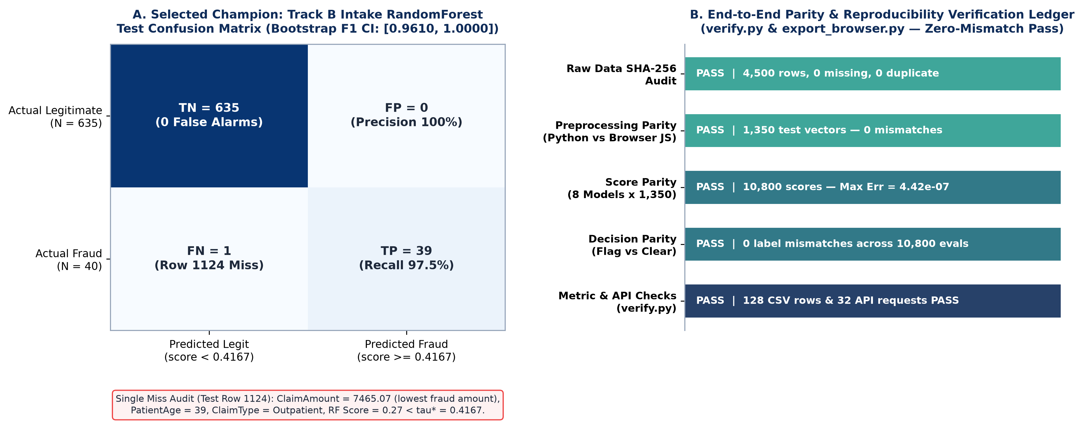
Fig. 6. Intake RandomForest confusion matrix, Row 1124 miss forensic audit, and Python-to-Browser parity ledger.
VI. CONCLUSION & FUTURE WORK
Removing upstream Cluster proxies confirms Random Forest and XGBoost maintain 1.0000 PR-AUC both randomly and chronologically while neural networks degrade. TabTransformer leads supervised DL (0.9911 PR-AUC baseline), Autoencoder fails under manifold overlap (0.0523 PR-AUC), and browser weight exports match Python within 4.42e-7 across 10,800 scores. Future extensions integrate calibrated FastAPI model execution inside /agentic/predict, clinical RAG/OCR document pipelines, and PostgreSQL audit persistence.
REFERENCES
[1] L. Breiman, 'Random Forests,' Machine Learning, 45(1):5-32, 2001. doi:10.1023/A:1010933404324.
[2] T. Chen and C. Guestrin, 'XGBoost: A Scalable Tree Boosting System,' ACM SIGKDD, 2016. doi:10.1145/2939672.2939785.
[3] G. Ke et al., 'LightGBM: A Highly Efficient Gradient Boosting Decision Tree,' NeurIPS 2017.
[4] C. Cortes and V. Vapnik, 'Support-vector networks,' Machine Learning, 1995. doi:10.1007/BF00994018.
[5] K. He et al., 'Deep Residual Learning for Image Recognition,' IEEE CVPR 2016.
[6] X. Huang et al., 'TabTransformer: Tabular Data Modeling Using Contextual Embeddings,' arXiv:2012.06678, 2020.
[7] Y. Gorishniy et al., 'Revisiting Deep Learning Models for Tabular Data,' NeurIPS 2021.
[8] L. Grinsztajn et al., 'Why do tree-based models still outperform deep learning on tabular data?,' NeurIPS 2022.
[9] M. Sakurada and T. Yairi, 'Anomaly Detection Using Autoencoders with Nonlinear Dimensionality Reduction,' MLSDA 2014.
[10] R. Chalapathy and S. Chawla, 'Deep Learning for Anomaly Detection: A Survey,' arXiv 2019.
[11] R. A. Bauder and T. M. Khoshgoftaar, 'Medicare Fraud Detection Using Machine Learning Methods,' IEEE ICMLA 2017.
[12] J. M. Johnson and T. M. Khoshgoftaar, 'Medicare fraud detection using neural networks,' J. Big Data 6:63, 2019.
[13] A. du Preez et al., 'Fraud detection in healthcare claims using machine learning: A systematic review,' Artif. Intell. Med. 160, 2025.
[14] K. Kapadiya et al., 'Blockchain and AI-Empowered Healthcare Insurance Fraud Detection,' IEEE Access 10, 2022.
[15] N. V. Chawla et al., 'SMOTE: Synthetic Minority Over-sampling Technique,' JAIR 16, 2002.
[16] T. Saito and M. Rehmsmeier, 'The Precision-Recall Plot Is More Informative than the ROC Plot,' PLOS ONE, 2015.
[17] S. Kaufman et al., 'Leakage in Data Mining,' ACM TKDD 6(4), 2012.
[18] R. Geirhos et al., 'Shortcut learning in deep neural networks,' Nature Machine Intelligence, 2020.
[19] S. M. Lundberg and S.-I. Lee, 'A Unified Approach to Interpreting Model Predictions,' NeurIPS 2017.
[20] P. Lewis et al., 'Retrieval-Augmented Generation for Knowledge-Intensive NLP Tasks,' NeurIPS 2020.

