Medical Insurance Claim Fraud Detection
  - Technical Project Report for Approach 1 and Approach 2
20 October 2026

Project outcome
The project compares five classical classifiers in Approach 1 with three neural classifiers in Approach 2. It includes a reproducible training and evaluation pipeline, 32 fitted model and experiment combinations, an interactive website, a research manuscript and a presentation. All result tables derive from the experiment artifacts generated on 20 October 2026.
The default website configuration uses Random Forest without Cluster. On the random test split, it flags 39 of 40 fraud cases and no legitimate cases at threshold 0.4167. Its AP is 1.0000 and F1 is 0.9873. Removing claim amount as well reduces its AP to 0.2066. This dependency is central to interpreting the project.
Component | Delivered scope
Approach 1 | Logistic Regression, Random Forest, XGBoost, SVM, histogram Gradient Boosting
Approach 2 | MLP, Residual MLP and 1D CNN
Data | Original workbook, shared partitions, feature contracts and row manifests
Evaluation | Default and validation thresholds, amount ablation, temporal assessment and uncertainty
Demonstration | Browser inference plus local FastAPI endpoint
Submission files | Research paper, technical report and editable PowerPoint

Reading guide
The following chapters describe the problem, dataset, preprocessing, algorithms, evaluation, results, model sensitivity, website and reproduction steps. Appendices provide the artifact map, runtime versions and references. The report treats model scores as support for human review. It does not use the score to approve or reject insurance coverage.

1 Problem and system scope
The task is supervised binary classification of structured insurance claim records. A score ranks the tendency of a claim to resemble the workbook’s Fraud class. The demonstration converts that score to a review flag only after applying the displayed threshold. The intended audience is a project evaluator assessing methodology, measured comparison and implementation.

1 1 Functional requirements
- Train and evaluate every existing classical algorithm using reproducible paths and a shared dataset split.
- Extend the existing MLP with two supervised neural architectures, keeping Approach 2 at three algorithms.
- Fit preprocessing only on training rows and retain validation and test predictions for audit.
- Compare the original input contract with an intake contract that excludes an undocumented Cluster field.
- Provide model selection, claim entry, navigation between approaches and comparison of model outputs in one website.
- Provide consistent figures and results in a research manuscript, report and presentation.

1 2 Implemented processing flow
The offline flow reads the workbook, audits its structure, creates source-row partitions, fits the selected preprocessor, trains the eight algorithms, selects checkpoints and thresholds on validation data, and writes test scores and metrics. Export then converts the fitted parameters and preprocessing state into browser-readable JSON. The website applies the same transformations and model functions to user input.
The optional local service loads the saved Python models and exposes /api/health and /api/predict. Static files and the API share http://127.0.0.1:8080. The hosted static website evaluates models in the visitor’s browser and therefore does not depend on a Python server being online.

2 Dataset audit
The supplied workbook contains 4,500 rows and 19 columns, of which 270 labels are Fraud and 4,230 are Legitimate [1]. The repository-root copy and Approach 1 raw-data copy have identical bytes. There are no missing cells or duplicate complete rows. The source hash is recorded in dataset_audit.json and the run manifest.
Field group | Columns and handling
Identifiers | ClaimID, PatientID and ProviderID are unique and excluded.
Claim details | ClaimAmount is retained except in the amount ablation. ClaimDate supplies year, month and weekday.
Near unique attributes | DiagnosisCode, ProcedureCode and ProviderLocation are excluded.
Patient attributes | Age, income, gender, marital status and employment status are retained.
Categorical intake fields | ProviderSpecialty, ClaimType and ClaimSubmissionMethod are retained.
Post adjudication attribute | ClaimStatus is excluded from every model.
Undocumented feature | Cluster is retained only for the original benchmark.
Target | ClaimLegitimacy maps Fraud to 1 and Legitimate to 0.

2 1 Evidence requiring caution
Cluster | Fraud | Legitimate
0 | 0 | 1144
1 | 267 | 833
2 | 0 | 1104
3 | 3 | 1149

Cluster 1 contains 98.89% of the fraud records. All fraud claim amounts exceed 7,465.06 source units. The mean fraud amount is 8,733.57, compared with 4,776.80 for legitimate claims. Legitimate amounts overlap the fraud range. Dataset origin, currency, label adjudication and field timing are undocumented, so these patterns may reflect the collection or construction process.

3 Preprocessing and partition controls
Experiment | Encoded fields | Removed from original contract
Original | 29 | None beyond common exclusions
Intake | 28 | Cluster
Amount sensitivity | 27 | Cluster and ClaimAmount
Chronological intake | 28 | Cluster

Common exclusions are ClaimStatus, ClaimID, PatientID, ProviderID, DiagnosisCode, ProcedureCode and ProviderLocation. ClaimDate itself is replaced by year, month and weekday. The target never enters the feature transformer. Random partition indices match the original Approach 1 arrays for every split after preprocessing, allowing a direct comparison.
Numeric columns pass through a training-fitted median imputer and StandardScaler. Categorical columns pass through a training-fitted most-frequent imputer and OneHotEncoder. The current workbook requires no filling. The training encoder controls column order and unseen-category handling. The website accepts only the known categorical choices to avoid silent unknown-field behavior. These operations fit on the training partition and transform the remaining partitions without refitting [4].
Split | Claims | Fraud | Fraud share
Random training | 3150 | 189 | 6.00%
Random validation | 675 | 41 | 6.07%
Random test | 675 | 40 | 5.93%
Chronological training | 3152 | 199 | 6.31%
Chronological validation | 677 | 34 | 5.02%
Chronological test | 671 | 37 | 5.51%

Random partitioning uses 70% training, 15% validation and 15% test with stratification and seed 42. Chronological training ends on 21 November 2023 and validation ends on 10 March 2024. Keeping date groups intact changes exact chronological counts. Split manifests record workbook row numbers and claim identifiers to make partition membership auditable.

4 Approach 1 classical algorithms
Model | Implementation and training settings
Logistic Regression | Linear log odds, balanced weights, lbfgs, max_iter 2000, seed 42.
Random Forest | 300 trees, balanced class weights, seed 42 and two parallel jobs.
XGBoost | 100 trees, maximum depth 6, learning rate 0.3, log loss objective, training negative-to-positive class ratio.
SVM | RBF kernel, balanced class weights and default C = 1. The sigmoid of the decision margin provides a bounded uncalibrated score.
Histogram Gradient Boosting | 100 boosting iterations, balanced class weights, seed 42. Registry name GradientBoosting refers to HistGradientBoostingClassifier.

The linear model provides a compact baseline. Random Forest averages decisions from separately grown trees. XGBoost and histogram Gradient Boosting learn successive trees to correct earlier errors. SVM separates the encoded feature vectors using an RBF kernel. The same encoded arrays feed every classical and neural model within each experiment.

4 1 Existing artifact verification
The original five classical models and original MLP checkpoint load and produce evaluation scores. Their metrics appear in legacy_artifact_audit.json. The original XGBoost artifact issues a serialization-version warning but evaluates successfully. Fresh models are saved separately under submission/models so that historical artifacts remain available for comparison.
The historical SVM uses separate prediction and probability paths. At probability threshold 0.5 its F1 differs from the historical .predict result. The fresh pipeline uses one sigmoid-margin score for all threshold decisions, avoiding that ambiguity. The original comparison’s SVM ranking metrics remain reproducible, but its threshold-dependent numbers must be read with their specific decision rule.
No grid search chooses hyperparameters from the test data. The configuration table defines a bounded model comparison, rather than a claim of globally optimal hyperparameters. Weighted training addresses the observed class imbalance without generating synthetic claim rows.

5 Approach 2 neural algorithms
Model | Architecture
MLP | Input of 27, 28 or 29 features, dense 64, ReLU, dropout 0.2, dense 32, ReLU, dropout 0.2, scalar logit.
Residual MLP | Input projection to 64, ReLU, two residual blocks. Each block uses dense 64, ReLU, dropout 0.2 and dense 64, adds its input and applies ReLU. A linear output yields a logit.
1D CNN | Treat the fixed feature vector as one channel. Conv1d 1 to 8 and 8 to 16, both kernel 3 and padding 1, each followed by ReLU. Flatten, dropout 0.2, dense 32, ReLU and scalar logit.

All neural models use weighted binary cross entropy with logits, with positive weight equal to the training negative-to-positive ratio (15.6667 for the random split) [5]. AdamW uses learning rate 0.001 and weight decay 0.0001. Batch size is 128. The maximum is 100 epochs, with patience 15 and checkpoint selection by validation AP. Seed 42, two CPU threads and deterministic PyTorch operations control the run. The saved best checkpoint, rather than the final epoch, supplies evaluation scores.
Intake model | Best epoch | Epochs run | Parameters
MLP | 27 | 42 | 3969
Residual MLP | 27 | 42 | 18561
1D CNN | 57 | 72 | 14833

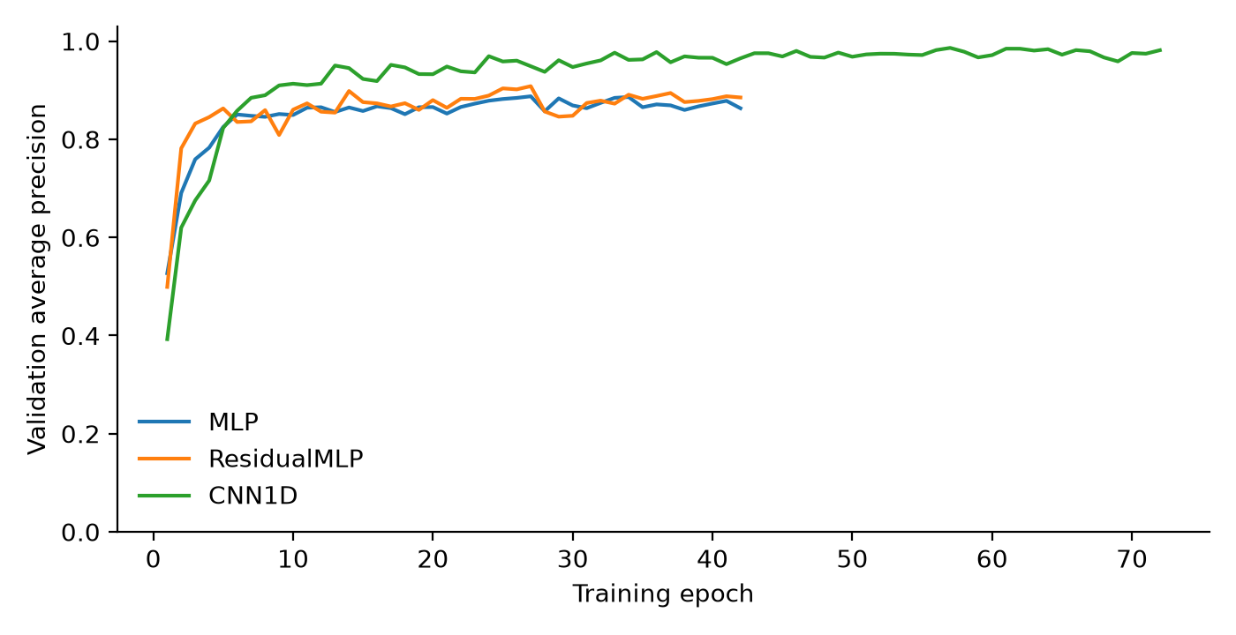
Figure 1 Intake validation AP by epoch. Each architecture restores its own best validation checkpoint.
The residual connections provide an additional dense comparator. The CNN uses a feature ordering fixed by preprocessing, although categorical and numeric columns have no physical spatial structure. Its outcome is specific to this encoding. The comparison does not assume that deep learning must outperform tree ensembles on tabular data [6].

6 Evaluation and threshold selection
Let TP and TN denote correctly flagged fraud and correctly unflagged legitimate claims. FP denotes a legitimate claim flagged for review; FN denotes a fraud claim below the decision threshold.
Measure | Definition
Accuracy | (TP + TN) / (TP + TN + FP + FN)
Precision | TP / (TP + FP)
Recall | TP / (TP + FN)
F1 | 2 TP / (2 TP + FP + FN)
Average precision | Sum over score groups of (R_k - R_(k-1)) P_k
ROC AUC | Probability that a fraud score exceeds a legitimate score, with half credit for a tie

P_k and R_k are precision and recall after including a tied-score group in descending score order. AP uses recall increments as weights [2]. ROC AUC measures ranking across the two classes [3]. Zero-positive precision is defined as zero. Every score is uncalibrated.
A fixed all-legitimate classifier obtains 94.00% accuracy on the full workbook and 94.0741% on the random test set, with zero fraud recall and F1. AP for a constant score equals prevalence. This provides a more informative reference than accuracy alone. Random-test prevalence is 40/675 = 0.0593.
Each model selects the threshold that maximizes validation F1. Ties choose the larger threshold. Ranking for the default intake model uses validation AP rounded to 12 decimals, validation F1 and finally the declared model order. The rule selects Random Forest. Test scores do not select a model or threshold. The complete results retain both the 0.5 and validation-F1 policies.

6 1 Worked numerical check
For intake Random Forest, the validation threshold is 0.4166667. On the test split, TN = 635, FP = 0, FN = 1 and TP = 39. Accuracy = (635 + 39)/675 = 99.8519%. Precision = 39/(39 + 0) = 100.00%. Recall = 39/(39 + 1) = 97.50%. F1 = 78/(78 + 0 + 1) = 0.987342. The same counts and equations appear in the saved evaluation evidence.
The verification script recomputes threshold metrics from counts and independently computes AP from tied score groups and ROC AUC from ranks. All 128 rows reconcile. A saved CSV prediction is therefore the traceable basis of every reported result, rather than a copied plot label.

7 Main comparison results
Model | AP | Precision | Recall | F1 | FP / FN
Logistic Regression | 0.8525 | 60.66% | 92.50% | 0.7327 | 24 / 3
Random Forest | 1.0000 | 100.00% | 97.50% | 0.9873 | 0 / 1
XGBoost | 1.0000 | 97.56% | 100.00% | 0.9877 | 1 / 0
SVM | 0.8181 | 74.42% | 80.00% | 0.7711 | 11 / 8
Histogram GB | 0.9765 | 100.00% | 97.50% | 0.9873 | 0 / 1
MLP | 0.8866 | 74.00% | 92.50% | 0.8222 | 13 / 3
Residual MLP | 0.8765 | 75.51% | 92.50% | 0.8315 | 12 / 3
1D CNN | 0.9667 | 96.97% | 80.00% | 0.8767 | 1 / 8

Table 7 Intake experiment test results at validation-selected thresholds. Each algorithm uses the same 675 test rows.
Random Forest and XGBoost have perfect test ranking in the intake experiment. Random Forest misses one fraud claim, while XGBoost flags one legitimate claim. Histogram Gradient Boosting has the same count-level result as Random Forest, although its AP is lower. This illustrates why ranking quality and threshold quality should be reported together.
The 1D CNN has the highest neural AP, 0.9667. Its threshold of 0.9691 produces one false positive and eight false negatives. MLP and Residual MLP each detect 37 fraud cases but generate 13 and 12 false positives respectively. The operating point determines whether ranking improvements translate into a useful review workload.
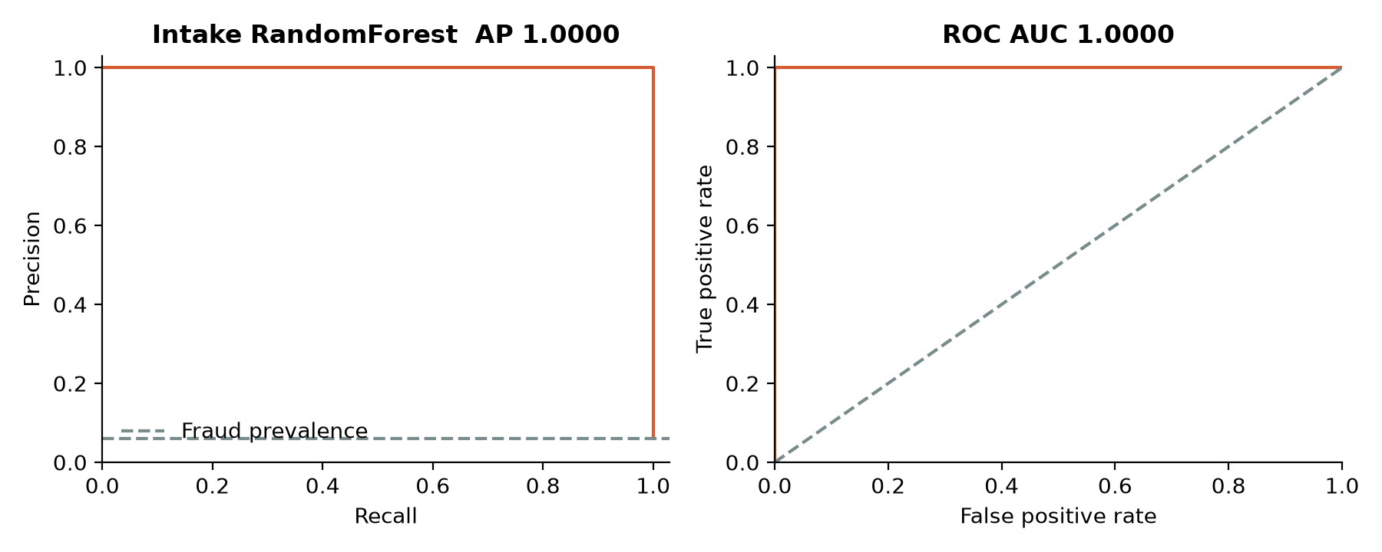
Figure 2 Intake Random Forest precision recall and ROC curves. The dashed PR reference marks test prevalence.

8 Effects of threshold adjustment
Model | F1 at 0.5 | F1 at validation threshold | Chosen threshold
Logistic Regression | 0.6724 | 0.7327 | 0.7618
Random Forest | 0.9873 | 0.9873 | 0.4167
XGBoost | 0.9877 | 0.9877 | 0.2121
SVM | 0.7400 | 0.7711 | 0.5859
Histogram GB | 0.9873 | 0.9873 | 1.0000
MLP | 0.7048 | 0.8222 | 0.8359
Residual MLP | 0.8046 | 0.8315 | 0.2751
1D CNN | 0.8125 | 0.8767 | 0.9691

Validation-based threshold selection can improve an operating point, but the gain need not transfer to the test partition. The table shows both policies without selecting between them from test outcomes. Because validation contains only 41 fraud cases, a threshold can be sensitive to individual observations. A separate calibration or policy-tuning cohort would provide a stronger basis for production decisions.
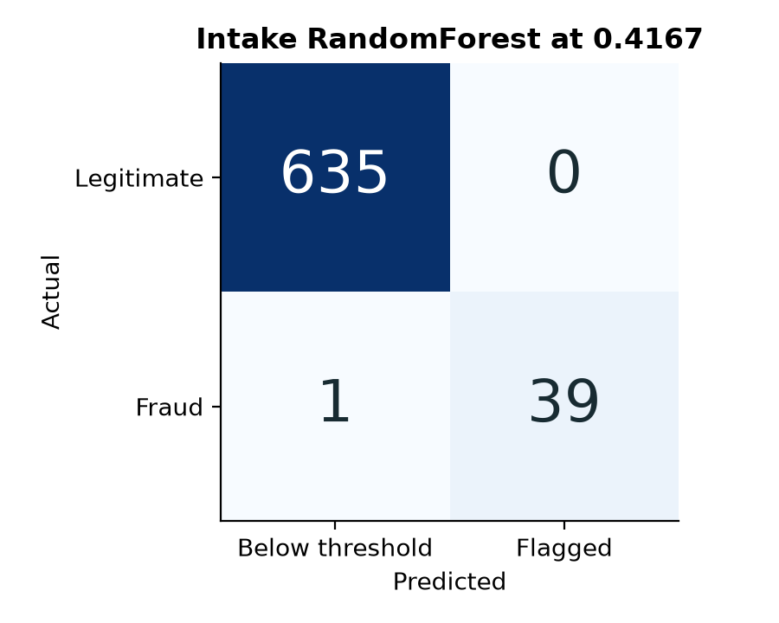
Figure 3 Default demonstration model at its frozen validation-selected threshold.

8 1 Score interpretation
All outputs are uncalibrated model scores. Class weighting changes the training objective, and the SVM score is a transformed margin. Thus a score of 0.80 does not establish an 80% probability of fraud. The website displays this distinction next to the result. Scores from different algorithms should not be averaged as if they shared a probability scale.

9 Feature sensitivity and error analysis
Model | Original AP | Intake AP | No amount AP | Temporal AP
Logistic Regression | 0.9186 | 0.8525 | 0.2318 | 0.8799
Random Forest | 0.9994 | 1.0000 | 0.2066 | 1.0000
XGBoost | 1.0000 | 1.0000 | 0.2128 | 1.0000
SVM | 0.9252 | 0.8181 | 0.1869 | 0.8396
Histogram GB | 0.9765 | 0.9765 | 0.2404 | 1.0000
MLP | 0.9538 | 0.8866 | 0.2303 | 0.8581
Residual MLP | 0.9567 | 0.8765 | 0.2246 | 0.7979
1D CNN | 0.9882 | 0.9667 | 0.2287 | 0.9172

Table 9 Test AP across the original, intake, amount-removed and chronological experiments.
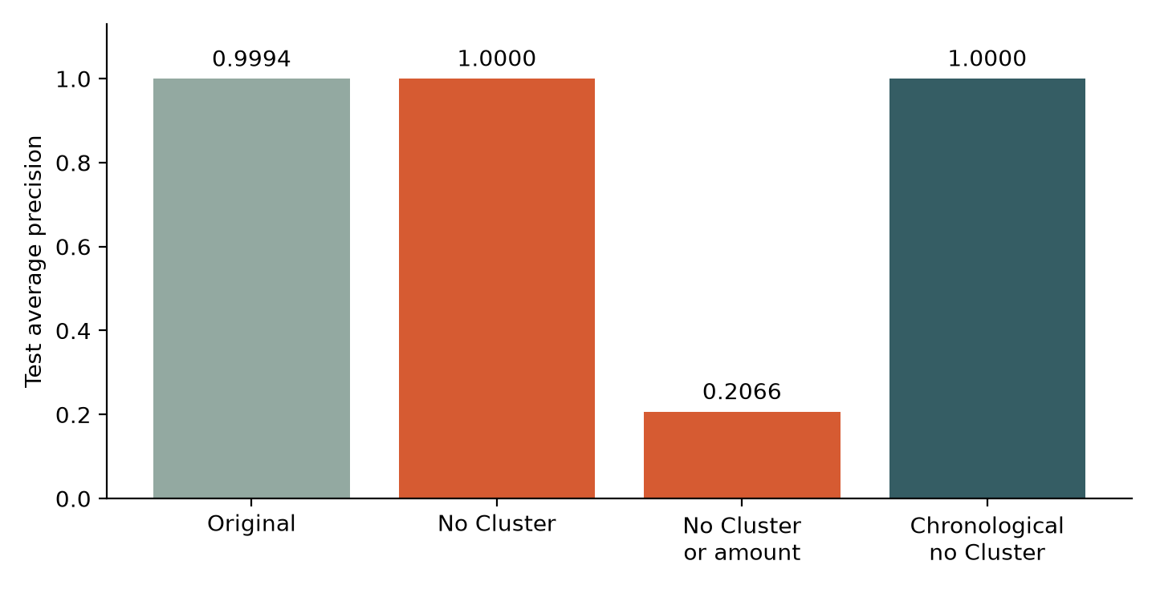
Figure 4 Random Forest sensitivity to the selected feature contract and the chronological split.
Removing Cluster does not remove the strong tree ranking. Removing both Cluster and ClaimAmount lowers AP across all algorithms to 0.1869–0.2404. Random Forest AP becomes 0.2066. Training impurity importance assigns about 44.0% to PatientIncome and 43.2% to ClaimAmount in the intake Random Forest. These importance scores describe fitted splits and are neither causal effects nor unbiased evidence of independent relevance.
The intake Random Forest has one false negative at workbook row 1124, with claim amount 7,465.07 source units, age 39 and claim type Outpatient. Its score is 0.2700, below the frozen threshold. The record belongs to the evaluation evidence; it does not justify changing the trained model after seeing the test result.

10 Chronological results and uncertainty
Model | AP | Precision | Recall | F1 | FP / FN
Logistic Regression | 0.8799 | 75.00% | 72.97% | 0.7397 | 9 / 10
Random Forest | 1.0000 | 100.00% | 100.00% | 1.0000 | 0 / 0
XGBoost | 1.0000 | 100.00% | 100.00% | 1.0000 | 0 / 0
SVM | 0.8396 | 68.09% | 86.49% | 0.7619 | 15 / 5
Histogram GB | 1.0000 | 100.00% | 100.00% | 1.0000 | 0 / 0
MLP | 0.8581 | 75.00% | 64.86% | 0.6957 | 8 / 13
Residual MLP | 0.7979 | 65.22% | 81.08% | 0.7229 | 16 / 7
1D CNN | 0.9172 | 81.08% | 81.08% | 0.8108 | 7 / 7

Table 10 Chronological intake experiment. Test contains 671 claims and 37 fraud labels.
Random Forest, XGBoost and histogram Gradient Boosting each obtain AP and F1 of 1.0000 on the later test period. The neural models have lower F1, ranging from 0.6957 for MLP to 0.8108 for CNN. All preprocessing and thresholds come from the earlier partitions. These dates assess internal temporal separation while remaining within the same undocumented workbook.

10 1 Conditional uncertainty
The selected random-split intake Random Forest has a 95% stratified bootstrap interval of 0.9610–1.0000 for F1 and 0.9250–1.0000 for recall, using 1,000 resamples and seed 2026. The method holds the model and threshold fixed and resamples positive and negative test rows separately. The AP interval is 1.0000–1.0000 because all observed test fraud scores outrank all legitimate scores. This degeneracy does not mean certainty about external population performance.
A single training seed and one split per experiment limit the comparison. The bootstrap does not include training variance, repeated threshold selection, changes in class prevalence or unknown shifts in label creation. Historical reuse of the random test split further limits strong generalization claims. More trustworthy improvement requires a documented independent dataset and repeated training within a prespecified protocol.

11 Website and prediction interface
Claim Fraud Lab provides four sections: project overview, model lab, measured results and method. The model lab switches between Approach 1 and Approach 2, selects one of the eight algorithms and selects either the 29-feature benchmark or 28-feature intake contract. Two examples from the workbook allow a quick demonstration. All model outputs include the decision threshold and feature count.
Interface element | Behavior
Feature contract | Intake omits Cluster. Original comparison requires Cluster. ClaimStatus and target are never model inputs.
Claim form | Checks required numbers, date validity, age range and known category choices.
Model inference | Evaluates exported fitted model parameters in the browser. It does not call an external prediction service.
Comparison | Shows all eight scores and indicates whether each exceeds its own threshold.
Results view | Switches among original, intake, amount sensitivity and chronological experiments.
Prediction export | Downloads the inputs, contract, threshold policy and model outputs as JSON.
Local API | POST /api/predict computes the same contract with Python artifacts. GET /api/health lists eight models.

The local site serves from http://127.0.0.1:8080. The private hosted copy is available at https://claim-fraud-lab-ravi-2026.clearbell16.chatgpt.site and uses the same static files and fitted parameter JSON. Browser inference allows the hosted demonstration to work without uploading claim inputs or exposing the local Python service. The two rendering paths serve the same completed model scope.

11 1 Implementation validation
Across 1,350 test-claim preprocessing comparisons, browser and Python feature vectors match exactly after float32 conversion. Across 10,800 model-score comparisons, the largest absolute difference is 0.00000044, with zero decision mismatches. API checks cover 32 valid prediction requests, four invalid-input cases and five static routes. Browser interaction checks cover example loading, model comparison and navigation.

12 Reproduction and demonstration procedure

12 1 Environment
Use Python 3.12 and the package versions in submission/requirements-lock.txt. Create a virtual environment at the repository root, then install dependencies. The tested environment uses CPU PyTorch. A CPU wheel index may be used for torch. The document builder uses the separate bundled artifact runtime and is not required to launch the model demonstration.
python -m venv .submission-venv
.submission-venv\Scripts\python.exe -m pip install -r submission\requirements-lock.txt
.submission-venv\Scripts\python.exe submission\scripts\run_pipeline.py
.submission-venv\Scripts\python.exe submission\scripts\export_browser.py
.submission-venv\Scripts\python.exe submission\scripts\make_figures.py
.submission-venv\Scripts\python.exe submission\scripts\verify.py
node submission\scripts\check_browser.mjs
powershell -ExecutionPolicy Bypass -File submission\START_DEMO.ps1

12 2 Demonstration sequence
- Open the site and state the two approaches and the dataset class imbalance.
- Use the intake contract and default Random Forest. Load the legitimate example and test it.
- Load the fraud example and compare all eight algorithms. Explain score and threshold differences.
- Switch to Approach 2 and test each neural architecture.
- Switch the feature contract to the original benchmark and show that Cluster becomes an input.
- Open Results and compare the amount sensitivity and chronological experiments. End with the amount dependency and external-validation limitation.

13 Artifact map and research limits
Path under submission | Purpose
scripts/run_pipeline.py | Shared data audit, training, validation, testing and selection
models/<experiment>/ | Fitted preprocessors, five classical models, three neural checkpoints and contract
results/metrics.csv | 128 metric records for partition and threshold policy combinations
results/predictions.csv | Auditable validation and test scores by workbook row
data/*_split_manifest.csv | Source-row partition membership
results/legacy_artifact_audit.json | Read-only evaluation of six historical trained artifacts
results/browser_parity.json | Browser and Python score consistency evidence
results/verification.json | Metric formulas and API checks
website/dist/ | Portable static model laboratory and parameter JSON
deliverables/ | Research manuscript, report and PowerPoint presentation

The source workbook and reference documents remain intact. The new submission pipeline resolves paths from its own location, so it does not rely on the old project/ directory used in several historical scripts. The website package contains only Approach 1 and Approach 2 model functions and experiment results.

13 1 Next research work
Document data origin, informed field timing and the label-adjudication process. Determine whether Cluster or any numerical feature was constructed using target information. Evaluate new claims collected independently of this workbook. Add repeated training and uncertainty over model fitting. Calibrate scores using a dedicated cohort and set review thresholds using explicit workload and error costs. Assess demographic subgroup performance only with adequate sample sizes and an agreed evaluation purpose.
The completed submission supports a reproducible model comparison and demonstration. The strong amount dependence, small positive test counts and unknown source provenance prevent a claim of production readiness for insurer decision making.

References and runtime record
[1] Project dataset. Health Insurance Fraud Claims.xlsx. Repository workbook, 4,500 records and 19 columns. Source origin, collection protocol and currency are undocumented. SHA-256 952b6e23c9845b9086994c08bc81323575968c318f845ea69e3b9609614b6a45.
[2] Scikit learn. Average precision score. https://scikit-learn.org/stable/modules/generated/sklearn.metrics.average_precision_score.html Accessed 20 October 2026.
[3] Scikit learn. Metrics and scoring. https://scikit-learn.org/stable/modules/model_evaluation.html Accessed 20 October 2026.
[4] Scikit learn. Common pitfalls and recommended practices. https://scikit-learn.org/stable/common_pitfalls.html Accessed 20 October 2026.
[5] PyTorch. BCEWithLogitsLoss. https://docs.pytorch.org/docs/stable/generated/torch.nn.BCEWithLogitsLoss.html Accessed 20 October 2026.
[6] Gorishniy and colleagues. Y. Gorishniy, I. Rubachev, V. Khrulkov and A. Babenko. Revisiting Deep Learning Models for Tabular Data. NeurIPS 34, 2021. https://proceedings.neurips.cc/paper_files/paper/2021/hash/9d86d83f925f2149e9edb0ac3b49229c-Abstract.html
[7] Experiment artifacts. submission/results/metrics.csv, predictions.csv, dataset_audit.json, selection.json, browser_parity.json and run_manifest.json. Reproducible internal experiment, 20 October 2026.
Runtime component | Measured version
Python | 3.12.14
numpy | 2.5.4
pandas | 3.0.6
scikit-learn | 1.9.1
xgboost | 3.4.1
torch | 2.14.1+cpu
joblib | 1.6.0

The final full training run took 63.88 seconds on the local CPU environment. This is an observed run duration, not a hardware-independent speed claim. Random seed is 42. Bootstrap seed is 2026.

