Classical and Neural Models for Medical Insurance Claim Fraud Detection
  - A comparative study of Approach 1 and Approach 2
20 October 2026

Abstract
This study compares five classical classifiers and three neural architectures for binary fraud detection on a repository workbook of 4,500 insurance claims, including 270 fraud labels. Approach 1 evaluates Logistic Regression, Random Forest, XGBoost, SVM and histogram Gradient Boosting. Approach 2 evaluates MLP, Residual MLP and 1D CNN. A shared stratified 70/15/15 split supports direct comparison. The protocol excludes post-adjudication status and identifiers, fits preprocessing only on training data and chooses decision thresholds using validation F1. An intake variant removes an unexplained Cluster field. Intake Random Forest achieves test average precision 1.0000 and F1 0.9873, with 39 true positives, one false negative and no false positives. However, removing both Cluster and claim amount reduces average precision to 0.2066 for that model. A chronological evaluation and a model-testing website complete the comparison. The evidence supports an internal benchmark demonstration and identifies substantial dependence on amount-related patterns. External validity remains unresolved.
Keywords: insurance claims, fraud classification, imbalanced data, classical machine learning, deep learning, average precision.

1 Introduction
A fraud classifier can prioritize claims for human review by assigning scores to structured intake information. The useful comparison is whether a model separates rare fraud labels from legitimate claims while keeping the review workload manageable. Accuracy alone can obscure that distinction: predicting every claim as legitimate gives 94.00% accuracy and zero fraud recall in this workbook.
The study addresses two questions within the existing project: how five classical methods compare with three neural architectures on identical partitions, and how sensitive the results are to uncertain dataset fields. It also connects the fitted models to a reproducible website demonstration. The contribution is a controlled evaluation and a functioning demonstration, rather than a new algorithm or evidence of performance on independent insurance operations.

2 Dataset and experimental design
The workbook contains 19 columns, no empty cells and no duplicate complete rows [1]. Claim dates span 9 July 2022 to 8 July 2024. The identifiers ClaimID, PatientID and ProviderID are unique in every row. DiagnosisCode and ProcedureCode each have 4,495 unique values. Such fields provide little reusable signal in a small benchmark and are excluded along with ProviderLocation.
Partition | Claims | Fraud | Legitimate
Training | 3150 | 189 | 2961
Validation | 675 | 41 | 634
Test | 675 | 40 | 635

ClaimLegitimacy maps Fraud to 1 and Legitimate to 0. Two stratified splits with seed 42 recreate the stored project partitions. Derived date features are year, month and weekday. Training-only median imputation and standard scaling process numeric inputs; mode imputation and one-hot encoding process six categorical fields. No imputation is needed for the current complete workbook. This fitting boundary follows standard leakage controls [4].

2 1 Feature contracts
The original comparison retains seven numeric and six categorical fields, yielding 29 encoded features. ClaimStatus is excluded because its adjudication timing could expose information unavailable at claim intake. The intake variant removes Cluster, yielding 28 features. Cluster 1 contains 267 of the 270 fraud labels, but its construction and availability are undocumented. The amount sensitivity variant also removes ClaimAmount, yielding 27 features. All three variants use the same random row partitions.

2 2 Chronological assessment
A separate intake experiment sorts by claim date and preserves complete dates at the boundaries. Training ends on 21 November 2023 (3,152 claims, 199 fraud cases). Validation runs from 22 November 2023 to 10 March 2024 (677 claims, 34 fraud cases). The test partition begins on 11 March 2024 (671 claims, 37 fraud cases). Preprocessing, neural checkpoint selection and thresholds are refitted within this chronological experiment. No calendar date appears in more than one partition.
The random test split has appeared in earlier project analyses. Consequently, the study is a retrospective internal comparison, not a newly locked external assessment. The sensitivity experiments do not change the selected model or threshold after examining their test outcomes.

3 Models and evaluation
Type | Algorithm | Configuration
1 | Logistic Regression | Balanced weights, lbfgs, maximum 2,000 iterations
1 | Random Forest | 300 trees, balanced weights
1 | XGBoost | 100 trees, depth 6, learning rate 0.3, training-derived class weight
1 | SVM | RBF kernel, balanced weights, sigmoid of decision margin
1 | Histogram GB | 100 iterations, balanced weights
2 | MLP | Input, 64, 32, 1 units with ReLU and 0.2 dropout
2 | Residual MLP | 64-unit projection, two 64-unit residual blocks, scalar output
2 | 1D CNN | Two kernel-3 convolutions with 8 and 16 channels, flatten, 32-unit dense layer, scalar output

All neural models use weighted binary cross entropy with logits, with positive weight equal to the training negative-to-positive ratio (15.6667 for the random split) [5]. AdamW uses learning rate 0.001 and weight decay 0.0001. Batch size is 128. The maximum is 100 epochs, with patience 15 and checkpoint selection by validation AP. Seed 42, two CPU threads and deterministic PyTorch operations control the run. The saved best checkpoint, rather than the final epoch, supplies evaluation scores.
The residual model is a compact project implementation with additive skip connections. Work on tabular deep learning motivates comparing strong dense and residual baselines [6], but this model does not reproduce that paper. The CNN follows the fixed encoded feature order; neighboring columns have no established spatial meaning. It is therefore an experimental comparator.
For each fitted model, the validation threshold maximizes F1 over unique validation scores. Equal F1 chooses the larger threshold. Primary model ranking uses validation AP rounded to 12 decimals, then validation F1, then the declared model order. The 0.5 policy is also retained to expose the effect of threshold choice. The test partition supplies final descriptive metrics only.

4 Evaluation measures
Let TP and TN denote correctly flagged fraud and correctly unflagged legitimate claims. FP denotes a legitimate claim flagged for review; FN denotes a fraud claim below the decision threshold.
Measure | Definition
Accuracy | (TP + TN) / (TP + TN + FP + FN)
Precision | TP / (TP + FP)
Recall | TP / (TP + FN)
F1 | 2 TP / (2 TP + FP + FN)
Average precision | Sum over score groups of (R_k - R_(k-1)) P_k
ROC AUC | Probability that a fraud score exceeds a legitimate score, with half credit for a tie

P_k and R_k are precision and recall after including a tied-score group in descending score order. AP uses recall increments as weights [2]. ROC AUC measures ranking across the two classes [3]. Zero-positive precision is defined as zero. Every score is uncalibrated.
The project previously labelled average_precision_score output as PR AUC. This study calls the quantity average precision (AP) because it uses step weighting rather than trapezoidal interpolation [2]. The distinction matters when curve shapes differ. AP and ROC AUC use scores, while accuracy, precision, recall and F1 depend on a decision threshold.

4 1 Independent verification
The evaluation stores each validation and test label, source row and predicted score. Independent confusion-count equations reproduce the threshold metrics. A grouped-score implementation reproduces AP; a rank-sum calculation reproduces ROC AUC, including ties. These checks cover 128 metric rows across 32 fitted model and experiment combinations [7].
For intake Random Forest at threshold 0.4167, TP = 39, TN = 635, FP = 0 and FN = 1. Accuracy is 674/675 = 99.8519%. Precision is 39/39 = 100.00%. Recall is 39/40 = 97.50%. F1 is 78/79 = 0.987342. Perfect AP can coexist with one false negative because ranking and a fixed operating threshold measure different properties.
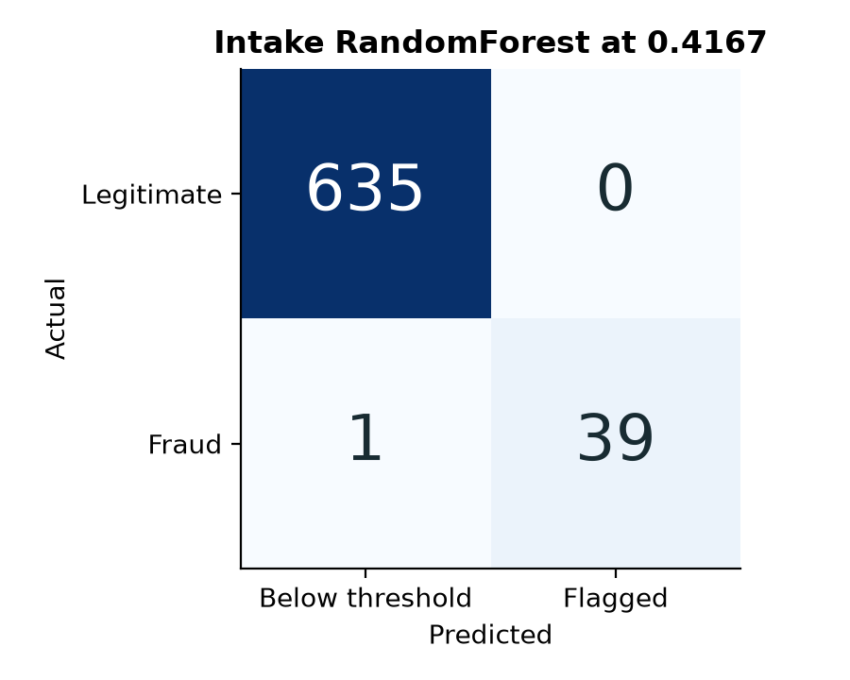
Figure 1 Intake Random Forest test confusion matrix at the validation-selected threshold.

5 Comparative results
Table 2 reports the intake experiment with Cluster removed. Every row uses that model’s own validation-selected threshold. The models share the same 675 test claims and 40 fraud cases. Random Forest wins the specified validation tie-break and serves as the default demonstration model. Test results alone would not justify changing that selection.
Model | AP | Precision | Recall | F1 | FP / FN
Logistic Regression | 0.8525 | 60.66% | 92.50% | 0.7327 | 24 / 3
Random Forest | 1.0000 | 100.00% | 97.50% | 0.9873 | 0 / 1
XGBoost | 1.0000 | 97.56% | 100.00% | 0.9877 | 1 / 0
SVM | 0.8181 | 74.42% | 80.00% | 0.7711 | 11 / 8
Histogram GB | 0.9765 | 100.00% | 97.50% | 0.9873 | 0 / 1
MLP | 0.8866 | 74.00% | 92.50% | 0.8222 | 13 / 3
Residual MLP | 0.8765 | 75.51% | 92.50% | 0.8315 | 12 / 3
1D CNN | 0.9667 | 96.97% | 80.00% | 0.8767 | 1 / 8

Table 2 Intake test results. AP and F1 are fractions. Precision and recall are percentages. FP and FN are counts.
XGBoost also achieves AP 1.0000 and has one false positive with no false negatives. Its F1 of 0.9877 marginally exceeds Random Forest’s 0.9873 at the selected thresholds, but the difference is one error of a different type. The best neural AP is 0.9667 for 1D CNN. Its selected threshold produces recall 80.00% and F1 0.8767. Neither architecture complexity nor AP alone guarantees a better operating point.
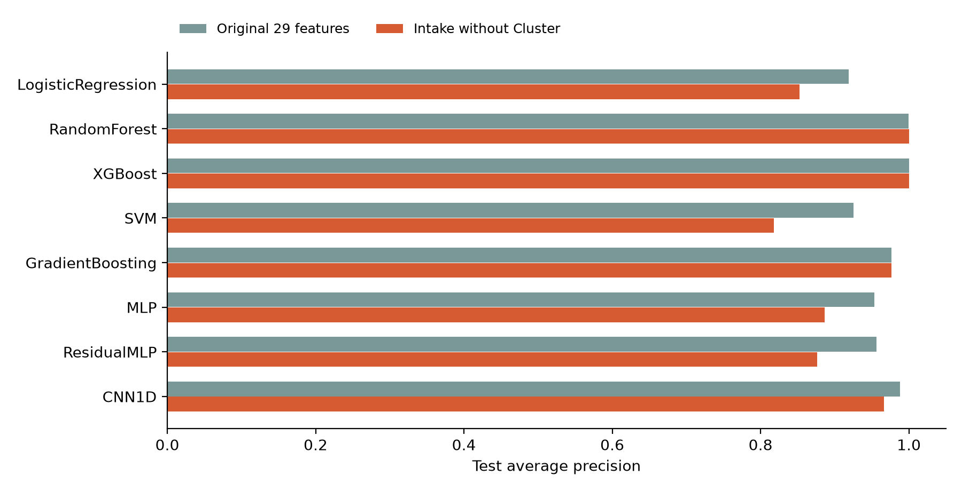
Figure 2 Test AP for the original 29-feature comparison and the intake variant without Cluster.

6 Sensitivity and uncertainty
Model | Original AP | Intake AP | No amount AP | Temporal AP
Logistic Regression | 0.9186 | 0.8525 | 0.2318 | 0.8799
Random Forest | 0.9994 | 1.0000 | 0.2066 | 1.0000
XGBoost | 1.0000 | 1.0000 | 0.2128 | 1.0000
SVM | 0.9252 | 0.8181 | 0.1869 | 0.8396
Histogram GB | 0.9765 | 0.9765 | 0.2404 | 1.0000
MLP | 0.9538 | 0.8866 | 0.2303 | 0.8581
Residual MLP | 0.9567 | 0.8765 | 0.2246 | 0.7979
1D CNN | 0.9882 | 0.9667 | 0.2287 | 0.9172

Table 3 Test AP under four experiments. Each chronological model refits on its own earlier training period.
Removing Cluster preserves strong tree performance but reduces AP for several linear and neural models. Removing claim amount as well produces AP values between 0.1869 and 0.2404 across all eight methods. Intake Random Forest falls from 1.0000 to 0.2066. All fraud amounts lie between 7,465.07 and 9,978.43 source units, although legitimate amounts overlap this range. The result indicates a strong amount-dependent pattern, rather than proof that amount alone determines fraud.
The chronological test yields AP and F1 of 1.0000 for Random Forest, XGBoost and histogram Gradient Boosting. This internal temporal result suggests stable patterns within the workbook. It does not resolve unknown data provenance or establish transportability to another insurer or collection process.
A stratified bootstrap with 1,000 replicates and seed 2026 keeps the fitted intake Random Forest and threshold fixed. The 95% percentile intervals are F1 0.9610 to 1.0000 and recall 0.9250 to 1.0000. The AP interval degenerates at 1.0000 because the observed scores perfectly rank the classes. These conditional intervals omit training variability, threshold-selection uncertainty and external distribution shift. They are not evidence that population AP equals one.

6 1 Improvement priorities
Removing the unexplained Cluster field improves the suitability of the input contract for a claim-intake demonstration. Additional priority work is to document the label and Cluster creation process, obtain independently labelled claims, evaluate across insurers and time, and calibrate scores on a separate partition. Thresholds should ultimately reflect measured review capacity and the relative costs of missed fraud and false alerts. The present study has neither those costs nor an external validation cohort.

7 Demonstration and conclusions
Claim Fraud Lab exposes both approaches through a shared form. A user selects the original or intake feature contract, chooses a model and threshold policy, and tests a claim or compares all eight algorithms. The browser evaluates exported fitted parameters locally. A same-origin FastAPI application provides an independent Python prediction endpoint. Inputs are validated, predictions display their thresholds, and results can be exported as JSON. The website labels all outputs as uncalibrated scores. The private demonstration is available at https://claim-fraud-lab-ravi-2026.clearbell16.chatgpt.site.
Verification covers 1,350 raw-claim preprocessing comparisons and 10,800 model-score comparisons across the two website feature contracts. Preprocessing agrees exactly after float32 conversion. The maximum score difference is below 0.000001 and there are no threshold decision mismatches. The API passes 32 prediction requests plus invalid-input checks. This establishes implementation consistency on the tested cases, not predictive validity outside the workbook.

7 1 Conclusion
The completed comparison contains five classical methods and three neural methods, with shared evaluation, feature sensitivity tests and a functioning model interface. Tree models dominate this internal benchmark. Removing Cluster preserves a strong default Random Forest result, while amount ablation exposes a major dependency in the dataset. The appropriate submission claim is a reproducible comparative prototype with explicit limits, supported by saved predictions and measured results.

References
[1] Project dataset. Health Insurance Fraud Claims.xlsx. Repository workbook, 4,500 records and 19 columns. Source origin, collection protocol and currency are undocumented. SHA-256 952b6e23c9845b9086994c08bc81323575968c318f845ea69e3b9609614b6a45.
[2] Scikit learn. Average precision score. https://scikit-learn.org/stable/modules/generated/sklearn.metrics.average_precision_score.html Accessed 20 October 2026.
[3] Scikit learn. Metrics and scoring. https://scikit-learn.org/stable/modules/model_evaluation.html Accessed 20 October 2026.
[4] Scikit learn. Common pitfalls and recommended practices. https://scikit-learn.org/stable/common_pitfalls.html Accessed 20 October 2026.
[5] PyTorch. BCEWithLogitsLoss. https://docs.pytorch.org/docs/stable/generated/torch.nn.BCEWithLogitsLoss.html Accessed 20 October 2026.
[6] Gorishniy and colleagues. Y. Gorishniy, I. Rubachev, V. Khrulkov and A. Babenko. Revisiting Deep Learning Models for Tabular Data. NeurIPS 34, 2021. https://proceedings.neurips.cc/paper_files/paper/2021/hash/9d86d83f925f2149e9edb0ac3b49229c-Abstract.html
[7] Experiment artifacts. submission/results/metrics.csv, predictions.csv, dataset_audit.json, selection.json, browser_parity.json and run_manifest.json. Reproducible internal experiment, 20 October 2026.

