STM32 Radar Target Detection
& Threat Alert System

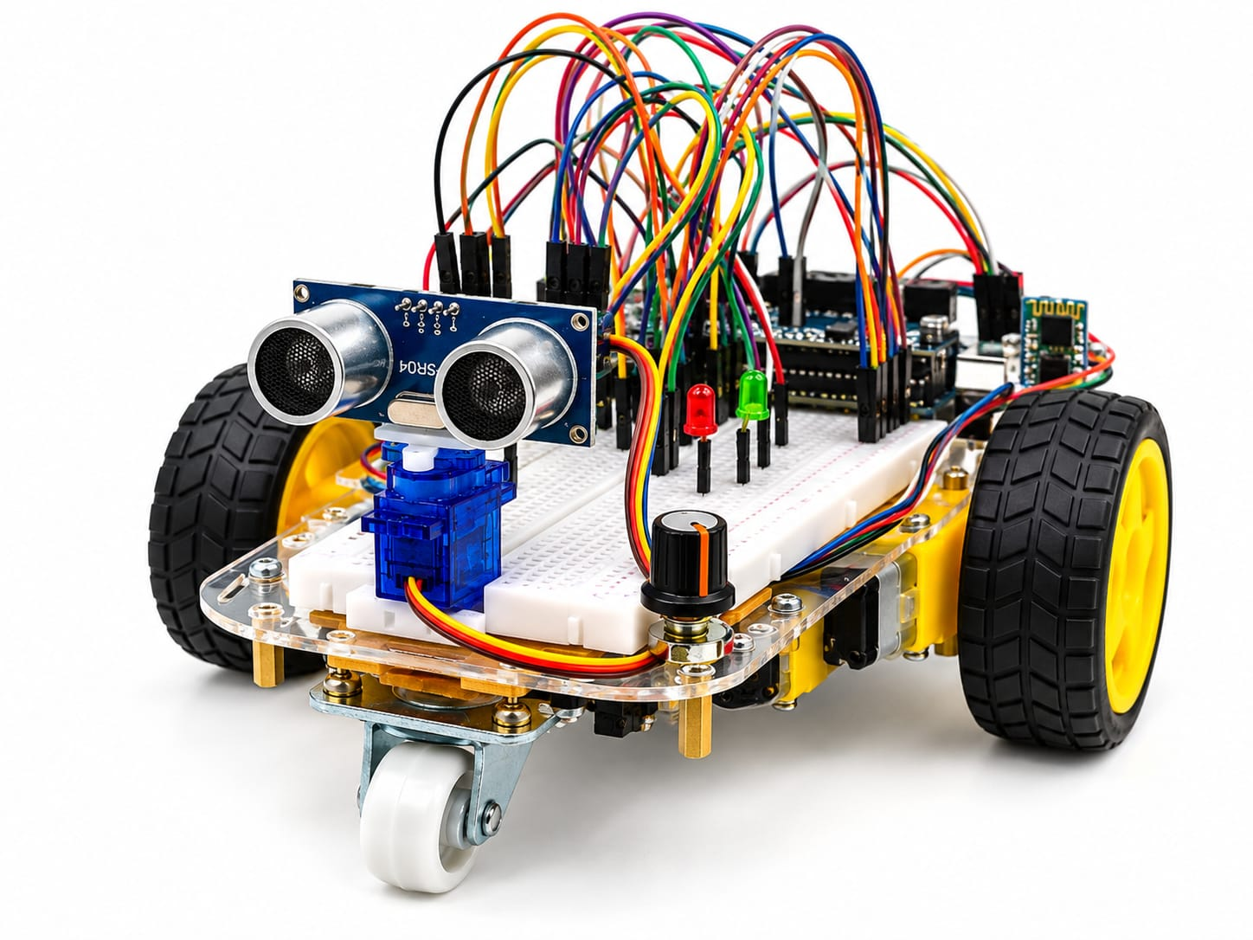

Course Code & Title | 23CSE304, Embedded Systems
Mentor | Dr. A. Baskar
Team | Team 1
Team Members
Kankatala Ganesh Giridhar | CB.SC.U4CSE24519
Suhas Reddy | CB.SC.U4CSE24503
GR Balaji | CB.SC.U4CSE24510
J Maneesh | CB.SC.U4CSE24514

1. Introduction
Classic sensor approaches (passive infrared, ultrasonic) suffer from restricted range, poor angular resolution, and high false-positive rates caused by ambient temperature changes, wind, or stray objects, in actual application; and thus, indoor security monitoring, perimeter alerting, and proximity-aware automation are regularly becoming critical in smart buildings, industrial facilities, and defence applications, to a significant degree.
The case study introduces the design and rollout of an STM32-based Radar Target Detection and Threat Alert System, in real-world scenarios. Against this backdrop, the HC-SR04 ultrasonic sensor is used as a baseline demonstrator by the current prototype, starting the full embedded pipeline, ADC-based threshold adjustment, PWM-driven servo sweep, GPIO-controlled LED and buzzer alerts, and UART telemetry output, before transitioning to the mm-wave radar sensor; this architecture is using the HLK-LD2450 24 GHz millimetre-wave radar module interfaced with an STM32F401CCU6 "Black Pill" microcontroller to detect, track and alert on moving human targets within a configurable alert zone, in many respects.
The project is normally offering hands-on experience with bare-metal STM32 programming covering peripheral initialisation (USART, ADC, TIM/PWM, GPIO), real-time sensor data acquisition, signal conditioning, and multi-output alert management, all core topics of the 23CSE304 Embedded Systems curriculum, broadly speaking.

2. Problem Statement & Motivation

2.1 Problem Statement
Conventional indoor intrusion detection systems hinge on PIR sensors that can (in actual operation) only detect the presence or absence of any heat source without offering distance, speed, or directional information, to a significant degree. Looking at it like this, ultrasonic sensors, while distance-capable, offer the narrow field of view and are susceptible to acoustic interference. There's a further need for one low-cost, embedded radar-based detection platform that can:
- Track multiple moving targets simultaneously with distance and angle information.
- Prescribe and adjust an alert zone in real time, through the hardware controls (potentiometer), on the whole.
- Immediately alert (visual LEDs, audible buzzer, serial dashboard).
- Gracefully handle sensor faults such as stale, missing, or malformed data frames.
- Operate autonomously on a low-power ARM Cortex-M4 microcontroller without an external PC.

2.2 Motivation
The motivation for this project stems from three key drivers:
Academic Learning, including The project exercises each major minor of the STM32F401, UART for sensor communication, ADC for analog threshold input, TIM/PWM for servo control, and GPIO for digital I/O, offering a comprehensive embedded systems case study, on the whole.
Understanding radar data scanning and real-time decision-making on a resource-constrained MCU is an industry-relevant skill, broadly speaking; in parallel with this, real-World Relevance, namely Millimetre-wave radar is increasingly employed in automotive (ADAS), smart home (presence detection), and industrial safety (perimeter monitoring) applications, on the whole.
Under ₹2,000, Cost Effectiveness - The entire bill of materials, STM32F401 Black Pill, HLK-LD2450 radar, LEDs, buzzer, potentiometer, and SG90 servo, costs, making it accessible for student projects and adjustable for rollout, on the whole.

3. Objectives
- Design and build an embedded radar target detection prototype on the STM32F401CCU6.
- Interface the HLK-LD2450 24 GHz radar sensor via UART and read its binary target frames, on the whole.
- Perform a real-time adjustable alert zone employing an ADC-connected potentiometer.
- Drive multi-modal alert outputs, such as red/green LEDs, active buzzer, SG90 servo visual sweep, and serial telemetry, in actual application.
- Apply sensor-fault detection for stale/missing/malformed frames to avoid false negatives.
- Record the full framework, circuit diagram, firmware architecture, build phases, and demonstration procedure.
- Establish a baseline ultrasonic demonstrator (HC-SR04) for the validation of the embedded pipeline, before radar integration, in many respects.

4. System Architecture & Method

4.1 High-Level Architecture
This architecture follows a sensor → processor → actuator pipeline:
- Target data are, more accurately, continuously emitted by Sensing Layer, such as The HLK-LD2450 radar (or HC-SR04 ultrasonic in the baseline), to a significant degree.
- Communication Layer, namely Sensor data is widely received by the STM32 over UART (radar) or GPIO pulse-timing (ultrasonic), in actual application.
- Processing Layer, covering The firmware is proving incoming frames, pulls target distance/angle/speed, and contrasts against the user-set alert threshold (read from ADC), in many respects.
- Decision Layer, such as If a target falls within the alert zone, a "THREAT" state is normally claimed; otherwise, "CLEAR" is kept up, to a significant degree; indeed, a "FAULT" state is triggered by a timeout mechanism if sensor data goes stale, in many respects.
- Output Layer, such as LEDs (red=threat, green=clear), buzzer (active on threat), servo (sweeps to indicate direction), and UART serial dashboard display the current state, on the whole.

4.2 Data Flow
- Data are, in practice, continuously stressed by the radar/sensor reports.
- The STM32 receives, checks and scans every data frame.
- Target distance/angle is, in practice, pulled and in comparison to the configurable ADC threshold.
- Alert outputs (LEDs, buzzer, servo, serial) are, in practice, modified in real time.
- A fault state (not a false "clear" is currently entered by the framework), if data is uniformly missing or stale beyond a timeout period potentially, in actual application.

4.3 Development Methodology
The project follows an incremental prototyping method:
Checks all minor drivers and the alert logic. Phase 1, Baseline (Current): HC-SR04 ultrasonic sensor with full embedded pipeline (ADC, PWM, GPIO, UART output), broadly speaking.
Perform binary frame parser, multi-target monitoring, and freshness timeout, so phase 2, Radar Integration (Planned): Replace HC-SR04 with HLK-LD2450 via UART, in actual application.
Phase 3, Laser Aiming (Future): Add a laser module synchronised with the servo to visually spot and aim at the detected target location, in many respects.

5. Hardware Components
# | Component | Specification | Role in System | Approx. Cost (₹)
1 | STM32F401CCU6 "Black Pill" | ARM Cortex-M4, 84 MHz, 256 KB Flash | Central microcontroller, is, more accurately, running all firmware, ADC, PWM, UART, GPIO | 350
2 | HLK-LD2450 | 24 GHz FMCW mmWave radar | Moving-target detection sensor, reports distance, angle, speed via UART | 850
3 | HC-SR04 (Baseline) | Ultrasonic, 2-400 cm range | Baseline distance sensor for Phase 1 prototype validation | 50
4 | SG90 Micro Servo | 180° rotation, 5V, PWM controlled | Visual sweep indicator, points toward the detected target direction | 100
5 | 10 kΩ Potentiometer | Linear taper | User-adjustable alert-zone threshold via ADC input | 10
6 | Red LED + Resistor | 5mm, 220Ω current-limiting resistor | Threat/alert visual indicator (active-low) | 5
7 | Green LED + Resistor | 5mm, 220Ω current-limiting resistor | Clear/safe status visual indicator (active-low) | 5
8 | Active Buzzer | 5V, continuous tone | Audible threat alert | 20
9 | Push Button | Momentary, normally-open | Alert acknowledge / pause-resume control | 5
10 | 16×2 I²C LCD (Optional) | HD44780 + PCF8574 backpack | On-device telemetry display | 150
11 | Breadboard + Jumper Wires | 830-point breadboard, M-M / M-F wires | Prototyping and interconnection | 100
12 | USB Cable + Power Supply | Micro-USB, 5V/1A adapter | Power and programming interface | 150
Total Estimated BOM Cost: ~₹1,400 (with ultrasonic) / ~₹1,900 (with radar)

6. Software

Language: C (bare-metal, no RTOS)
Toolchain - ARM GCC / Keil µVision / STM32CubeIDE
HAL: Direct register-level programming (CMSIS headers only)
Debug: ST-Link V2, UART serial monitor (9600 baud)

7. Circuit Diagram & Pin Mapping

7.1 Circuit Diagram
The circuit diagram of the prototype is uncovered below; in turn, the HC-SR04 ultrasonic sensor connects via GPIO (trigger on PA6, echo on PA7), to a significant degree; indeed, the STM32F401CCU6 Black Pill is the central controller, so the SG90 servo is often driven by PWM on PA8, in real-world scenarios. Within this framework, the potentiometer feeds an analog voltage to PA0 (ADC); in turn, also, active-low LEDs are on PA10 (red) and PA11 (green), on the whole; in fact, as, well, the UART serial output is mainly on PA2/PA3 for telemetry monitoring.
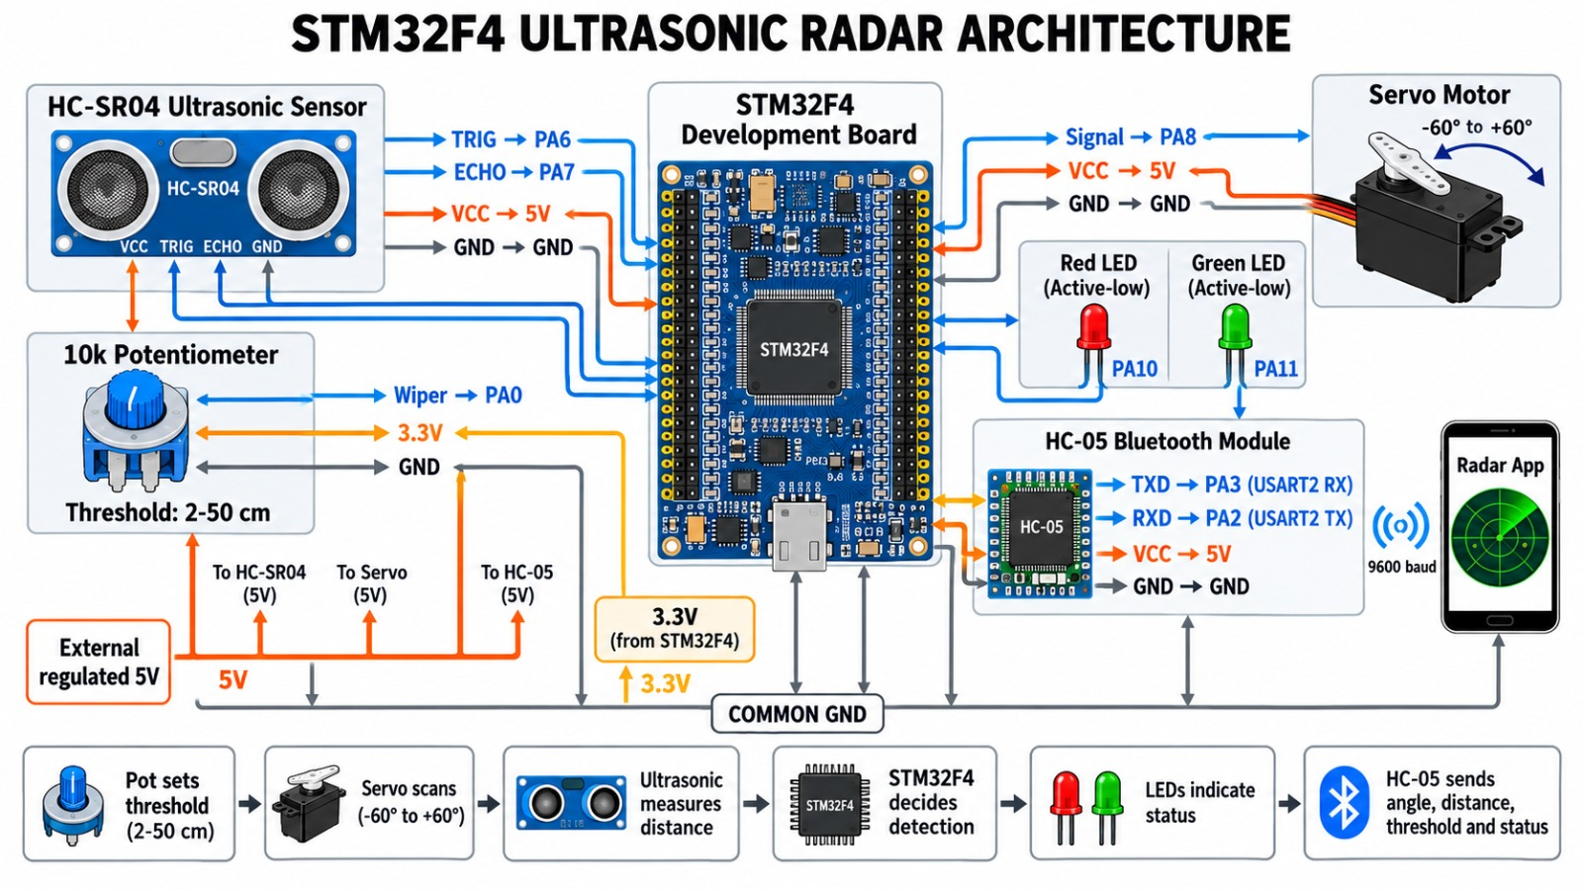
Figure 1, such as Circuit Diagram / Prototype Wiring

7.2 Pin Mapping Table
Signal | STM32 Pin | Peripheral | Notes
HC-SR04 Trigger | PA6 | GPIO Output | 10µs pulse to begin measurement
HC-SR04 Echo | PA7 | GPIO Input | Pulse width = distance × 58 µs/cm
LD2450 TX → STM32 RX | PA10 (USART1_RX) | USART1 RX | Cross-connect: radar TX to MCU RX
LD2450 RX ← STM32 TX | PA9 (USART1_TX) | USART1 TX | For radar configuration commands
Potentiometer Wiper | PA0 | ADC1 CH0 | 0-3.3V analog input for threshold
Servo PWM | PA8 | TIM1 CH1 | 50 Hz, 1-2 ms pulse width
Red LED (Active-Low) | PA10 | GPIO Output | 220Ω series resistor; LOW = ON
Green LED (Active-Low) | PA11 | GPIO Output | 220Ω series resistor; LOW = ON
UART2 TX (Telemetry) | PA2 | USART2 TX | 9600 baud serial output
UART2 RX | PA3 | USART2 RX | For future bidirectional control
LCD SDA (Optional) | PB9 | I²C1 SDA | External pull-up required
LCD SCL (Optional) | PB8 | I²C1 SCL | External pull-up required
Push Button | PB0 (Candidate) | GPIO Input | Internal pull-up, active-low

8. Novelty & Key Features

Millimetre-Wave Radar on a Student-Budget MCU
Diverse from most student projects that are usually employing elementary PIR or ultrasonic sensors, a 24 GHz FMCW radar (HLK-LD2450) with an affordable STM32F401 is typically blended by this framework; this brings industrial-grade target detection, distance and angle of up to 3 happening together moving targets, into an academic prototype costing under ₹2,000, to a significant degree.

Software-Defined Configurable Alert Zone
The alert zone is often not hardcoded. Under these conditions, a potentiometer connected to the ADC is generally allowing real-time, continuous adjustment of the detection threshold without re-flashing firmware, in real-world scenarios; this mirrors real-world configurable security systems, to a significant degree.

Multi-Modal Alert Outputs
This architecture is often offering parallel visual (red/green LEDs), audible (buzzer), mechanical (servo sweep), and digital (UART serial telemetry) feedback, which is mainly making sure the alert is caught regardless of the operator's attention mode, in many respects.

Explicit Sensor-Fault Handling
More like than silently uncovering "CLEAR" when the sensor stops responding, the firmware is performing a freshness timeout that's transitioning to a separate FAULT state; this is a safety-critical design pattern infrequently seen in student-level projects, on the whole.

Bare-Metal Register-Level Programming
The entire firmware is typically written employing direct CMSIS register access, no HAL abstraction layers; this is usually supplying careful knowledge of STM32 minor architecture (clock gating, alternate function mapping, timer prescalers, ADC conversion sequences), in actual application.

Incremental Sensor-Adapter Architecture
The firmware is designed so the sensing layer (HC-SR04 or LD2450) is making a widespread "target record" data structure, in many respects; swapping sensors needs only changing the driver module, not the alert logic, output drivers, or principal loop, revealing modular embedded design, broadly speaking.

9. Use Cases & Applications
The adjustable threshold is allowing tuning for separate room sizes; more accurately, Indoor Perimeter Security, namely Roll out at entry points, corridors, or restricted subfields to detect and alert on unauthorised movement, broadly speaking.
The mm-wave radar is working through the thin walls and isn't changed by ambient light or temperature, in real-world scenarios; along these dimensions, smart Home Presence Detection, encompassing Detect human presence for automated lighting, HVAC activation, or elderly fall detection, on the whole.
When a worker enters the arranged danger radius, the buzzer and LED alert the operator to halt equipment, in real-world scenarios; more accurately, Industrial Safety Zones, covering Monitor exclusion zones around machinery, broadly speaking.
Laboratory Access Monitoring, namely Track entry/exit patterns in research labs or server rooms without cameras, preserving privacy while keeping up security logs via serial telemetry, in actual application.
Embedded Systems Education: Serve as a broad teaching platform covering UART, ADC, PWM, GPIO, timer interrupts, fault handling, and real-time data processing on ARM Cortex-M, in actual application.
Defence & Surveillance Prototyping - Act as a proof-of-concept for automated sentry systems that are normally detecting strategying targets and directionally cue (future laser module), to a significant degree.

10. Phases to Build & Run

10.1 Hardware Assembly
- Place the STM32F401CCU6 Black Pill on a breadboard.
- Connect the HC-SR04 ultrasonic sensor, namely VCC → 5V, GND → GND, TRIG → PA6, ECHO → PA7, on the whole.
- Connect the SG90 servo, namely signal wire → PA8, VCC → external 5V supply (not from STM32), GND → common ground, on the whole.
- Connect the 10 kΩ potentiometer, including outer pins → 3.3V and GND, wiper → PA0, in real-world scenarios.
- Connect the red LED + 220Ω resistor to PA10 and the green LED + 220Ω resistor to PA11 (active-low configuration - cathode to pin, anode to 3.3V), on the whole.
- Connect the active buzzer between a GPIO pin and GND (use a transistor driver if current exceeds 20 mA), in real-world scenarios.
- Connect a USB cable from the Black Pill to your PC for power and serial monitoring, on the whole.
- Optionally connect the 16×2 I²C LCD to PB8 (SCL) and PB9 (SDA) with external pull-up resistors, to a significant degree.

10.2 Firmware Compilation & Flashing
- Install STM32CubeIDE or Keil µVision with the STM32F4 device pack.
- Create a new project targeting the STM32F401CCU6.
- Taken together, copy code.c into the project source directory; so, ensure the stm32f4xx.h CMSIS header is especially included in the project, in actual application.
- Settle any toolchain-specific warnings. Building on this finding, build the project (Ctrl+B in STM32CubeIDE or F7 in Keil), in many respects.
- Connect an ST-Link V2 debugger to the SWD header on the Black Pill (SWDIO, SWCLK, GND, 3.3V), on the whole.
- Flash the gathered binary to the MCU employing the IDE's built-in flash programmer.
- Open a serial terminal (PuTTY, Tera Term, or Arduino Serial Monitor) at 9600 baud on the related COM port, in actual application.

10.3 Running the Demonstration
- Power the framework. Viewed through this lens, the green LED should, in this setting, turn ON (clear state), in actual application.
- Gather the serial terminal printing: Angle, Distance and Threshold.
- Place your hand or an object within the sensor's detection range.
- The red LED is turning ON, OFF is being turned by the green LED, if the measured distance is ≤ the threshold, in actual application; indeed, along these dimensions, also the serial output is revealing "OBJECT DETECTED".
- Rotate the potentiometer to increase or lessen the alert threshold in real time.
- Watch the servo sweep continuously between -60° and +60°.
- Remove the object and check the system returns to "CLEAR / NO ECHO" with the green LED, to a significant degree.

11. Outputs
# | Deliverable | Format | Status
1 | Problem Statement & Motivation Document | This Report (Section 2) | ✔ Complete
2 | One-Page Project Writeup | This Report (Sections 1-3) | ✔ Complete
3 | Circuit Diagram | JPEG Image + Pin Table (Section 7) | ✔ Complete
4 | Prototype Image | JPEG photograph (covered in report) | ✔ Complete
5 | Source Code (code.c) | C source file on GitHub | ✔ Complete
6 | README.md with Build Instructions | Markdown on GitHub | ✔ Complete
7 | Working Demo Video | MP4/link in GitHub repository | ⏳ Pending
8 | Final Report (this document) | Word (.docx) / PDF | ✔ Complete
9 | Presentation Slides | PDF (TEAM 1 PPT ES.pdf) | ✔ Complete

12. Future Enhancements
The current prototype shows a solid embedded foundation, so the following enhancements are planned for successive development phases:

HLK-LD2450 Radar Integration
The firmware will, to some extent, carry out a binary frame parser with header/tail validation and CRC inspecting, to a significant degree, and replace the HC-SR04 ultrasonic sensor with the HLK-LD2450 24 GHz millimetre-wave radar; this will allow happening together monitoring of up to 3 moving targets with distance, angle and speed data reported at high frame rates over UART, in real-world scenarios.

Laser Target Spotting & Aiming Synchronisation
Mount a low-power laser module (e.g., KY-008 5V laser diode) on the SG90 servo, in actual application; indeed, what's more, when the radar detects a target, the servo will rotate to the computed target angle, to a significant degree. Against this backdrop, also the laser will turn on to visually "spot" the detected target's position, successfully createing a synchronised radar-detect → servo-aim → laser-spot pipeline, revealing closed-loop target tracking, to a significant degree.

Multi-Target Tracking with Priority
Execute a target prioritisation algorithm that picks the closest or fastest-approaching target for the servo/laser to track; while still logging all detected targets on the serial dashboard, on the whole.

Wireless Telemetry (ESP32 / Bluetooth)
Add an ESP32 or HC-05 Bluetooth module to stream target data wirelessly to a mobile app or web dashboard for remote monitoring, in real-world scenarios.

OLED/TFT Radar Display
Replace the 16×2 LCD with a small OLED or TFT show revealing a real-time top-down radar plot with target blips, alert zone boundary, and status indicators, in many respects.

RTOS Migration
Port the firmware to FreeRTOS for deterministic task scheduling, separating sensor reading, alert processing, display updates, and communication into the autonomous tasks with stipulated priorities, in many respects.

13. Conclusion
The current baseline prototype, employing the HC-SR04 ultrasonic sensor, is, more accurately, checking the complete embedded pipeline, analog threshold input via ADC, servo sweep control via PWM, LED and buzzer alert outputs via GPIO, in real-world scenarios. And more, real-time serial telemetry via UART, all realized, through the bare-metal register-level C programming on the STM32F401CCU6, in real-world scenarios. Viewed through this lens, the design and execution of an STM32-based radar target detection and threat alert framework are successfully laid out by this case study, in real-world scenarios.
The modular firmware architecture is making sure a clean migration path to the HLK-LD2450 24 GHz radar sensor, which will bring multi-target monitoring, speed estimation, and through-wall detection capabilities, in actual application; more accurately, closed-loop embedded control with real-time sensor fusion will further be revealed by the planned laser aiming synchronisation, broadly speaking.
The project is generally service broad hands-on experience with core embedded systems concepts, peripheral initialisation, real-time data acquisition, signal processing, fault handling, and multi-output actuation, fulfilling the learning aims of the 23CSE304 Embedded Systems course, on the whole.

14. Academic Acknowledgements
This case study was put together as part of the academic curriculum, under the guidance and mentorship of the faculty listed below, in many respects; indeed, we gratefully notice the institutional support and academic resources offered, broadly speaking.
Course: 23CSE304, Embedded Systems
Mentor: Dr. A. Baskar
Department, such as Department of Computer Science and Engineering
Institution - School of Computing, Amrita Vishwa Vidyapeetham, Coimbatore, India

Team Members
Name | Registration Number | Contribution
Kankatala Ganesh Giridhar | CB.SC.U4CSE24519 | Project coordination, system architecture, STM32 firmware integration, radar-interface planning, documentation and final testing
Suhas Reddy | CB.SC.U4CSE24503 | Hardware research, component verification, and wiring support
GR Balaji | CB.SC.U4CSE24510 | Test-plan preparation, alert-zone validation, and demonstration support
J Maneesh | CB.SC.U4CSE24514 | Presentation support, findings recording, and project documentation assistance

