* Q_01

package Q_01;  
public class Question_01 {  
 public static void main(String[] args) {  
 double A=2.0;  
 double B=3.0;  
 double C=4.0;  
 double X=5.0;  
 double Y=6.0;  
 double r=7.0;  
  
 //a. The square root of B*B + 4AC  
 double square_rt = Math.*sqrt*(B * B + 4 * A * C);  
 System.*out*.println("a.The square root of B² + 4AC: " + square_rt);  
  
 // b. The square root of X + 4Y*Y*Y  
 double squart = Math.*sqrt*(X + 4 * Math.*pow*(Y, 3));  
 System.*out*.println("b.The square root of X + 4Y³: " + squart);  
  
 // c. The cube root of the product of X and Y  
 double cube_root = Math.*pow*(X * Y, 1.0/3.0);  
 System.*out*.println("c.The cube root of the product of X and Y: " + cube_root);  
  
 // d. The area of a circle  
 double area = Math.*PI* * r * r;  
 System.*out*.println("d.The area of the circle is: " + area);  
  
  
  
 }  
}

* Q_02

package Q_02;  
  
import java.util.Scanner;  
  
public class Question_02 {  
 public static void main(String[] args) {  
 Scanner scanner = new Scanner(System.*in*);  
 System.*out*.print("Enter length in centimeters: ");  
 double cm = scanner.nextDouble();  
  
 double inches = cm/2.54;  
 int feet = (int)(inches/12);  
 inches = inches %12;  
  
 System.*out*.printf("%.2f centimeters is equal to %d feet and %.2f inches%n", cm, feet, inches);  
  
 scanner.close();  
  
 }  
}

* Q_03

package Q_03;  
  
import java.util.Scanner;  
  
public class Question_03 {  
 public static void main(String[] args) {  
 Scanner scanner = new Scanner(System.*in*);  
 System.*out*.print("Enter Temperature in degrees celsius: ");  
 double celsius =scanner.nextDouble();  
  
 double Fahrenheit =(1.8*celsius)+32;  
  
 System.*out*.printf("%.2f degrees Celsius is equal to %.2f degrees Fahrenheit%n", celsius, Fahrenheit);  
 scanner.close();  
  
 }  
}

* Q_04

package Q_04;  
  
import java.util.Scanner;  
  
public class Question_04 {  
 public static void main(String[] args) {  
 Scanner scanner =new Scanner(System.*in*);  
 System.*out*.print("Enter your weight in pounds: ");  
 double weight =scanner.nextDouble();  
  
 double calories = weight * 19;  
 System.*out*.println("You need " + calories + " calories per day.");  
 scanner.close();  
 }  
}

* Q_05

package Q_05;  
  
  
import java.util.Scanner;  
  
public class Question_05 {  
 public static void main(String[] args) {  
 Scanner scanner =new Scanner(System.*in*);  
 System.*out*.print("Enter Temperature in Fahrenheit: ");  
 double fahrenheit = scanner.nextDouble();  
  
  
 double celsius = (5.0 / 9) * (fahrenheit - 32);  
 System.*out*.println("Temperature in Celsius: " + celsius);  
 scanner.close();  
  
 }  
  
}

* Q_06

package Q_06;  
  
import java.util.Scanner;  
  
public class Question_06 {  
 public static void main(String[] args) {  
 Scanner scanner = new Scanner(System.*in*);  
 System.*out*.print("Enter the year you were born: ");  
 int birthYear = scanner.nextInt();  
  
 int currentYear = java.time.Year.*now*().getValue();  
 int age = currentYear - birthYear;  
  
 System.*out*.println("You were born in " + birthYear + " and will be (are) " + age + " this year.");  
 scanner.close();  
 }  
  
}

* Q_07

package Q_07;  
  
import java.util.Scanner;  
  
public class Question_07 {  
 public static void main(String[] args) {  
 Scanner scanner=new Scanner(System.*in*);  
 System.*out*.print("Enter your weight: ");  
 int w= scanner.nextInt();  
 System.*out*.print("Enter your height (CM): ");  
 int h= scanner.nextInt();  
  
 double formula=(double) h/100.0;  
 double BMI=(double) w / (formula*formula);  
  
 System.*out*.println("Your BMI IS "+ BMI);  
  
 }  
}

* Q_08

package Q_08;  
  
import java.util.Scanner;  
  
public class Question_08 {  
 public static void main(String[] args) {  
 Scanner scanner = new Scanner(System.*in*);  
 System.*out*.print("Enter the radius of the sphere(CM): ");  
 double radius = scanner.nextDouble();  
  
 double volume = (4 / 3.0) * Math.*PI* * Math.*pow*(radius, 3);

System.*out*.printf("The volume of the sphere is: %.2f",volume);

scanner.close();  
 }  
}

* Q_09

package Q_09;

import java.util.Scanner;

public class Question_09 {

public static void main(String[] args) {

Scanner scanner = new Scanner(System.in);

System.out.print("Enter the initial investment amount (P): ");

double principal = scanner.nextDouble();

System.out.print("Enter the annual interest rate (R) in %: ");

double rate = scanner.nextDouble();

System.out.print("Enter the number of years (N): ");

int years = scanner.nextInt();

double amount = principal * Math.pow(1 + (rate / 100), years);

System.out.printf("The investment will grow to: %.2f",amount);

scanner.close();

}

}

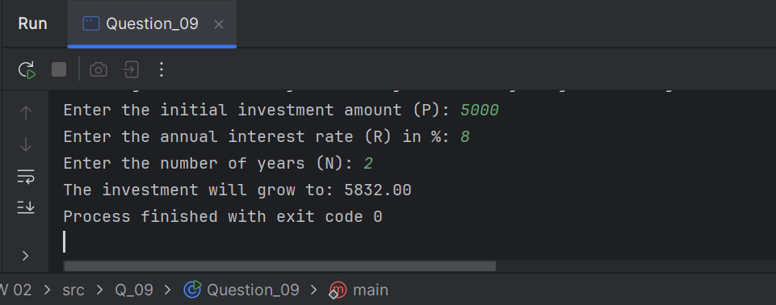

* Q_10

package Q_10;  
  
import java.util.Scanner;  
  
public class Question_10 {  
 public static void main(String[] args) {  
 int months_in_year=12;  
  
 Scanner scanner = new Scanner(System.*in*);  
  
 System.*out*.print("Loan amount: ");  
 double loan_amount=scanner.nextDouble();  
  
 System.*out*.print("annual interest rate: ");  
 double annual_interest_rate=scanner.nextDouble();  
  
 System.*out*.print("loan period: ");  
 double loan_period=scanner.nextDouble();  
  
 double monthly_interest_rate=annual_interest_rate/100.0/months_in_year;  
 double number_of_payments=loan_period*months_in_year;  
 double monthly_payment=(loan_amount*monthly_interest_rate)/(1-Math.*pow*(1/(1+monthly_interest_rate),number_of_payments));  
 double total_payment=monthly_payment*number_of_payments;  
  
 System.*out*.println("Monthly interest rate is :- " + monthly_interest_rate +"%");  
 System.*out*.println("Number of payments is :- " + number_of_payments );  
 System.*out*.println("Monthly Payment is :- " + monthly_payment +" rupees");  
 System.*out*.println("Total payment is :- " + total_payment +" rupees");  
 }  
}

