**Lab worksheet 3: Defining Classes**

**Q_01**

Code:

package Q_01;  
  
import java.util.Scanner;  
  
public class Temperature {  
 private double celsius;  
  
 // No-arg constructor  
 public Temperature() {  
 this.celsius = 0.0;  
 }  
  
 // Parameterized constructor  
 public Temperature(double celsius) {  
 this.celsius = celsius;  
 }  
  
 // Getter for Celsius  
 public double toCelsius() {  
 return celsius;  
 }  
  
 // Getter for Fahrenheit  
 public double toFahrenheit() {  
 return celsius * 9 / 5 + 32;  
 }  
  
 // Setter for Celsius  
 public void setCelsius(double celsius) {  
 this.celsius = celsius;  
 }  
  
 // Setter for Fahrenheit  
 public void setFahrenheit(double fahrenheit) {  
 this.celsius = (fahrenheit - 32) * 5 / 9;  
 }  
  
 public static void main(String[] args) {  
 Scanner scanner = new Scanner(System.*in*);  
  
 System.*out*.print("Enter temperature in Celsius: ");  
 double celsiusInput = scanner.nextDouble();  
  
 Temperature temp = new Temperature(celsiusInput);  
 System.*out*.printf("%.2f°C is equivalent to %.2f°F\n",  
 temp.toCelsius(), temp.toFahrenheit());  
  
 scanner.close();  
  
  
 }  
}

Output :

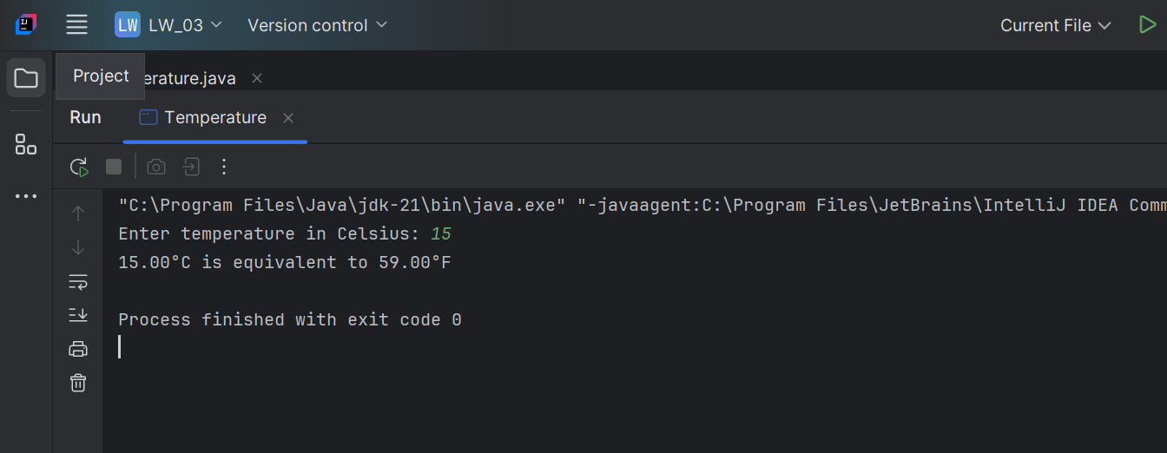

**Q_02**

Code:

package Q_02;  
  
import java.util.Scanner;  
import Q_01.Temperature ;  
  
  
public class Celsius {  
 public static void main(String[] args) {  
 Scanner scanner = new Scanner(System.*in*);  
  
 System.*out*.print("Enter Temperature in Fahrenheit: ");  
 double fahrenheit = scanner.nextDouble();  
  
 Temperature temp =new Temperature();  
 temp.setFahrenheit(fahrenheit);  
  
 System.*out*.printf("%.2f°F is equivalent to %.2f°C\n",fahrenheit,temp.toCelsius());  
 }  
  
}

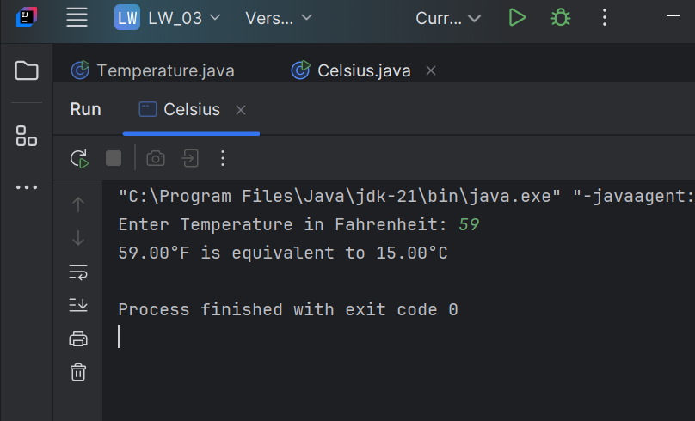

**Q_03**

Code:

package Q_03;  
  
import java.util.Scanner;  
  
public class Circle {  
 private double radius;  
  
 //No-arg constructor  
 public Circle(){  
 this.radius=0.0;  
 }  
 // Parameterized constructor  
 public Circle(double radius) {  
 this.radius = radius;  
 }  
  
 // Setter for radius  
 public void setRadius(double radius) {  
 this.radius = radius;  
 }  
  
 // Getter for radius  
 public double getRadius() {  
 return radius;  
 }  
  
 // Compute area  
 public double computeArea() {  
 return Math.*PI* * radius * radius;  
 }  
  
 // Compute circumference  
 public double computeCircumference() {  
 return 2 * Math.*PI* * radius;  
 }  
  
 public static void main(String[] args) {  
 Scanner scanner = new Scanner(System.*in*);  
  
 System.*out*.print("Enter inner radius (ri): ");  
 double ri = scanner.nextDouble();  
  
 System.*out*.print("Enter outer radius (ro): ");  
 double ro = scanner.nextDouble();  
  
 Circle innerCircle = new Circle(ri);  
 Circle outerCircle = new Circle(ro);  
  
 double shadedArea = outerCircle.computeArea() - innerCircle.computeArea();  
  
 System.*out*.printf("Area of the circular region: %.2f\n", shadedArea);  
  
 scanner.close();  
 }  
  
  
}

Output:

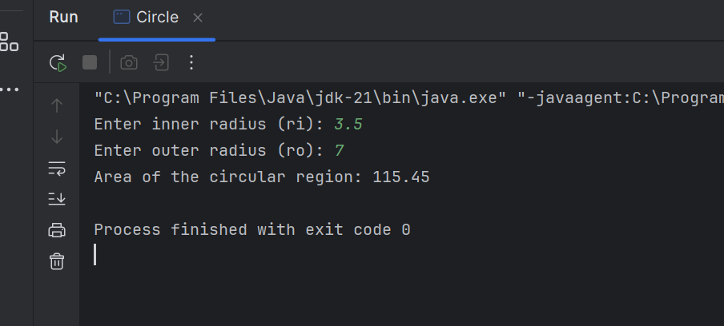

**Q_04**

Code:

package Q_04;  
  
class Owner {  
 private String ownerName;  
 private String phoneNo;  
  
 public Owner() {  
 this.ownerName = "Unknown";  
 this.phoneNo = "Unknown";  
 }  
  
 public Owner(String name, String num) {  
 this.ownerName = name;  
 this.phoneNo = num;  
 }  
  
 public String getOwnerName() {  
 return ownerName;  
 }  
  
 public void setOwnerName(String name) {  
 this.ownerName = name;  
 }  
  
 public String getPhoneNo() {  
 return phoneNo;  
 }  
  
 public void setPhoneNo(String num) {  
 this.phoneNo = num;  
 }  
}  
  
class Bicycle {  
 // Data Member  
 private Owner owner;  
  
 // Constructor: Initializes the data member  
 public Bicycle() {  
 owner = new Owner(); // Default Owner object  
 }  
  
 public Bicycle(Owner owner) {  
 this.owner = owner;  
 }  
  
 // Returns the Owner object  
 public Owner getOwner() {  
 return owner;  
 }  
 // Assigns the Owner object  
 public void setOwner(Owner owner) {  
 this.owner = owner;  
 }  
}  
  
public class BicycleOwner {  
 public static void main(String[] args) {  
 Owner owner_1 = new Owner("vidarshana", "0762244909");  
 Bicycle bike1 = new Bicycle(owner_1);  
  
 Owner owner_2 = new Owner();  
 owner_2.setOwnerName("Nimal");  
 owner_2.setPhoneNo("0784134943");  
 Bicycle bike2 = new Bicycle();  
 bike2.setOwner(owner_2);  
  
 System.*out*.println("Bike 1 Owner: " + bike1.getOwner().getOwnerName() + ", Phone: " + bike1.getOwner().getPhoneNo());  
 System.*out*.println("Bike 2 Owner: " + bike2.getOwner().getOwnerName() + ", Phone: " + bike2.getOwner().getPhoneNo());  
 }  
}

Output:

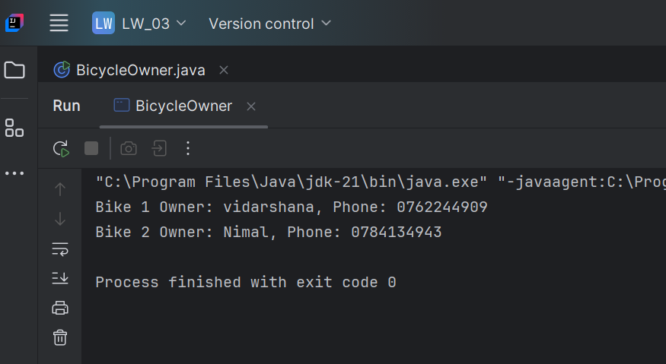

**Q_05**

Code:

* Course

package Q_05;  
  
  
class Course {  
 private String courseName;  
 private String courseCode;  
 private Lecturer lecturer; // Has-a relationship with Lecturer  
  
 // Default Constructor  
 public Course() {  
 this.courseName = "Unknown";  
 this.courseCode = "None";  
 this.lecturer = new Lecturer();  
 }  
  
 // Parameterized Constructor  
 public Course(String courseName, String courseCode, Lecturer lecturer) {  
 this.courseName = courseName;  
 this.courseCode = courseCode;  
 this.lecturer = lecturer;  
 }  
  
 // Getter and Setter for Course Name  
 public String getCourseName() {  
 return courseName;  
 }  
  
 public void setCourseName(String courseName) {  
 this.courseName = courseName;  
 }  
  
 // Getter and Setter for Course Code  
 public String getCourseCode() {  
 return courseCode;  
 }  
  
 public void setCourseCode(String courseCode) {  
 this.courseCode = courseCode;  
 }  
  
 // Getter and Setter for Lecturer  
 public Lecturer getLecturer() {  
 return lecturer;  
 }  
  
 public void setLecturer(Lecturer lecturer) {  
 this.lecturer = lecturer;  
 }  
  
  
 public void displayCourseInfo() {  
 System.*out*.println("Course Name: " + courseName);  
 System.*out*.println("Course Code: " + courseCode);  
 lecturer.displayLecturerInfo();  
 }  
}

* Lecturer

package Q_05;  
  
class Lecturer {  
 private String lecturerName;  
 private String courseTeaching;  
  
 // Constructor  
 public Lecturer() {  
 this.lecturerName = "Unknown";  
 this.courseTeaching = "None";  
 }  
  
 // Parameterized Constructor  
 public Lecturer(String lecturerName, String courseTeaching) {  
 this.lecturerName = lecturerName;  
 this.courseTeaching = courseTeaching;  
 }  
  
 // Getter and Setter for Lecturer Name  
 public String getLecturerName() {  
 return lecturerName;  
 }  
  
 public void setLecturerName(String lecturerName) {  
 this.lecturerName = lecturerName;  
 }  
  
 // Getter and Setter for Course Teaching  
 public String getCourseTeaching() {  
 return courseTeaching;  
 }  
  
 public void setCourseTeaching(String courseTeaching) {  
 this.courseTeaching = courseTeaching;  
 }  
  
  
 public void displayLecturerInfo() {  
 System.*out*.println("Lecturer Name: " + lecturerName);  
 System.*out*.println("Course Teaching: " + courseTeaching);  
 }  
}

* Student

package Q_05;  
  
class Student {  
 private String studentName;  
 private String degreeName;  
 private String courseFollowing;  
  
 // Default Constructor  
 public Student() {  
 this.studentName = "Unknown";  
 this.degreeName = "Unknown";  
 this.courseFollowing = "None";  
 }  
  
 // Parameterized Constructor  
 public Student(String studentName, String degreeName, String courseFollowing) {  
 this.studentName = studentName;  
 this.degreeName = degreeName;  
 this.courseFollowing = courseFollowing;  
 }  
  
 // Getter and Setter for Student Name  
 public String getStudentName() {  
 return studentName;  
 }  
  
 public void setStudentName(String studentName) {  
 this.studentName = studentName;  
 }  
  
 // Getter and Setter for Degree Name  
 public String getDegreeName() {  
 return degreeName;  
 }  
  
 public void setDegreeName(String degreeName) {  
 this.degreeName = degreeName;  
 }  
  
 // Getter and Setter for Course Following  
 public String getCourseFollowing() {  
 return courseFollowing;  
 }  
  
 public void setCourseFollowing(String courseFollowing) {  
 this.courseFollowing = courseFollowing;  
 }  
  
 // Display Student Info  
 public void displayStudentInfo() {  
 System.*out*.println("Student Name: " + studentName);  
 System.*out*.println("Degree Program: " + degreeName);  
 System.*out*.println("Enrolled Course: " + courseFollowing);  
 }  
}

* Main

package Q_05;  
  
import java.util.Scanner;  
  
public class Main {  
 public static void main(String[] args) {  
 Scanner scanner =new Scanner(System.*in*);  
  
 System.*out*.print("Enter Lecturer's Name: ");  
 String lecturerName = scanner.nextLine();  
 System.*out*.print("Enter Course Taught by Lecturer: ");  
 String lecturerCourse = scanner.nextLine();  
  
  
 Lecturer lecturer = new Lecturer(lecturerName, lecturerCourse);  
  
 // Get Course details  
 System.*out*.print("Enter Course Name: ");  
 String courseName = scanner.nextLine();  
 System.*out*.print("Enter Course Code: ");  
 String courseCode = scanner.nextLine();  
  
  
 Course course = new Course(courseName, courseCode, lecturer);  
  
  
 System.*out*.print("Enter Student's Name: ");  
 String studentName = scanner.nextLine();  
 System.*out*.print("Enter Student's Degree Name: ");  
 String degreeName = scanner.nextLine();  
  
 // Create Student object  
 Student student = new Student(studentName, degreeName, courseName);  
  
 // Display Information  
 System.*out*.println("\n ``` Course Information ```");  
 course.displayCourseInfo();  
  
 System.*out*.println("\n ``` Student Information ```");  
 student.displayStudentInfo();  
  
 scanner.close();  
  
 }  
}

Output:

