**Assignment 11.2**

Create table realEstate in Hive database

Load dataset into table realEstate.

step 1:

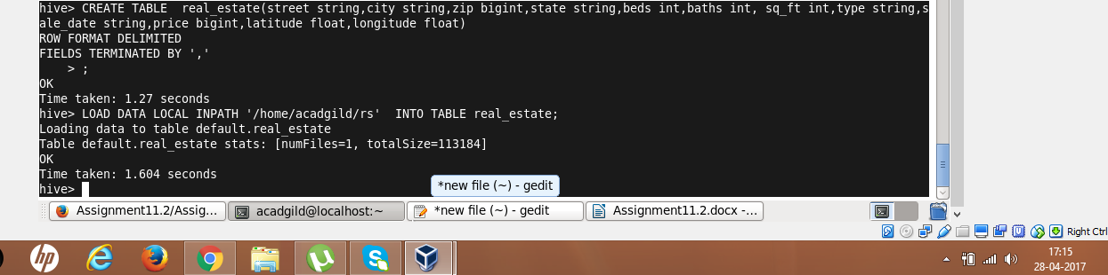

Step 2:

Using Dynamic partition give separate lists of residential apartments with more than 2 beds. Also include columns in following order City,Baths,Sq_feet,Price,flat_type,Beds respectively.

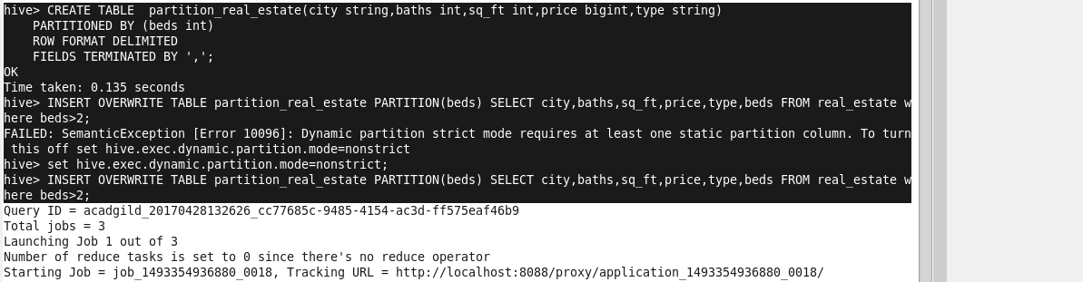

OUTPUT:

SELECT * FROM partition_real_estate;

