**Assignment 13.2**

load an input dataset from Pig to Hbase table and send the steps and screenshot of the final output

**creating hbase**

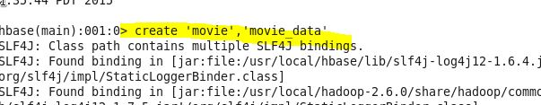

**input to load into pig relation**

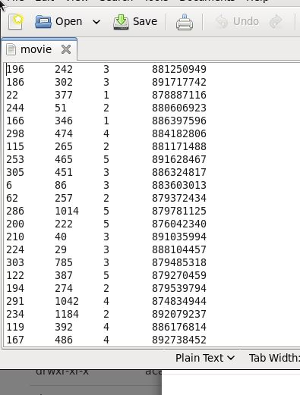

**pig command to load input**

**pig relation.JPG**

**load pig relation into Hbase**

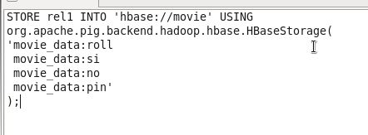

**output of hbase using scan command**

