**Government Polytechnic College Aurangabad**

**(**An Autonomous Institute of Technical Education)



“PERSUIT FOR EXCELLENCE”

JAVA PROJECT

**Java Editor**

Submitted By-

Vaishnavi Nighvekar (177043)

Ganesh Pandit (177045)

Aniket Yadav (177063)

Guided by-

Ingle Madam

DEPARTMENT OF INFORMATION TECHNOLOGY

ACADEMIC YEAR 2019-2020

**DEPARTMENT OF INFORMATION TECHNOLOGY**

**GOVERNMENT POLYTECHNIC, AURANGABAD**

**(An Autonomous Institute of Government of Maharashtra)**

**CERTIFICATE**

This is to certify that Miss**. VAISHNAVI NIGHVEKAR, GANESH PANDIT and** **ANIKET YADAV** has successfully completed java mini project titled “**Java Editor”** during the academic year 2019-2020, in partial fulfilment of Diplomain **Information Technology** of Government Polytechnic, Aurangabad. To the best of my knowledge and belief this seminar work has not been submitted elsewhere.

**Date : 18/5/2020**

**Prof. R. Ingle Prof. M. A. Dhaygude**

**Project Guide H.O.D, I. T**

**Prof. F. A. Khan**

**PRINCIPAL**

**ABSTRACT**

There are number of coding editors available in order to code in particular language and one of the most used programming languages is Java. So every time to use java, mostly we need to download and install another editor or IDE for that language. This seems tedious process and storage wasting of system. So we proposed an editor named "Java Editor" which will offer easy access to java language and will support many type of other functions and its very friendly to use and understand. The software specifically designed for Educational institutions where PC's seems to below ended that is having low RAM and disk space.

User will be able to create new file and saved with particular extension, and the program will run according to extension on single click. User will be able to import packages, methods and other basic syntax within the specific language just by clicking it from side panel. This Editor will be very helpful to write a particular program without any hesitation and will also be very helpful to every java programmer, because it will offer “one click run”, “one click copy” functions.

**INTRODUCTION**

The **Java Editor** is a type of very simple editor specially designed for java and is used in java console programing and normal java programs. The screen for java editor is divided into two parts 1) The plain TextArea where you can easily write programs and can also adjust its size by expanding the window size, the default font size of this text area is 10 and default font style is calibre. 2) The second part of the screes contains the tree, where all the regular functions, class, package, and other keyword are defined. You can easily just double click on the tree to copy the corresponding name of the tree to the text area.

All this type of functions of the editor will help the user to type the program conveniently and efficiently. Rather than this functioning there is a status bar and a menubar in the editor window which will help you in other options.

* Status Bar-

The status bar is a very important component of the window, it helps the user to understand the cursor’s position and the size of the window. When the user will resize the window the size in the bottom right corner will automatically change and it will show you the accurate size of the window with its height and width. At the left hand side there is a line and column label, this label will help to see the cursors current position. The label will change continuously on any keep pressed and then it will show you the accurate position of the cursor.

* Menu Bar-

This is a most important element of the editor window as it contains every functioning of the editor. The editor will help you and guide you to save, open, close, and to create new file for the editor. There is also a menu for Editing which contains the options such as cut, copy, paste and print the file. The next menu is format menu and this menu will help you so that you can adjust the font style and font size for your file. The last menu is Run which have two sub menu, they are **Run Java** and **Run appletviewer**. As there name suggest what this options actually do is to run the java program and the applet program separately.

**FEATURES**

**The Java Editor contains the following features:**

1. **Friendly GUI :-**

Rather than the other Editor that are very hard to understand and a bit of confusing, the java Editor is very easy to learn and it’s also very easy to use for a fresh user.

1. **Easy Working:-**

This Editor will help you to run the program easily and only in one click other changes in Editor are also very easy to implement.

1. **Click & Copy:-**

The click and copy function help the user to copy the multiple statements program in just 2 clicks. This will help the user to type the program without any efforts.

1. **Useful Tools:-**

The java Editor contains the status bar which will help the user to keep the track of his/her program, it is done by showing the line and columns number at the bottom.

1. **Tree View:-**

The Tree view will help the user to differentiate between the various function, packages and other conditional statements and between many keyword.

**ADVANTAGES AND DISADVANTAGES**

**Advantages:-**

* Provides “one click run” and “one click copy” functions.
* Provides easy way to run and type the program.
* Provides Format support with different font styles and sizes.
* Allow to use applet in your program.
* Tree structure will help to differentiate every class, packages, and many functions.

**Disadvantages:-**

* Unable to perform the programs for servlet and jsp.
* The limitation for the programs is only up to applet, AWT and swing.
* Lack to different frameworks such as “struds” and “spring”
* Unable to identify the shortcuts for the save and open.

**IMPLIMENTATION**

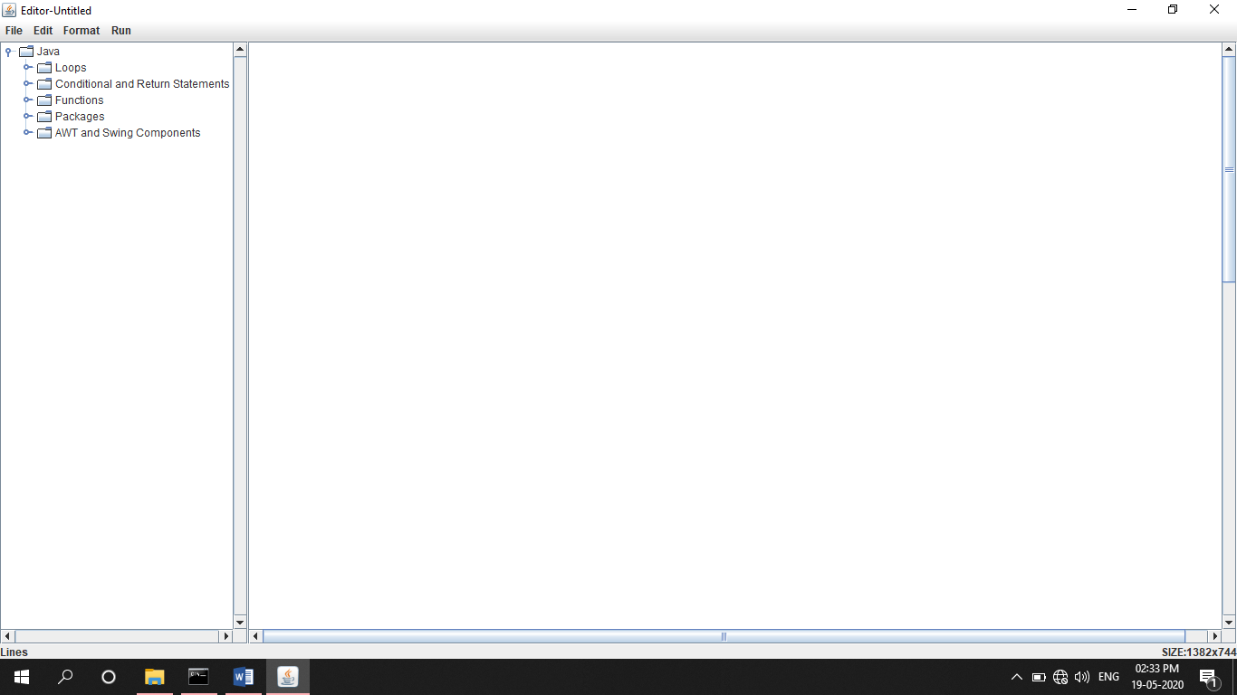 This phase will content the screen shorts for our projects and its working.

**Figure 1: Start Page**

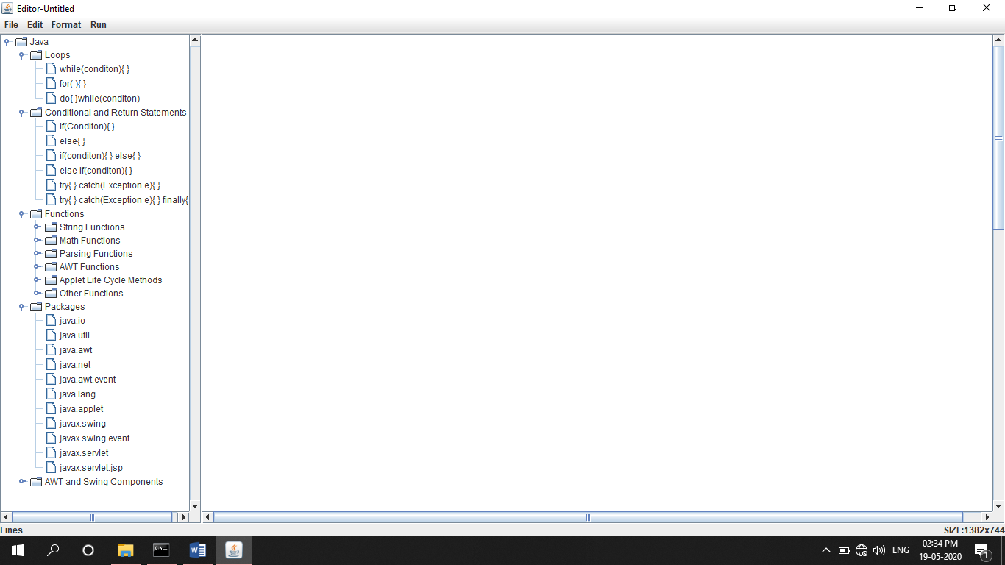

**Figure 2: Tree Structure**

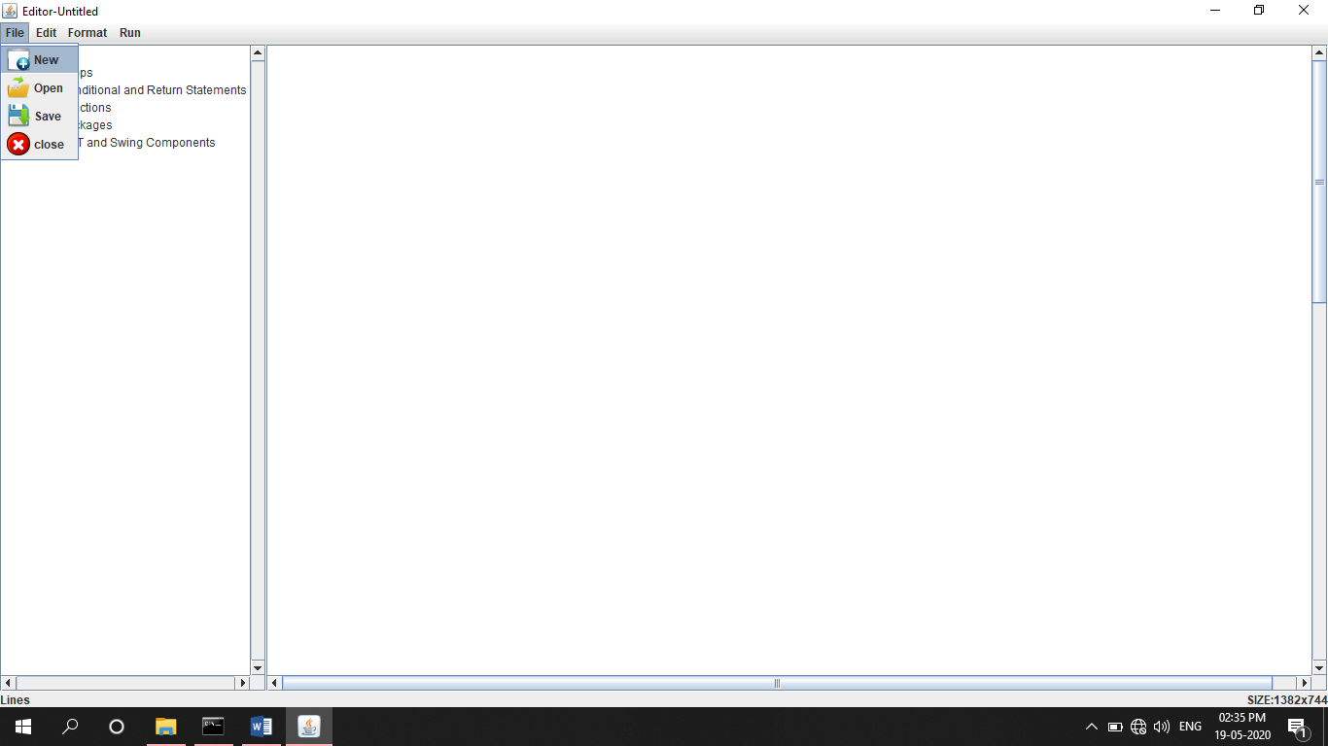

**Figure 3: File Menu**

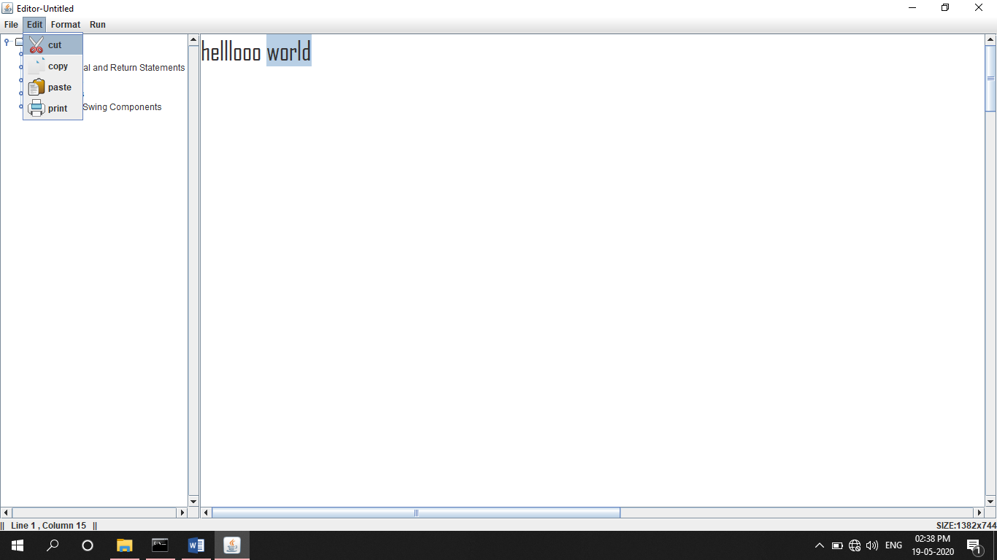

**Figure 4: Edit Menu**

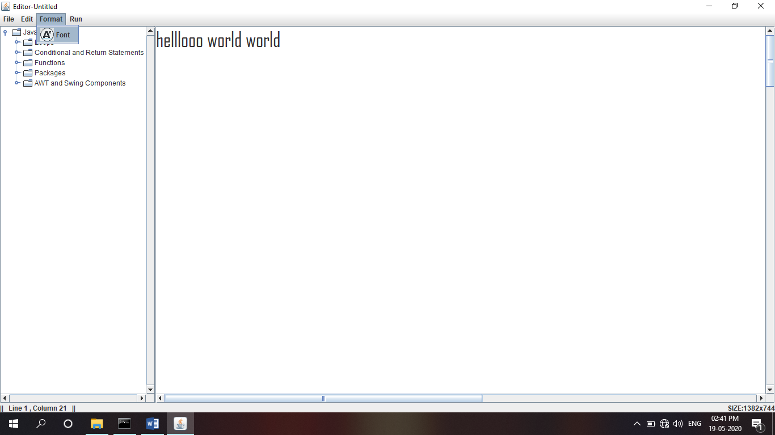

**Figure 5: Format Menu**

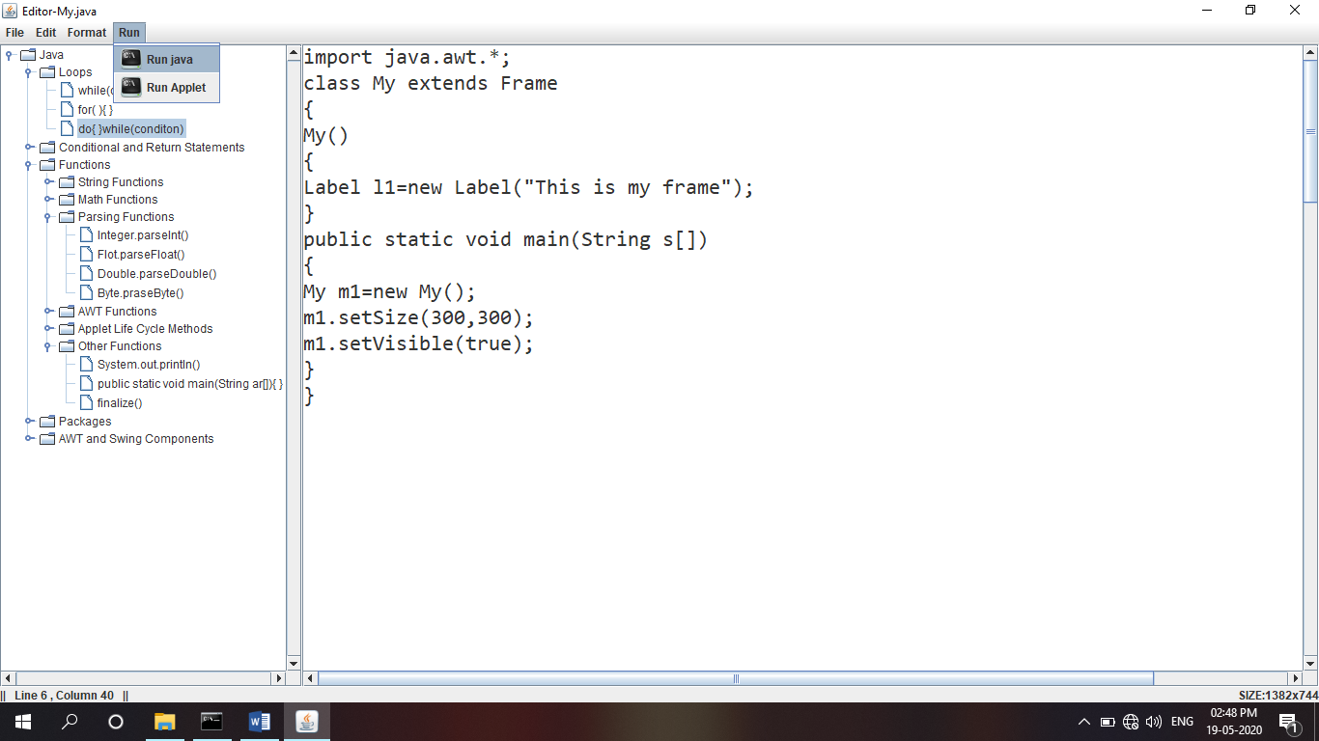

**Figure 6: Run Menu**

**CODE**

1. **Editor.java:-**

**import java.awt.*;**

**import javax.swing.*;**

**import javax.swing.event.*;**

**import java.io.*;**

**import java.awt.event.*;**

**import javax.swing.plaf.metal.*;**

**import javax.swing.text.*;**

**import javax.swing.tree.*;**

**class Editor extends JFrame implements ActionListener {**

**JTextArea t;**

**JFrame f;**

**String name,path;**

**Font m_font;**

**String nodename;**

**Editor()**

**{**

**nodename="";**

**f = new JFrame("Editor-Untitled");**

**f.setLayout(new BorderLayout());**

**f.setDefaultCloseOperation(JFrame.EXIT_ON_CLOSE);**

**try {**

**// Set metl look and feel**

**UIManager.setLookAndFeel("javax.swing.plaf.metal.MetalLookAndFeel");**

**// Set theme to ocean**

**MetalLookAndFeel.setCurrentTheme(new OceanTheme());**

**}**

**catch (Exception e) {**

**}**

**t = new JTextArea(100,100);**

**JScrollPane scroll=new JScrollPane(t);**

**scroll.setVerticalScrollBarPolicy(JScrollPane.VERTICAL_SCROLLBAR_ALWAYS);**

**scroll.setHorizontalScrollBarPolicy(JScrollPane.HORIZONTAL_SCROLLBAR_ALWAYS);**

**JPanel statusBar = new JPanel(new BorderLayout());**

**JLabel lines=new JLabel("Lines");**

**final JLabel status = new JLabel("Statusbar");**

**statusBar.add(status,BorderLayout.EAST);**

**statusBar.add(lines,BorderLayout.WEST);**

**JMenuBar mb = new JMenuBar();**

**JMenu m1 = new JMenu("File");**

**JMenuItem mi1 = new JMenuItem("New",new ImageIcon("F:\\study\\java project\\img\\new.png"));**

**JMenuItem mi2 = new JMenuItem("Open",new ImageIcon("F:\\study\\java project\\img\\Open.png"));**

**JMenuItem mi3 = new JMenuItem("Save",new ImageIcon("F:\\study\\java project\\img\\Save.png"));**

**JMenuItem mi9 = new JMenuItem("close",new ImageIcon("F:\\study\\java project\\img\\close.png"));**

**mi1.addActionListener(this);**

**mi2.addActionListener(this);**

**mi3.addActionListener(this);**

**mi9.addActionListener(this);**

**m1.add(mi1);**

**m1.add(mi2);**

**m1.add(mi3);**

**m1.add(mi9);**

**JMenu m2 = new JMenu("Edit");**

**JMenuItem mi4 = new JMenuItem("cut",new ImageIcon("F:\\study\\java project\\img\\Cut.png"));**

**JMenuItem mi5 = new JMenuItem("copy",new ImageIcon("F:\\study\\java project\\img\\Copy.png"));**

**JMenuItem mi6 = new JMenuItem("paste",new ImageIcon("F:\\study\\java project\\img\\Paste.png"));**

**JMenuItem mi7 = new JMenuItem("print",new ImageIcon("F:\\study\\java project\\img\\Print.png"));**

**mi4.addActionListener(this);**

**mi5.addActionListener(this);**

**mi6.addActionListener(this);**

**mi7.addActionListener(this);**

**m2.add(mi4);**

**m2.add(mi5);**

**m2.add(mi6);**

**m2.add(mi7);**

**JMenu m3 = new JMenu("Format");**

**JMenuItem mi8 = new JMenuItem("Font",new ImageIcon("F:\\study\\java project\\img\\fonttt.png"));**

**mi8.addActionListener(this);**

**m3.add(mi8);**

**JMenuItem mc = new JMenuItem("close");**

**JMenu mr = new JMenu("Run");**

**JMenuItem mir = new JMenuItem("Run java",new ImageIcon("F:\\study\\java project\\img\\Run.png"));**

**JMenuItem mirr = new JMenuItem("Run Applet",new ImageIcon("F:\\study\\java project\\img\\Run.png"));**

**mr.add(mir);**

**mr.add(mirr);**

**mc.addActionListener(this);**

**mir.addActionListener(this);**

**mirr.addActionListener(this);**

**mb.add(m1);**

**mb.add(m2);**

**mb.add(m3);**

**mb.add(mr);**

**DefaultMutableTreeNode node1=new DefaultMutableTreeNode ("Java");**

**DefaultMutableTreeNode inner1=new DefaultMutableTreeNode("Loops");**

**DefaultMutableTreeNode inneri1=new DefaultMutableTreeNode("while(conditon){\n\n }");**

**DefaultMutableTreeNode inneri2=new DefaultMutableTreeNode("for( ){\n\n }");**

**DefaultMutableTreeNode inneri3=new DefaultMutableTreeNode("do{\n\n }\nwhile(conditon)");**

**DefaultMutableTreeNode inner2=new DefaultMutableTreeNode("Conditional and Return Statements");**

**DefaultMutableTreeNode inneri4=new DefaultMutableTreeNode("if(Conditon){\n\n }");**

**DefaultMutableTreeNode inneri5=new DefaultMutableTreeNode("else{\n\n }");**

**DefaultMutableTreeNode inneri6=new DefaultMutableTreeNode("if(conditon){\n\n }\n else{\n\n }");**

**DefaultMutableTreeNode inneri7=new DefaultMutableTreeNode("else if(conditon){\n\n }");**

**DefaultMutableTreeNode in1=new DefaultMutableTreeNode("try{\n\n }\n catch(Exception e){\n\n }");**

**DefaultMutableTreeNode in2=new DefaultMutableTreeNode("try{\n\n }\n catch(Exception e){\n\n }\n finally{\n\n }");**

**DefaultMutableTreeNode inner3=new DefaultMutableTreeNode("Functions");**

**DefaultMutableTreeNode innerinner1=new DefaultMutableTreeNode("String Functions");**

**DefaultMutableTreeNode in3=new DefaultMutableTreeNode("compareTo()");**

**DefaultMutableTreeNode in4=new DefaultMutableTreeNode("equals()");**

**DefaultMutableTreeNode in5=new DefaultMutableTreeNode("valueOf()");**

**DefaultMutableTreeNode in6=new DefaultMutableTreeNode("substring()");**

**DefaultMutableTreeNode in7=new DefaultMutableTreeNode("replace()");**

**DefaultMutableTreeNode in8=new DefaultMutableTreeNode("toString()");**

**DefaultMutableTreeNode in9=new DefaultMutableTreeNode("charAt()");**

**DefaultMutableTreeNode in10=new DefaultMutableTreeNode("concat()");**

**DefaultMutableTreeNode in11=new DefaultMutableTreeNode("endsWith()");**

**DefaultMutableTreeNode in12=new DefaultMutableTreeNode("lastIndexOf()");**

**DefaultMutableTreeNode in13=new DefaultMutableTreeNode("firstIndexOf()");**

**DefaultMutableTreeNode in14=new DefaultMutableTreeNode("getChars()");**

**DefaultMutableTreeNode in15=new DefaultMutableTreeNode("getBytes()");**

**DefaultMutableTreeNode in16=new DefaultMutableTreeNode("indexOf()");**

**DefaultMutableTreeNode in17=new DefaultMutableTreeNode("length()");**

**DefaultMutableTreeNode in18=new DefaultMutableTreeNode("split()");**

**DefaultMutableTreeNode in19=new DefaultMutableTreeNode("startsWith()");**

**DefaultMutableTreeNode in20=new DefaultMutableTreeNode("toLowerCase()");**

**DefaultMutableTreeNode in21=new DefaultMutableTreeNode("toUpperCase()");**

**DefaultMutableTreeNode innerinner2=new DefaultMutableTreeNode("Math Functions");**

**DefaultMutableTreeNode in22=new DefaultMutableTreeNode("pow()");**

**DefaultMutableTreeNode in23=new DefaultMutableTreeNode("sqrt()");**

**DefaultMutableTreeNode in24=new DefaultMutableTreeNode("abs()");**

**DefaultMutableTreeNode in25=new DefaultMutableTreeNode("ceil()");**

**DefaultMutableTreeNode in26=new DefaultMutableTreeNode("floor()");**

**DefaultMutableTreeNode in27=new DefaultMutableTreeNode("floorDiv()");**

**DefaultMutableTreeNode in28=new DefaultMutableTreeNode("min()");**

**DefaultMutableTreeNode in29=new DefaultMutableTreeNode("max()");**

**DefaultMutableTreeNode in30=new DefaultMutableTreeNode("round()");**

**DefaultMutableTreeNode in31=new DefaultMutableTreeNode("random()");**

**DefaultMutableTreeNode innerinner3=new DefaultMutableTreeNode("Parsing Functions");**

**DefaultMutableTreeNode in32=new DefaultMutableTreeNode("Integer.parseInt()");**

**DefaultMutableTreeNode in33=new DefaultMutableTreeNode("Flot.parseFloat()");**

**DefaultMutableTreeNode in34=new DefaultMutableTreeNode("Double.parseDouble()");**

**DefaultMutableTreeNode in35=new DefaultMutableTreeNode("Byte.praseByte()");**

**DefaultMutableTreeNode innerinner4=new DefaultMutableTreeNode("AWT Functions");**

**DefaultMutableTreeNode in36=new DefaultMutableTreeNode("setSize()");**

**DefaultMutableTreeNode in37=new DefaultMutableTreeNode("setVisible()");**

**DefaultMutableTreeNode in38=new DefaultMutableTreeNode("setTitle()");**

**DefaultMutableTreeNode in39=new DefaultMutableTreeNode("setText()()");**

**DefaultMutableTreeNode in40=new DefaultMutableTreeNode("getText()");**

**DefaultMutableTreeNode in41=new DefaultMutableTreeNode("setAlignment()");**

**DefaultMutableTreeNode in42=new DefaultMutableTreeNode("getAlignment()");**

**DefaultMutableTreeNode in43=new DefaultMutableTreeNode("setLabel()");**

**DefaultMutableTreeNode in44=new DefaultMutableTreeNode("getLabel()");**

**DefaultMutableTreeNode in45=new DefaultMutableTreeNode("setState()");**

**DefaultMutableTreeNode in46=new DefaultMutableTreeNode("getState()");**

**DefaultMutableTreeNode in47=new DefaultMutableTreeNode("getSelectedCheckBox()");**

**DefaultMutableTreeNode in48=new DefaultMutableTreeNode("setSelectedCheckBox()");**

**DefaultMutableTreeNode in49=new DefaultMutableTreeNode("add()");**

**DefaultMutableTreeNode in50=new DefaultMutableTreeNode("getSelectedItem()");**

**DefaultMutableTreeNode in51=new DefaultMutableTreeNode("getSelectedItems()");**

**DefaultMutableTreeNode in52=new DefaultMutableTreeNode("select()");**

**DefaultMutableTreeNode in53=new DefaultMutableTreeNode("getItemCount()");**

**DefaultMutableTreeNode in54=new DefaultMutableTreeNode("getItem()");**

**DefaultMutableTreeNode in55=new DefaultMutableTreeNode("getSelectedText()");**

**DefaultMutableTreeNode in56=new DefaultMutableTreeNode("isEditable");**

**DefaultMutableTreeNode in57=new DefaultMutableTreeNode("apped()");**

**DefaultMutableTreeNode in58=new DefaultMutableTreeNode("insert()");**

**DefaultMutableTreeNode in59=new DefaultMutableTreeNode("getEchoChar()");**

**DefaultMutableTreeNode in60=new DefaultMutableTreeNode("setEchoChar()");**

**DefaultMutableTreeNode in61=new DefaultMutableTreeNode("replaceRange()");**

**DefaultMutableTreeNode innerinner5=new DefaultMutableTreeNode("Applet Life Cycle Methods");**

**DefaultMutableTreeNode app1=new DefaultMutableTreeNode("public void init()\n{\n\n}");**

**DefaultMutableTreeNode app2=new DefaultMutableTreeNode("public void start()\n{\n\n}");**

**DefaultMutableTreeNode app3=new DefaultMutableTreeNode("public void paint()\n{\n\n}");**

**DefaultMutableTreeNode app4=new DefaultMutableTreeNode("public void stop()\n{\n\n}");**

**DefaultMutableTreeNode app5=new DefaultMutableTreeNode("public void destroy()\n{\n\n}");**

**DefaultMutableTreeNode app6=new DefaultMutableTreeNode("repaint()");**

**DefaultMutableTreeNode innerinner6=new DefaultMutableTreeNode("Other Functions");**

**DefaultMutableTreeNode inneri8=new DefaultMutableTreeNode("System.out.println()");**

**DefaultMutableTreeNode inneri9=new DefaultMutableTreeNode("public static void main(String ar[]){\n\n }");**

**DefaultMutableTreeNode in62=new DefaultMutableTreeNode("finalize()");**

**DefaultMutableTreeNode inner4=new DefaultMutableTreeNode("Packages");**

**DefaultMutableTreeNode inneri10=new DefaultMutableTreeNode("java.io");**

**DefaultMutableTreeNode inneri11=new DefaultMutableTreeNode("java.util");**

**DefaultMutableTreeNode inneri12=new DefaultMutableTreeNode("java.awt");**

**DefaultMutableTreeNode inneri13=new DefaultMutableTreeNode("java.net");**

**DefaultMutableTreeNode inneri14=new DefaultMutableTreeNode("java.awt.event");**

**DefaultMutableTreeNode in63=new DefaultMutableTreeNode("java.lang");**

**DefaultMutableTreeNode in64=new DefaultMutableTreeNode("java.applet");**

**DefaultMutableTreeNode inneri15=new DefaultMutableTreeNode("javax.swing");**

**DefaultMutableTreeNode in65=new DefaultMutableTreeNode("javax.swing.event");**

**DefaultMutableTreeNode in66=new DefaultMutableTreeNode("javax.servlet");**

**DefaultMutableTreeNode in67=new DefaultMutableTreeNode("javax.servlet.jsp");**

**DefaultMutableTreeNode inner6=new DefaultMutableTreeNode("AWT and Swing Components");**

**DefaultMutableTreeNode inneri17=new DefaultMutableTreeNode("Label");**

**DefaultMutableTreeNode inneri18=new DefaultMutableTreeNode("Button");**

**DefaultMutableTreeNode inneri19=new DefaultMutableTreeNode("Choice");**

**DefaultMutableTreeNode inneri21=new DefaultMutableTreeNode("TextField");**

**DefaultMutableTreeNode inneri22=new DefaultMutableTreeNode("TextArea");**

**DefaultMutableTreeNode inneri23=new DefaultMutableTreeNode("Checkbox");**

**DefaultMutableTreeNode in68=new DefaultMutableTreeNode("CheckBoxGroup");**

**DefaultMutableTreeNode in69=new DefaultMutableTreeNode("List");**

**DefaultMutableTreeNode innerii25=new DefaultMutableTreeNode("MenuBar");**

**DefaultMutableTreeNode innerii26=new DefaultMutableTreeNode("Menu");**

**DefaultMutableTreeNode innerii27=new DefaultMutableTreeNode("MenuItem");**

**DefaultMutableTreeNode in70=new DefaultMutableTreeNode("JLabel");**

**DefaultMutableTreeNode in71=new DefaultMutableTreeNode("JButton");**

**DefaultMutableTreeNode in72=new DefaultMutableTreeNode("JTextField");**

**DefaultMutableTreeNode in73=new DefaultMutableTreeNode("JTextArea");**

**DefaultMutableTreeNode in74=new DefaultMutableTreeNode("JComboBox");**

**DefaultMutableTreeNode in75=new DefaultMutableTreeNode("JCheckBox");**

**DefaultMutableTreeNode in76=new DefaultMutableTreeNode("jRadioButton");**

**DefaultMutableTreeNode in77=new DefaultMutableTreeNode("JTree");**

**DefaultMutableTreeNode in78=new DefaultMutableTreeNode("JPasswordField");**

**DefaultMutableTreeNode in79=new DefaultMutableTreeNode("JMenuBar");**

**DefaultMutableTreeNode in80=new DefaultMutableTreeNode("JMenu");**

**DefaultMutableTreeNode in81=new DefaultMutableTreeNode("JMenuItem");**

**node1.add(inner1);**

**inner1.add(inneri1);**

**inner1.add(inneri2);**

**inner1.add(inneri3);**

**node1.add(inner2);**

**inner2.add(inneri4);**

**inner2.add(inneri5);**

**inner2.add(inneri6);**

**inner2.add(inneri7);**

**inner2.add(in1);**

**inner2.add(in2);**

**node1.add(inner3);**

**inner3.add(innerinner1);**

**innerinner1.add(in3);**

**innerinner1.add(in4);**

**innerinner1.add(in5);**

**innerinner1.add(in6);**

**innerinner1.add(in7);**

**innerinner1.add(in8);**

**innerinner1.add(in9);**

**innerinner1.add(in10);**

**innerinner1.add(in11);**

**innerinner1.add(in12);**

**innerinner1.add(in13);**

**innerinner1.add(in14);**

**innerinner1.add(in15);**

**innerinner1.add(in16);**

**innerinner1.add(in17);**

**innerinner1.add(in18);**

**innerinner1.add(in19);**

**innerinner1.add(in20);**

**innerinner1.add(in21);**

**inner3.add(innerinner2);**

**innerinner2.add(in22);**

**innerinner2.add(in23);**

**innerinner2.add(in24);**

**innerinner2.add(in25);**

**innerinner2.add(in26);**

**innerinner2.add(in27);**

**innerinner2.add(in28);**

**innerinner2.add(in29);**

**innerinner2.add(in30);**

**innerinner2.add(in31);**

**inner3.add(innerinner3);**

**innerinner3.add(in32);**

**innerinner3.add(in33);**

**innerinner3.add(in34);**

**innerinner3.add(in35);**

**inner3.add(innerinner4);**

**innerinner4.add(in36);**

**innerinner4.add(in37);**

**innerinner4.add(in38);**

**innerinner4.add(in39);**

**innerinner4.add(in40);**

**innerinner4.add(in41);**

**innerinner4.add(in42);**

**innerinner4.add(in43);**

**innerinner4.add(in44);**

**innerinner4.add(in45);**

**innerinner4.add(in46);**

**innerinner4.add(in47);**

**innerinner4.add(in48);**

**innerinner4.add(in49);**

**innerinner4.add(in50);**

**innerinner4.add(in51);**

**innerinner4.add(in52);**

**innerinner4.add(in53);**

**innerinner4.add(in54);**

**innerinner4.add(in55);**

**innerinner4.add(in56);**

**innerinner4.add(in57);**

**innerinner4.add(in58);**

**innerinner4.add(in59);**

**innerinner4.add(in60);**

**innerinner4.add(in61);**

**inner3.add(innerinner5);**

**innerinner5.add(app1);**

**innerinner5.add(app2);**

**innerinner5.add(app3);**

**innerinner5.add(app4);**

**innerinner5.add(app5);**

**innerinner5.add(app6);**

**inner3.add(innerinner6);**

**innerinner6.add(inneri8);**

**innerinner6.add(inneri9);**

**innerinner6.add(in62);**

**node1.add(inner4);**

**inner4.add(inneri10);**

**inner4.add(inneri11);**

**inner4.add(inneri12);**

**inner4.add(inneri13);**

**inner4.add(inneri14);**

**inner4.add(in63);**

**inner4.add(in64);**

**inner4.add(inneri15);**

**inner4.add(in65);**

**inner4.add(in66);**

**inner4.add(in67);**

**node1.add(inner6);**

**inner6.add(inneri18);**

**inner6.add(inneri19);**

**inner6.add(inneri21);**

**inner6.add(inneri22);**

**inner6.add(inneri23);**

**inner6.add(in68);**

**inner6.add(in69);**

**inner6.add(innerii25);**

**inner6.add(innerii26);**

**inner6.add(innerii27);**

**inner6.add(in70);**

**inner6.add(in71);**

**inner6.add(in72);**

**inner6.add(in73);**

**inner6.add(in74);**

**inner6.add(in75);**

**inner6.add(in76);**

**inner6.add(in77);**

**inner6.add(in78);**

**inner6.add(in79);**

**inner6.add(in80);**

**inner6.add(in81);**

**JTree jt=new JTree(node1);**

**jt.setShowsRootHandles(true);**

**JScrollPane scroll1=new JScrollPane(jt);**

**scroll1.setVerticalScrollBarPolicy(JScrollPane.VERTICAL_SCROLLBAR_ALWAYS);**

**scroll1.setHorizontalScrollBarPolicy(JScrollPane.HORIZONTAL_SCROLLBAR_ALWAYS);**

**f.add(scroll1,BorderLayout.WEST);**

**jt.getSelectionModel().addTreeSelectionListener(new TreeSelectionListener(){**

**public void valueChanged(TreeSelectionEvent e){**

**DefaultMutableTreeNode selectedNode=(DefaultMutableTreeNode) jt.getLastSelectedPathComponent();**

**try{**

**nodename=selectedNode.getUserObject().toString();**

**}**

**catch(Exception ee)**

**{**

**}**

**if(nodename=="Java"||nodename=="Loops"||nodename=="Conditional and Return Statements"||nodename=="Functions"||nodename=="Packages"||**

**nodename=="AWT and Swing Components"||nodename=="String Functions"||nodename=="Math Functions"||nodename=="Parsing Functions"||**

**nodename=="AWT Functions"||nodename=="Applet Life Cycle Methods"||nodename=="Other Functions"){}**

**else{**

**t.insert(nodename,t.getCaretPosition());**

**}**

**}**

**});**

**f.setJMenuBar(mb);**

**f.add(scroll,BorderLayout.CENTER);**

**f.add(statusBar, BorderLayout.SOUTH);**

**f.setSize(1000, 600);**

**f.show();**

**f.addComponentListener(new ComponentAdapter() {**

**public void componentResized(ComponentEvent e) {**

**status.setText("SIZE:"+f.getWidth() + "x" + f.getHeight());**

**}**

**});**

**t.addKeyListener(new KeyAdapter(){**

**public void keyReleased(KeyEvent e){**

**int lineNumber=0, column=0, pos=0;**

**try**

**{**

**pos=t.getCaretPosition();**

**lineNumber=t.getLineOfOffset(pos);**

**column=pos-t.getLineStartOffset(lineNumber);**

**}catch(Exception excp){}**

**if(t.getText().length()==0){lineNumber=0; column=0;}**

**lines.setText("|| Line "+(lineNumber+1)+" , Column "+(column+1)+" ||");**

**}**

**});**

**}**

**public void actionPerformed(ActionEvent e)**

**{**

**String s = e.getActionCommand();**

**if (s.equals("cut")) {**

**t.cut();**

**}**

**else if (s.equals("copy")) {**

**t.copy();**

**}**

**else if (s.equals("paste")) {**

**t.paste();**

**}**

**else if (s.equals("Save")) {**

**int r=0;**

**File fi=null;**

**JFileChooser j = new JFileChooser("f:");**

**if(name==null){**

**r = j.showSaveDialog(null);**

**}**

**if (r == JFileChooser.APPROVE_OPTION) {**

**if(name==null){**

**fi = new File(j.getSelectedFile().getAbsolutePath());**

**name=fi.getName();**

**f.setTitle("Editor-"+name);**

**path=j.getSelectedFile().getAbsolutePath();**

**}**

**else{**

**fi=new File(path);**

**}**

**try {**

**FileWriter wr = new FileWriter(fi, false);**

**BufferedWriter w = new BufferedWriter(wr);**

**w.write(t.getText());**

**w.flush();**

**w.close();**

**JOptionPane.showMessageDialog(f, "File Saved");**

**}**

**catch (Exception evt) {**

**JOptionPane.showMessageDialog(f, evt.getMessage());**

**}**

**}**

**else**

**JOptionPane.showMessageDialog(f, "the user cancelled the operation");**

**}**

**else if (s.equals("print")) {**

**try {**

**t.print();**

**}**

**catch (Exception evt) {**

**JOptionPane.showMessageDialog(f, evt.getMessage());**

**}**

**}**

**else if (s.equals("Open")) {**

**JFileChooser j = new JFileChooser("f:");**

**int r = j.showOpenDialog(null);**

**if (r == JFileChooser.APPROVE_OPTION) {**

**File fi = new File(j.getSelectedFile().getAbsolutePath());**

**name=fi.getName();**

**f.setTitle("Editor-"+name);**

**path=j.getSelectedFile().getAbsolutePath();**

**try {**

**String s1 = "", sl = "";**

**FileReader fr = new FileReader(fi);**

**BufferedReader br = new BufferedReader(fr);**

**sl = br.readLine();**

**while ((s1 = br.readLine()) != null) {**

**sl = sl + "\n" + s1;**

**}**

**t.setText(sl);**

**}**

**catch (Exception evt) {**

**JOptionPane.showMessageDialog(f, evt.getMessage());**

**}**

**}**

**else**

**JOptionPane.showMessageDialog(f, "the user cancelled the operation");**

**}**

**else if (s.equals("New")) {**

**t.setText("");**

**name=null;**

**f.setTitle("Editor-Untitled");**

**}**

**else if (s.equals("close")) {**

**f.setVisible(false);**

**}**

**else if(s.equals("Font")){**

**m_font= FontChooser.showDialog(this, "Select font");**

**t.setFont(m_font);**

**}**

**else if (s.equals("Run java")) {**

**File ff=new File("C:\\Users\\admin\\fille.bat");**

**try{**

**String s1 = "", sl = "",temp1,temp2;**

**int flag=1;**

**FileReader fr = new FileReader(ff);**

**BufferedReader br = new BufferedReader(fr);**

**sl = br.readLine();**

**temp1=sl.substring(0,1);**

**temp2=path.substring(0,1);**

**sl=sl.replace(temp1,temp2);**

**while ((s1 = br.readLine()) != null) {**

**if(flag==1){**

**temp1=s1.substring(3,s1.lastIndexOf("\\"));**

**temp2=path.substring(0,path.lastIndexOf("\\"));**

**s1=s1.replace(temp1,temp2);**

**}**

**if(flag==2){**

**temp1=s1.substring(6,s1.lastIndexOf("."));**

**s1=s1.replace(temp1+".java",name);**

**}**

**if(flag==3){**

**s1=s1.replace(temp1,name.substring(0,name.lastIndexOf(".")));**

**}**

**sl = sl + "\n" + s1;**

**flag++;**

**}**

**br.close();**

**FileWriter wr = new FileWriter(ff, false);**

**BufferedWriter w = new BufferedWriter(wr);**

**w.write(sl);**

**w.flush();**

**w.close();**

**Desktop.getDesktop().open(ff);**

**}**

**catch(Exception evt){**

**JOptionPane.showMessageDialog(f, "Please Select a File First");**

**}**

**}**

**else if (s.equals("Run Applet")) {**

**File ff=new File("C:\\Users\\admin\\fille2.bat");**

**try{**

**String s1 = "", sl = "",temp1,temp2;**

**int flag=1;**

**FileReader fr = new FileReader(ff);**

**BufferedReader br = new BufferedReader(fr);**

**sl = br.readLine();**

**temp1=sl.substring(0,1);**

**temp2=path.substring(0,1);**

**sl=sl.replace(temp1,temp2);**

**while ((s1 = br.readLine()) != null) {**

**if(flag==1){**

**temp1=s1.substring(3,s1.lastIndexOf("\\"));**

**temp2=path.substring(0,path.lastIndexOf("\\"));**

**s1=s1.replace(temp1,temp2);**

**}**

**if(flag==2){**

**temp1=s1.substring(6,s1.lastIndexOf("."));**

**s1=s1.replace(temp1+".java",name);**

**}**

**if(flag==3){**

**s1=s1.replace(temp1+".java",name);**

**}**

**sl = sl + "\n" + s1;**

**flag++;**

**}**

**br.close();**

**FileWriter wr = new FileWriter(ff, false);**

**BufferedWriter w = new BufferedWriter(wr);**

**w.write(sl);**

**w.flush();**

**w.close();**

**Desktop.getDesktop().open(ff);**

**}**

**catch(Exception evt){**

**JOptionPane.showMessageDialog(f, "Please Select a File First");**

**}**

**}**

**}**

**public static void main(String args[])**

**{**

**Editor e = new Editor();**

**}**

**}**

**class FontChooser extends JComponent**

**{**

**public static Font showDialog(Component parent, String title)**

**{**

**final FontChooser pane = new FontChooser();**

**FontTracker ok = new FontTracker(pane);**

**JDialog dialog =**

**createDialog(parent, title, true,**

**pane, ok, null**

**);**

**dialog.setVisible(true);**

**dialog.addWindowListener(**

**new FontChooserDialog.Closer());**

**dialog.addComponentListener(**

**new FontChooserDialog.DisposeOnClose());**

**return ok.getSelectedFont();**

**}**

**public static JDialog createDialog(**

**Component parent, String title,**

**boolean modal,**

**FontChooser chooserPane,**

**ActionListener okListener,**

**ActionListener cancelListener)**

**{**

**return new FontChooserDialog(**

**parent, title, modal, chooserPane,**

**okListener, cancelListener);**

**}**

**public FontChooser()**

**{**

**setLayout(new BorderLayout());**

**PreviewPanel previewPane = new PreviewPanel();**

**m_inputPane = new InputPanel(previewPane);**

**add(m_inputPane, BorderLayout.CENTER);**

**add(previewPane, BorderLayout.SOUTH);**

**}**

**public Font getSelectedFont()**

**{**

**return m_inputPane.getSelectedFont();**

**}**

**private InputPanel m_inputPane;**

**class InputPanel extends JPanel**

**{**

**public InputPanel(ListSelectionListener listener)**

**{**

**setLayout(new BorderLayout());**

**Box nameBox = Box.createVerticalBox();**

**nameBox.add(Box.createVerticalStrut(10));**

**JLabel fontNameLabel = new JLabel("Font Name:");**

**nameBox.add(fontNameLabel);**

**if (listener != null)**

**{**

**m_fontNameList.addListSelectionListener(listener);**

**}**

**JScrollPane namePane =**

**new JScrollPane(m_fontNameList);**

**nameBox.add(namePane);**

**nameBox.add(Box.createVerticalStrut(10));**

**Box styleBox = Box.createVerticalBox();**

**styleBox.add(Box.createVerticalStrut(10));**

**JLabel fontStyleLabel = new JLabel("Font Style:");**

**styleBox.add(fontStyleLabel);**

**if (listener != null)**

**{**

**m_fontStyleList.addListSelectionListener(listener);**

**}**

**JScrollPane stylePane = new JScrollPane(m_fontStyleList);**

**styleBox.add(stylePane);**

**styleBox.add(Box.createVerticalStrut(10));**

**Box sizeBox = Box.createVerticalBox();**

**sizeBox.add(Box.createVerticalStrut(10));**

**JLabel fontSizeLabel = new JLabel("Size:");**

**sizeBox.add(fontSizeLabel);**

**if (listener != null)**

**{**

**m_fontSizeList.addListSelectionListener(listener);**

**}**

**JScrollPane sizePane = new JScrollPane(m_fontSizeList);**

**sizeBox.add(sizePane);**

**sizeBox.add(Box.createVerticalStrut(10));**

**Box mainBox = Box.createHorizontalBox();**

**mainBox.add(Box.createHorizontalStrut(10));**

**mainBox.add(nameBox);**

**mainBox.add(Box.createHorizontalStrut(10));**

**mainBox.add(styleBox);**

**mainBox.add(Box.createHorizontalStrut(10));**

**mainBox.add(sizeBox);**

**mainBox.add(Box.createHorizontalStrut(10));**

**add(mainBox, BorderLayout.CENTER);**

**}**

**public Font getSelectedFont()**

**{**

**return new Font(m_fontNameList.getFontName(),**

**m_fontStyleList.getFontStyle(),**

**m_fontSizeList.getFontSize()**

**);**

**}**

**private FontNameList m_fontNameList =**

**new FontNameList();**

**private FontStyleList m_fontStyleList =**

**new FontStyleList();**

**private FontSizeList m_fontSizeList =**

**new FontSizeList();**

**}**

**class PreviewPanel extends JPanel**

**implements ListSelectionListener**

**{**

**public PreviewPanel()**

**{**

**setLayout(new FlowLayout());**

**Box box = Box.createVerticalBox();**

**JLabel previewLabel = new JLabel("Preview:");**

**box.add(previewLabel);**

**m_text.setEditable(false);**

**m_text.setBackground(Color.white);**

**m_text.setForeground(Color.black);**

**JScrollPane pane = new JScrollPane(m_text);**

**pane.setPreferredSize(new Dimension(300, 80));**

**box.add(pane);**

**add(box);**

**}**

**public void valueChanged(ListSelectionEvent ev)**

**{**

**m_text.setFont(FontChooser.this.getSelectedFont());**

**}**

**private JTextField m_text = new JTextField(**

**"This is sample text");**

**}**

**}**

**class FontNameList extends JList**

**{**

**FontNameList()**

**{**

**super(m_fontNames);**

**setSelectedIndex(0);**

**setVisibleRowCount(5);**

**}**

**String getFontName()**

**{**

**String name = (String) getSelectedValue();**

**return name;**

**}**

**private static final String[] m_fontNames =**

**GraphicsEnvironment.getLocalGraphicsEnvironment().**

**getAvailableFontFamilyNames();**

**}**

**class FontStyleList extends JList**

**{**

**FontStyleList()**

**{**

**super(m_fontStyles);**

**setSelectedIndex(0);**

**setVisibleRowCount(5);**

**}**

**int getFontStyle()**

**{**

**int style = 0;**

**String name = (String) getSelectedValue();**

**if (name.equals("Regular"))**

**{**

**style = Font.PLAIN;**

**}**

**else if (name.equals("Italic"))**

**{**

**style = Font.ITALIC;**

**}**

**else if (name.equals("Bold"))**

**{**

**style = Font.BOLD;**

**}**

**else**

**{**

**style = Font.BOLD + Font.ITALIC;**

**}**

**return style;**

**}**

**private static final String[] m_fontStyles =**

**{**

**"Regular", "Italic", "Bold", "Bold Italic"**

**};**

**}**

**class FontSizeList extends JList**

**{**

**FontSizeList()**

**{**

**super(m_fontSizes);**

**setSelectedIndex(4);**

**setVisibleRowCount(5);**

**}**

**int getFontSize()**

**{**

**int size = Integer.parseInt(**

**(String) getSelectedValue());**

**return size;**

**}**

**private static final String[] m_fontSizes =**

**{**

**"6", "8", "10", "12", "14", "16", "18",**

**"20", "22", "24", "36", "72"**

**};**

**}**

**class FontChooserDialog extends JDialog**

**{**

**public FontChooserDialog(**

**Component component,**

**String title,**

**boolean modal,**

**FontChooser chooserPane,**

**ActionListener okListener,**

**ActionListener cancelListener)**

**{**

**super(JOptionPane.getFrameForComponent(component),**

**title, modal);**

**System.out.println("hello");**

**m_chooserPane = chooserPane;**

**Container contentPane = getContentPane();**

**contentPane.setLayout(new BorderLayout());**

**contentPane.add(m_chooserPane, BorderLayout.CENTER);**

**JPanel buttonPane = new JPanel();**

**buttonPane.setLayout(new FlowLayout(FlowLayout.CENTER));**

**JButton okButton = new JButton("OK");**

**buttonPane.add(okButton);**

**getRootPane().setDefaultButton(okButton);**

**okButton.setActionCommand("OK");**

**if (okListener != null)**

**{**

**okButton.addActionListener(okListener);**

**}**

**okButton.addActionListener(new ActionListener()**

**{**

**public void actionPerformed(ActionEvent e)**

**{**

**dispose();**

**}**

**}**

**);**

**JButton cancelButton = new JButton("Cancel");**

**buttonPane.add(cancelButton);**

**cancelButton.setActionCommand("cancel");**

**if (cancelListener != null)**

**{**

**cancelButton.addActionListener(cancelListener);**

**}**

**cancelButton.addActionListener(new ActionListener()**

**{**

**public void actionPerformed(ActionEvent e)**

**{**

**dispose();**

**}**

**}**

**);**

**contentPane.add(buttonPane, BorderLayout.SOUTH);**

**pack();**

**setLocationRelativeTo(component);**

**}**

**static class Closer extends WindowAdapter**

**{**

**public void windowClosing(WindowEvent e)**

**{**

**Window w = e.getWindow();**

**w.setVisible(false);**

**}**

**}**

**static class DisposeOnClose extends ComponentAdapter**

**{**

**public void componentHidden(ComponentEvent e)**

**{**

**Window w = (Window) e.getComponent();**

**w.dispose();**

**}**

**}**

**private FontChooser m_chooserPane;**

**}**

**class FontTracker implements ActionListener**

**{**

**public FontTracker(FontChooser chooser)**

**{**

**m_chooser = chooser;**

**}**

**public void actionPerformed(ActionEvent e)**

**{**

**m_font = m_chooser.getSelectedFont();**

**}**

**public Font getSelectedFont()**

**{**

**return m_font;**

**}**

**private FontChooser m_chooser;**

**private Font m_font;**

**}**

1. **fille.bat:-**

**f:**

**cd f:\**

**javac MidLines.java**

**java MidLines**

**pause**

1. **Fille2.bat:-**

**f:**

**cd f:\**

**javac MidLines.java**

**appletviewer MidLines.java**

**pause**

**Conclusion:-**

In this way we have created a mini project i.e. “Java Editor” and written a report on it containing each and every detail of our project. Through this project we have learned different type concepts to create our project, we have also learned that how other editor works and what are the functions they provide in their editor. In this report we have covered the chapters such as

1. Introduction.
2. Features.
3. Advantages and Disadvantages.
4. Implementation.

We have explained that how our project works and its detailed information in the introduction. Other than that we have also defined that, what is the need for our project and scope for our project in the abstract.