A CRM APPLICATION FOR WHOLESALE RICE MILL

REPORT

PREPEARED BY

GANESH SRUNGAVARAPU

**A CRM Application for Wholesale Rice Mill**

**1. Project Overview**

The Rice Mill CRM Application is a comprehensive solution designed to streamline and optimize the daily operations of a rice mill factory. The primary objective is to track and report daily rice production, sales, and revenue while providing valuable insights to stakeholders. This project leverages Salesforce’s capabilities, including custom objects, workflows, and dashboards, to enhance operational efficiency, improve customer satisfaction, and ensure data accuracy. Through this initiative, we aim to provide a centralized platform for managing and analyzing rice mill activities, empowering the organization to make data-driven decisions and achieve long-term growth. Key aspects of the project include automated reporting, role-based access control, and data visualization, all tailored to the unique requirements of a wholesale rice mill.

**2. Objectives Business Goals:**

● Enhance operational transparency for the rice mill owner.

● Automate the generation of daily reports for production, sales, and revenue.

● Improve customer experience by providing personalized updates and insights.

● Provide role-based data access for improved security and accountability.

**Specific Outcomes**:

● Enable automated tracking of rice supply, sales, and revenue through custom reports and dashboards.

● Improve decision-making by providing detailed analytics on customer preferences and product performance.

● Streamline operational workflows using master-detail relationships, roll-up summary fields, and formula fields.

● Establish efficient communication channels with consumers through email notifications.

**3. Salesforce Key Features and Concepts Utilized**

**1. Custom Objects:**

● Supplier Object: Manages supplier details, including total rice supplied.

● Rice Mill Object: Tracks daily operations, rice inventory, and pricing.

● Consumer Object: Stores customer information, rice purchases, and payment details. ● Rice Details Object: Captures granular data on rice types, quantities, and transactions. **1. Roll-Up Summary Fields:**

● Summarize data such as total rice supplied to a mill or total rice taken by shops.

**1. Cross-Object Formula Fields:**

● Calculate total payment amounts (e.g., Rice Taken by Shops × Price per Kilogram).

**1. Validation Rules:**

● Ensure data integrity by validating fields such as phone numbers, email addresses, and mandatory entries.

1. Permission Sets and Role Hierarchy:

● Implement role-based access control:

○ Owners can access all data.

○ Employers can view worker records and related data.

○ Workers have restricted access to update daily transactions.

**1. Reports and Dashboards:**

● Generate daily summaries and visualize performance metrics, such as revenue trends and inventory levels, through bar and donut charts.

**1. Apex Classes and Triggers:**

● Automate email notifications to customers, enhancing communication and engagement.

**4. Step-by-Step Implementation Creating Developer Account:**

1. Visit Salesforce Developer Signup.

2. Fill in the required details: Name, Email, Role (Developer), Company, and Username (e.g., username@organization.com).

3. Verify the account through the email received and set up your password.

Objects: **Create Supplier Object:**

● Navigate to Object Manager > Create > Custom Object.

● Label Name: Supplier; Plural Label: Suppliers.

● Enable "Allow Reports" and "Track Field History."

● Save the object.

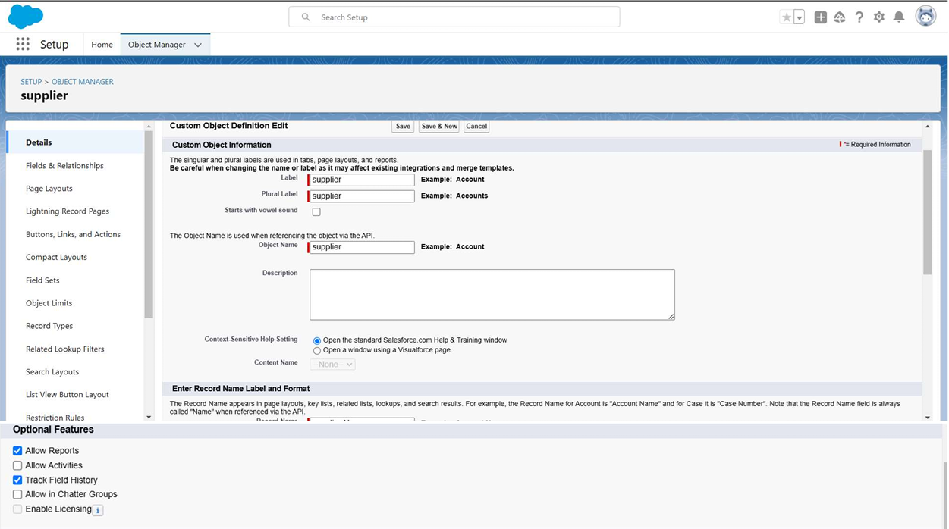

**Create Rice Mill Object**:

● Label Name: Rice Mill; Plural Label: Rice Mills.

● Record Name: Auto Number (e.g., Rice-{000}); Starting Number: 1.

● Enable "Allow Reports" and "Track Field History."

● Save the object.

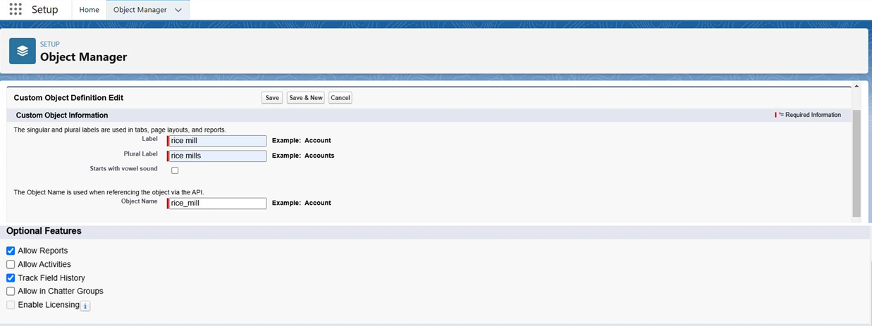

**Create Consumer Object:**

● Label Name: Consumer; Plural Label: Consumers.

● Record Name: Auto Number (e.g., Consumers-{000}); Starting Number: 1

. ● Save and enable search functionality.

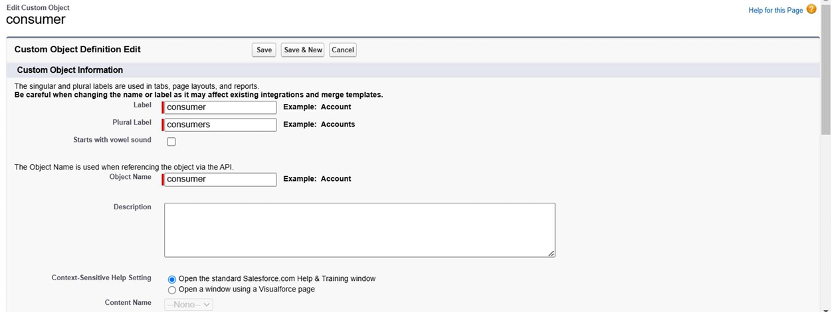 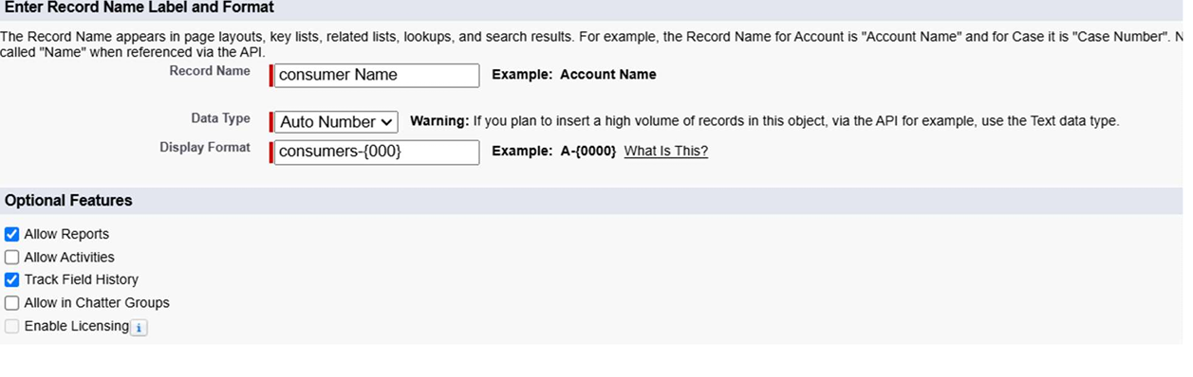

**Create Rice Details Object:**

● Label Name: Rice Details; Plural Label: Rice Details.

● Record Name: Auto Number (e.g., Rice-{000}); Starting Number: 1.

● Save and enable search functionality.

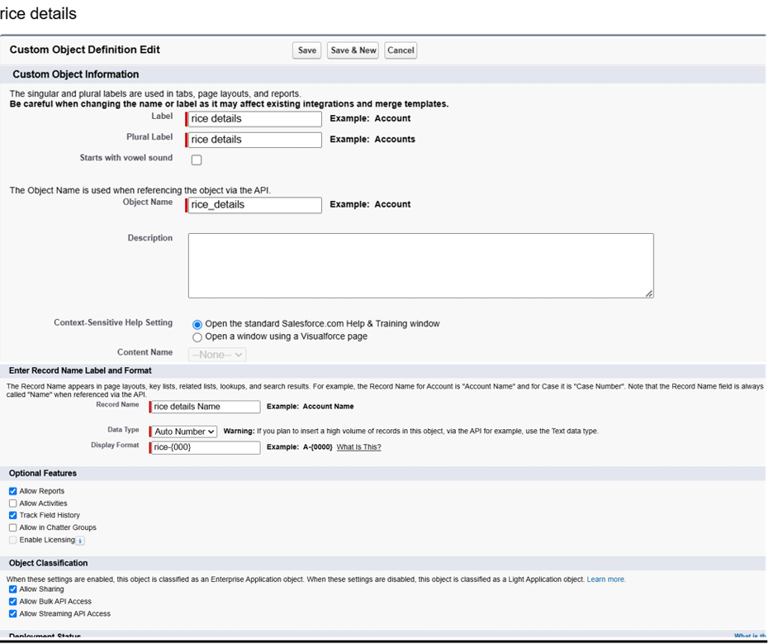

**Tabs: Creating a Custom Tab**:

● Go to Setup > Tabs > New Custom Tab.

● Select the object (e.g., Supplier) and choose a tab style.

● Assign it to the appropriate profiles and save.

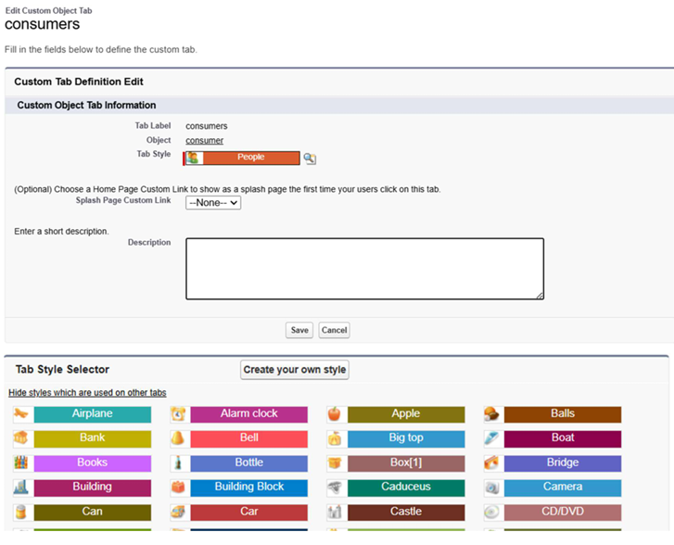

**Creating Remaining Tabs:**

● Repeat the above steps for Rice Mill, Consumer, and Rice Details objects.

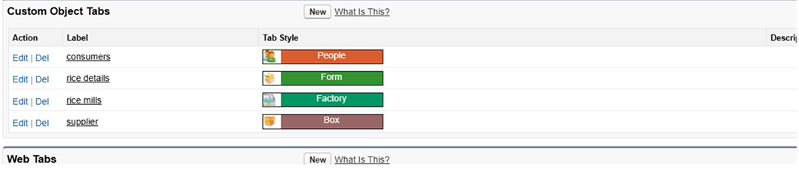

**The Lightning App:**

Create a Lightning App:

● Navigate to Setup > Search for 'App Manager' > New Lightning App.

● Enter app details (e.g., Name: My Rice CRM) and customize branding.

● Add navigation items: Supplier, Rice Mill, Consumer, and Rice Details.

● Save and assign profiles.

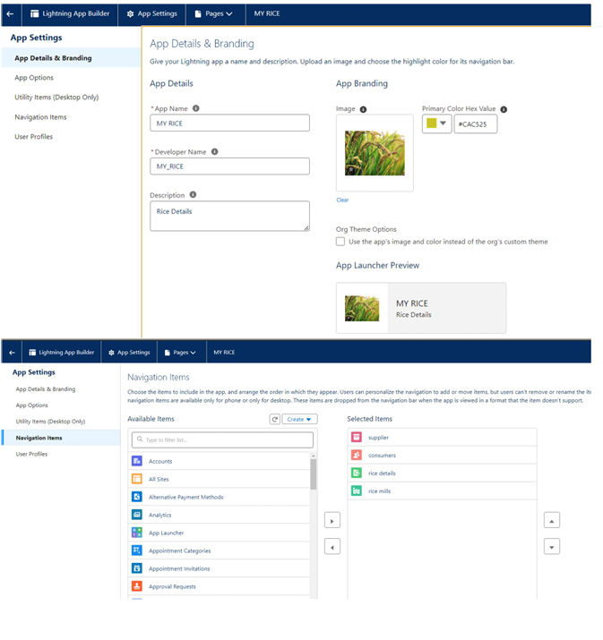

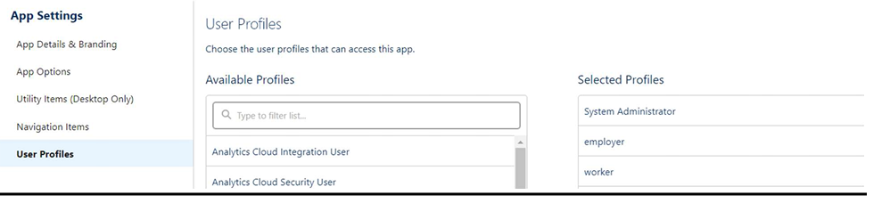

**Fields:**

Creating the Rice Distributed Field in Rice Details Object:

● Go to the setup page >> click on object manager >> From drop down click edit for rice details object

● Click on fields & relationship >> click on New.

● Field Name: Rice Distributed; Data Type: Number; Length: 5.

● Save the field.

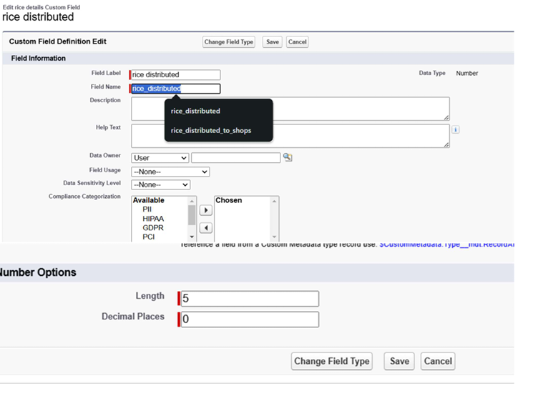

**Creating Junction Object:**

● Create relationships between Supplier and Rice Details, and Rice Mill and Rice Details using master-detail relationships.

● Go to the setup page >> click on object manager >> From drop down click edit for rice details object.

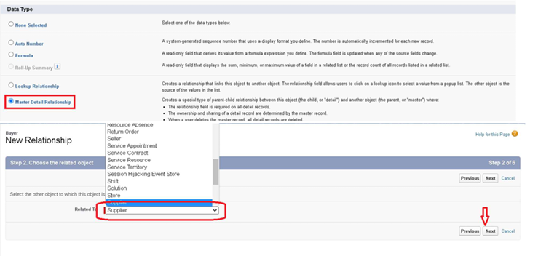

Creating a Master-Detail Relationship: ● Example: Between Consumer and Rice Mill. ● **Field Label:**

Rice Mill Name; Data Type: Master-Detail.

● Go to the setup page >> click on object manager >> From drop down click edit for consumer object.

● Click on fields & relationship >> click on New , Select “Master-Detail relationship” as data type and click Next.

● Select the related object “ rice mill”. Give Field Label as “rice mill name” and click Next. Next >> Next >> Save.

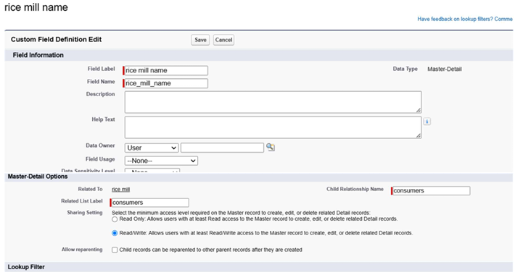

**Creating the Roll-Up Summary:**

● Summarize fields like total rice distributed in Supplier and Consumer objects.

● Use SUM as the aggregation type.

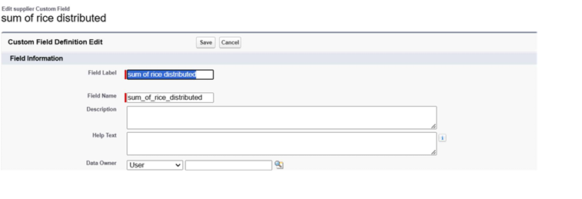

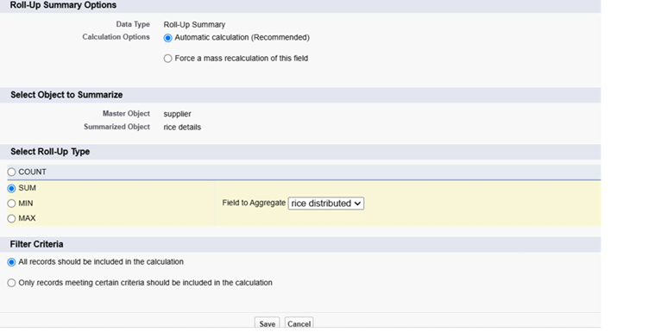

**Creating Fields in Objects:**

● Add fields like Price per Kilogram, Rice Type (Picklist), and Mode of Payment (Picklist) in respective objects.Go to the setup page >> click on object manager >> From drop down click edit for rice details object.

● Click on fields & relationship >> click on New.

● Select Data type as “master detail” and click Next.

● Given the Field Label as “ supplier name ” and length as “ 5

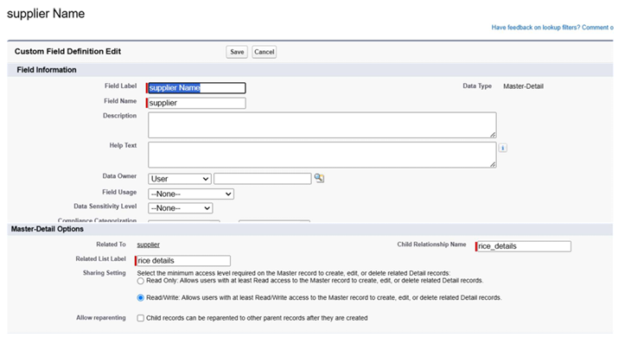

**Creating Cross-Object Formula Field in Consumer Object:**

● Field Name: Amount Paid; Formula: Rice_Taken_by_Shops__c *Rice_Price_per_Kg__c. ● Save the formula.

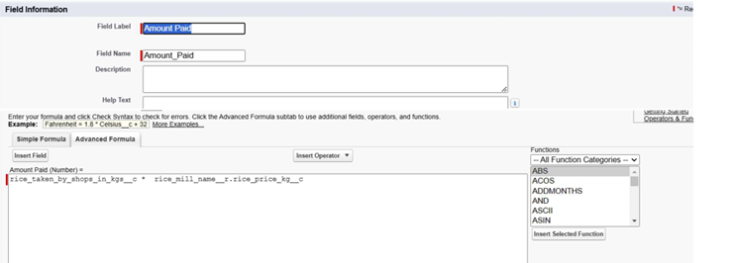

**Creating the Validation Rule:**

● Example: For phone number/email validation in Consumer object.

● Formula: OR(ISBLANK(Phone_Number__c), ISBLANK(Email__c)).

● Error Message: "Phone number or email cannot be blank."

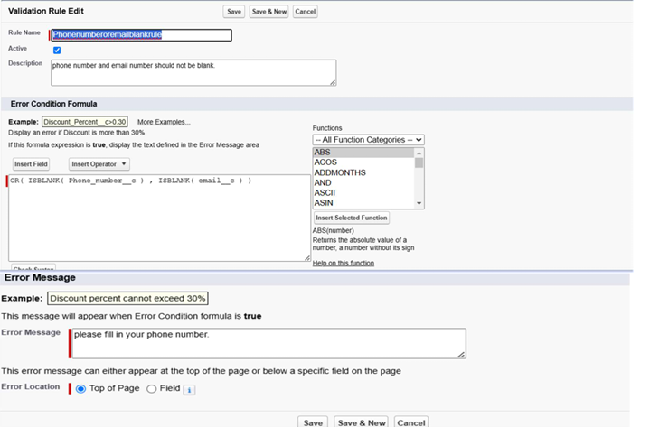

**Page Layouts: Creating the Page Layout:**

● Navigate to Object Manager > Select Object(consumer) > Page Layouts > New.

● Customize sections:

○ Personal Details: Name, Phone, Email.

○ Rice Details: Rice Type, Quantity.

○ Payment Details: Mode of Payment, Amount Paid.

● Save and assign the layout to profiles.

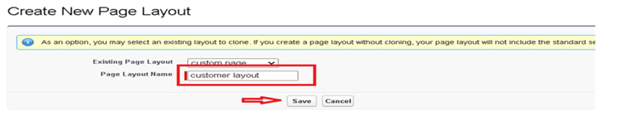

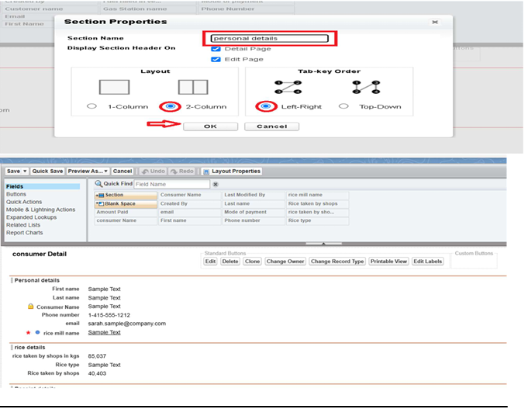

**Profiles:**

**Owner Profile:**

● Clone Standard User profile and rename it as Owner.

● Grant full access to all objects and tabs.

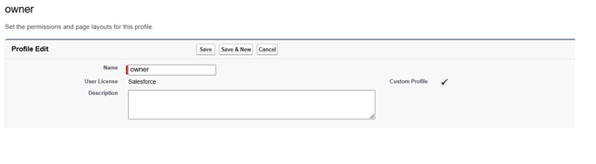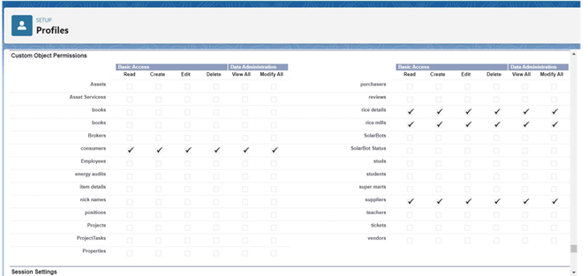

**Employer Profile:**

● Clone Standard Platform User profile and rename it as Employer.

● Restrict access to certain objects like Workers.

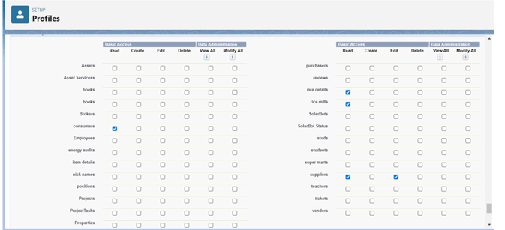

**Worker Profile:**

● Clone Standard Platform User profile and rename it as Worker.

● Allow limited access to update transactions only.

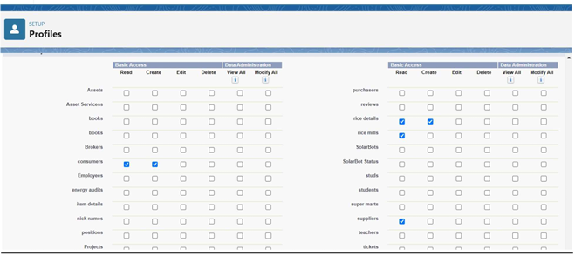

**Role & Role Hierarchy:**

Creating Owner Role:

● Go to Setup > Roles > Set Up Roles.

● Click on Add Role under CEO and Give Label as “owner” and Role name gets auto

populated.

● Role Label: Owner; Save the role.

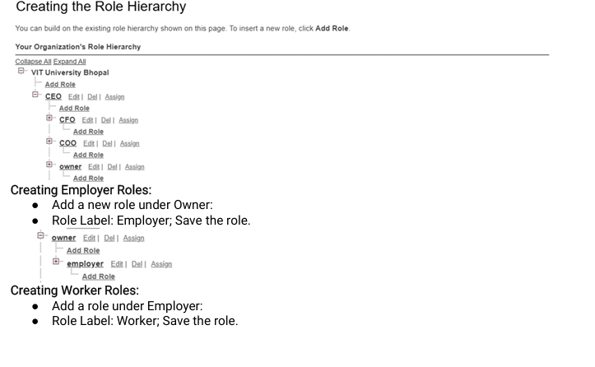

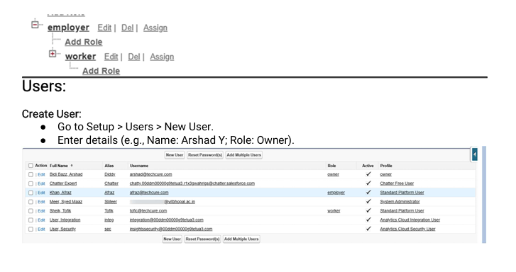

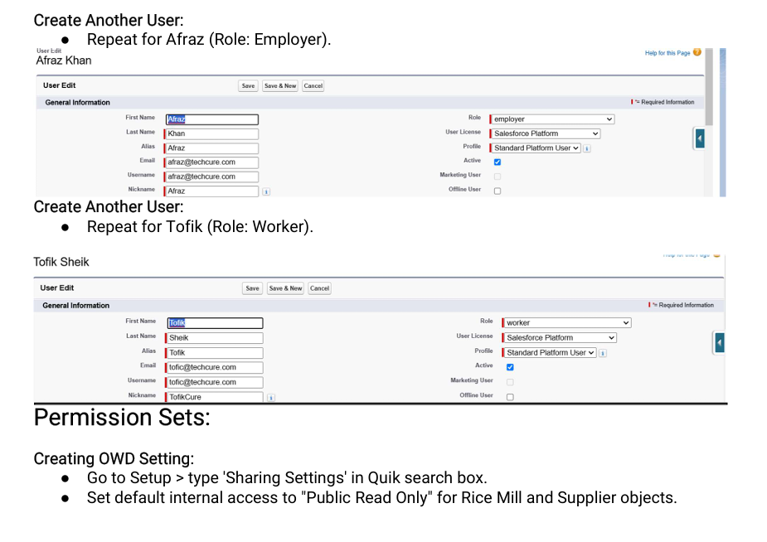

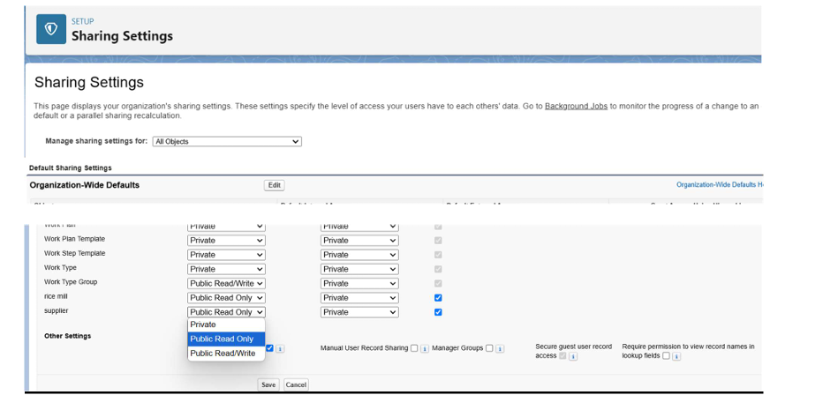

**Reports: Create Report:**

● Go to Reports > New Report > Select "Rice Mills with Consumers".

● Add fields: Consumer Name, Rice Type, Mode of Payment, Amount Paid.

● Group rows by Rice Taken by Shops and save as "Range of Amount Per Day".

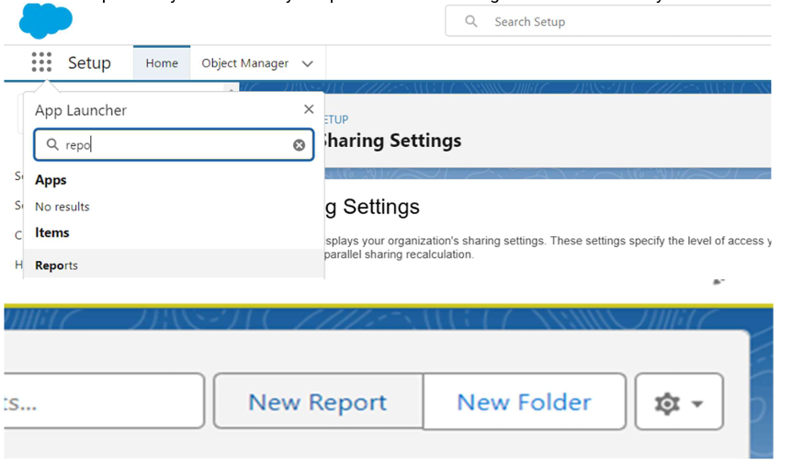

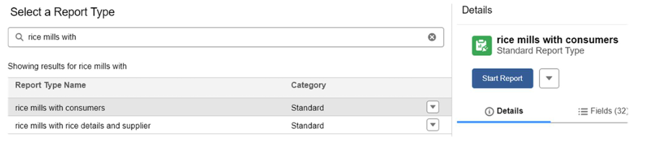

**Sharing Report to Owner:**

1. Go to the created report, click on the dropdown menu next to the report name.

2. Select Subscribe.

3. In the settings window, choose:

○ Send report as another user (Owner's email).

○ Set the frequency as Daily.

4. Click Save.

The owner will receive a daily email with updated rice mill data.

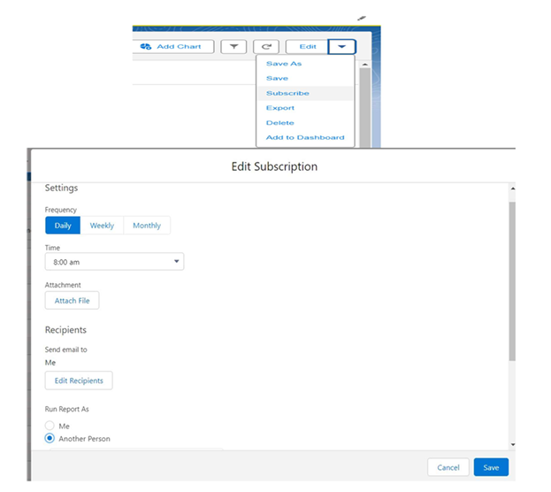

Create Report Folder:

1. Go to Reports from the App Launcher.

2. Click on New Folder.

3. Name the folder: “Estimated Rice Per Day.”

4. Move the created report Range of Amount Per Day into this folder:

○ Select the report dropdown.

○ Choose Move > Select folder: Estimated Rice Per Day > Save.

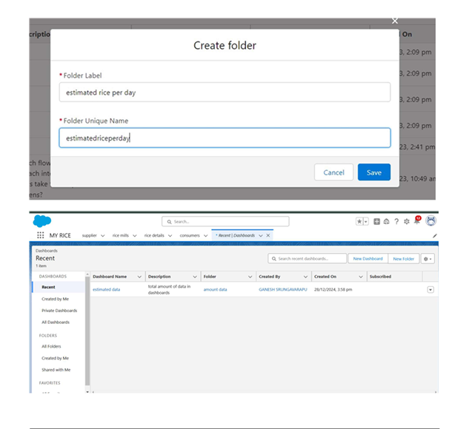

**Dashboards**

1. Create Dashboard Folder:

1. Navigate to Dashboards in the App Launcher

. 2. Click New Folder, and name it Amount Data Dashboard.

3. Save the folder.

2. Create Dashboard:

1. Go to the Dashboards tab > New Dashboard.

2. Enter the name: “Rice Mill Summary” and save it in Amount Data Dashboard.

3. Add components:

○ Select Reports (e.g., “Range of Amount Per Day”

○ Component 1: Vertical Bar Chart:

○ X-axis: Rice Taken by Shops.

○ Y-axis: Sum of Amount.

○ Component 2: Donut Chart:

○ Sort by: Sum of Amount Paid

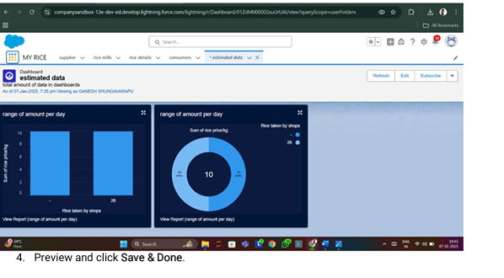.

**APEX**

1. Creating an Apex Class (ConsumerRecord):

1. Open Developer Console (Gear icon > Developer Console).

2. Go to File > New > Apex Class.

3. Add the following code:

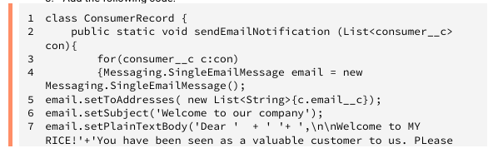

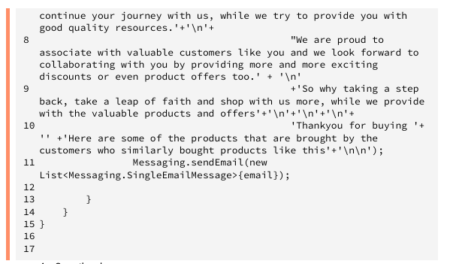

4. Save the class.

**2. Creating an Apex Trigger:**

1. Go to Developer Console > File > New > Trigger.

2. Name the trigger: ConsumerTrigger. Set the object to Consumer__c.

3. Add the following code:

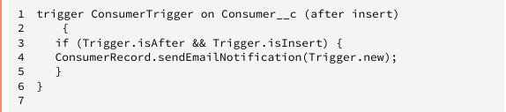

4. Save the trigger. This ensures an email is sent whenever a new Consumer record is created.

**5. Testing and Validation Unit Testing:**

● Apex classes and triggers were validated to ensure error-free email notifications.

● Roll-up summary and formula fields were tested for accurate calculations.

**User Interface Testing:**

● Verified functionality of page layouts, ensuring seamless navigation and usability.

● Ensured accurate rendering of reports and dashboards.

**End-to-End Testing:**

● Simulated daily workflows, including data entry, report generation, and dashboard updates, to validate system reliability.

● Tested role-based access controls to ensure proper data visibility and security.

6. Key Scenarios Addressed by Salesforce in the Implementation Project

**1. Daily Reporting:**

● Automating the generation of daily production, sales, and revenue reports for the owner.

**1. Role-Based Data Access:**

● Providing tailored access to data based on user roles (e.g., Owner, Employer, Worker). **1. Enhanced Customer Engagement:**

● Sending email notifications to customers with details of their purchases and payments.

**1. Data Integrity:**

● Ensuring data consistency and reliability through validation rules and error handling. **1. Business Insights:**

● Delivering actionable insights through reports and dashboards, enabling data-driven decisions.

**7. Conclusion Summary of Achievements:**

The Rice Mill CRM Application successfully automated and optimized the rice mill’s operational processes.

Key achievements include:

**● Operational Efficiency:**

○ Streamlined workflows and improved resource allocation through automated data management.

**Data Visualization:**

○ Developed dynamic reports and dashboards to provide real-time insights into production, sales, and revenue.

**● Enhanced Security:**

○ Implemented robust role-based access control, ensuring data confidentiality and integrity.

**● Improved Customer Communication:**

○ Automated email notifications and integrated customer engagement tools.

**● Scalability:**

○ Built a scalable and modular solution using Salesforce's flexible framework, ensuring adaptability for future enhancements.

The Rice Mill CRM Application exemplifies the transformative power of Salesforce to meet specific industry needs, driving operational excellence and enabling long-term success for the rice mill.