TITLE:- Small Business Product Recommendation System
Introduction :
In today’s data-driven marketplace, small retailers often struggle to interpret complex customer buying behaviours hidden within transactional data. This project addresses that challenge by developing a Small Business Product Recommendation System that analyses purchase transactions to identify relationships among products frequently bought together.
Using Apache Spark (Scala) for large-scale data processing, the project constructs a copurchase graph network where nodes represent products and edges represent co-purchase relationships. The network is analysed using degree centrality and weighted degree (strength) metrics to identify the most influential and frequently co-purchased products in the network.
The resulting graph is visualized using Gephi, enabling the discovery of product clusters, hub items, and the overall structure of customer purchasing patterns. Finally, insights are presented through an interactive Tableau dashboard, highlighting top-selling products, strong copurchase pairs, and network connectivity trends. This integrated Spark + Gephi + Tableau workflow transforms raw transactional data into actionable business intelligence, supporting smarter inventory management, cross-selling, and personalized recommendation strategies.

Project Objectives:
The primary objective of this project is to design and implement a graph-based product recommendation framework for a small retail business using real-world purchase data. The system aims to uncover hidden co-purchase patterns and provide actionable insights to enhance sales strategies and customer engagement.
The specific goals of the project are to:
- Load and preprocess a real-world retail transaction dataset for analysis.
  - Dataset Source: Retail Transactions Dataset – Kaggle
- Build a product co-purchase graph, where:
  - Each node represents an individual product.
  - Each edge represents a co-purchase relationship weighted by frequency.
- Identify high-demand and highly connected products using degree and weighted degree centrality to find key influencers within the network.
- Detect isolated products with no co-purchase connections, indicating independent buying patterns.
- Visualize the co-purchase network using Gephi, ranking nodes by weighted degree to highlight strong co-purchase relationships.
- Create an interactive Tableau dashboard that consolidates key insights, including topselling products, frequent co-purchase pairs, and degree-based connectivity metrics.
Through these objectives, the project demonstrates how graph theory, network visualization, and business analytics can help small retailers interpret customer behavior, design product bundles, and optimize cross-selling strategies.

Source Code:
Fig1: Imports required Spark SQL, GraphX and helper libraries and defines the input CSV path

Fig2: Reads the CSV with headers and selects only the Transaction_ID and Product columns
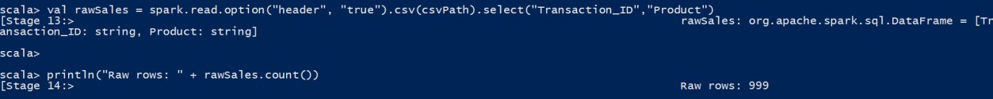
Fig3: Custom UDF that extracts individual product strings from the raw Product column

Fig4 : Applies the UDF to create an array column items, normalizes each element to lowercase and trims whitespace. Filters out transactions with no items.


Fig5 : Explodes the items array into rows to count how often each product appears across all transactions, producing the productCounts DataFrame used for ranking top products.
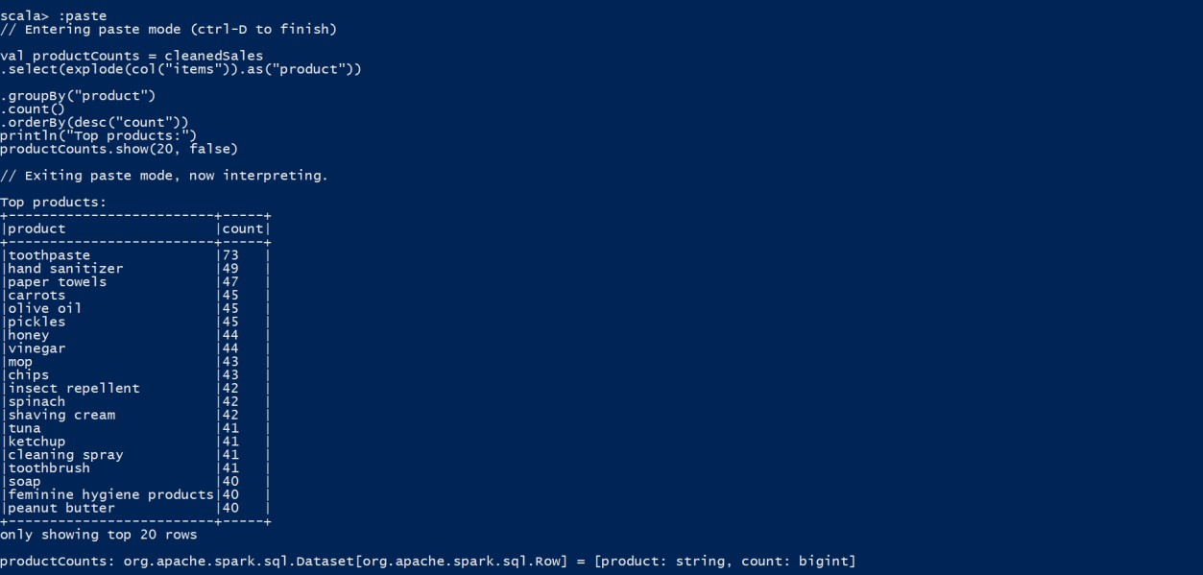
Fig6 : Converts each transaction’s item list into all unique unordered pairs

Fig7 : Reduces the pair RDD to counts (weights) representing how many transactions contained each product pair. Converts to a DataFrame cooccurrenceDF for export and visualization
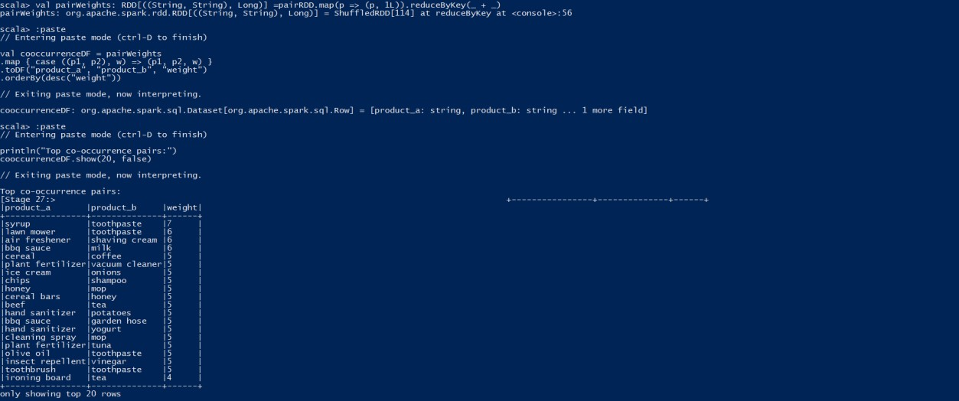

Fig8 : Maps each product to a numeric vertex id

Fig9 : Building the vertexRDD and edgeRDD

Fig10: Constructing the graph


Fig11 :Computing isolated products

Fig12: Exporting results


Grap Visualization using Gephi :

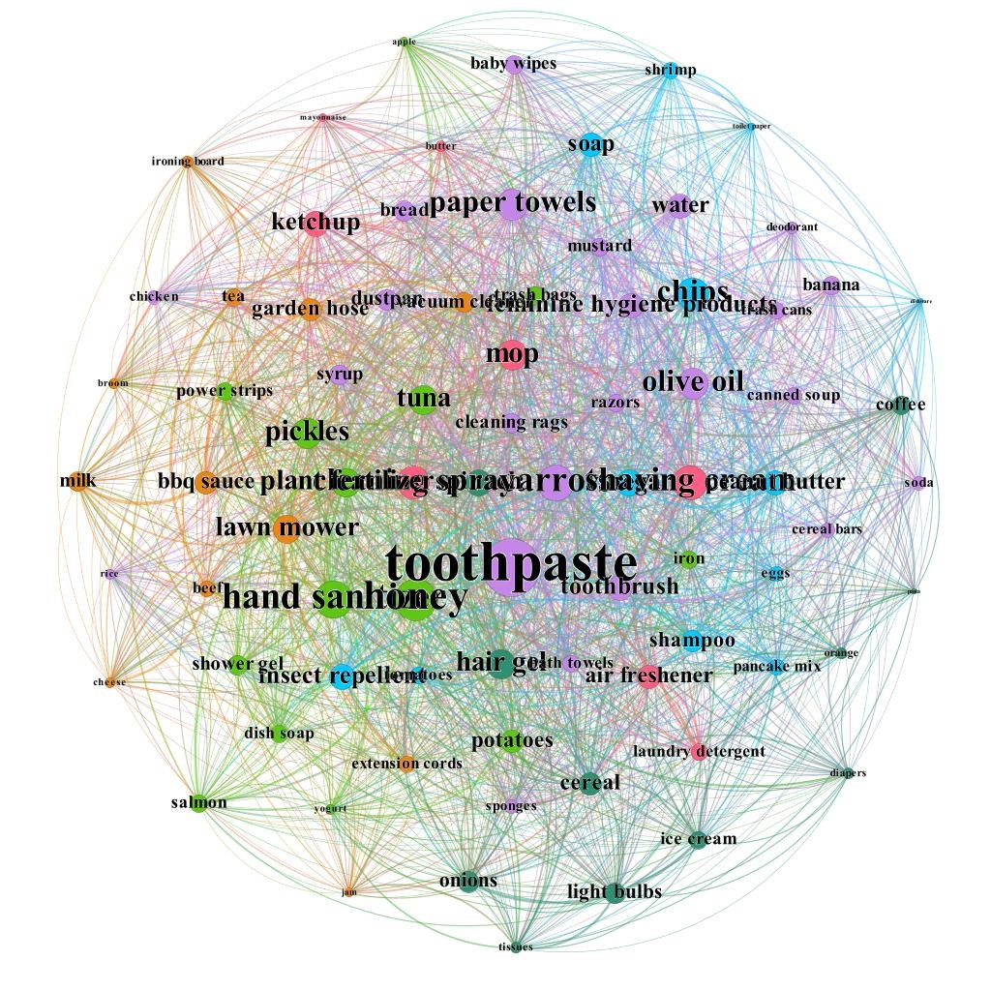
Fig 10 : Product Co-Purchase Network in Gephi (Node Size by Weighted Degree).

Description:

The co-purchase product network generated from Spark GraphX was imported into Gephi for visual analysis. The network represents each product as a node, and every co-purchase relationship as a weighted edge — where the weight denotes how frequently two products were bought together. The visual design in Gephi was optimized to highlight the most influential and frequently co-purchased items.

Visualization Process:
- Imported the vertices.csv (Product IDs and Names) and edges.csv (Source, Target, Weight) files into Gephi.
- Applied the ForceAtlas2 layout algorithm to spatially organize the network for clarity and balance.
- Set the Node Size ranking to Weighted Degree, so larger nodes represent products that have higher total co-purchase strength (i.e., they appear frequently with many other products).
- Used Modularity Class coloring to visually cluster related groups of products — each color indicates a community of frequently co-purchased items.
- Adjusted Edge Thickness and Transparency based on edge weights to highlight stronger product pairings.
- Enabled Label Visibility and used size scaling to make key products (with high connectivity) more prominent.

Interpretation:
- Larger nodes (e.g., toothpaste, hand sanitizer, paper towels) have higher weighted degrees, meaning they are involved in numerous and strong co-purchase relationships.
- Node color clusters reveal natural product groupings
- Sparse or small nodes correspond to low-connectivity products, potentially independent purchases or niche items.

Tableau Dashboard Interpretation
The Tableau dashboard integrates multiple perspectives of the retail co-purchase network, offering a comprehensive analytical view of product performance, connectivity, and association strength derived from the transactional dataset.

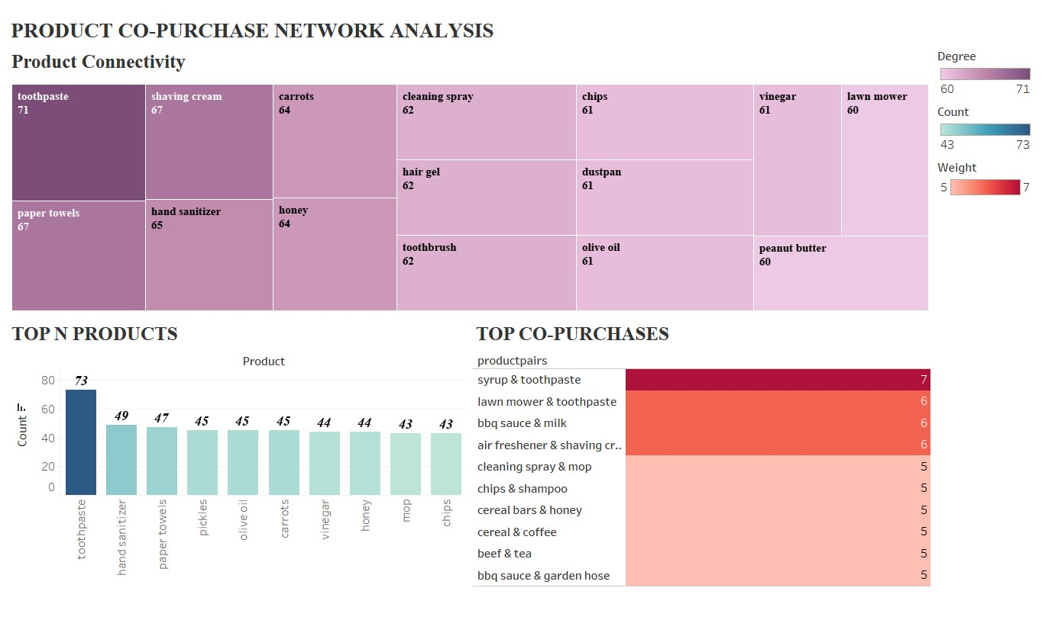

1. Product Connectivity (Treemap)
This treemap visualizes the top 15 most connected products within the co-purchase network based on their degree centrality scores.
Each block represents a product, with size and color intensity corresponding to its connectivity level (degree).
- Toothpaste holds the highest centrality score (71), establishing itself as the primary hub in the co-purchase network.
- Other highly connected items include paper towels (67), shaving cream (67), hand sanitizer (65), carrots (64), and honey (64) — indicating these products are frequently purchased with multiple others.
- Lower-ranked nodes such as olive oil, vinegar, and peanut butter still maintain strong degrees (60–61), showing moderate but consistent engagement across transactions.

2. Top N Products (Bar Chart)
This bar chart highlights the top 10 most frequently purchased products by total transaction count.
- Toothpaste again leads the ranking with 73 sales, reaffirming its role as both a highdemand and highly connected item.
- Following it are hand sanitizer (49) and paper towels (47), representing strong customer preference toward hygiene essentials.
- Mid-ranked items such as pickles, olive oil, carrots, and honey reveal consistent purchase frequency in everyday shopping patterns.

3. Top Co-Purchases (Heatmap)
This heatmap displays the top 10 most frequent co-purchased product pairs, ranked by edge weight — the number of times two items appear together in transactions.
- The strongest co-purchase relationship is between “Syrup & Toothpaste” (weight 7), followed by “Lawn Mower & Toothpaste” and “BBQ Sauce & Milk” (each weight 6).
- Other notable pairs include “Cleaning Spray & Mop”, “Chips & Shampoo”, and “Cereal & Coffee”, suggesting cross-category purchase behaviors that bridge grocery and household items.

Overall Analytical Summary
This dashboard merges graph-based metrics (from Spark and Gephi) with visual business insights (via Tableau) to illustrate three key retail dimensions:
- Influence — which products connect most within the network (Top 15 by Degree).
- Demand — which products sell most frequently (Top 10 by Count).
- Association — which product pairs co-occur most strongly (Top 10 Co-Purchases).
Together, these visuals enable small businesses to identify hub products, cross-selling opportunities, and strategic inventory priorities, effectively turning raw transaction data into actionable retail intelligence.

Result & Conclusion

Results
The Small Business Product Recommendation System successfully uncovered meaningful insights from the transactional retail dataset using a hybrid analytics approach — combining Apache Spark (Scala) for data processing, Gephi for network visualization, and Tableau for business intelligence reporting.
- Data Processing & Network Construction (Apache Spark):
  - Transactional data was cleaned, normalized, and transformed into product-level arrays.
  - A co-purchase network was built where each node represents a product and each edge represents the frequency of co-purchases. o Spark’s GraphX module enabled the calculation of degree centrality for each product, identifying key items influencing multiple purchase relationships.
  - Exported datasets — product_counts.csv, cooccurrence_pairs.csv, and degrees.csv — formed the analytical foundation for visualization.
- Network Visualization (Gephi):
  - The co-purchase network was visualized using Gephi, with node size proportional to weighted degree and edge thickness representing co-purchase frequency. o Toothpaste emerged as the most connected product (degree = 71), demonstrating its dominant cross-category influence in customer purchase patterns.
- Interactive Insights (Tableau Dashboard):
  - The Tableau dashboard integrated three analytical layers — Product Connectivity (Top 15), Top 10 Products by Count, and Top Co-Purchases — for comprehensive interpretation.
  - Visual cues such as color gradients and bar lengths highlighted product performance, sales frequency, and co-purchase intensity.
  - Key insights:
    - Toothpaste, paper towels, and hand sanitizer were identified as both highly purchased and highly connected products.
    - The most frequent co-purchase pairs were Syrup & Toothpaste, BBQ Sauce & Milk, and Lawn Mower & Toothpaste, revealing cross-category shopping trends.
    - No isolated products were detected, indicating that all products had at least one co-purchase linkage — a healthy sign of inter-product association.

Conclusion
This project successfully demonstrates how graph analytics can transform basic sales transactions into strategic insights for small retail businesses.
By integrating Spark for computation, Gephi for network exploration, and Tableau for visualization, the system effectively:
- Identified high-impact (hub) products that drive multiple purchases.
- Revealed strong co-purchase patterns for bundle recommendations.
- Highlighted sales trends that can guide inventory and marketing strategies.
The degree centrality analysis provided a measurable indicator of product influence within the network, allowing retailers to prioritize items that create the greatest downstream impact on sales.
Ultimately, the Small Business Product Recommendation System establishes a scalable, datadriven framework that small retailers can adopt to enhance customer experience, optimize stock planning, and improve revenue through intelligent product recommendations

