AWS

Lambda,EC2,S3, Dinomo db, event bridge , Scaling and load balancing, event bridge,

Cloud track to logs , sqs clould formation.

Ec2 Services:

[Amazon Web Services (AWS) : Elastic Compute Cloud (EC2) Explained in Hindi](AWS.docx)

EC2 stands for Elastic Compute Cloud. EC2 is an on-demand computing service on the AWS cloud platform. Under computing, it includes all the services a computing device can offer to you along with the flexibility of a virtual environment. It also allows the user to configure their instances as per their requirements i.e. allocate the RAM, ROM, and storage according to the need of the current task. Even the user can dismantle the virtual device once its task is completed and it is no more required. For providing, all these scalable resources AWS charges some bill amount at the end of every month, the bill amount is entirely dependent on your usage. EC2 allows you to rent virtual computers.

**Elastic Compute Client:**

* Ec2 provide secure environment.
* As per demand we can resize or scaling (on demand we can scale up and down as user require )

**Create First EC2 Instance**

1. Operating system.
2. Compute power
3. Ram
4. Storage
5. Network speed (uploading and downloading)
6. Firewall (which site open)
7. Bootstrap can apply

Search EC2

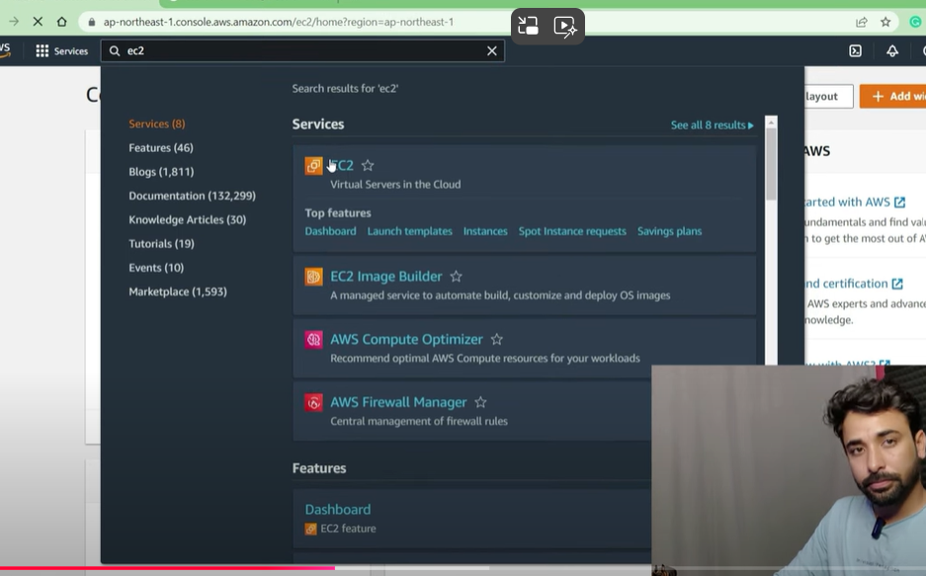

**Region needs to select**

