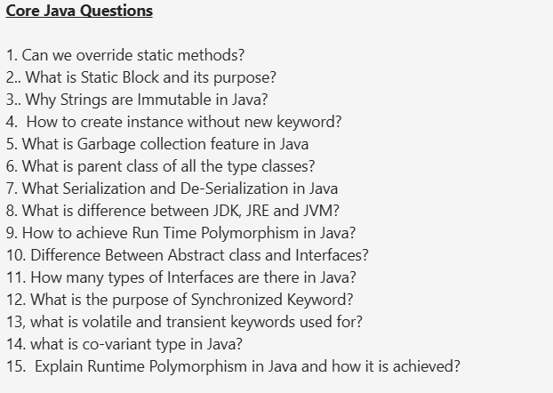  
  
  
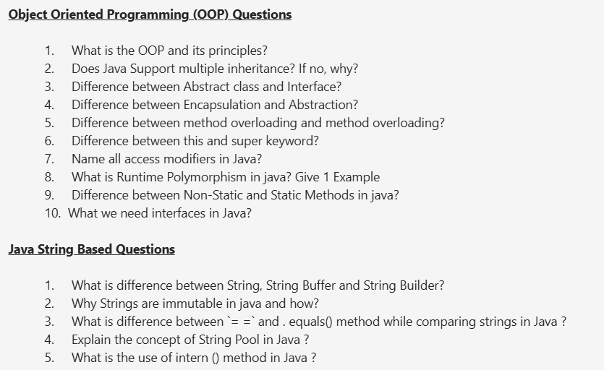  
  
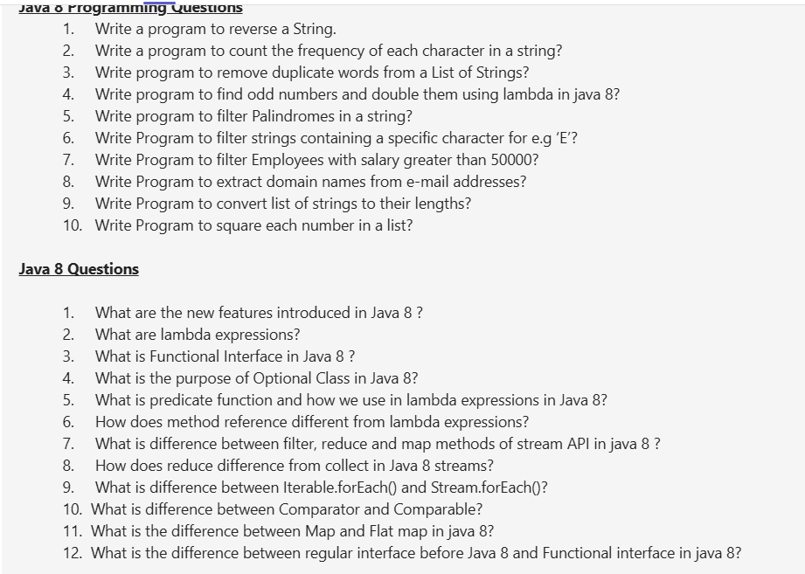

s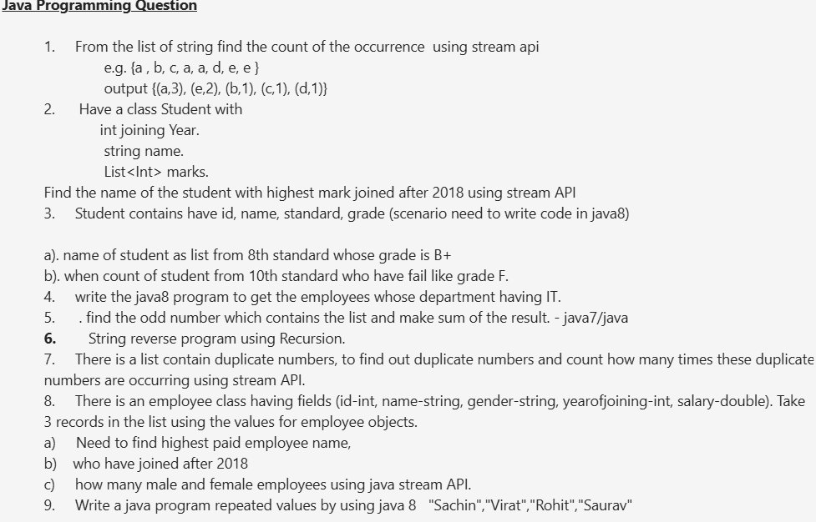  
  
  
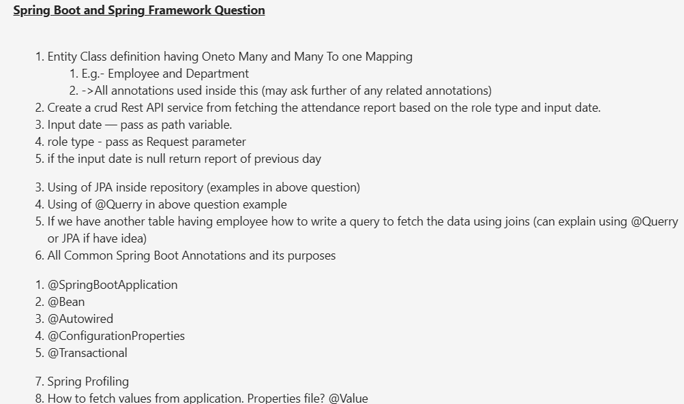

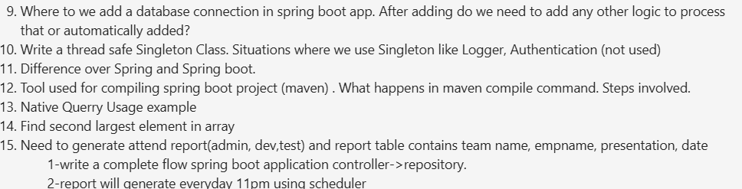  
  
  
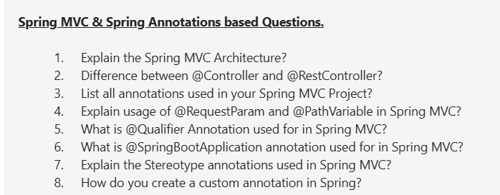

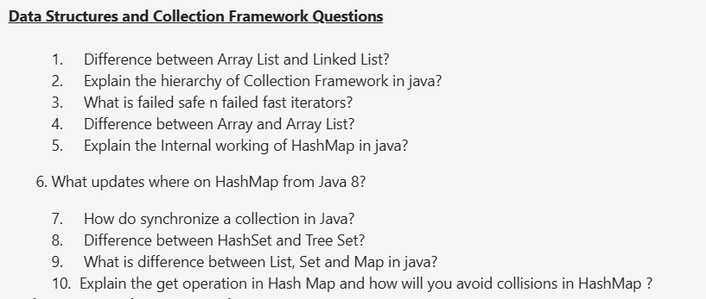  
  
  
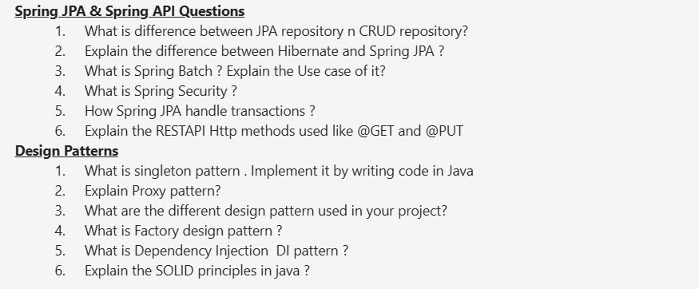

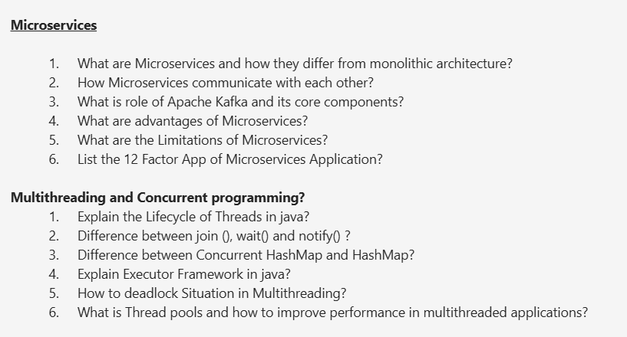

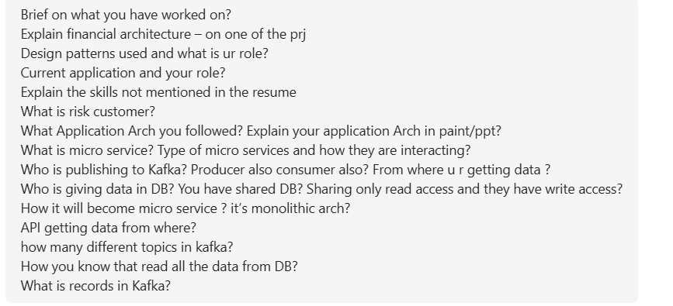

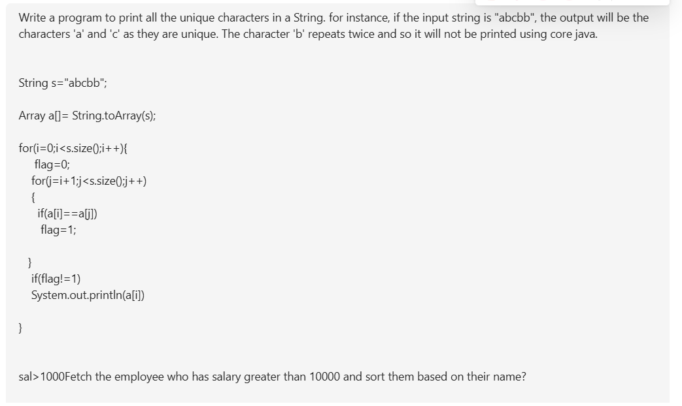  
  
  
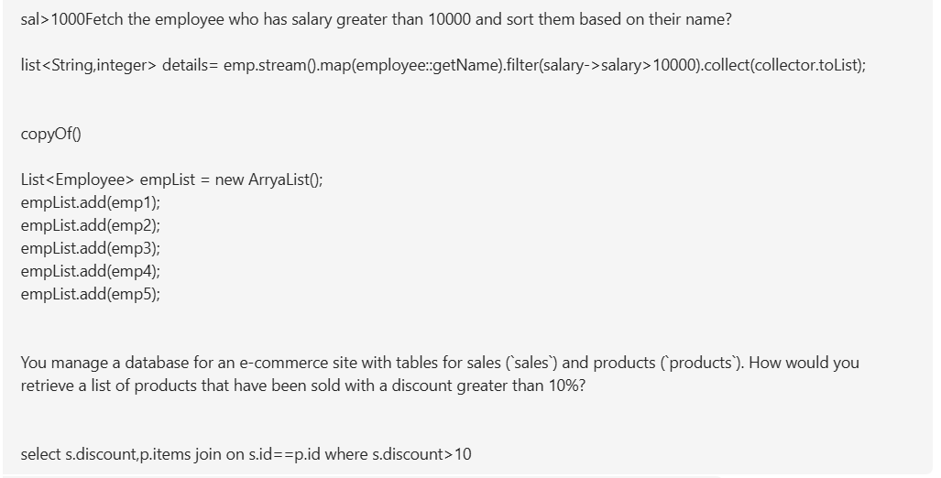  
  
  
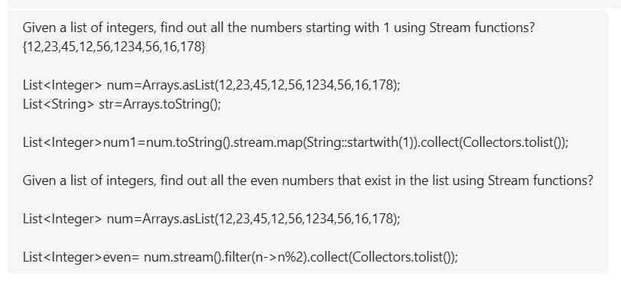

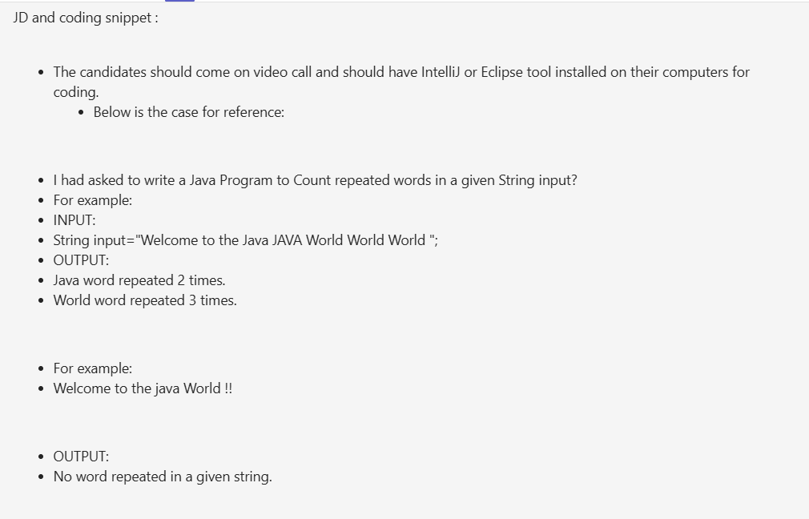

Today, Night

Spring boot JPA.   
Set internal working.  
Optional Class.  
Saga Design Pattern.  
Collection Farmwork in Differences   
Login Manage in Microservice. JWT  
Docker video. >>>

///////////////////////////////////////////////////////////////////////  
Need TO Complete  
Retry Mechanism >> Today 2/12/2024.  
REFRESH Token  
Kubernetes >> Today 2/12/2024  
Java Ke basic program (Daily)

Tomorrow.

EKS.  
 Load Balancing.  
 CRQS Microservice.  
 Thread Access and thread in Details.  
 Thread dump.  
 Security Http and Https.  
 Cashing Radis @EnableCashing in Spring boot.   
///////////////////////////////////////////////////////////////////////////////  
 28/11/2024  
 Replica in Kafka.  
 Scaling   
///////////////////////////////////////////////////////////////////////////////