Thread

What is thread

Thread is low priority processor which is used to excute the process.

Multitasking programming is of two types which are as follows:

1. Process-based Multitasking
2. Thread-based Multitasking

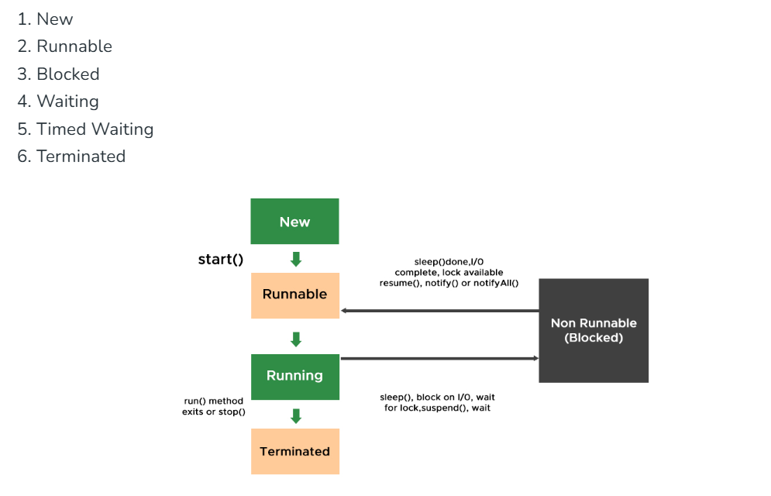

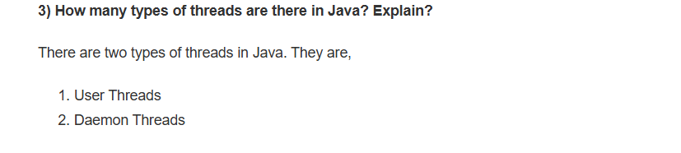

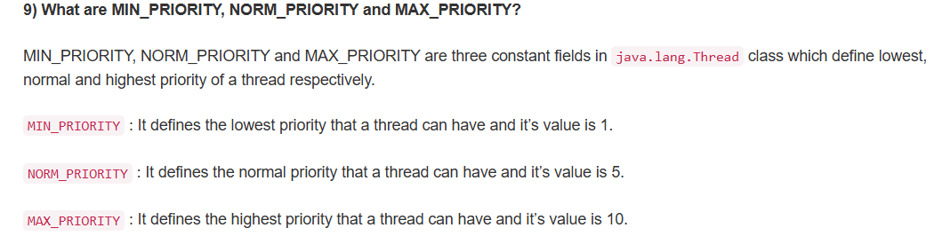

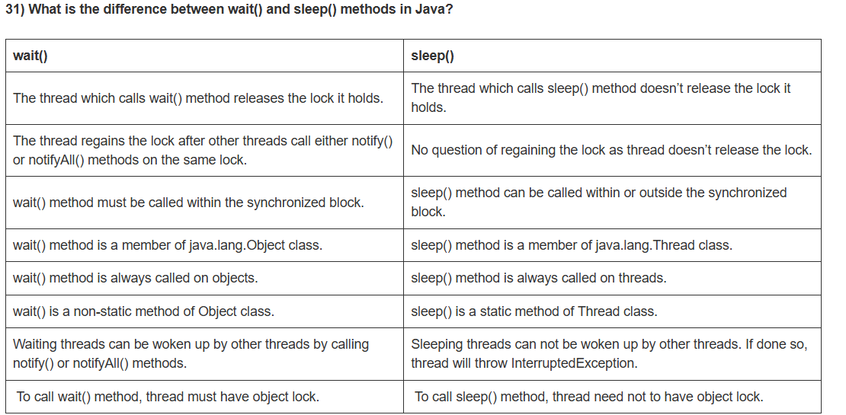

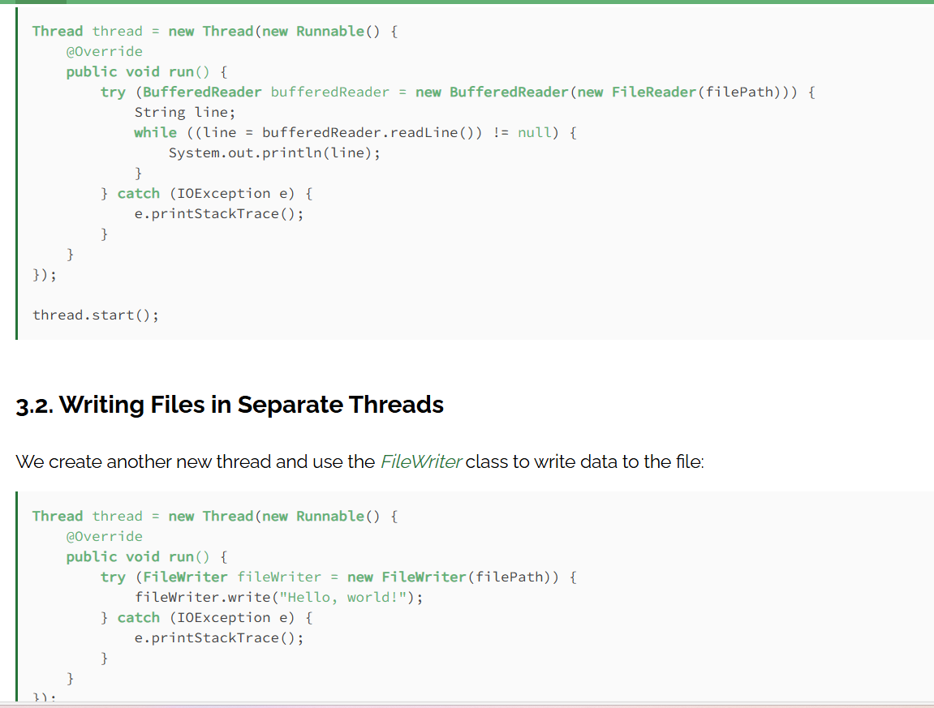

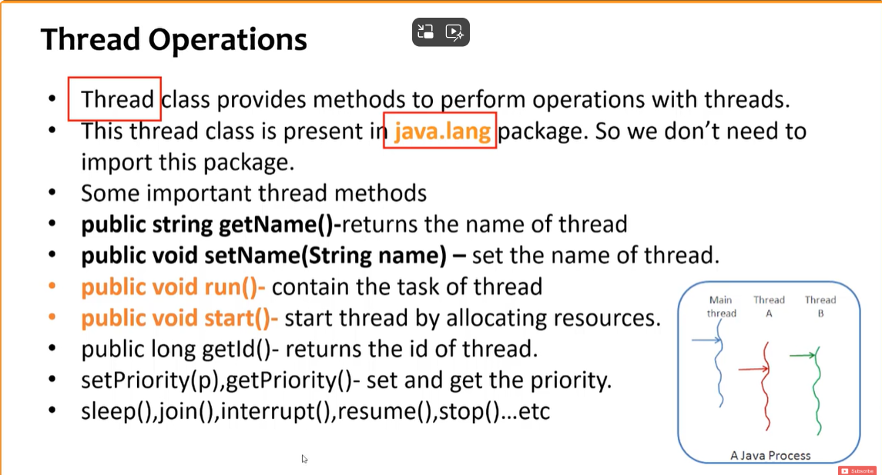

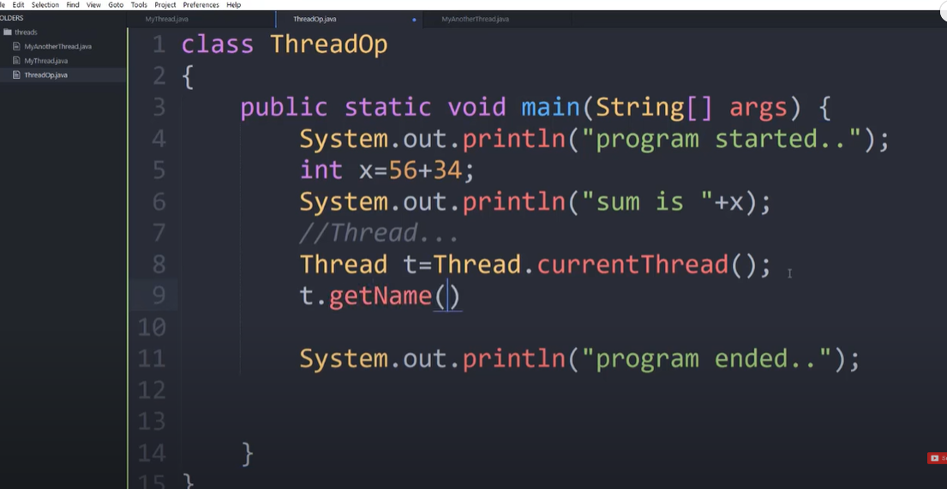

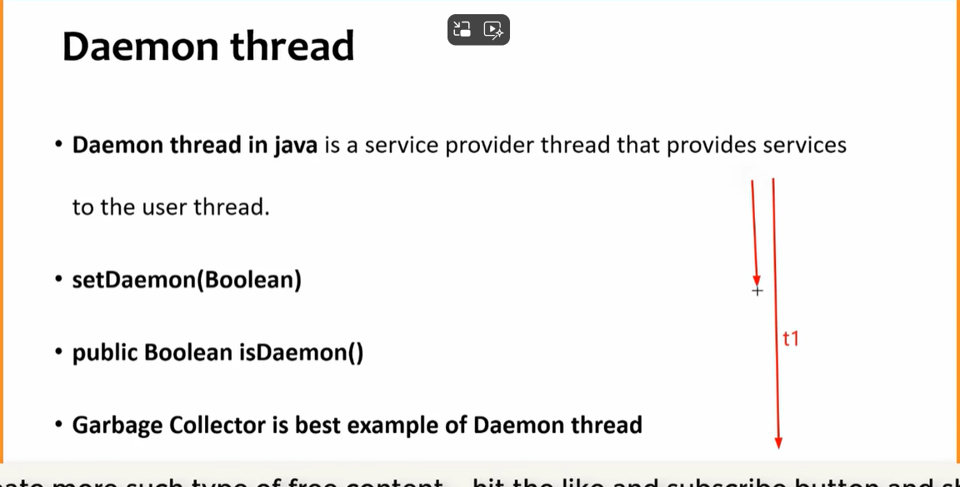

Race condition if multiple thread working at same time

On class data incunsestency will be tehre to remove it

Synchronized block or synchronized method we can use

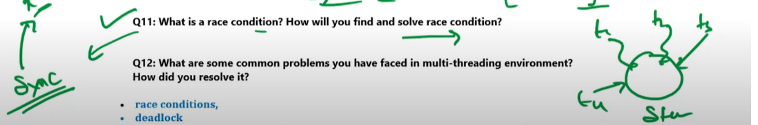

Executor Fream Work.