NAME : GANESH SAINATH BALKI

PNR : 230345920032

1. LOGIN INTO YOUR GITHUB ACCOUNT USING GITHUB CREDENTIALS.

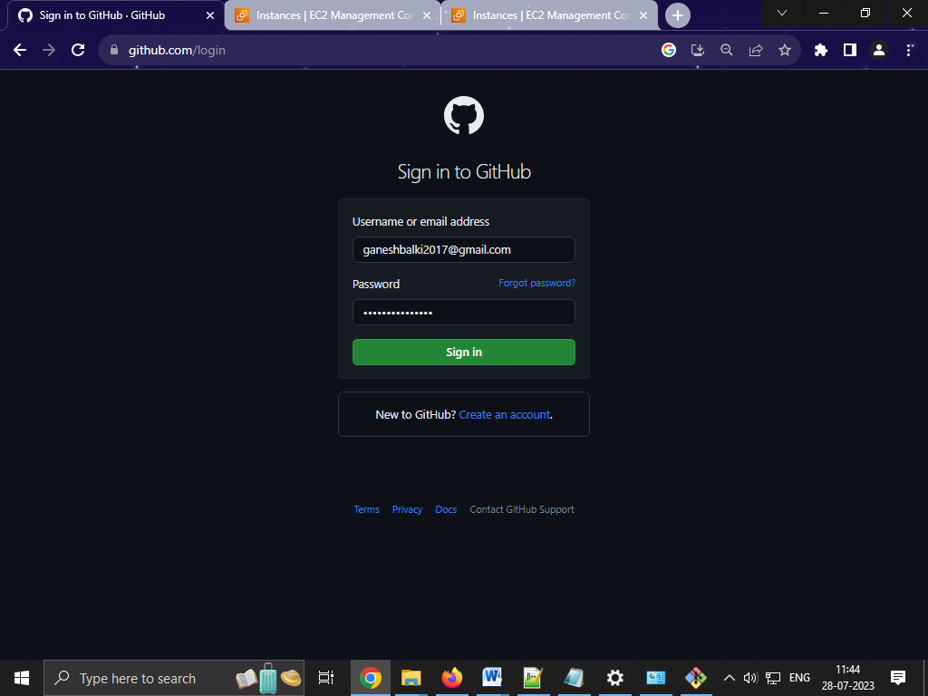

1. CREATE PUBLIC GITHUB REPOSITORY WITH NAME NORTHWIND TO YOUR GITHUB SUBSCRIPTION.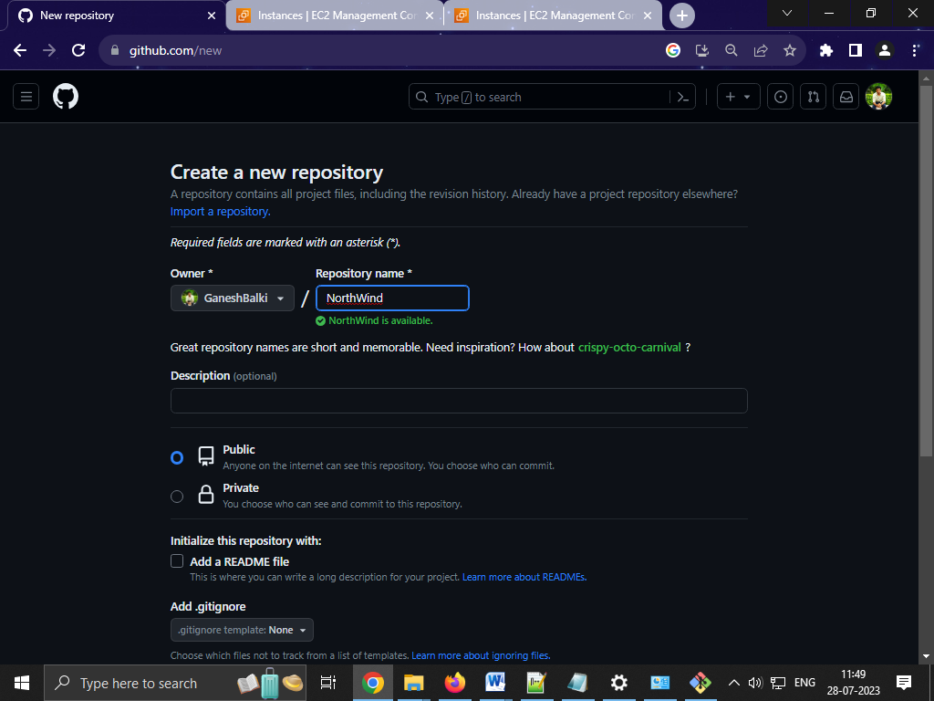

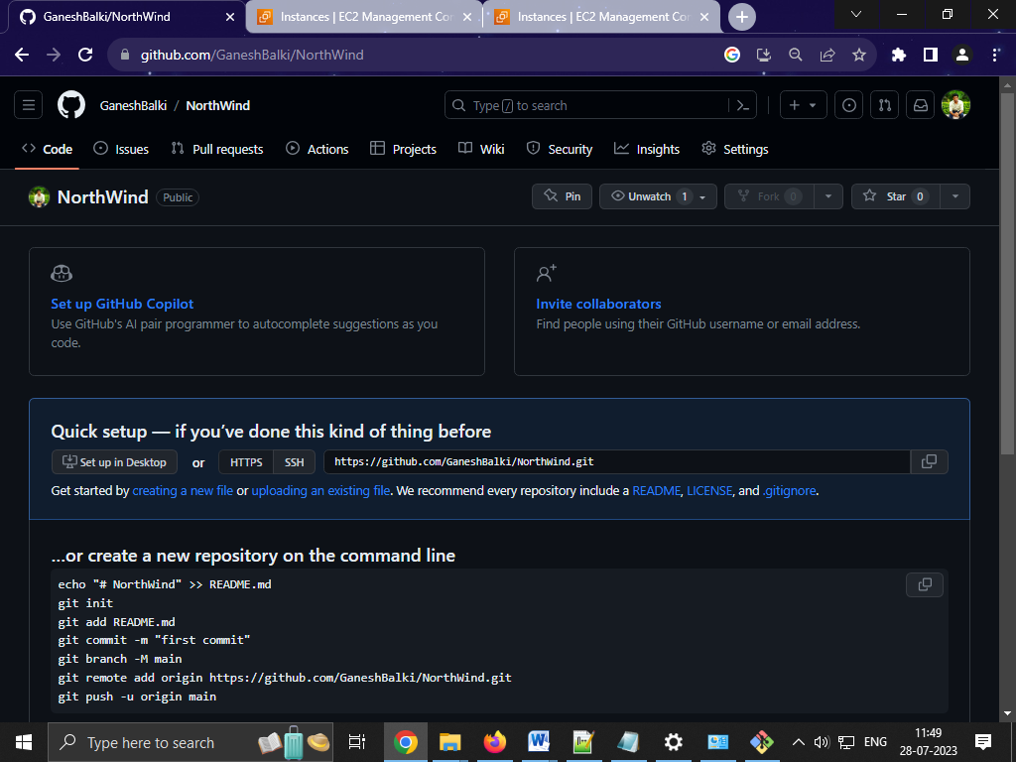

1. CLONE GITHUB NORTHWIND CODE REPOSITORY TO YOUR DEVELOPER MACHINE USING GIT COMMANDS.

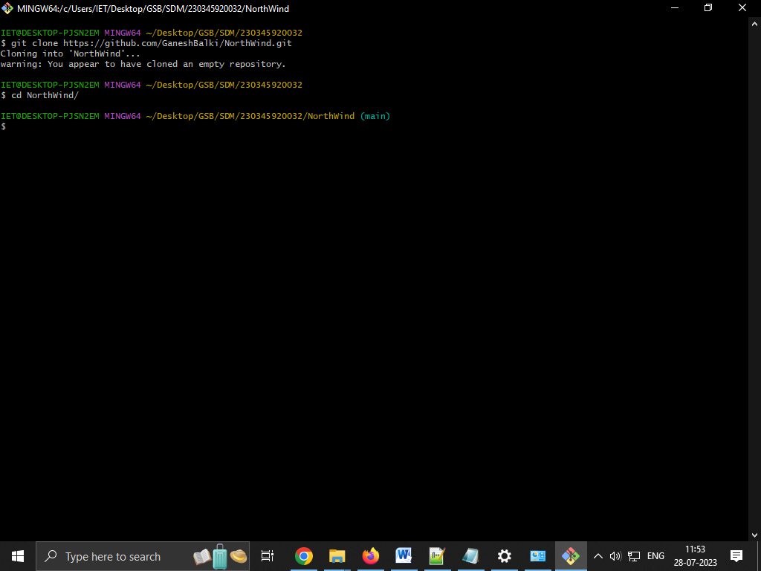

1. UPLOAD DOCKERFILE,PACKAGE.JSON AND SERVER.JS FROM LOCAL REPO TO GITHUB NORTHWIND REPOSITORY

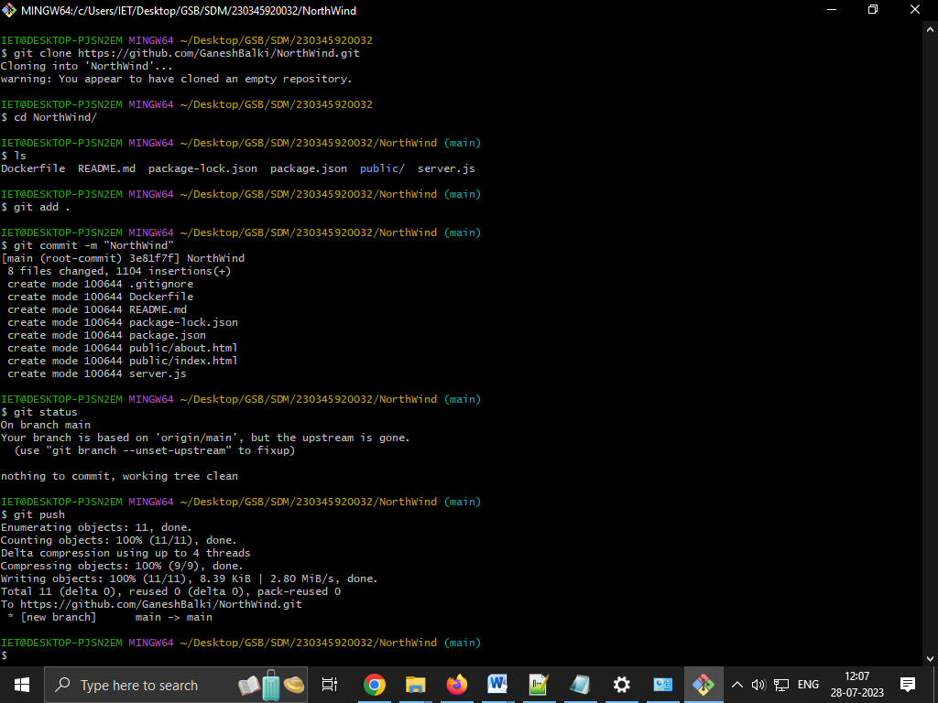

1. CREATE LINUX AMAZON VIRTUAL SERVER USING YOUR FREE TRIAL AWS SUBSCRIPTION

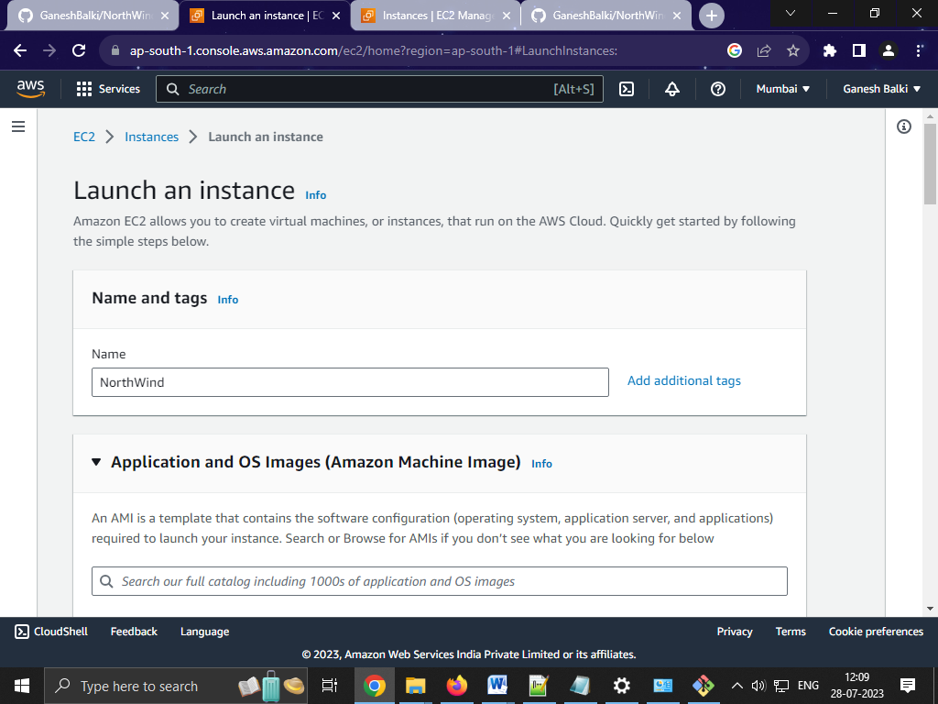

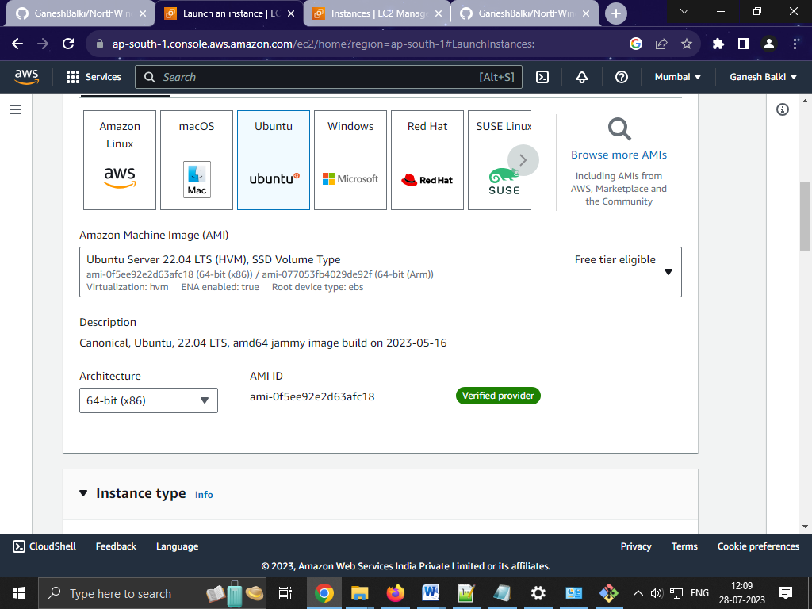

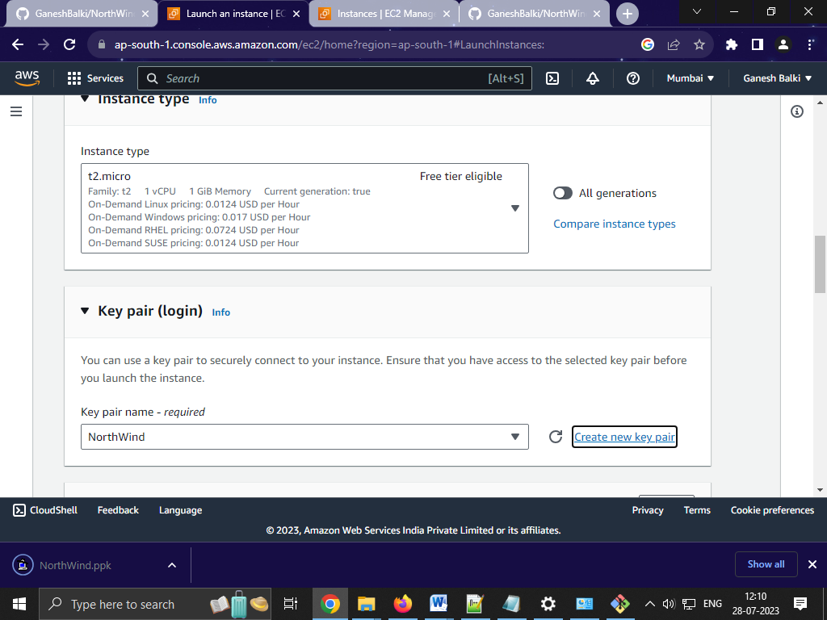

1. ACCESSS VIRTUAL SERVER OF LINUX CREATED CREATED IN AWS USING LINUX SHELL

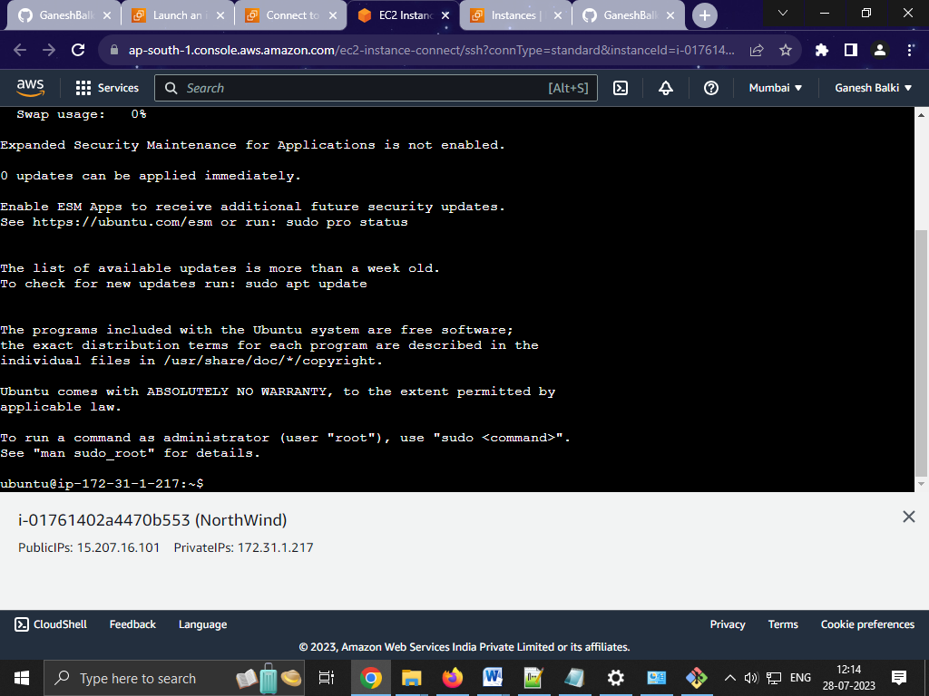

1. UPDATE LINUX WITH LATEST PATCH

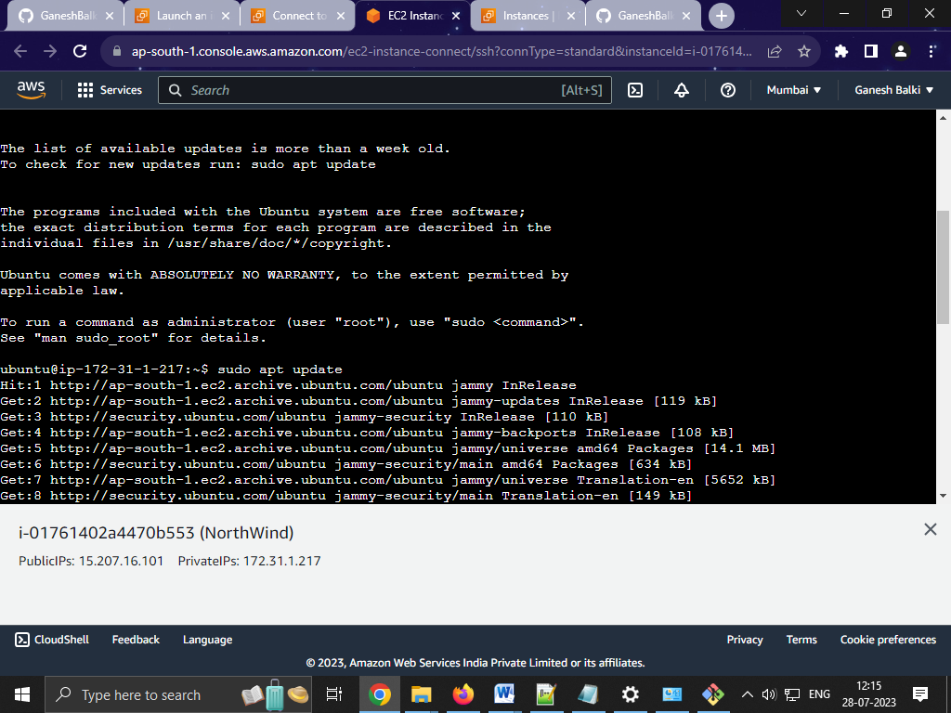

1. INSTALL GIT CLIENT IN LINUX VIRTUAL SERVER

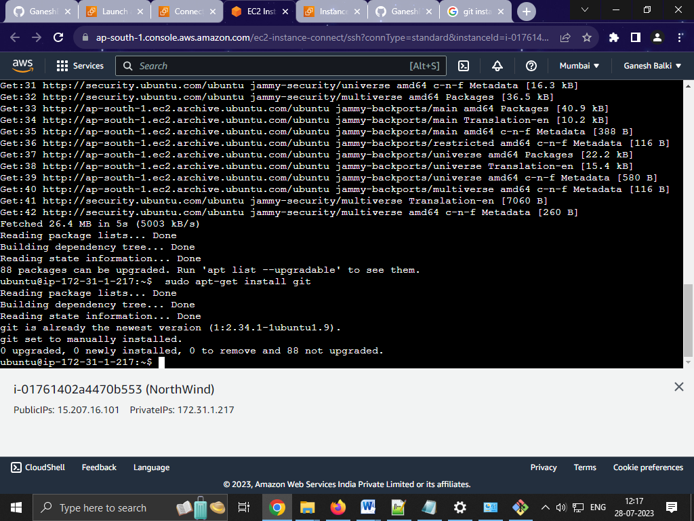

1. CLONE NORTHWIND PUBLIC CODE REPOSITORY TO VIRTUAL SERVER

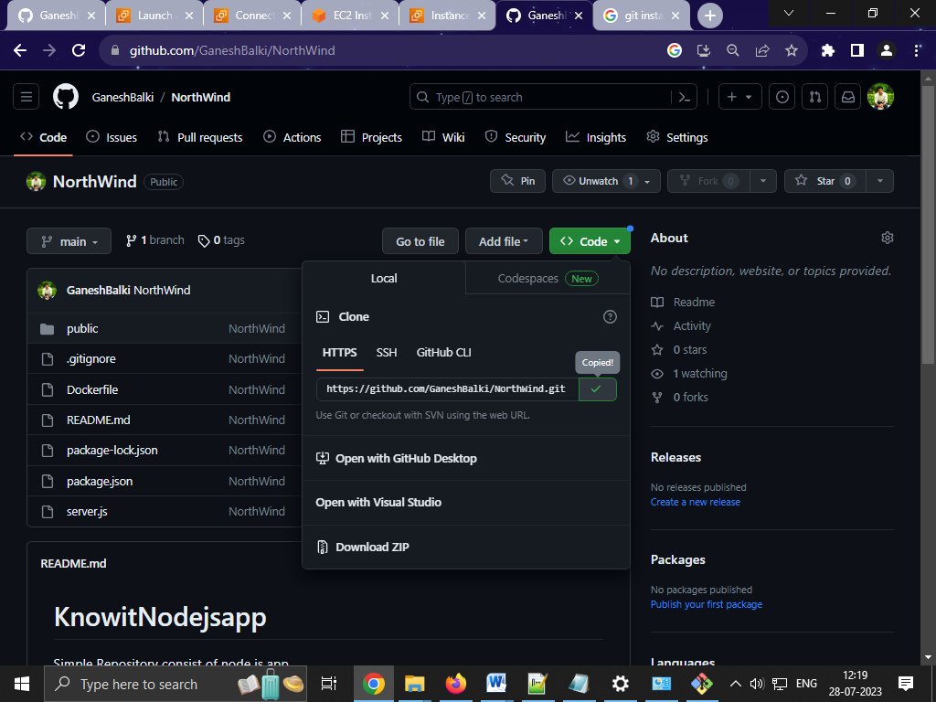

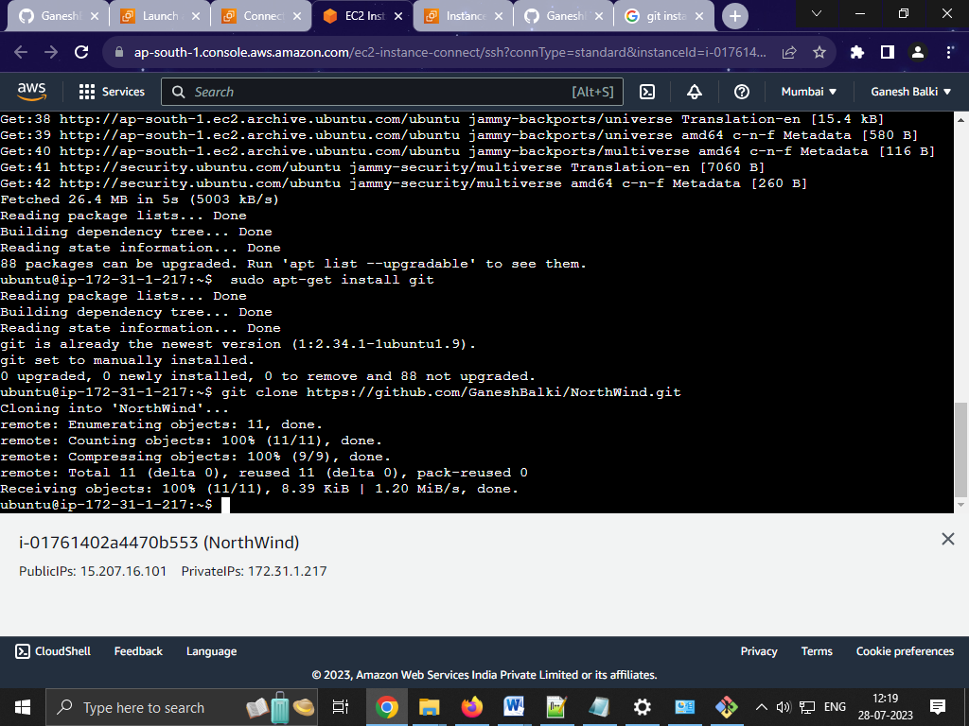

1. INSTALL DOCKER TO LINUX VIRTAL SERVER

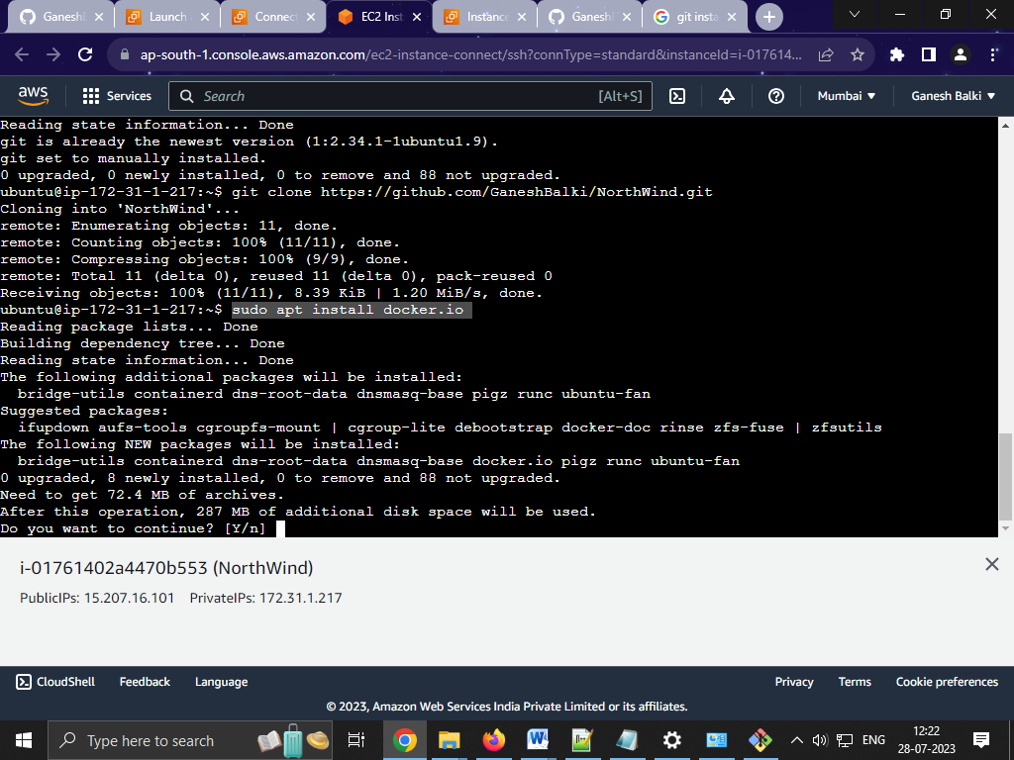

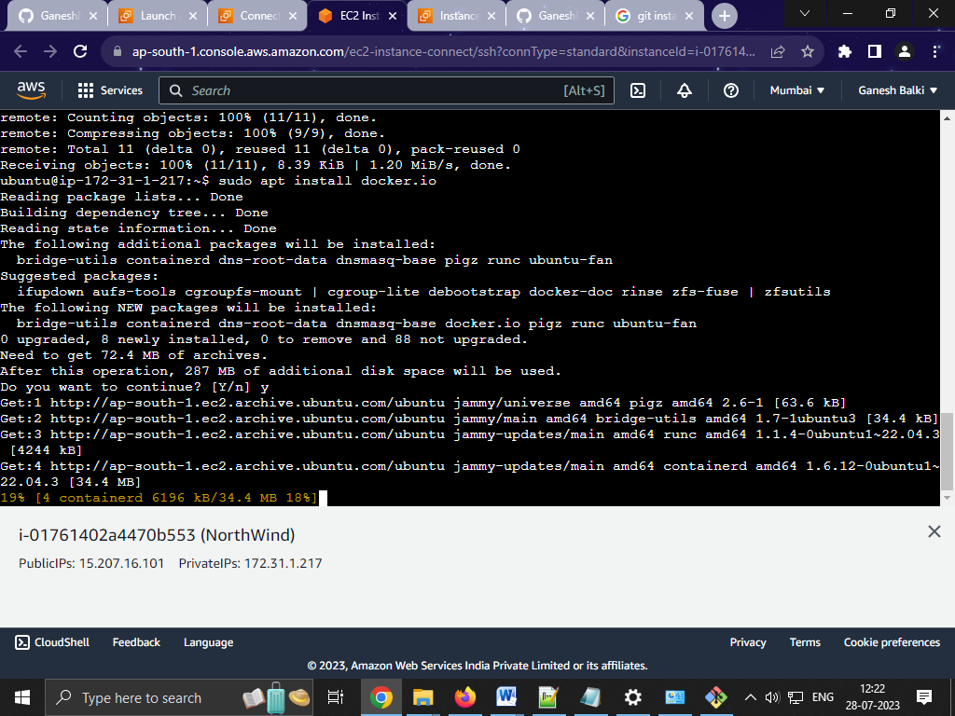

1. SHOW THE STATUS OF DOCKER AS RUNNING

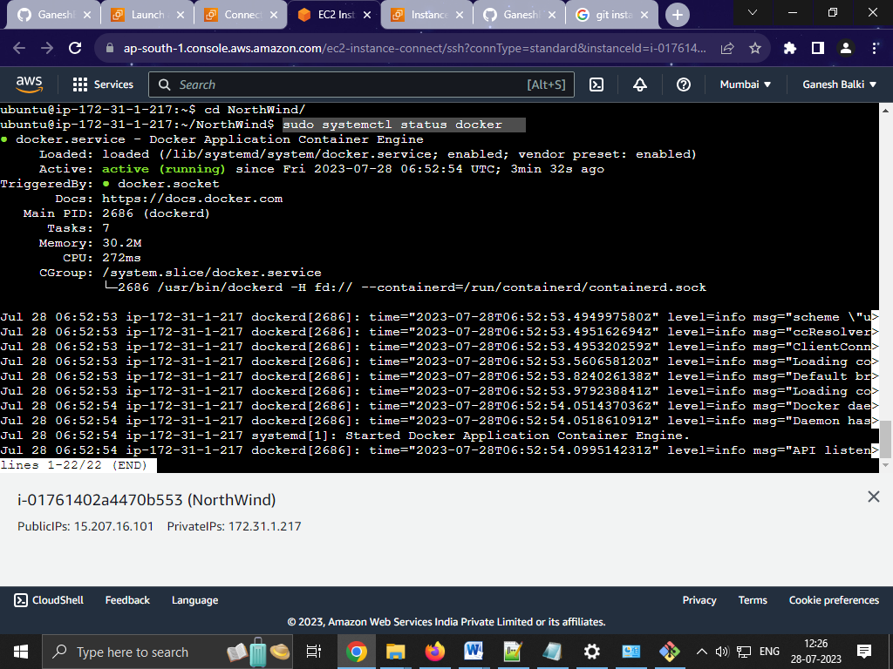

1. BUILD DOCKER CONTAINER IMAGE FOR NARTHWIND APPLICATION WHICH IS CLONED TO VIRTUAL SERVER

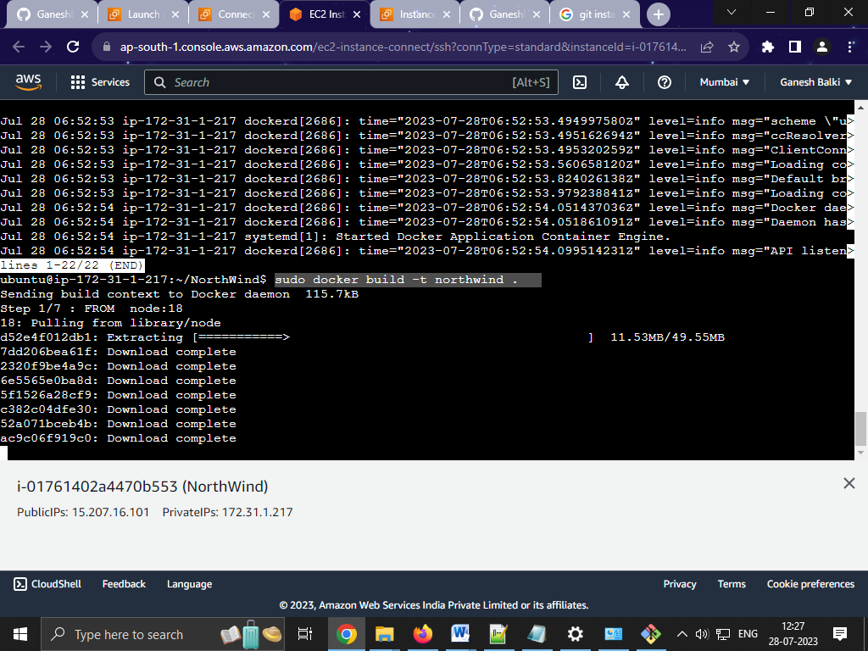

1. ENSURE DOCKER CONTAINER IMAGES ARE DOWNLOADED TO VIRTUAL SERVER

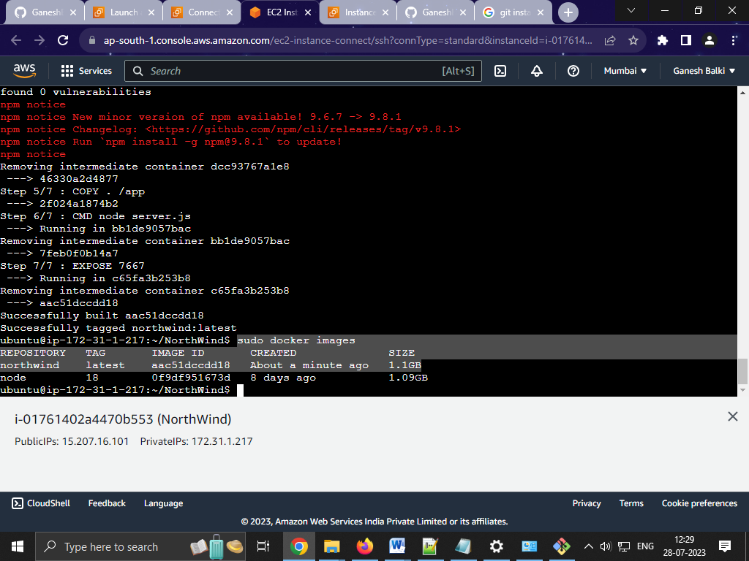

1. RUN CONTAINER INSTANCE OF NORTHWIND USING DOCKER COMMAD

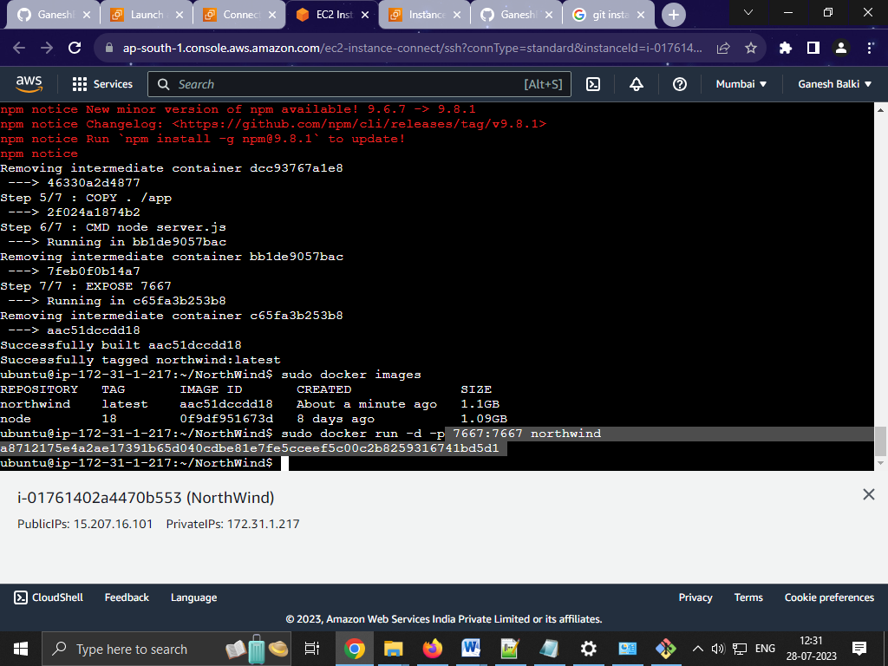

1. LIST DOWN CONTAINER INSTANCES RUNNING DOCKER ON LINUX VIRUAL SERVER

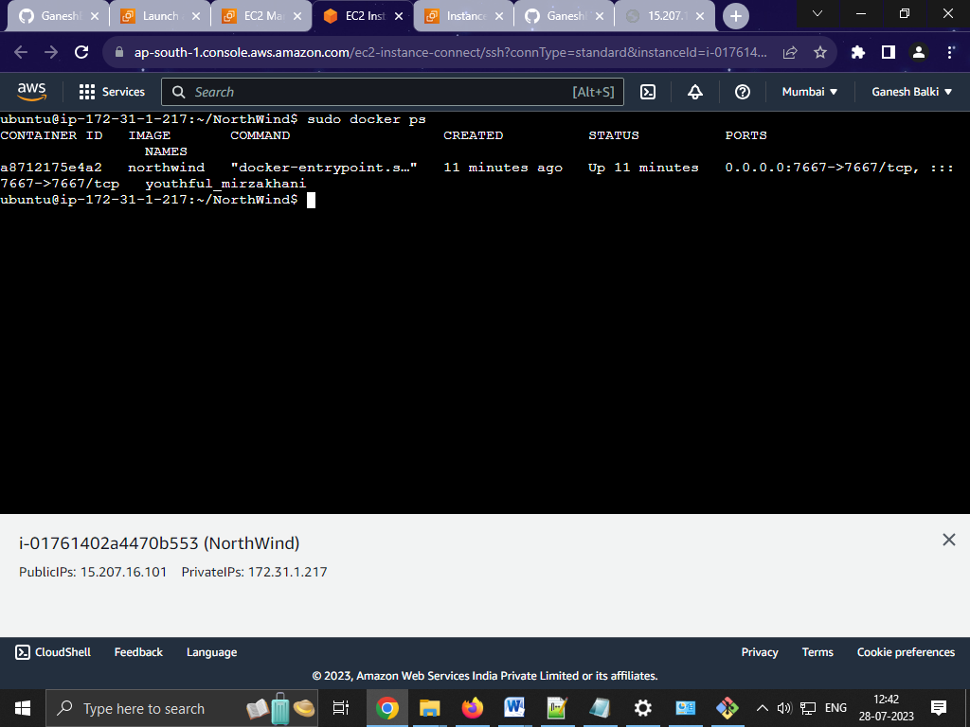

1. ALLOW ALL TRAFFIC TO ACCEPTED BY SETTING FIREWALL INCOMING RULE.

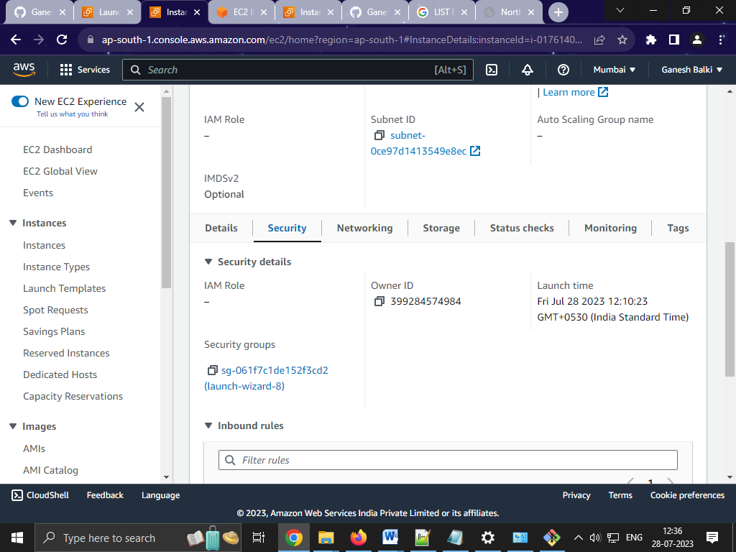

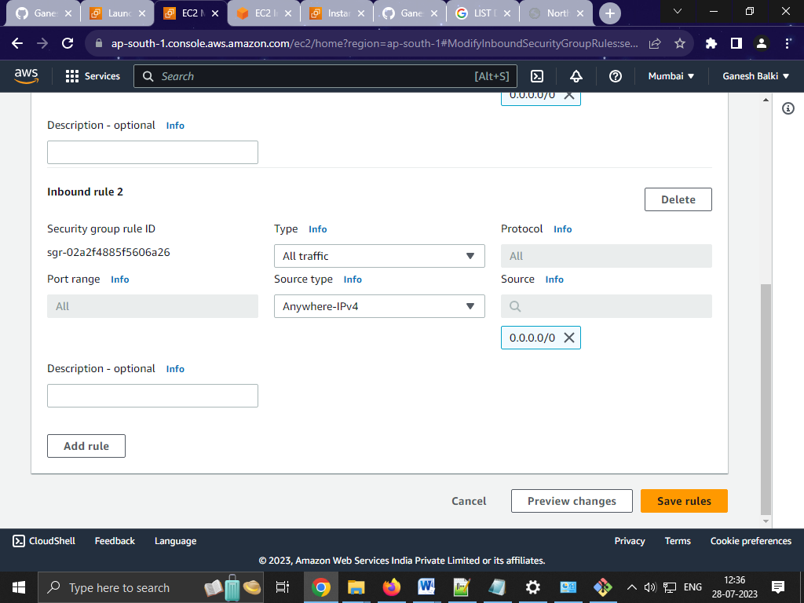

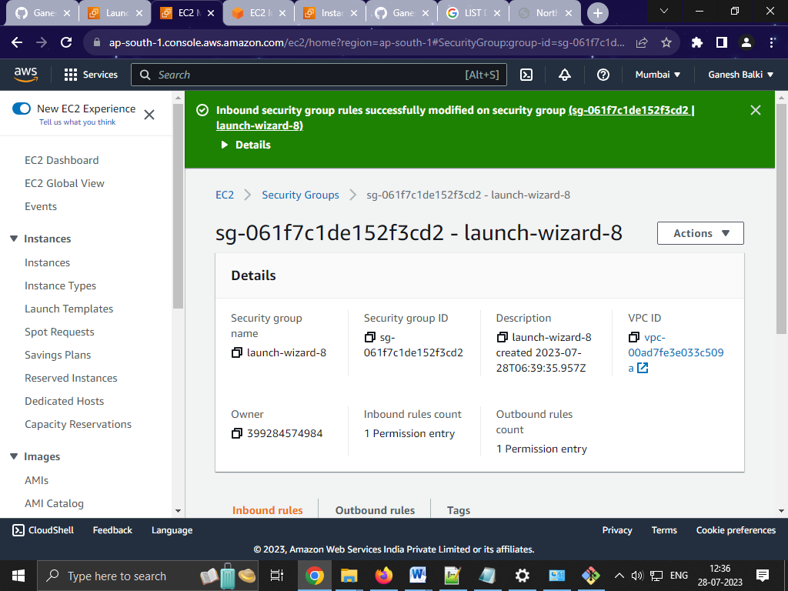

1. ACCESS HOSTED WEBSITE USING YOUR BROWSER AND SHOW PAGE OF WEBSITE.

