Aim of the paper
The paper discusses an algorithm to detect intersections in a road from the bird’s eye view.

Relevant work
Earlier papers implemented this using a video-based solution. But due to poor lighting conditions, and interference from other vehicles make this approach difficult.

Explanation of the algorithm
The algorithm first scans the environment using LiDAR sensors. A beam will be launched in adaptive distance in front of the autonomous vehicle. This can be used to detect all obstacles i.e people, trees, curbs, other vehicles, etc. Then the algorithm revomes other obstacles to keep only curbs and trees. This is then fed into the classification algorithm which classifies the road as a T-intersection, cross intersection, normal intersection or no intersection.
The beams are launched from the vehicle at an adaptive distance i.e. The distance changes with respect to the speed of the vehicle. If the vehicle is slower, distance is short, and if it is faster, the distance is longer. 360 beams are fired at once, with a separation of 1 degree between them. The beams are numbered from 0 to 359.
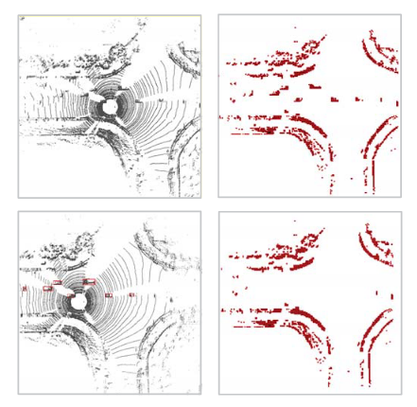

This is the binary image created using LiDAR sensor.
Essentially a grid is created with a cell for each point in the point cloud. A point cloud is a set of points in space.
Using the data from LiDAR sensor, only curbs and trees are extracted.

After the beam is fired, the feature set is made using the length of the beams. The lengths are normalized. Thus the feature is a 360-D vector.
Now the problem is formulated as a classification problem with the above feature set.

Testing the data
Now the test data is divided into two groups. First one is less complex than the second one. On test data 1 the accuracy is around 93.62 %. On test data 2 the accuracy is around 82.5%.

Drawbacks of the paper
For complex data sets, with more traffic the accuracy of the algorithm falls. It also doesn’t detect direction of the intersection.

.

