**ERR Diagram:**

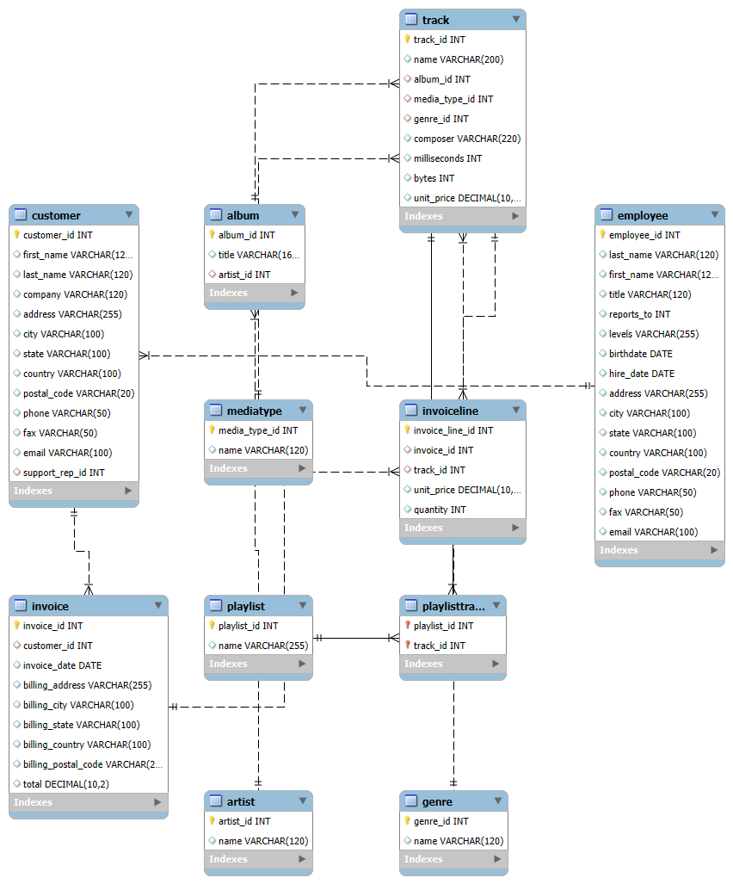

**1. Customer Table**

**Primary Key (PK):** customer_id

**Attributes:** first_name, last_name, company, address, city, state, country, postal_code, phone, fax, email, support_rep_id.

**Foreign Key (FK):** support_rep_id → employee.employee_id

(Each customer may have a support representative assigned.)

**Relationships:**

One-to-Many: Customer → Invoice (a customer can have many invoices).

Many-to-One: Customer → Employee (many customers can be assigned to one employee).

**2. Employee Table**

**PK:** employee_id

**Attributes:** last_name, first_name, title, reports_to, levels, birthdate, hire_date, address, city, state, country, postal_code, phone, fax, email.

**FK:** reports_to → employee.employee_id (self-referencing hierarchy).

**Relationships:**

One-to-Many (self): An employee can manage other employees.

One-to-Many: Employee → Customer (employees support many customers).

**3. Invoice Table**

**PK:** invoice_id

**Attributes:** customer_id, invoice_date, billing_address, billing_city, billing_state, billing_country, billing_postal_code, total.

**FK:** customer_id → customer.customer_id

**Relationships:**

Many-to-One: Invoice → Customer (an invoice belongs to a single customer).

One-to-Many: Invoice → InvoiceLine (an invoice contains multiple lines/tracks).

**4. InvoiceLine Table**

**PK:** invoice_line_id

**Attributes:** invoice_id, track_id, unit_price, quantity.

**FKs:**

invoice_id → invoice.invoice_id

track_id → track.track_id

**Relationships:**

**Many-to-One:** InvoiceLine → Invoice (line belongs to one invoice).

**Many-to-One:** InvoiceLine → Track (line references one track).

**5. Track Table**

**PK:** track_id

**Attributes:** name, album_id, media_type_id, genre_id, composer, milliseconds, bytes, unit_price.

**FKs:**

album_id → album.album_id

media_type_id → mediatype.media_type_id

genre_id → genre.genre_id

**Relationships:**

Many-to-One: Track → Album, Track → Mediatype, Track → Genre.

One-to-Many: Track → InvoiceLine (a track can appear on many invoices).

Many-to-Many: Track ↔ Playlist (via PlaylistTrack).

**6. Album Table**

**PK:** album_id

**Attributes:** title, artist_id.

**FK:** artist_id → artist.artist_id

**Relationships:**

Many-to-One: Album → Artist.

One-to-Many: Album → Track (an album contains multiple tracks).

**7. Artist Table**

**PK:** artist_id

**Attributes:** name.

**Relationships:**

One-to-Many: Artist → Album (an artist can have multiple albums).

**8. MediaType Table**

**PK:** media_type_id

**Attributes:** name.

**Relationships:**

One-to-Many: Mediatype → Track (tracks are available in various media types).

**9. Genre Table**

**PK:** genre_id

**Attributes:** name.

**Relationships:**

One-to-Many: Genre → Track.

**10. Playlist Table**

**PK:** playlist_id

**Attributes:** name.

**Relationships:**

Many-to-Many: Playlist ↔ Track (via PlaylistTrack).

**11. PlaylistTrack Table**

**Composite PK:** (playlist_id, track_id)

**FKs:**

playlist_id → playlist.playlist_id

track_id → track.track_id

**Relationships:**

Implements many-to-many relationship between Playlist and Track.

**Relationships Overview:**

**One-to-Many:**

Customer → Invoice

Invoice → InvoiceLine

Employee → Customer

Employee (self) → Employee (reports_to hierarchy)

Artist → Album

Album → Track

Genre → Track

MediaType → Track

Track → InvoiceLine

**Many-to-Many:**

Playlist ↔ Track (via PlaylistTrack).

**One-to-One:**

Not explicitly present (though Employee self-reporting can mimic hierarchy but not strictly one-to-one).

Not explicitly present (though Employee self-reporting can mimic hierarchy but not strictly one-to-one).