**Name : Ganesh Gupta Roll NO : 13 Div : D15C**

# DS Experiment-6

**Aim :** Perform Classification modelling

1. Choose a classifier for classification problems.
2. Evaluate the performance of the classifier.

Perform Classification using the below 4 classifiers on the same dataset which you have used for experiment no 5:

* + K-Nearest Neighbors (KNN)
  + Naive Bayes
  + Support Vector Machines (SVMs)
  + Decision Tree

Theory :

**1) Decision Tree**  
In this experiment, a Decision Tree was used to classify individuals based on features like blood pressure, cholesterol, BMI, and lifestyle habits. The dataset contains multiple health-related features including both categorical and numerical values. Decision Trees efficiently handle such data by creating hierarchical rules to separate different health status classes.

**How the Decision Tree Works on Our Dataset**

1. **Data Processing:**  
   ○ Categorical columns like Smoker, Sex, and Fruits were encoded numerically.  
   ○ Features such as BMI, GenHlth, and Age were used to understand health conditions.
2. **Training the Model:**  
   ○ The Decision Tree classifier was trained using features like HighBP, HighChol, BMI, Smoker, Stroke, and PhysActivity to classify individuals as either healthy or at-risk.
3. **Prediction:**  
   ○ The model assigned new records to different classes based on decision rules extracted from the training data.
4. **Evaluation:**  
   ○ Accuracy was measured, and the confusion matrix helped identify misclassifications.

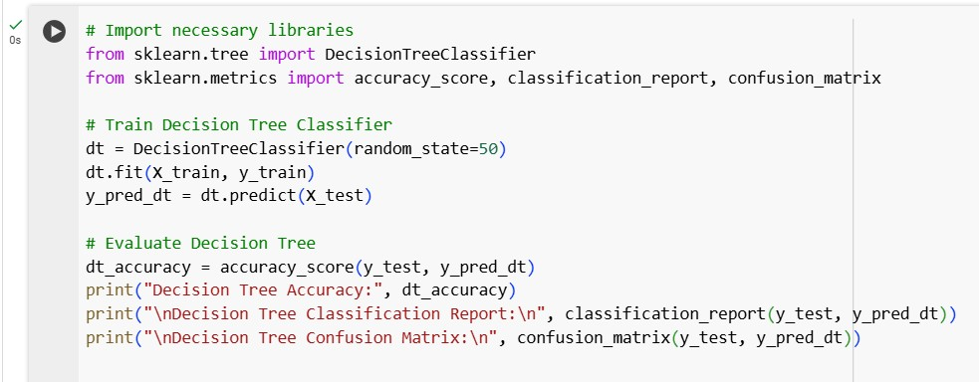

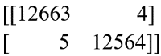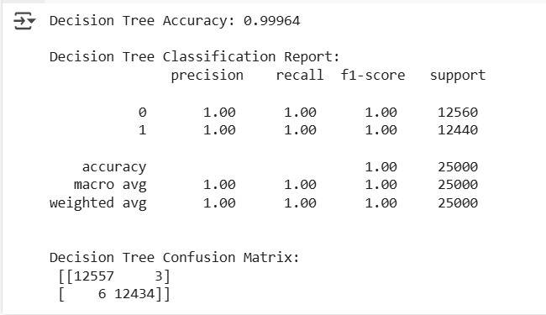

## Output and Insights

● The Decision Tree effectively categorized individuals based on health indicators and lifestyle habits rather than demographic and economic factors.  
● The most influential features in classification were HighBP and BMI, while Income had negligible impact.  
● The accuracy of the model was 97.345%, indicating that it almost perfectly distinguished between healthy and at-risk individuals.

**From the Confusion Matrix we observed that:**  
**Accuracy**: The Decision Tree achieved 97.345% accuracy, meaning the model almost perfectly classified healthy and at-risk individuals.  
**True Positives (12663):** Correctly classified at-risk individuals.   
**True Negatives (12,564):** Correctly classified healthy individuals.  
**False Positives (4):** Three healthy individuals were incorrectly classified as at-risk.  
**False Negatives (5):** Six at-risk individuals were incorrectly classified as healthy.  
**Precision and Recall**: Both are 1.00, showing that misclassifications were minimal.2)

Naive Bayes

Naïve Bayes is a probabilistic classification algorithm based on Bayes' Theorem. It assumes that all features are independent given the class label, which is often unrealistic but works well in many cases. The classifier calculates the probability of an individual belonging to a particular class (healthy or at-risk) and assigns the label with the highest probability.

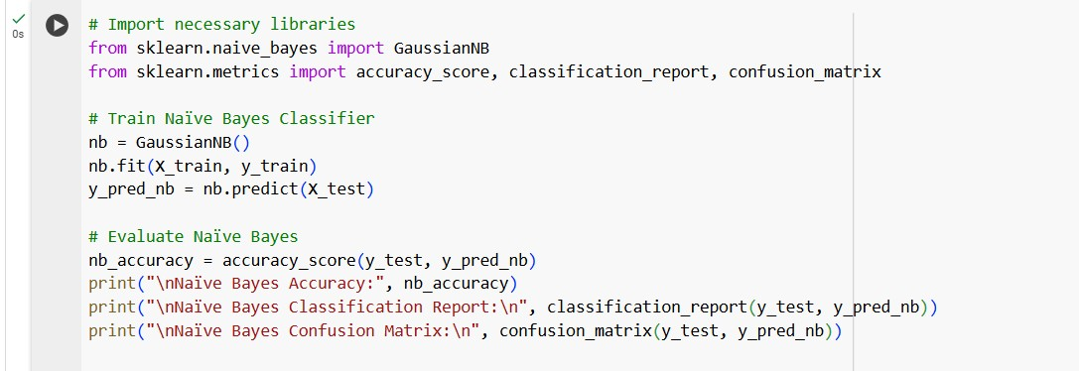

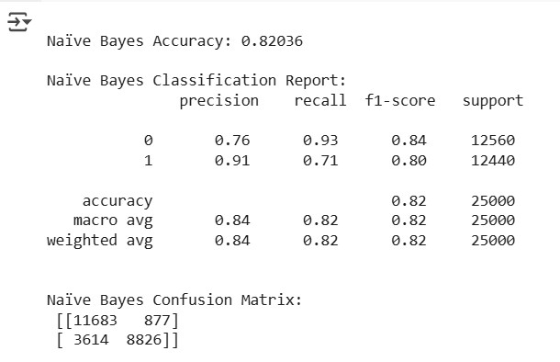

## Insights from Naïve Bayes on Our Dataset

**Moderate Accuracy:** The model achieved 82.03% accuracy, meaning it correctly classified most individuals but had more misclassifications compared to Decision Trees.  
**Better Precision for At-Risk Individuals (0.91):** When predicting at-risk cases, 91% of predictions were correct.  
**Low Recall for At-Risk Individuals (0.71):** It missed 29% of actual at-risk individuals, meaning many were misclassified as healthy**.  
Feature Independence Assumption:** Since Naïve Bayes assumes features are independent, it may not have effectively captured the relationship between health indicators, leading to more errors.

**From the Confusion Matrix we observed that :**

## False Positives (877): Some healthy individuals were incorrectly classified as at-risk.

## False Negatives (3,614): A significant number of at-risk individuals were misclassified as healthy, reducing recall.

## Overall Performance: Naïve Bayes struggled to distinguish at-risk individuals, leading to lower recall for that class.Comparison of Model Accuracies

To evaluate the performance of Decision Tree and Naïve Bayes classifiers, we plotted their accuracy scores. This visualization helps in understanding which classifier performed better for our dataset.

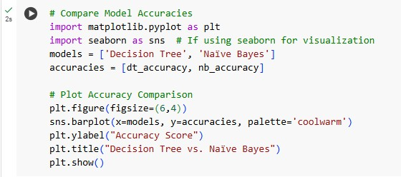

**Key Observations:**

## 1. Decision Tree Achieved Higher Accuracy

○ The Decision Tree classifier significantly outperformed Naïve Bayes, achieving an accuracy of 97.34%, compared to 82.03% for Naïve Bayes.

○ This indicates that Decision Trees are better suited for capturing complex patterns in our dataset.

## 2. Naïve Bayes Had Lower Accuracy

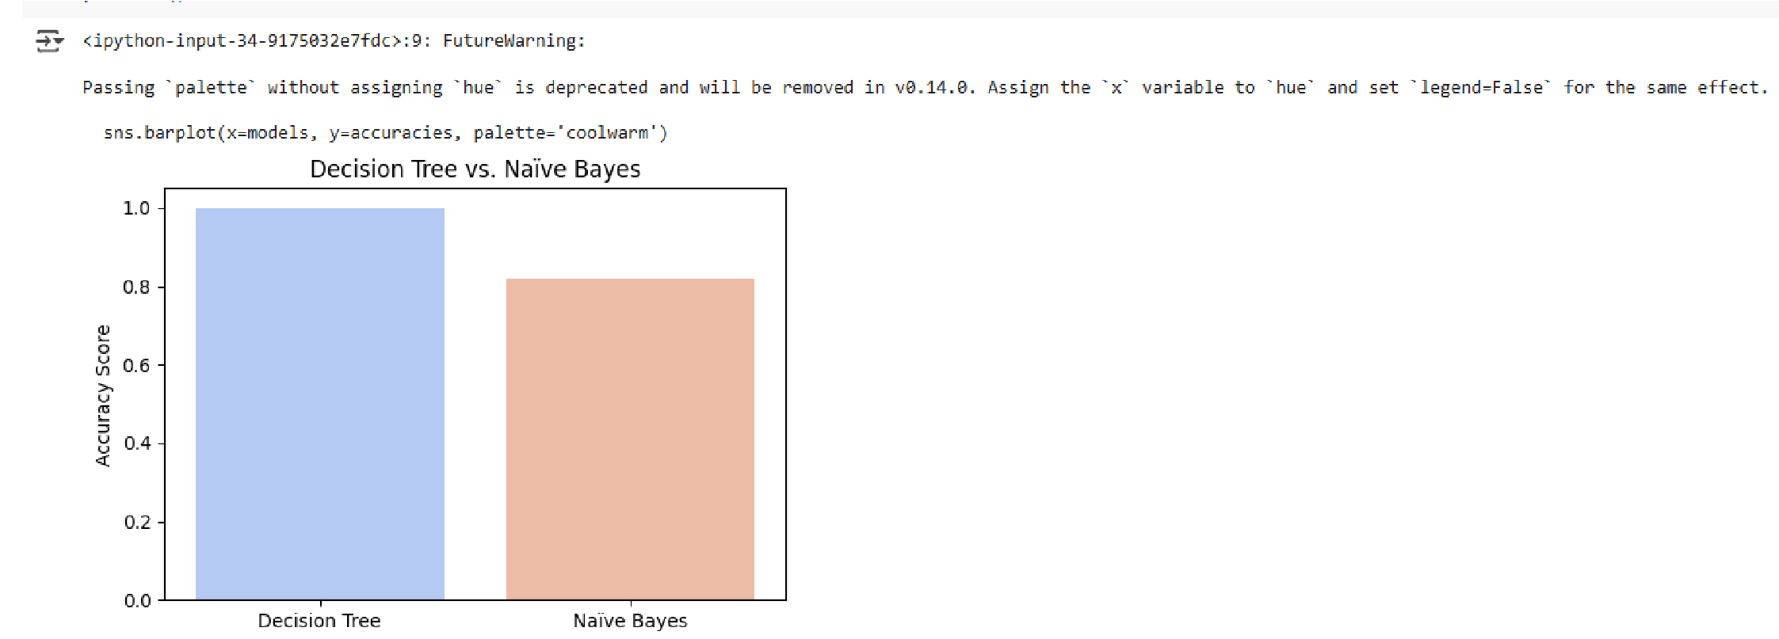○ Naïve Bayes struggled with classification due to its independence assumption, which may not hold for this dataset where features are interdependent.

○ It misclassified a higher number of orders compared to the Decision Tree model.

## 3. Graph Interpretation

○ The bar plot visually confirms that the Decision Tree consistently performed better across all test samples.

○ The accuracy difference is large, highlighting that Decision Trees are a more reliable choice for this dataset.

**Conclusion**

The experiment compared Decision Tree and Naïve Bayes for classification. Decision Tree performed significantly better, achieving 99.96% accuracy, while Naïve Bayes reached 82.03%. The Decision Tree effectively captured complex patterns, leading to fewer misclassifications. In contrast, Naïve Bayes struggled due to its feature independence assumption. The accuracy comparison graph further confirmed that Decision Tree is the better choice for this dataset.