**Demonstration of UNIX Commands.**

1. Write the sequence of commands to

* list the files from C2
* delete the file from C1 which ends with .sh
* change the name of file any one file which exist in C1 to temp.prg

C2

OSPP

C1

MC

CSE

* To create Directory CSE **mkdir CSE**
* Go to CSE directory through **cd CSE**
* Under CSE Create 2 Sub Directory OSPP and MC using

**mkdir OSPP** and **mkdir MC.**

* Under OSPP Create 2 Sub Directory C1 and C2 using **mkdir C1** and **mkdir C2.**
* Go to OSPP Directory using **cd C1** and **cd C2**
* To list the file from C2.

**Cd C2**

**ls**

* To Delete the files from C1 which end with .sh

**cd ..**

**cd C1**

**rm *.sh**

* To change Name of the file...

**rv file1.txt temp.prg**

1. Write a command know the memory occupied by a file.

**ls -shR**

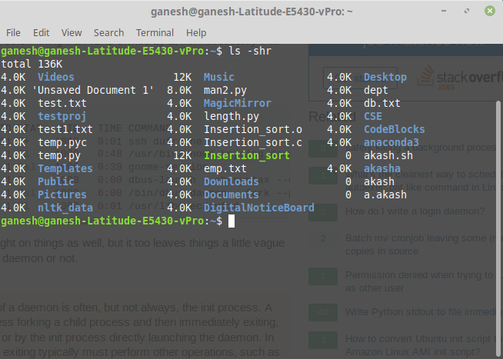

1. How do display all process running on your system?

**Ps**

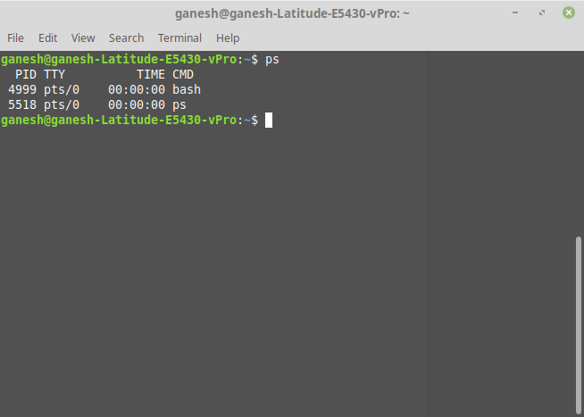

1. How do you compare the efficiency of the programs test1.c and test2.c(any two c programs) ?

**realtime1=$(mktemp)**

**realtime2=$(mktemp)**

**\time -o "${realtime1}" -f "%e" sleep 5 &**

**\time -o "${realtime2}" -f "%e" sleep 10 &**

**wait**

**printf "Number of seconds used by program1: %s\n" $ (cat "${realtime1}")**

**printf "Number of seconds used by program2: %s\n" $ (cat "${realtime2}")**

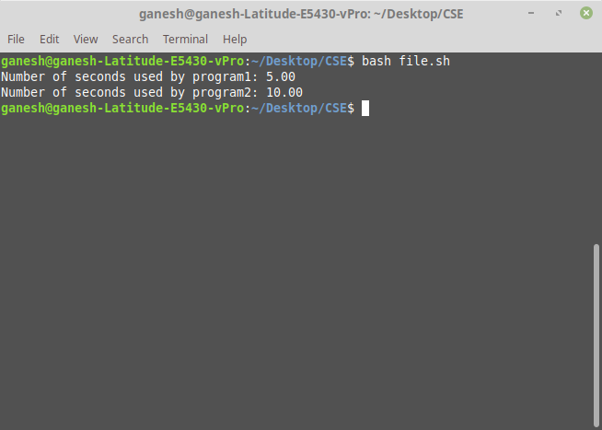

5. Write a command to kill zombie process.

To find Zombie Process...

**pps aux | grep Z**

To Kill Zombie Process...

**kill -s SIGCHLD pid**

6. Identify three demon processes and tasks they perform.

**ps -xj**

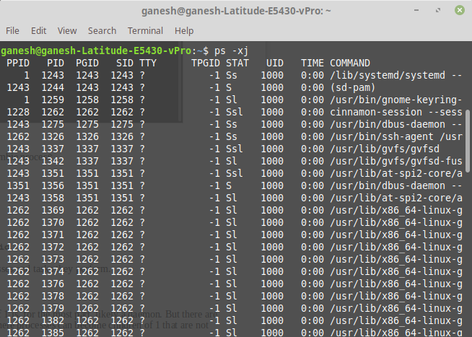

Anything with the PPID of 1 is, for the most part, likely a daemon. But there are situations that can arise where processes can become children of 1 that are not technically daemons.