Demonstration of UNIX Commands.

- Write the sequence of commands to

- list the files from C2
- delete the file from C1 which ends with .sh
- change the name of file any one file which exist in C1 to temp.prg

C2
OSPP
C1
MC
CSE

- To create Directory CSE mkdir CSE
- Go to CSE directory through cd CSE
- Under CSE Create 2 Sub Directory OSPP and MC using
mkdir OSPP and mkdir MC.
- Under OSPP Create 2 Sub Directory C1 and C2 using mkdir C1 and mkdir C2.
- Go to OSPP Directory using cd C1 and cd C2
- To list the file from C2.
Cd C2
ls
- To Delete the files from C1 which end with .sh
cd ..
cd C1
rm *.sh
- To change Name of the file...
rv file1.txt temp.prg

- Write a command know the memory occupied by a file.
ls -shR
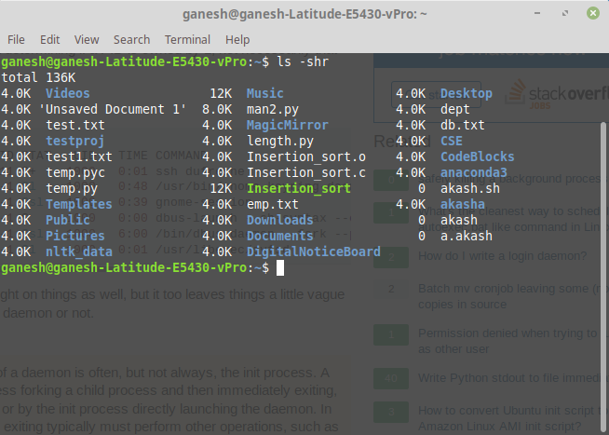

- How do display all process running on your system?
Ps
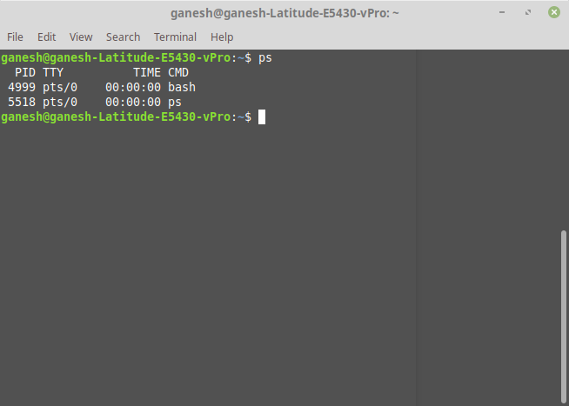

- How do you compare the efficiency of the programs test1.c and test2.c(any two c programs) ?
realtime1=$(mktemp)
realtime2=$(mktemp)
\time -o "${realtime1}" -f "%e" sleep 5 &
\time -o "${realtime2}" -f "%e" sleep 10 &
wait
printf "Number of seconds used by program1: %s\n" $ (cat "${realtime1}")
printf "Number of seconds used by program2: %s\n" $ (cat "${realtime2}")
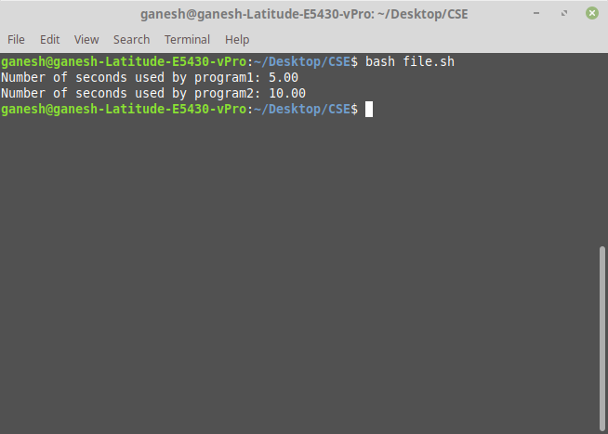
5. Write a command to kill zombie process.
To find Zombie Process...
pps aux | grep Z
To Kill Zombie Process...
kill -s SIGCHLD pid
6. Identify three demon processes and tasks they perform.
ps -xj
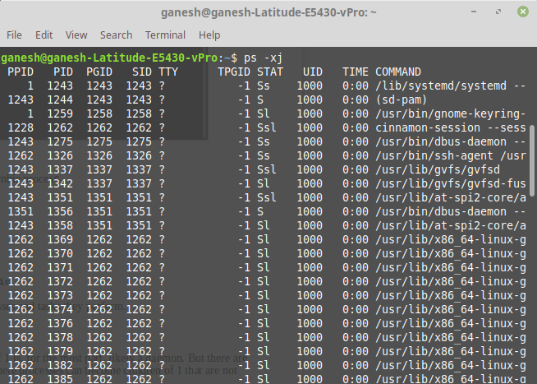

Anything with the PPID of 1 is, for the most part, likely a daemon. But there are situations that can arise where processes can become children of 1 that are not technically daemons.

