**Case Study:** .NET Core Clean architecture, CQRS, MediatR, Specification, Repository Design pattern

**Business Usecases**

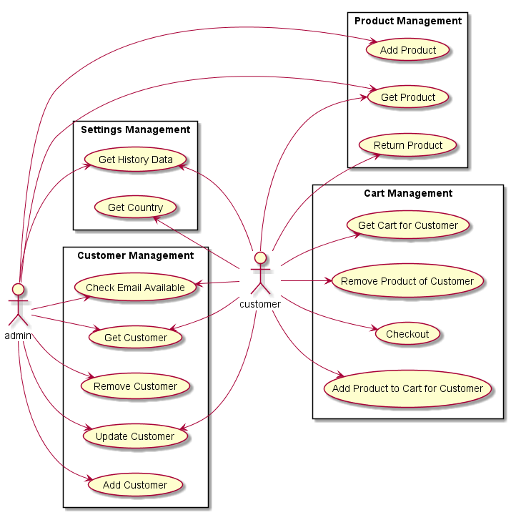

# High level context

ERD:

