**Objectives**

**- solution link:**

**https://github.com/cpit252/lab-04/tree/main/src/main/java/sa/edu/kau/fcit/cpit252/lab4BuilderFactory**

**In this lab you will**

1. **understand a real-world scenario and choose when to apply the appropriate design pattern.**
2. **design and implement the builder design pattern.**
3. **design and implement the factory method design pattern.**
4. **write unit tests and apply Test-Driven Development (TDD).**

**Problem Statement**

A developer is working on a game that features characters from the famed fantasy novel, [the Lord of the Rings ↗](https://en.wikipedia.org/wiki/The_Lord_of_the_Rings). She’s working on a feature that allows users to create avatars that reflect and represent the characters in the novel. An *avatar* is a graphical representation of a user or a user’s character. The creation of an avatar is inherently a step-by-step process. You start with a skin tone and additional facial features such as hair, eye brows, mustache, eyeglasses each of which has different styles. This feature is inspired by the highly customized and inclusive feature of creating an avatar in the Snapchat app, which is also named a *Bitmoji* and shown below.

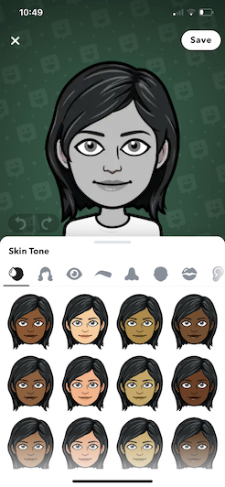

She started working on three characters: *Aragorn*, *Legolas*, and *Frodo Baggins*. These characters will be represented by three avatars: Knight, Archer, and  Flag Bearer respectively. These avatars can be customized with different skin tones, hair colors, hair types, body types and a set of facial features.

