Assignment_4

Ganesh Reddy

2023-11-12

## Loading the Required packages

library(flexclust)

## Warning: package 'flexclust' was built under R version 4.3.2

## Loading required package: grid

## Loading required package: lattice

## Loading required package: modeltools

## Loading required package: stats4

library(cluster)  
library(tidyverse)

## ── Attaching core tidyverse packages ──────────────────────── tidyverse 2.0.0 ──  
## ✔ dplyr 1.1.3 ✔ readr 2.1.4  
## ✔ forcats 1.0.0 ✔ stringr 1.5.0  
## ✔ ggplot2 3.4.3 ✔ tibble 3.2.1  
## ✔ lubridate 1.9.3 ✔ tidyr 1.3.0  
## ✔ purrr 1.0.2

## ── Conflicts ────────────────────────────────────────── tidyverse_conflicts() ──  
## ✖ dplyr::filter() masks stats::filter()  
## ✖ dplyr::lag() masks stats::lag()  
## ℹ Use the conflicted package (<http://conflicted.r-lib.org/>) to force all conflicts to become errors

library(factoextra)

## Warning: package 'factoextra' was built under R version 4.3.2

## Welcome! Want to learn more? See two factoextra-related books at https://goo.gl/ve3WBa

library(FactoMineR)

## Warning: package 'FactoMineR' was built under R version 4.3.2

library(ggcorrplot)

## Warning: package 'ggcorrplot' was built under R version 4.3.2

## 1.Use only the numerical variables (1 to 9) to cluster the 21 firms. Justify the various choices made in conducting the cluster analysis, such as weights for different variables, the specific clustering algorithm(s) used, the number of clusters formed, and so on.

### Loading the data

pharma<- read.csv("Pharmaceuticals.csv")  
  
head(pharma)

## Symbol Name Market_Cap Beta PE_Ratio ROE ROA Asset_Turnover  
## 1 ABT Abbott Laboratories 68.44 0.32 24.7 26.4 11.8 0.7  
## 2 AGN Allergan, Inc. 7.58 0.41 82.5 12.9 5.5 0.9  
## 3 AHM Amersham plc 6.30 0.46 20.7 14.9 7.8 0.9  
## 4 AZN AstraZeneca PLC 67.63 0.52 21.5 27.4 15.4 0.9  
## 5 AVE Aventis 47.16 0.32 20.1 21.8 7.5 0.6  
## 6 BAY Bayer AG 16.90 1.11 27.9 3.9 1.4 0.6  
## Leverage Rev_Growth Net_Profit_Margin Median_Recommendation Location Exchange  
## 1 0.42 7.54 16.1 Moderate Buy US NYSE  
## 2 0.60 9.16 5.5 Moderate Buy CANADA NYSE  
## 3 0.27 7.05 11.2 Strong Buy UK NYSE  
## 4 0.00 15.00 18.0 Moderate Sell UK NYSE  
## 5 0.34 26.81 12.9 Moderate Buy FRANCE NYSE  
## 6 0.00 -3.17 2.6 Hold GERMANY NYSE

## Choosing columns 3 to 11 now, and putting the information in variable Info 1

pharma1 <- pharma[3:11]  
  
head(pharma1)

## Market_Cap Beta PE_Ratio ROE ROA Asset_Turnover Leverage Rev_Growth  
## 1 68.44 0.32 24.7 26.4 11.8 0.7 0.42 7.54  
## 2 7.58 0.41 82.5 12.9 5.5 0.9 0.60 9.16  
## 3 6.30 0.46 20.7 14.9 7.8 0.9 0.27 7.05  
## 4 67.63 0.52 21.5 27.4 15.4 0.9 0.00 15.00  
## 5 47.16 0.32 20.1 21.8 7.5 0.6 0.34 26.81  
## 6 16.90 1.11 27.9 3.9 1.4 0.6 0.00 -3.17  
## Net_Profit_Margin  
## 1 16.1  
## 2 5.5  
## 3 11.2  
## 4 18.0  
## 5 12.9  
## 6 2.6

summary(pharma1)

## Market_Cap Beta PE_Ratio ROE   
## Min. : 0.41 Min. :0.1800 Min. : 3.60 Min. : 3.9   
## 1st Qu.: 6.30 1st Qu.:0.3500 1st Qu.:18.90 1st Qu.:14.9   
## Median : 48.19 Median :0.4600 Median :21.50 Median :22.6   
## Mean : 57.65 Mean :0.5257 Mean :25.46 Mean :25.8   
## 3rd Qu.: 73.84 3rd Qu.:0.6500 3rd Qu.:27.90 3rd Qu.:31.0   
## Max. :199.47 Max. :1.1100 Max. :82.50 Max. :62.9   
## ROA Asset_Turnover Leverage Rev_Growth   
## Min. : 1.40 Min. :0.3 Min. :0.0000 Min. :-3.17   
## 1st Qu.: 5.70 1st Qu.:0.6 1st Qu.:0.1600 1st Qu.: 6.38   
## Median :11.20 Median :0.6 Median :0.3400 Median : 9.37   
## Mean :10.51 Mean :0.7 Mean :0.5857 Mean :13.37   
## 3rd Qu.:15.00 3rd Qu.:0.9 3rd Qu.:0.6000 3rd Qu.:21.87   
## Max. :20.30 Max. :1.1 Max. :3.5100 Max. :34.21   
## Net_Profit_Margin  
## Min. : 2.6   
## 1st Qu.:11.2   
## Median :16.1   
## Mean :15.7   
## 3rd Qu.:21.1   
## Max. :25.5

### The data in pharma1 and the pharma updated dataframe will be scaled according to the varying weights assigned to each variable along the rows. using the factoextra package’s get dist and fviz dist functions to measure the distance between data rows and visualize the distance matrix

norm_data <- scale(pharma1)  
row.names(norm_data) <- pharma[,1]  
distance <- get_dist(norm_data)  
corr <- cor(norm_data)  
fviz_nbclust(norm_data,kmeans,method = "silhouette")

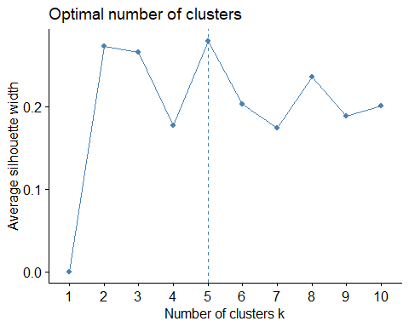

### To check the correlation between key variables, create a correlation matrix and print

corr <- cor(norm_data)  
ggcorrplot(corr, outline.color = "grey50", lab = TRUE, hc.order = TRUE, type = "full")

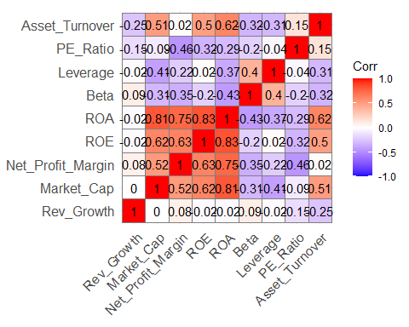

*The ROA, ROE, Net Profit Margin, and Market Cap are all high, according to the Correlation Matrix*

### Finding out the relative importance of the primary variables in the data set will be done using principal component analysis.

assuming the optimal cluster size is 5

pca <- PCA(norm_data)

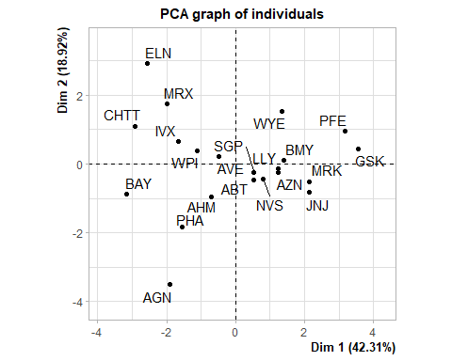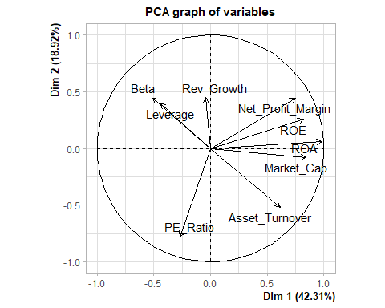

var <- get_pca_var(pca)  
fviz_pca_var(pca, col.var="contrib",  
 gradient.cols = c("grey","yellow","purple","red","blue"),ggrepel = TRUE ) + labs( title = "PCA Variable Variance")

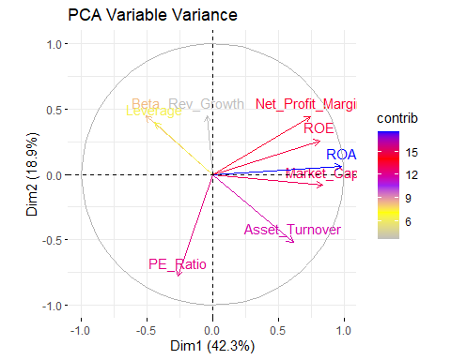

### Using the elbow technique to discover the ideal number of customers, we can infer from PCA Variable Variance that ROA, ROE, Net Profit Margin, Market Cap, and Asset Turnover contribute over 61% to the two PCA components/dimensions Variables

set.seed(10)  
  
wss <- vector()  
for(i in 1:10) wss[i] <- sum(kmeans(norm_data,i)$withinss)  
fviz_nbclust(norm_data, kmeans, method = "wss")

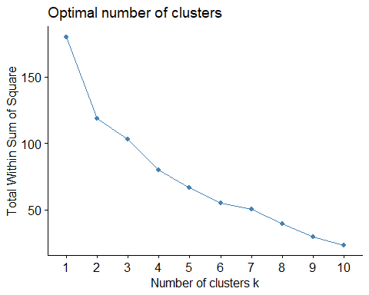

wss

## [1] 180.00000 118.56934 95.99420 79.21748 65.61035 52.67476 47.66961  
## [8] 41.12605 31.81763 31.57252

*Exactly as predicted, the ideal cluster is at number 5.*

## Determining the optimal cluster size.

### Silhouette*

fviz_nbclust(norm_data, kmeans, method = "silhouette")



This demonstrates that five clusters are the optimum number. Using the k-means method to create a 5 clusters.

set.seed(1)  
k5 <- kmeans(norm_data, centers = 5, nstart = 31) # k = 5, number of restarts = 31  
k5$centers

## Market_Cap Beta PE_Ratio ROE ROA Asset_Turnover  
## 1 -0.76022489 0.2796041 -0.47742380 -0.7438022 -0.8107428 -1.2684804  
## 2 -0.43925134 -0.4701800 2.70002464 -0.8349525 -0.9234951 0.2306328  
## 3 -0.03142211 -0.4360989 -0.31724852 0.1950459 0.4083915 0.1729746  
## 4 -0.87051511 1.3409869 -0.05284434 -0.6184015 -1.1928478 -0.4612656  
## 5 1.69558112 -0.1780563 -0.19845823 1.2349879 1.3503431 1.1531640  
## Leverage Rev_Growth Net_Profit_Margin  
## 1 0.06308085 1.5180158 -0.006893899  
## 2 -0.14170336 -0.1168459 -1.416514761  
## 3 -0.27449312 -0.7041516 0.556954446  
## 4 1.36644699 -0.6912914 -1.320000179  
## 5 -0.46807818 0.4671788 0.591242521

k5$size

## [1] 4 2 8 3 4

fviz_cluster(k5, data = norm_data)

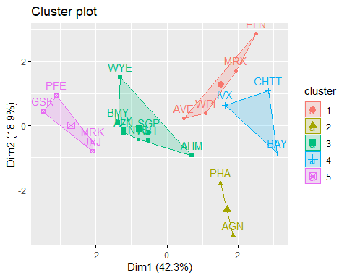

#### Manhattan Distance when using Kmeans Clustering.

set.seed(15)  
k51 = kcca(norm_data, k=5, kccaFamily("kmedians"))  
k51

## kcca object of family 'kmedians'   
##   
## call:  
## kcca(x = norm_data, k = 5, family = kccaFamily("kmedians"))  
##   
## cluster sizes:  
##   
## 1 2 3 4 5   
## 6 5 6 2 2

#### Using predict function.

clusters_index <- predict(k51)  
dist(k51@centers)

## 1 2 3 4  
## 2 3.945545   
## 3 3.168054 2.377053   
## 4 3.724526 4.795056 4.301987   
## 5 3.578425 5.494529 4.448919 4.043870

image(k51)  
points(norm_data, col=clusters_index, pch=19, cex=0.9)

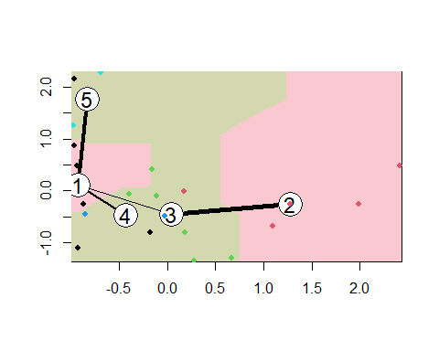

## 2.Interpret the clusters with respect to the numerical variables used in forming the clusters Using Kmeans method to calculate Mean.

pharma1%>% mutate(Cluster = k5$cluster) %>% group_by(Cluster) %>% summarise_all("mean")

## # A tibble: 5 × 10  
## Cluster Market_Cap Beta PE_Ratio ROE ROA Asset_Turnover Leverage  
## <int> <dbl> <dbl> <dbl> <dbl> <dbl> <dbl> <dbl>  
## 1 1 13.1 0.598 17.7 14.6 6.2 0.425 0.635  
## 2 2 31.9 0.405 69.5 13.2 5.6 0.75 0.475  
## 3 3 55.8 0.414 20.3 28.7 12.7 0.738 0.371  
## 4 4 6.64 0.87 24.6 16.5 4.17 0.6 1.65   
## 5 5 157. 0.48 22.2 44.4 17.7 0.95 0.22   
## # ℹ 2 more variables: Rev_Growth <dbl>, Net_Profit_Margin <dbl>

clusplot(norm_data,k5$cluster, main="Clusters",color = TRUE, labels = 2,lines = 0)

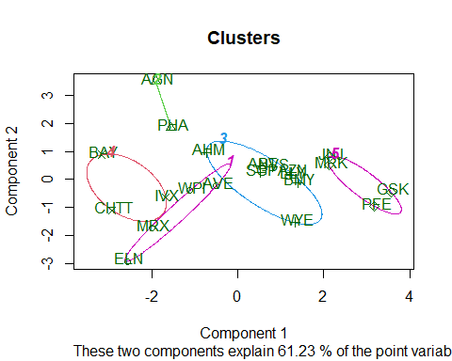

*Companies are categorized into different clusters as follows:*

* Cluster 1: ELN, MRX, WPI and AVE+
* Cluster 2: AGN and PHA+
* Cluster 3: AHM,WYE,BMY,AZN, LLY, ABT, NVS and SGP+
* Cluster 4: BAY, CHTT and IVX+
* Cluster 5: JNJ, MRK, PFE and GSK+

*From the means of the cluster variables, it can be obtain as follow:*

* Cluster 1 has the best Net Profit Margin, the lowest PE ratio, and the fastest sales growth. It can be bought or kept on hand as a reserve.+
* Cluster 2 PE ratio is very high.+
* Cluster 3 has a medium risk.+
* Cluster 4 Despite having an excellent PE ratio, it is incredibly risky to own due to its extremely high risk, extremely high leverage, and poor Net Profit margin. Also very low is revenue growth.+
* Cluster 5 has strong market capitalization, ROI, ROA, ROA on assets, ROA on turnover of assets, and ROA on net profit margin. A low PE ratio indicates that the stock price is moderately valued and may thus be bought and kept. Revenue growth of 18.5% is also favorable.+

### 2B Is there a pattern in the clusters with respect to the numerical variables (10 to 12)?

We can examining patterns by visualizing clusters against the variables

Info_2 <- pharma[12:14] %>% mutate(Clusters=k5$cluster)  
ggplot(Info_2, mapping = aes(factor(Clusters), fill =Median_Recommendation))+geom_bar(position='dodge')+labs(x ='Clusters')

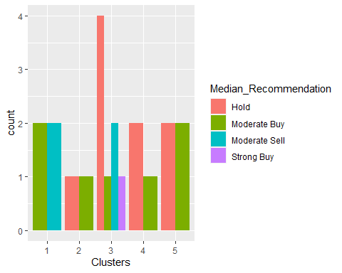

ggplot(Info_2, mapping = aes(factor(Clusters),fill = Location))+geom_bar(position = 'dodge')+labs(x ='Clusters')

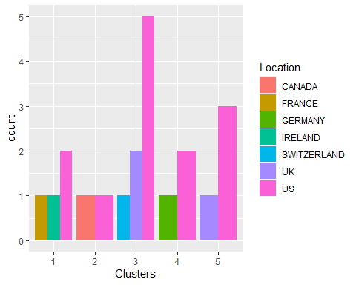

ggplot(Info_2, mapping = aes(factor(Clusters),fill = Exchange))+geom_bar(position = 'dodge')+labs(x ='Clusters')

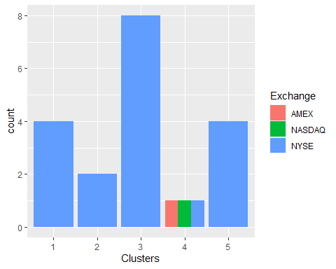

The variable in clusters, There is a trend in the median recommendations  
  
There doesn't seem to be any discernable pattern among the clusters, locations, or exchanges other than the fact that the majority of the clusters/companies are listed on the NYSE and situated in the United States.*

## 3. Provide an appropriate name for each cluster using any or all of the variables in the data set.

To Name for the clusters, Here I have consider Market_Cap, Beta, PE_Ratio, ROE, ROA, Asset_Turnover. and based on that I have defined the Clusters

*Cluster 1: Profitable Giants*

* Identified by substantial Market Cap, low Beta, low PE Ratio, high ROE, ROA, and Asset Turnover. These entities represent formidable, profitable giants in the market.+

*Cluster 2: High Beta, High Risk Players*

* Marked by elevated Beta and PE Ratio, Cluster 2 signifies entities with higher risk levels. Investors should exercise caution due to increased market sensitivity and potential overvaluation.+

*Cluster 3: Balanced Performers*

* Cluster 3 strikes a balance across Market Cap, Beta, and PE Ratio, representing entities in a moderate-risk category. These balanced performers exhibit stability and potential.+

*Cluster 4: High Risk, Low Efficiency*

* Despite a strong PE Ratio, entities in Cluster 4 face exceptionally high risk, with low efficiency indicated by poor ROE, ROA, and Asset Turnover. This cluster is deemed high-risk and less efficient.+

*Cluster 5: Efficient Powerhouses*

* Cluster 5 showcases entities with strong efficiency metrics, including high ROE, ROA, and Asset Turnover, paired with a moderately valued PE Ratio. These efficient powerhouses are attractive for both purchase and retention.+