**Shortest Path Calculator User Guide**

User can see a screen as shown below.

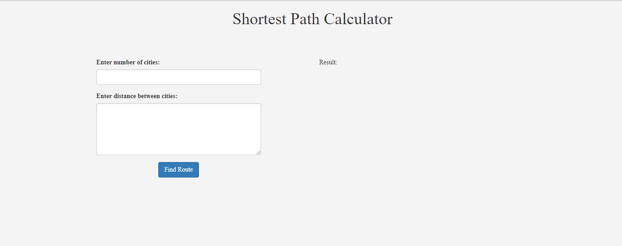

User need to give the number of cities in the 1st text box and the path of the file which contains the distance between each cities in the second text area.

Now Click on Find route button.

User will be able to see the Result in the right side as shown below.

