NAME:GANESH KUMAR KORRA

STUDENT ID:700761716 ICP-6

NEURAL NETWORKS

GITHUB: <https://github.com/GaneshKumarKorra/ICP6>

Video Link: <https://drive.google.com/file/d/1_7hda_0Y0UofFKR-MsvVH4mR1tx4ObZb/view?usp=sharing>

**Q**

**1**

**:**

**Code**

**:**

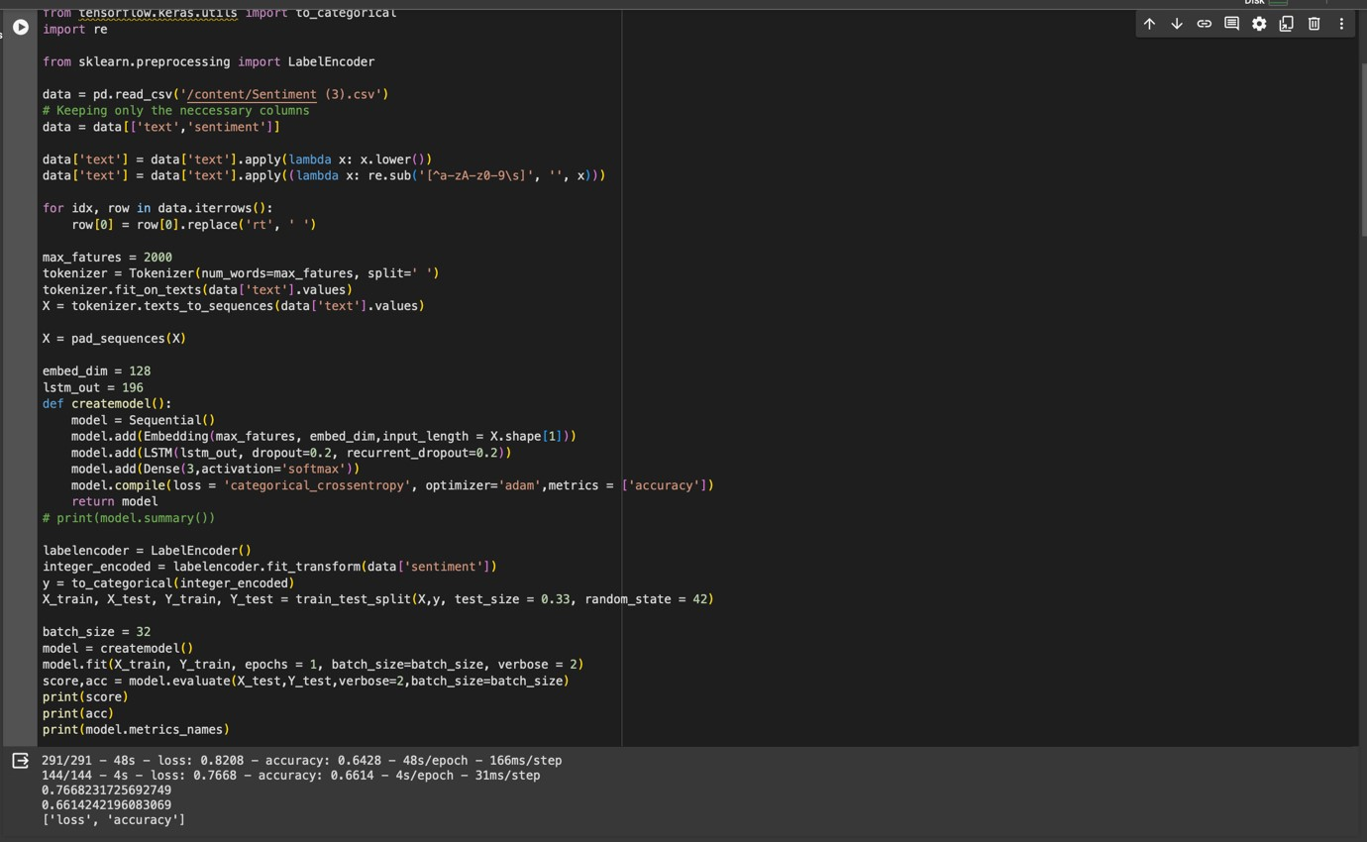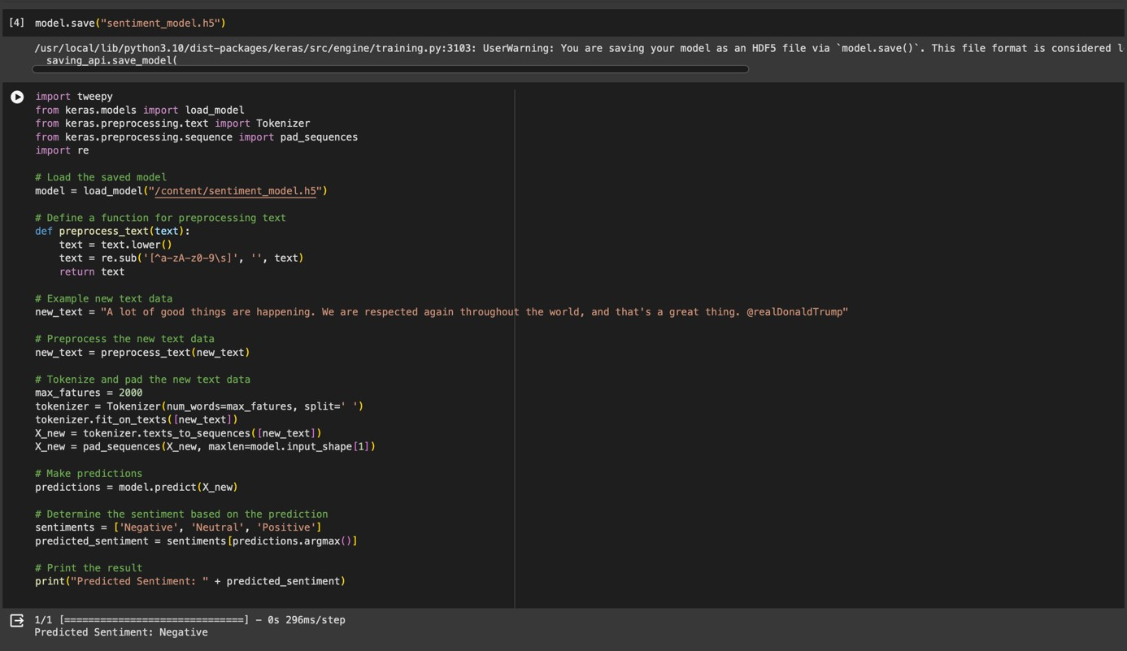

**Output:**

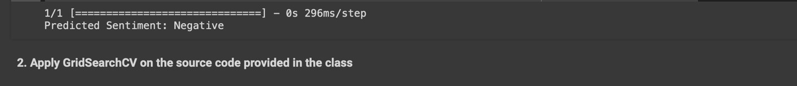

**Q2:**

**Code:**

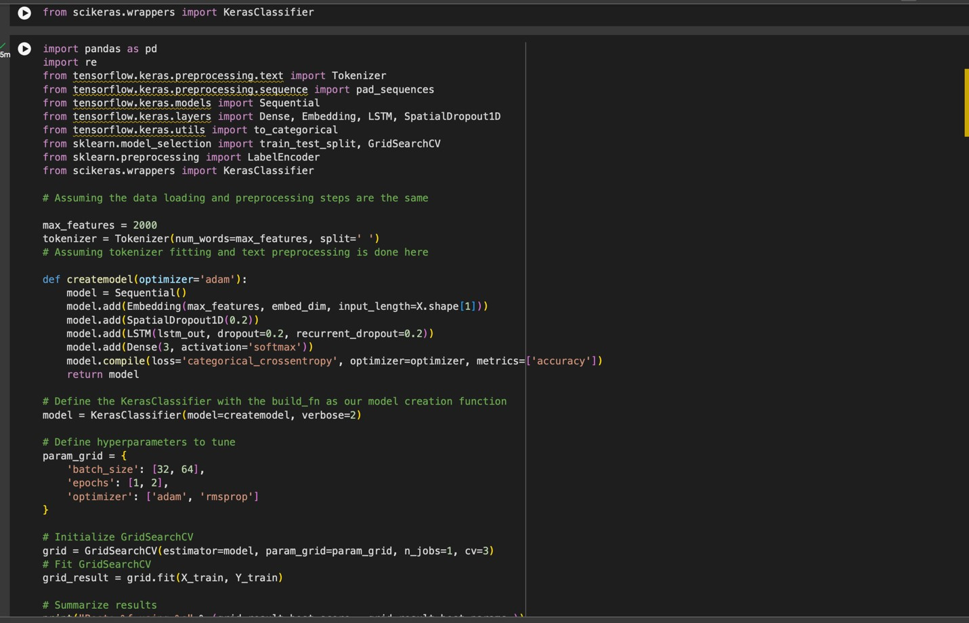

**Output:**

