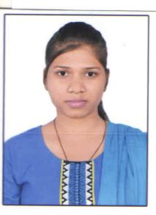

PHP Developer

**Aarti Burman**

**Phone:** +91 9685185488 **Email:** aartiburman65@gmail.com

**PROFILE**

Motivated PHP Developer seeks employment as part of a dynamic software development team. Fluent in several programming languages.

**EDUCATION**

**BE(Computer Science)** Graduated, June 2016SGBM Institute of Technology 6.9 CGPA  
RGPV Division 1  
Jabalpur MP

**10+2** July 2009St. Norbert G. H. School Division 2  
MP Board   
Jabalpur MP

**SKILLS**

* Experience building a variety of different web applications and sites
* MySQL
* Fluent in HTML5
* JavaScript
* Very familiar with CSS3
* Ajax
* laravel
* Codeigniter
* WordPress
* Self -starter
* Jquery
* REST API

**WORK EXPERIENCE**

**Sept 2021- current**

**PHP Developer**

Codemeg soft solution pvt. Ltd

Indore, Navlakha

**Oct 2020- Aug 2021**

**PHP Developer**

Jump Online Solution

Indore, Sukhliya

**July 2018 – January 2020  
Junior executive (php developer)**

iksula Pvt Ltd  
Indore, Vijay Nager

**August 2017- February 2018**

**Junior Web developer**Minnat Technology (php)

jabalpur,MP

**January 2017 - June 2017**

**Web developer [1 Year]**

(6 month training+4 month work)

Appin Technology(php ,Mysql)

jabalpur,MP

**Project**

* <http://roxymentmoney.com/> PHP Design, Development
* <https://www.smoothpapers.co.uk/> WIX Design
* <http://qualitydevelopers.co.nz/> PHP Design, Development
* <https://smoothfeathers.co.uk/> Wordpress Design
* <http://netwest.demataccountonline.com/> wordpress Design
* <https://fryconindia.com/homepage> wordpress Design
* <https://waytwodigital.com/allapp/> CI Development
* <http://dilipbagaria.in/> PHP Design, Development
* <http://kuchvkharido.xyz/Permendra/DogsTraining/> CI Design, Development
* <https://divineredu.com/> CI Design, Development
* <https://handybookweb.com/admin/> (admin) laravel Development
* Handybook (application) CI Development
* <http://dev.codemeg.com/ilol> laravel Development
* Ilol(application) laravel Development
* <https://newdev.codemeg.com/rewawale/> laravel Development
* <https://dev.codemeg.com/nashmi/> laravel Development

**INTERESTS**

|  |  |
| --- | --- |
| * Chess | * Craft |
| * Painting | * Music |

**PERSONAL DETAILS**

Father’s Name: Mr. Gopal Prasad Burman Mother’s Name : Guddi Burman

Marital Status: Single Nationality: Indian  
Birthday: July 11, 1993 Gender: Female

**Declaration**

I, Aarti burman, hereby declare that the information contained herein is true and correct to the best of my knowledge and belief.

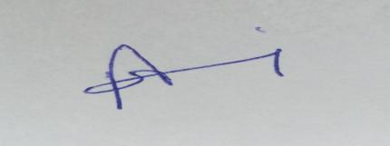

____________________________  
Aarti Burman