Turing Machine Languages

Based on Chapters 23-24-25 of (Cohen 1997)

Introduction
A language L over alphabet is called recursively enumerable (r.e.) if there is a Turing machine T that accepts every word in L and either crashes or loops forever on every word that is not in L. A language L over alphabet is called recursive if there is a Turing machine T that accepts every word in L and crashes on every word that is not in L. In other words, a language is recursive if there is a Turing machine that accepts that language that never goes into an infinite loop. There are languages that are r.e. but not recursive. We will see some of these languages later. Here are some facts about r.e. and recursive languages.
Theorem. If the language L is recursive then its complement L' is also recursive. The set of recursive languages is closed under complement.
Proof. To prove this we construct a Turing machine that accepts L' and always halts or crashes. We begin with the Turing machine that accepts L. We know that this Turing machine always halts or crashes. We add an extra state to the machine for L and we add some transitions to this new state to prevent the machine for L from ever crashing. We make this state a REJECT state. Once the machine enters this state, processing stops and the string is rejected. To make the machine for L', we simply change this REJECT state to a HALT state and change the HALT state to a REJECT state. QED
Note that we couldn't do this if the Turing machine for L sometimes loops. Just changing HALT to REJECT and vice versa would not change the behavior of the Turing machine on the strings that cause it to loop. These strings are in L' and should lead to the HALT state in the machine for L' but they don't. Thus the machine created by changing HALT to REJECT and vice versa is not the machine for L'.
There are many Turing machines for any given language. One of these machines might have a loop set (strings that cause it to loop) while another may not. If a language is recursive, then there is a Turing machine for it that does not have a loop set. If a language is recursively enumerable (r.e.), every Turing machine for it will have a loop set.
Theorem. If L is r.e. and L' is also r.e., then L and L' are both recursive.
Proof. Let T₁ accept L and T₂ accept L'. Create a new machine, T₃, that accepts L and rejects L'. Do this by having T₃ repeatedly do one step of T₁ followed by one step of T₂. We could use a multi-tape machine and put the input on each of two tapes to start with. Then we have T₁ work on one of the tapes and T₂ work on the other. Sooner or later, either T₁ or T₂ will accept. We build T₃ so that if T₁ accepts, then T₃ accepts, and if T₂ accepts, then T₃ rejects. Thus T₃ always accepts or rejects; it never loops. Then L, the language accepted by T₃, is recursive and by the previous theorem, so is L'. QED
Theorem. If T₁ and T₂ are Turing machines that accept L₁ and L₂, then there is a Turing machine T₃ that accepts L₁ L₂. The set of r.e. languages is closed under union.
Proof. First we change T₁ and T₂ so that they never crash but instead loop forever on words not in L₁ or L₂. Then we make T₃ so that it runs T₁ and T₂ alternately, as in the previous proof. If either T₁ or T₂ accepts, then T₃ accepts. If both loop then T₃ will loop. So T₃ accepts L₁ L₂. QED
Theorem. The set of r.e. languages is closed under intersection.
Proof. Let T₁ and T₂ be Turing machines that accept the r.e. languages L₁ and L₂. Build a Turing machine T₃ that first runs T₁ on an input and then, if T₁ accepts, T₃ runs T₂ on that same input. If T₂ accepts, then T₃ accepts. If either T₁ or T₂ rejects then T₃ will reject. If either T₁ or T₂ loops, then T₃ will loop too. So T₃ accepts L₁ L₂.

Encodings of Turing Machines
We can represent a Turing machine with a table of transitions. For consistency we number the states of a Turing machine 1, 2, 3, ..., making the start state 1 and the HALT state 2. Here is a Turing machine and a table that represents it.
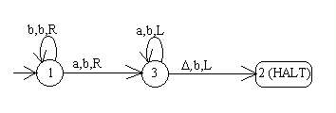
From | To | Read | Write | To
1 | 1 | b | b | R
1 | 3 | a | b | R
3 | 3 | a | b | L
3 | 2 |  | b | L
This table along with our knowledge of which states are the start state and HALT state tells us all we need to know about this Turing machine. We can encode this table as a string over = {a,b} as follows. Consider the general row:
From | To | Read | Write | To
x₁ | x₂ | x₃ | x₄ | x₅
We encode x₁ and x₂ as strings of a's whose lengths equal the values x₁ and x₂, and terminate them with a b. The entries x₃, x₄, and x₅ are encoded by these tables:
x₃, x₄ | Encoding
a | aa
b | ab
 | ba
# | bb

x₅ | Encoding
L | aa
R | ab
S | ba
So each row is a string in the language a⁺ba⁺b(a+b)⁶. The above table is encoded as follows. The spaces are shown for clarity, but in reality they would not be part of the string.
ababababab abaaabaaabab aaabaaabaaabaa aaabaabbaabaa
Since there can be no transitions out of the HALT state 2, aaba⁺b(a+b)⁶ is a set of forbidden strings for rows. The set of strings a⁺ba⁺b(a+b)⁴bb is also forbidden since there is no tape movement encoded bb.
We can look at a string that is an encoding of a Turing machine and decode it provided that its syntax is correct. Our author calls this encoding scheme CWL (code word language.)

A Non-Recursively-Enumerable Language
Our author names the following language ALAN as an honor to Alan Turing.
ALAN = {all Turing machine encodings that are not accepted by the Turing machines they encode or that define invalid Turing machines}
Note that an invalid Turing machine may not have a state 1 (the start state) or may have edges leaving state 2 (the HALT state.) Here is an example of a string in the language ALAN along with the Turing machine that the string encodes. Remember that the blanks in the string are not really there.
abaaabaaaaab aaabaaabababab aaabaabaaaaab
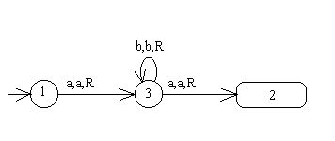
What happens when you feed the encoding for the Turing machine to the machine itself? The machine accepts the string, so this string is not in ALAN.
The language ALAN is a strange one, so strange that it is not even recursively enumerable. We will prove this by contradiction. Assume that ALAN is r.e. Then there is a Turing machine that accepts ALAN. Call this Turing machine T. Now T can be encoded in CWL just as any Turing machine can be encoded. Call its encoding code(T). Consider the question, "Is code(T) in ALAN?" We shall consider the two possible answers separately.
Case 1: code(T) is in ALAN
Since T accepts words that are in ALAN, T accepts code(T). But ALAN contains no code word that is accepted by the machine it encodes, so this is a contradiction.
Case 2: code(T) is not in ALAN
Then T does not accept code(T). But then code(T) is in ALAN because any encoding that is not accepted by the machine it encodes is in ALAN. Again, this is a contradiction.
Since both cases lead to contradictions, ALAN is not a recursively enumerable language. This example proves the following theorem.
CASE 1: code(T) is in ALAN
CLAIM | REASON
1. T accepts ALAN | 1. Definition of T
2. ALAN contains no code word that is accepted by the machine it represents. | 2. Definition of ALAN
3. Code(T) is in ALAN | 3. Hypothesis
4. T accepts the word code(T) | 4. From 1 and 3
5. Code(T) is not in ALAN | 5. From 2 and 4
6. Contradiction | 6. From 3 and 5

CASE 2: code(T) is NOT in ALAN
CLAIM | REASON
1. T accepts ALAN | 1. Definition of T
2. If a word is not accepted by the machine it represents, it is in ALAN . | 2. Definition of ALAN
3. Code(T) is NOT in ALAN | 3. Hypothesis
4. code(T) in not accepted by T | 4. From 1 and 3
5. Code(T) is in ALAN | 5. From 2 and 4
6. Contradiction | 6. From 3 and 5

Theorem. Not all languages are recursively enumerable.
The argument used above is similar to other paradoxes. Here are a couple more:
- True or False: Right now I am telling a lie.
- In a certain city the barber, who is a man, shaves every man who does not shave himself. Who shaves the barber?

The Universal Turing Machine
A universal Turing machine, UTM, is a Turing machine that can be fed as input a string composed of two parts:
- an encoded Turing machine T followed by a marker
- a string that is to be run through T
The UTM "runs" T on the string. If T crashes then the UTM crashes. If T accepts then the UTM accepts, and if T loops then the UTM loops. Other people have figured out the details of the UTM and proven that such a machine can be built. Typically implementations involve at least three additional tapes, one on which the UTM copies the encoding of T and another on which it copies the string to be fed to T. The third additional tape is used to keep track of which state T is in. The UTM operates by looking up a transition for T's current state using the current symbol of the input string for T, then carrying out that transition.

A Recursively Enumerable Language That Is Not Recursive
Let MATHISON = {all Turing machine encodings that are accepted by the Turing machines they encode}. Note that Mathison is Alan Turing's middle name.
Theorem. MATHISON is recursively enumerable.
Proof. We use the universal Turing machine here and send it the encoding of a Turing machine followed by the marker and that same encoding again. If the encoded Turing machine accepts its own encoding then the UTM will accept. Thus the UTM can be used to accept the language MATHISON. QED
Let L = CWL' MATHISON. This language L contains all strings that are not Turing machine encodings or are Turing machine encodings that are accepted by the machines they encode. Note that L is the complement of ALAN. What kind of language is L?
Since CWL is a regular language, CWL' is also a regular language and therefore recursively enumerable. MATHISON is recursively enumerable as we proved above. We have a theorem that the class of recursively enumerable languages is closed under union. Therefore L is recursively enumerable even though its complement, ALAN, is not.
Theorem. There are r.e. languages that are not recursive.
Proof. L is an r.e. language that is not recursive. By a previous theorem, if L was recursive then its complement would be, too. We know that ALAN is not even r.e., so L cannot be recursive. QED

Decidability
We will first discuss the question of membership. The membership question is always something like, "Given a machine (or a grammar or expression), does that machine (or grammar or expression) accept (generate) string w?" We found that it is always possible to decide membership for the regular and context-free languages. Given a grammar or a regular expression we can turn it into an equivalent machine. Given an FA or a PDA, we can run the string through the machine and see if the string gets accepted. Since neither an FA nor a PDA ever goes into an infinite loop, they will always give us an answer. The membership question for the set of recursive languages is also decidable because the Turing machine for a recursive language never goes into an infinite loop. But we find that the membership question for the r.e. languages is not decidable!

The Halting Problem
The membership question for the recursively enumerable languages is known as the halting problem, since halting means accepting on a Turing machine. Is it possible to tell for a given Turing machine and a given string, whether that Turing machine accepts that string? No, it is not always possible. We cannot simply run the string through the machine and get a definitive answer. Sometimes we will get an answer; we get an answer of yes if the TM accepts the string and an answer of no if the TM crashes. But what if the TM loops? How will we know it is looping? It may just be taking a long time but will accept or crash momentarily. A UTM cannot give us an answer to the membership question because all it does is simulate the TM. It is not possible to remove the loop set from every TM; if we could do that then all recursively enumerable languages would actually be recursive and we know this is not true. So we have the theorem below.
First let's define the language HALT. Let HALT = {code(T)#w | T is a Turing machine and T accepts string w}. HALT contains pairs of strings separated by # as a marker; the first string is an encoded Turing machine T, and the second string is an input string for T. Only those pairs where the machine T accepts the string w are in HALT.
Theorem. HALT is not recursive.
Proof. Assume that HALT is recursive. Then there is a Turing machine that decides HALT. Call this Turing machine HP. HP will somehow determine if its input T halts on string w and will print "yes" on its tape if T halts and "no" otherwise. HP must print "no" if T crashes or if T loops. HP itself always either halts or crashes; it never loops because the language it accepts is recursive.
Now let's build another Turing machine, M, that uses HP as a subroutine. This new Turing machine will be able to decide the language L as defined above, which we know is undecidable, and thus we will get a contradiction. Recall that L contains all strings that are not Turing machine encodings or are Turing machine encodings that are accepted by the machines they encode.
M will receive a string w as input. M behaves as follows:
- Check whether w is a valid encoding of a Turing machine. If it is not, then accept.
- If w is a valid TM encoding, then send w to HP twice with a marker between the w's. If HP says yes then accept. If HP says no then reject.
Since we proved earlier that L is not recursive, such a machine as M cannot really exist. The only part of M that is impossible is HP, so HP cannot really exist. Thus the notion that HALT is recursive cannot be true. QED

Acceptance of the Empty String
What about this simple question: "Is it possible to tell whether a given TM, T, accepts the string ?" The answer to this question, surprisingly, is no.
Theorem. It is not decidable whether or not Turing machine T accepts the string .
Proof. Assume that the question is decidable. Then there is a Turing machine, call it LAMBDA, that can decide the language {code(T) | T accepts }. LAMBDA prints "yes" on its tape if it is fed the encoding of a Turing machine T that accepts , and it prints "no" on its tape if it is fed the encoding of a Turing machine T that does not accept . We shall show that it is impossible for such a machine to exist by demonstrating how we could use it to decide the halting problem.
Given LAMBDA we could build HP as follows. Recall that HP is given as input an encoded Turing machine and a string. HP decides whether or not the Turing machine accepts the string. The version of HP that we will build first takes the TM and the string it is fed as input and uses them to create a different machine. Call this different machine T*. HP creates T* so that the first thing T* does is check whether its input tape is empty and, if it is, T* writes the characters of the string w on its input tape. Then it runs T on that string. If T accepts then T* accepts. If T* begins with some input on its input tape other than , it crashes.
Think about the way that T* is designed. The only possible string that it can accept as input is . If any other input is found on its input tape, T* crashes. Moreover, T* accepts only if the machine T (the input to HP) accepts the string w (also input to HP.)
We have reduced the question of whether or not T accepts w to the question of whether T* accepts . And by our assumption, the machine LAMBDA can decide whether or not a Turing machine accepts . So this version of HP constructs T* and then passes it to LAMBDA. If LAMBDA answers "yes" then HP answers "yes". If LAMBDA answers "no" then HP answers "no".
Thus if LAMBDA exists, then HP exists. Since we proved earlier that HP cannot exist, neither can LAMBDA. QED

The Emptiness Question
Is it possible to decide for a given Turing machine whether that Turing machine accepts any strings at all? This, too, is not always possible.
Theorem. There is no Turing machine that can take the encoding of another Turing machine T as input and decide whether T accepts any words. Restated, this theorem says that the emptiness question for recursively enumerable languages is undecidable.
Proof. Assume that there is a Turing machine that can decide whether its input, T, accepts any words at all. Call this Turing machine NOTEMPTY. We feed the encoding of a Turing machine T to NOTEMPTY, and NOTEMPTY prints "yes" on its tape if T accepts at least one word and prints "no" on its tape if T does not accept any words. Now we will show how, if NOTEMPTY exists, we can use it to construct a LAMBDA machine. Because we proved earlier that a LAMBDA machine cannot exist, NOTEMPTY cannot exist either.
Build our new LAMBDA machine as follows. When LAMBDA is given an encoded Turing machine T and asked whether it accepts , it alters machine T slightly and then encodes the altered version and passes it to NOTEMPTY. LAMBDA alters its input machine T by making T first erase its input tape then do whatever it was going to do originally. So, the machine that gets passed to NOTEMPTY does whatever T does, but starts out with an empty input tape. Call this altered machine T*. Now if NOTEMPTY tests T* and says yes, then we know T* accepts at least one word. The only word T* could possibly accept is since T* always begins with on its tape. So we then know that T accepts and LAMBDA can write "yes" on its tape. If NOTEMPTY tests T* and says no, then we know that T does not accept so LAMBDA can write "no" on its tape.
Since we know that the machine LAMBDA cannot really exist, neither can NOTEMPTY. QED
Other References:
http://www.cs.appstate.edu/~dap/classes/2490/chap23.html

Chapter 24 - Chomsky Hierarchy

Phrase-Structure Grammars (PSGs)
Think of the way in which a derivation is done with a context-free grammar. With context-free grammars we are always free to replace a nonterminal in a working string with the right-hand-side of any of its rules. It doesn't matter what is on either side of that nonterminal in the working string. In other words, the context of the nonterminal doesn't matter.
English and other natural languages are not built this way. In a natural language the context in which a word is used may change the meaning of the word. As a matter of fact, even programming languages such as C++ are not completely context-free. If you use the string "<<" in a C++ program and there is an ostream to its left, then this string is the insertion operator. But if "<<" has an integer to its left, then it is the bitwise left-shift operator.
For each class of languages prior to the recursive languages we saw both an acceptor (a machine) and a generator (a regular expression or a grammar.) But for the recursive and recursively enumerable languages we have seen only the acceptors. We shall now study grammars for languages accepted by Turing machines, beginning with grammars for the r.e. languages.
The grammars we study in this chaper are called phrase-structure grammars. A phrase-structure gramar is defined as follows:
- a finite alphabet of terminals
- a finite set of symbols called nonterminals that includes the starting nonterminal, S
- a finite list of productions of the form string1 string2 where string1 is any string of terminals and nonterminals that must include at least one nonterminal and string2 is any string of terminals and nonterminals whatsoever.
A derivation with a phrase-structure grammar is done the same way as a derivation with a context-free grammar. The language generated by the PSG is an r.e. language, although this remains to be proven. Here is an example:
S XS
|
X aX
| a
aaaX ba
Here is a derivation made from this grammar. At each step the set of symbols that gets replaced in the next step is underlined.
S XS
XXS
XXXS
XXX
aXXX
aaXXX
aaaXXX
baXX
baaXX
baaaXX
bbaX
bbaa
Notice that using the rule aaaX ba makes the working string get shorter! The only rules in context-free grammars that caused working strings to get shorter were -rules. With PSGs, terminals in working strings can disappear. Interestingly, leftmost derivations are not always possible with these grammars.
Note that a context-free grammar is a phrase-structure grammar. You can see this if you review the restrictions on phrase-structure grammars. So languages that can be generated by context-free grammars are a subset of languages that can be generated by phrase-structure grammars.
Recall that the language {a^{n}b^{n}a^{n} | n > 0} is not a context-free language. We can generate this language with a phrase-structure grammar:
S aSBA
| abA
AB BA
bB bb
bA ba
aA aa
Here are some derivations using this grammar, first a derivation of aba and then a derivation of aabbaa.
S abA
aba

S aSBA
aabABA
aabBAA
aabbAA
aabbaA
aabbaa
We use the S rules to build up the leftmost group of a's in our working string, using the rule S abA last. At this point our working string will contain a group of a's followed by one b and a sequence of alternating A's and B's beginning with an A and ending with an A. The next thing we need to do is shuffle the A's and B's using the AB BA rule until all the B's come before all the A's. Then we begin turning A's into a's and B's into b's using the rules bB bb, bA ba, and aA aa.
It is possible to "get stuck" during a derivation with a PSG by using rules in an order that leads nowhere. For example, consider what happens if we do not shuffle the A's and B's before we change them to little letters.
S aSBA
aabABA
aabaBA
?
Now we're stuck. We can draw a total language tree for a phrase-structure grammar but some branches will end with working strings that cannot be used to derive any words. In the tree for the above grammar, one branch will end with the working string aabaBA.
Here is an interesting theorem.
Theorem. Given a PSG for language L, there is another PSG for L which has the same alphabet of terminals and whose rules are all of the form
string of nonterminals string of terminals and nonterminals
where the left side cannot be , but the right side can.
Proof. We give an algorithm for changing any PSG into a PSG meeting the restriction that the left-hand-sides of its rules contain only nonterminals. Make up a new nonterminal for each terminal and add one rule for each, rules such as
N₁ a
N₂ b
etc.
Then change all occurrences of each terminal into the nonterminal corresponding to that terminal. QED
The first grammar below is changed into the second by this algorithm:
S XS
|
X aX
| a
aaaX ba

S XS
|
X N₁X
| N₁
N₁N₁N₁X N₂N₁
N₁ a
N₂ b
A grammar of the form just described, in which each rule's left-hand-side is a string of only nonterminals, is called type 0 (type zero.) Because of the previous theorem we know that the phrase-structure grammars and the type 0 grammars are equivalent. Type 0 is one of the four classes of grammars that Noam Chomsky defined in 1959. The table below summarizes Chomsky's Hierarchy:
Type | Name | Restrictions on Rules  X Y | Acceptor
0 | Phrase-structure =  Recursively Enumerable | X = string of nonterminals  Y = any string | TM
1 | Context-sensitive | X = string of nonterminals  Y = any string with length at least the length of X | LBA (linear-bounded automaton, which is a TM with bounded tape)
2 | Context-free | X = one nonterminal  Y = any string | PDA
3 | Regular | X = one nonterminal  Y = tN or Y = t, where t is a terminal and N is a nonterminal | FA
Chomsky's descriptions of language classes match nicely with some of the ones we have studied. We have completely described types 2 and 3, although Chomsky did not subdivide his type 2 languages into deterministic and nondeterministic the way we did. Type 1 is a class that computer theorists don't work with very often, but we suspect that natural languages fall into this category. Note that the type 1 category does not correspond exactly to the class of recursive languages, but is a subclass of those languages. In other words, type 1 languages are recursive but not all recursive languages are type 1 languages. We can look at the rules of a grammar and determine that the grammar generates a context-sensitive (type 1) language, but it is impossible to look at the rules of a grammar and tell that the grammar generates a recursive language.
Here is our more detailed hierarchy of languages.
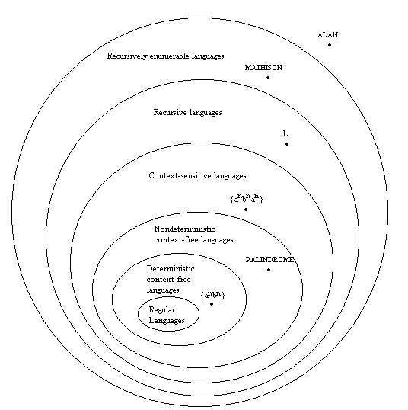
No two of these classes are the same. We have placed a language in each class that is not a member of any of that class's subclasses. Note that the language L in the class of recursive languages is defined by our author in this chapter, but we will not discuss it. Suffice it to say that there are languages (like L) that are recursive but not context-sensitive.

Type 0 = Recursively Enumerable = Recognizable by TM
We have yet to prove that the set of languages that can be generated by phrase-structure grammars is the same set of languages that can be recognized by Turing machines, but this is true. The author gives algorithms to convert a phrase-structure (type 0) grammar into a Turing machine and to convert a Turing machine into a phrase-structure grammar. We will not learn these algorithms but will take them as proof that phrase-structure grammars and Turing machines correspond to the same set of languages.

Closure Properties of R.E. Languages
We proved in chapter 23 that the set of r.e. languages is closed under union and intersection. We did this by using the Turing machine for each of two languages and showing how we could build another Turing machine that was a union machine or an intersection machine. In this chapter we prove (using grammars) that the set is also closed under concatenation and Kleene star. We know from our work with the language, ALAN, and its complement, CWL' MATHISON, that the set of r.e. languages is not closed under complement.
Theorem. Given L₁ and L₂, two r.e. languages, the language L₁L₂ is also r.e. In other words, the set of r.e. languages is closed under concatenation.
Proof. The proof we used to show that the set of context-free languages is closed under concatenation almost works here, except that we need to subscript both the terminals and the nonterminals in each of our original grammars to keep from mixing up the rules of the different grammars. Refer back to that proof in chapter 17. QED
Example: Consider the language LL where language L is defined by this grammar:
S a
aS b
Note that the only string that this grammar can produce is the string a, so the only string that we should produce by concatenating the languages is the string aa. We create two copies of this grammar, one subscripted with 1 and the other with 2. Think what would happen if we only subscripted the nonterminals of the grammars. We could do this derivation:
S S₁S₂
aS₂
b
To avoid such mistakes, we subscript both terminals and nonterminals, as follows:
S₁ a₁
a₁S₁ b₁

S₂ a₂
a₂S₂ b₂
Now we build a new grammar by introducing a new nonterminal S and the rule S S₁S₂. We also have to add the productions a₁ a, b₁ b, a₂ a, and b₂ b.
S S₁S₂
S₁ a₁
a₁S₁ b₁
a₁ a
b₁ b
S₂ a₂
a₂S₂ b₂
a₂ a
b₂ b
Theorem. If L is an r.e. language, then L* is also r.e. The set of recursively enumerable languages is closed under Kleene star.
Proof. Here we have to be careful not to allow strings of terminals from one occurrence of a word in L to attach themselves to a part of the derivation from another word in L, and possibly produce a word not in L*. We need to make two copies of our grammar, one subscripted with a 1 and one subscripted with a 2, then alternate between these grammars when producing strings in L*. We then add the rules
S S₁S₂S
| S₁
|
We need to subscript both terminals and nonterminals as we did in the previous proof. QED
We have finished our study of languages for this semester. Here is a table to summarize our findings.
Type of Language | Language Defined By | Corresponding Acceptor | Does Nondeterminism  Give More Power? | Set Is Closed Under
regular language | regular expression | finite automaton, transition graph | no | union,  concatenation,  Kleene star,  intersection,  complement
context-free language | context-free grammar | pushdown automaton | yes | concatenation,  Kleene star,  union
recursive language | phrase-structure grammar | Turing machine  that never loops | no | concatenation,  Kleene star,  union,  intersection,  complement
recursively enumerable language | phrase-structure grammar | Turing machine | no | concatenation,  Kleene star,  union,  intersection

References:
Cohen, D. (1997) Introduction to Computer Theory, 2nd Edition

CHAPTER 25: COMPUTABILITY

A Turing Machine for Binary addition is given below:
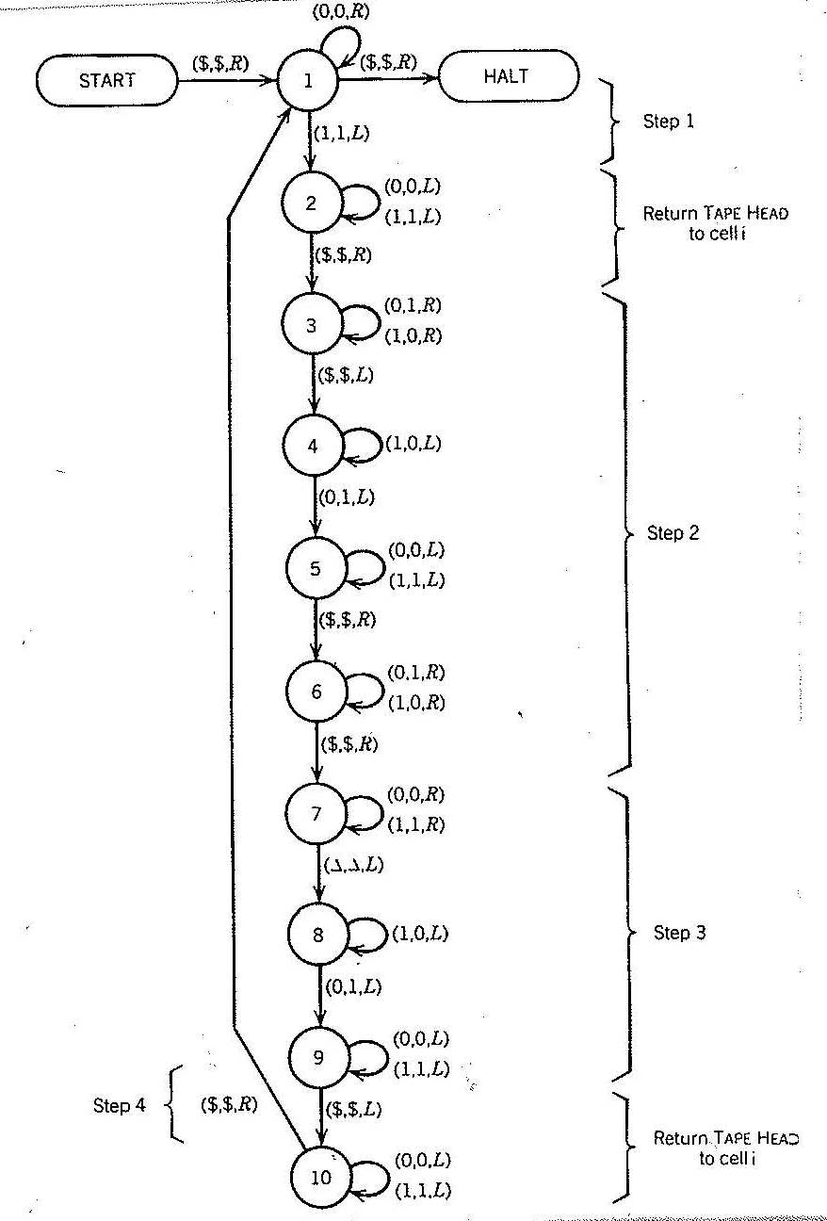

References:
Cohen, D. (1997) Introduction to Computer Theory, 2nd Edition

