**Step 1 :** **GATHERING ALL REQUIREMENTS**

BASIC REQUIREMENTS :

* Application must show all the list of current movies and shows.
* Users should be able to search for movies.
* App must show list of all Theaters for a selected movie.
* App must allow user to book ticket for a show.
* --------------------------------------------------------------------------------------------
* App must allow Theaters to add/edit shows.

Questions for interviewer :

* Does the app supports multi-screen theaters too ? or only single screen theaters ?
* Does the app will support multi-languages movies or not ?
* Auto-matic seat selection ? or manual seat selection ?
* Does the app accept online payments ?

ASSUMPTIONS :

* App shows only single screen theatre.­
* Every Theater has capacity on (no of seats) available.
* Registered Users will be allowed to :
* Search for movies &
* Book tickets.

(History of Bookings will be stored)

* Guest Users will be allowed to :
* Only Searching movies is allowed,
* Not allowed to book tickets.
* Movies can have the following :
* Language – Telugu, English, Kannada
* Genre – Action, Comedy, Scientific

**Step 2 :** **CREATE USE-CASE DIAGRAMS**

* Step 2a : Identification of Actors

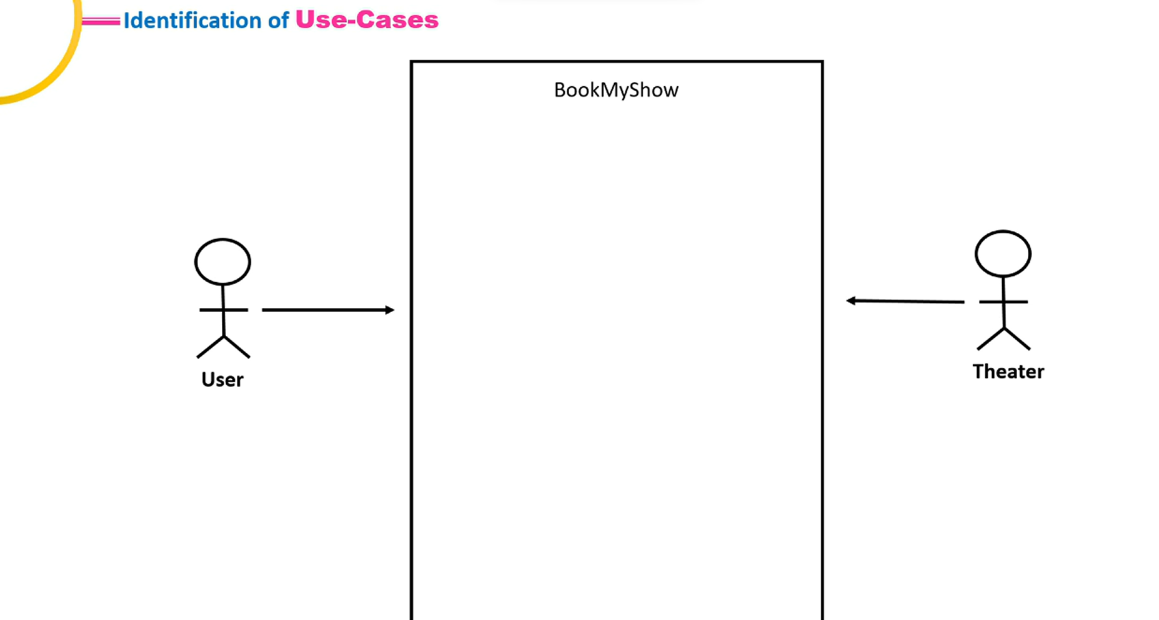

* Step 2b : Identification of Use-Cases  
  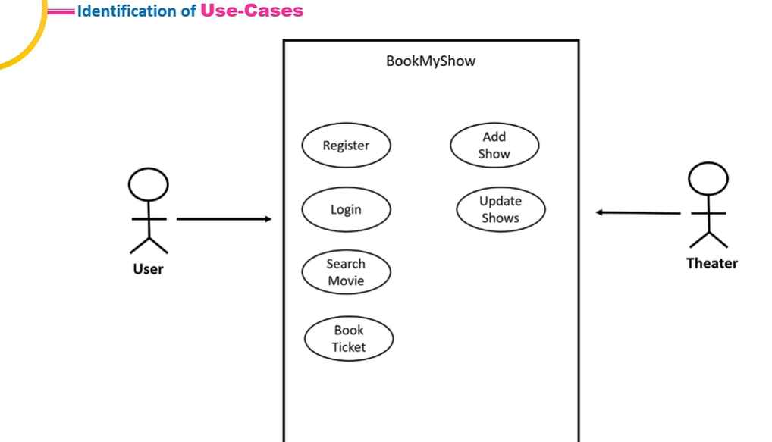
* Step 2c: Adding Associations  
  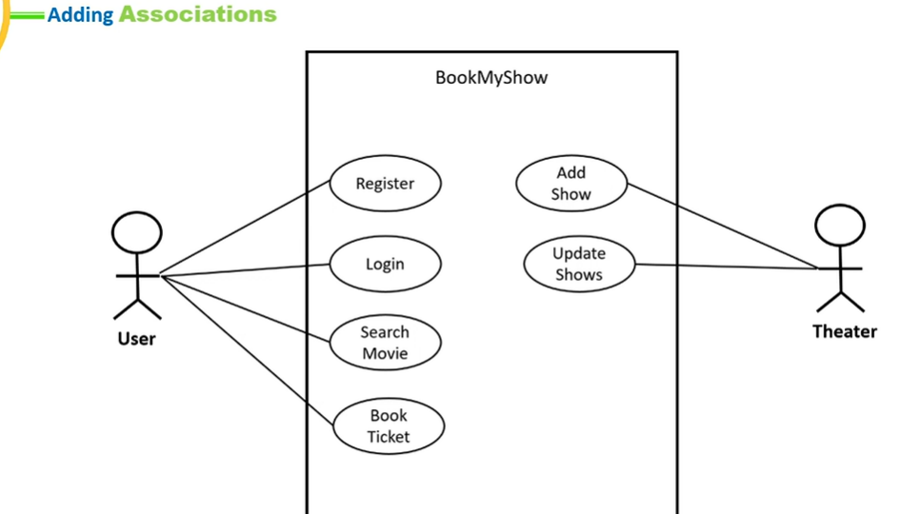
* Step 2d: Identification of Inclusive Use-Cases  
  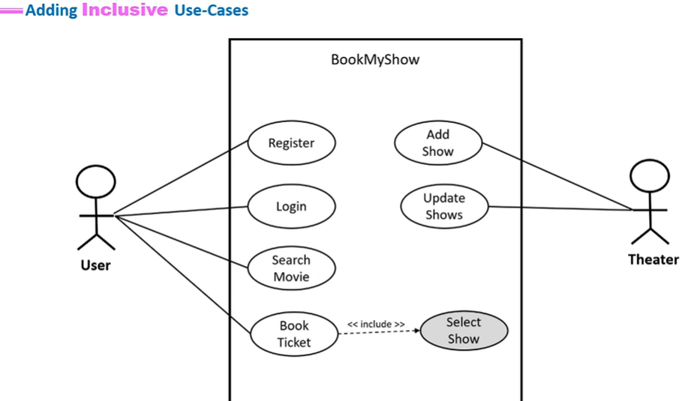
* Step 2e: Identification of Extension Use-Cases : skipping this , as we are just making an MVP (Minimal Viable Product) which means , we are just trying to satify basic basic things , functionalities.
* Step 2f: Identification of Inheritence  
  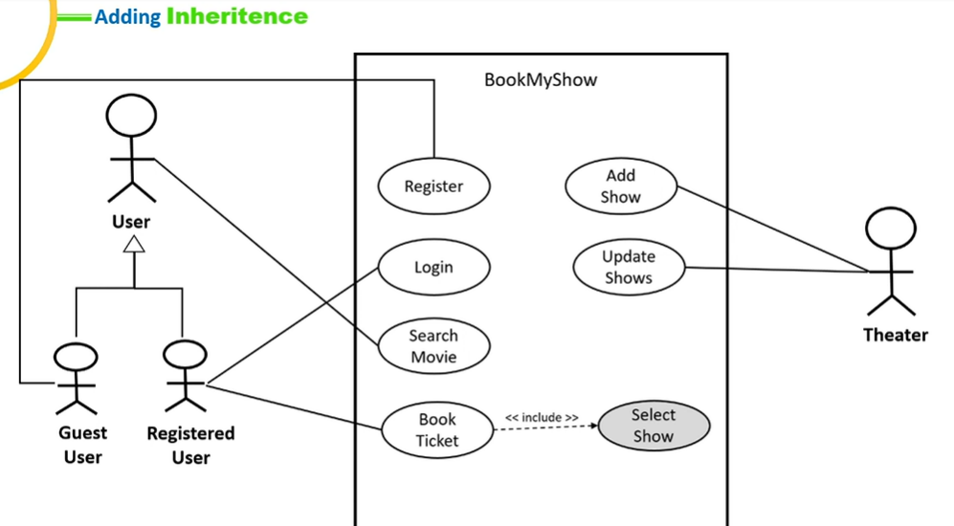  
  -------------------------------------------------------------------------------------------------  
  1) we have two types of users Guest and Registered.

2) Guest can use search movie feature as well as register too.

3) Registered user can use the feature of both search movies as well as book ticket.

**Step 3 :** **CREATE CLASS DIAGRAMS**

This step is very simple,  
just tag all possible nouns from the Step 1 and note down all the list of those nouns   
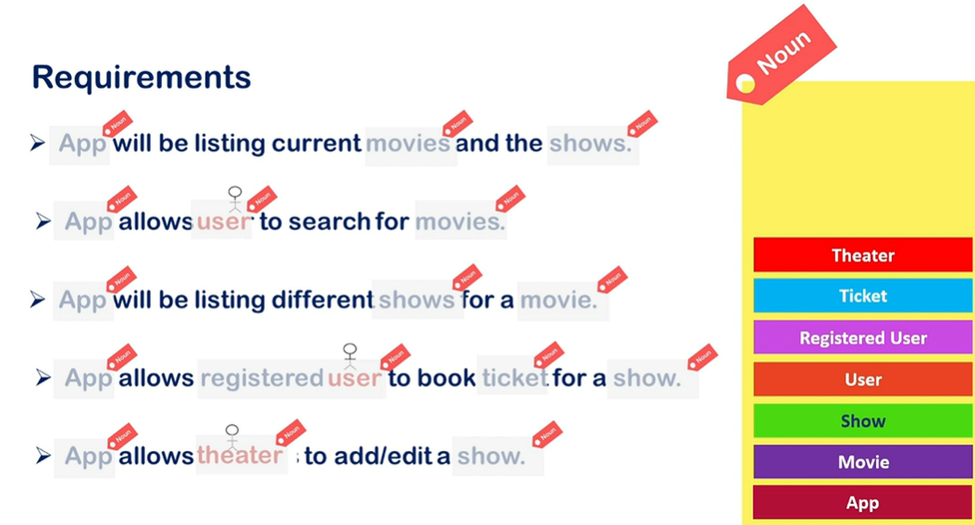  
------------------------------------------------------------------------------------------  
adding more found from suggestions:-  
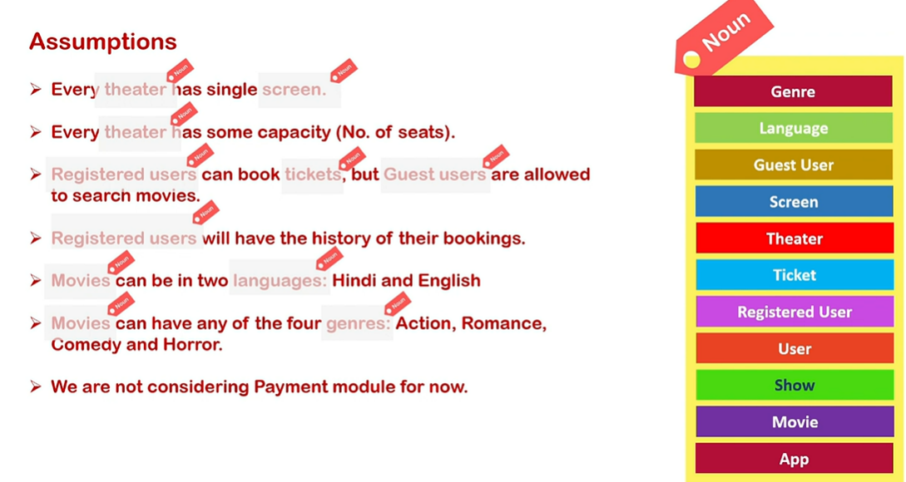  
--------------------------------------------------------------------  
Initial design structure:-  
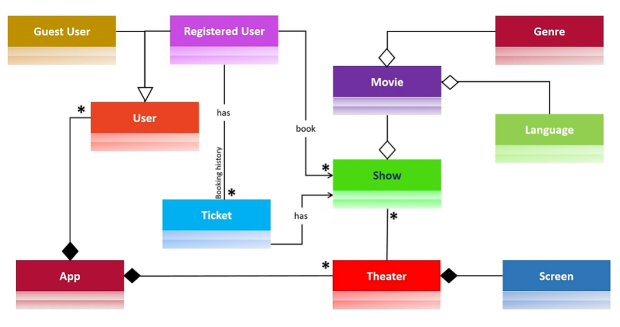  
-----------------------------------------------------------------------------------------------------------  
Modified Design :-  
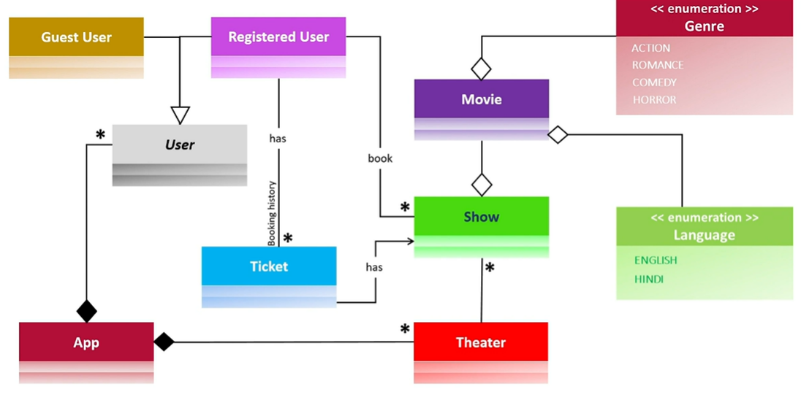  
------------------------------------------------------------------------------------------  
Further Modified by adding attributes and functionalities :-  
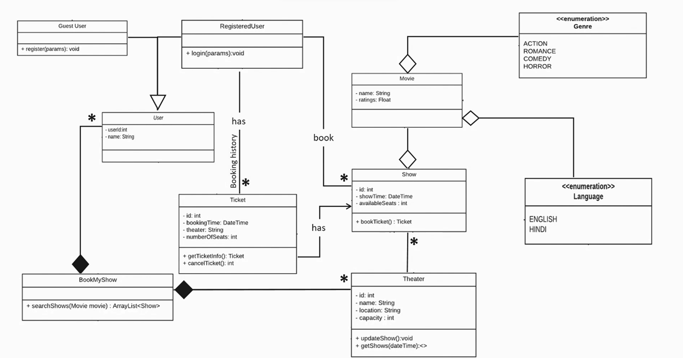

**Step 5 :** **CREATE SKELETON CODE**

**Refer the Java projects … available on git hub Object-Oriented-Design Repository**