SOFTWARE REQUIREMENTS SPECIFICATION
FOR
ODDTi™
Odd / Even Digital Hand-Cricket Game
Web Edition v2.2
Designed by: Ganesh P. Nair (GPN)
Version: 2.2
Document Type: Software Requirements Specification
© 2025 Ganesh P. Nair


Amendment Log
Version | Date | Change No. | Brief Description | Sections Changed
0.1 | 23/08/2026 | — | Initial SRS prepared for ODDTi v2.2 | All
0.2 | 23/08/2026 | 1 | Formalized functional and non-functional requirements | Sections 3–4
0.3 | 23/08/2026 | 2 | Added system models, use cases, UI and testing requirements | Sections 6–12

Document Control
Item | Details
Product | ODDTi™ — Odd / Even Digital Hand-Cricket Game
Version | Web Edition v2.2
Primary Author | Ganesh P. Nair (GPN)
Implementation | HTML, CSS and Vanilla JavaScript
Operating Mode | Fully offline
Primary Platforms | Safari, Chrome, Edge; iPadOS/macOS/iOS
Series Mode | Best-of-3

Contents
1. Introduction
1.1 Purpose
1.2 Scope
1.3 Definitions, Acronyms and Abbreviations
1.4 References
1.5 Overview
2. Overall Description
2.1 Product Perspective
2.1.1 System Interfaces
2.1.2 User Interface
2.1.3 Hardware Interfaces
2.1.4 Software Interfaces
2.1.5 Communications Interfaces
2.1.6 Memory / Storage Constraints
2.1.7 Operations
2.1.8 Site Adaptation Requirements
2.2 Product Functions
2.3 User Characteristics
2.4 Constraints
2.5 Assumptions and Dependencies
3. Functional Requirement Description
3.1 Functional Requirements List
3.2 FR-01 New Game and Mode Selection
3.3 FR-02 Toss
3.4 FR-03 Bat / Bowl Selection
3.5 FR-04 First Innings
3.6 FR-05 Second Innings / Chase
3.7 FR-06 Match Result
3.8 FR-07 Best-of-3 Series
3.9 FR-08 Score Log and Last Ball
3.10 FR-09 Auto-CPU Mode
3.11 FR-10 Reset and Navigation
4. Specific / Non-Functional Requirements
4.1 External Interface Requirements
4.2 Performance Requirements
4.3 Design Constraints
4.4 Software System Attributes
4.5 Data Requirements
4.6 Validation and Error Handling
5. System Requirements
6. System Models and Diagrams
7. Detailed Use Cases
8. User Interface Requirements
9. Business / Game Rules
10. Testing Requirements
11. Future Enhancements
12. Appendices

1. INTRODUCTION
ODDTi™ (read as “Oddity”) is a digital implementation of the traditional odd/even hand-cricket game commonly played by school students in India. The software converts the simple hand-game rules into a structured digital match with a toss, two innings, live scoring, target calculation, result declaration and optional Best-of-3 series play.

1.1 Purpose
The purpose of this Software Requirements Specification (SRS) is to define the functional, non-functional, interface, data, operational and testing requirements of ODDTi™ Web Edition v2.2. The document provides a common reference for design, implementation, testing and future maintenance.

1.2 Scope
- Provide a playable digital odd/even hand-cricket match against a CPU opponent.
- Provide a single-match mode and a Best-of-3 series mode.
- Implement a one-time toss using Odd/Even logic and numbers from 0–6.
- Allow the toss winner to choose Bat First or Bowl First.
- Manage two innings with automatic out detection when both selected numbers match.
- Maintain player and CPU scores, balls, target and runs required.
- Declare the match winner, winning margin or tie.
- Maintain a ball-by-ball Score Log and match-by-match Series Log.
- Provide Auto-CPU mode for rapid testing or automated play.
- Allow complete reset of match and series information.

1.3 Definitions, Acronyms and Abbreviations
Term | Meaning
ODDTi | Odd / Even Digital Hand-Cricket game; pronounced “Oddity”.
SRS | Software Requirements Specification.
CPU | Computer-controlled opponent.
Toss | Odd/Even decision used to determine who chooses innings.
Innings | A period in which one side bats until OUT or the chase is completed.
OUT | Condition where batting number equals bowling number.
Target | Score to be beaten by the chasing side.
Runs Required | Target + 1 − current chasing score.
Single Match | One complete match.
Best-of-3 | Series in which the first side to win two matches wins the series.
Auto-CPU | Optional automation of CPU turns for faster play/testing.

1.4 References
Primary product reference: ODDTi™ v2.2 Official Game Manual supplied with the project. The organization of this SRS follows the formal SRS style illustrated by the supplied reference SRS document, including amendment control, overall description, functional requirements, specific requirements, interfaces, attributes and testing-oriented sections.
Reference SRS consulted: Software Requirements Specification for Participatory Organic Guarantee System.

1.5 Overview
Section 2 describes the product as a whole. Section 3 defines the functional requirements. Section 4 defines non-functional and specific requirements. Section 5 specifies the operating environment. Section 6 presents system models. Section 7 gives detailed use cases. Sections 8–10 define the UI, game rules and testing requirements. Sections 11–12 cover future enhancements and appendices.

2. OVERALL DESCRIPTION

2.1 Product Perspective
ODDTi is a self-contained browser-based game. It does not require an external server, online account or network connection for normal play. The browser executes the HTML, CSS and Vanilla JavaScript implementation and maintains the current match and series state during gameplay.

2.1.1 System Interfaces
The system exposes its functions through the game interface: New Game, toss controls, innings controls, score display, logs, result panel and series controls.

2.1.2 User Interface
- Mode selector for Single Match / Best of 3.
- Toss selection and toss action controls.
- Bat First / Bowl First controls when applicable.
- Number input for values 0–6.
- Submit Number and Force End controls.
- Live scoreboard showing scores, balls, target and runs required.
- Last Ball display and Match Status.
- Match Result Panel.
- Score Log and Series Log.
- Auto-CPU toggle and reset/navigation controls.

2.1.3 Hardware Interfaces
No specialized hardware interface is required. The system runs on a conventional computer, tablet or smartphone capable of running a supported browser.

2.1.4 Software Interfaces
- HTML for document structure and game controls.
- CSS for layout, presentation and responsive display.
- Vanilla JavaScript for game logic, state management, random CPU selection and UI updates.
- Supported browsers include Safari, Chrome and Edge.
- A simplified TI-Python build may exist separately; this SRS primarily specifies the Web Edition v2.2.

2.1.5 Communications Interfaces
No network communication is required for normal gameplay. The Web Edition is designed to be fully playable offline.

2.1.6 Memory / Storage Constraints
The game does not require a server-side database. Match and series information is maintained within the application runtime/session unless a future version adds persistent storage.

2.1.7 Operations
Normal operation is user-driven. Auto-CPU can automate CPU turns. Refreshing the page resets the game state according to the v2.2 manual.

2.1.8 Site Adaptation Requirements
The interface should adapt to desktop and tablet/mobile screens. Landscape/fullscreen use is recommended for comfortable play on iPad or laptop.

2.2 Product Functions
- Start and reset matches.
- Select match mode.
- Conduct a single toss and determine toss winner.
- Select batting/bowling order.
- Play first innings until OUT or manual force-end.
- Start the second innings automatically.
- Calculate target and runs required.
- End the chase by target achievement or OUT.
- Declare winner, margin or tie.
- Record results in Best-of-3 mode.
- Provide score and series logs.
- Support Auto-CPU mode.

2.3 User Characteristics
- The primary user is a casual player familiar with basic odd/even hand-cricket.
- No programming knowledge is required.
- The user should understand the numbers 0–6 and the concept of odd/even.
- The interface should be understandable without a separate technical manual.

2.4 Constraints
- Batting/bowling inputs are restricted to 0–6.
- Only one toss is permitted per match.
- A matching player/CPU number results in OUT.
- A Best-of-3 series ends when one side reaches two match wins.
- The product is implemented using HTML, CSS and Vanilla JavaScript without requiring a backend.

2.5 Assumptions and Dependencies
- The browser supports modern HTML/CSS/JavaScript features used by the application.
- The CPU can generate a random number between 0 and 6.
- The user provides a valid number before submitting a turn.
- The game state is not expected to survive a page refresh in v2.2.
- The supplied ODDTi v2.2 manual is the authoritative gameplay reference for this SRS.

3. FUNCTIONAL REQUIREMENT DESCRIPTION

3.1 Functional Requirements List
ID | Functional Name | Requirement
FR-01 | New Game & Mode | The system shall start a new match and allow Single Match or Best-of-3 selection.
FR-02 | Toss | The system shall allow one toss per match using Odd/Even and a number from 0–6.
FR-03 | Bat/Bowl Selection | The toss winner shall be able to choose Bat First or Bowl First.
FR-04 | First Innings | The system shall execute batting/bowling turns, score runs and detect OUT.
FR-05 | Second Innings | The system shall start the chase and update Target and Runs Required.
FR-06 | Match Result | The system shall declare winner, margin or tie.
FR-07 | Series Mode | The system shall track Best-of-3 results and stop when one side wins two matches.
FR-08 | Score & Last Ball | The system shall display scores, balls, latest numbers and status.
FR-09 | Auto-CPU | The system shall support optional CPU automation.
FR-10 | Reset & Navigation | The system shall provide New Match, Next Match, Force End and Reset All controls.

3.2 FR-01 New Game and Mode Selection
Access / Actor: Player
Input:
- New Game command; mode selection.
Process:
- The player selects Single Match or Best-of-3.
- The system clears the current match state.
- The system prepares the toss phase.
- In Best-of-3, the series record is initialized or retained for the current series.
Output:
- A fresh match state with toss controls enabled.
- Correct mode displayed to the player.
Business / Validation Rules:
- A new match must not carry scoring data from the previous match.
- Best-of-3 series data may continue between matches until the series ends or Reset All is selected.

3.3 FR-02 Toss
Access / Actor: Player or CPU
Input:
- Odd/Even call.
- Toss number from 0–6 when the player conducts the toss.
Process:
- The caller chooses Odd or Even.
- The caller selects a number from 0–6.
- The CPU selects a random number from 0–6.
- The system calculates the sum.
- Odd sum awards the toss to Odd; even sum awards it to Even.
- The system records and locks the toss.
Output:
- Toss winner is displayed.
- Toss controls become disabled for that match.
Business / Validation Rules:
- Only one toss is permitted per match.
- Numbers outside 0–6 are invalid.
- CPU Toss allows the computer to make the call.

3.4 FR-03 Bat / Bowl Selection
Access / Actor: Player or CPU
Input:
- Toss winner.
- Bat First / Bowl First choice when the player wins.
Process:
- If the player wins the toss, the system enables the two choices.
- If CPU wins, CPU chooses whether to bat or bowl.
- The system assigns first and second innings roles.
Output:
- First innings starts with correct batting side.
- Toss controls remain disabled.
Business / Validation Rules:
- Only the toss winner chooses innings order.
- CPU choice is automatic/random according to the game logic.

3.5 FR-04 First Innings
Access / Actor: Batting side and CPU
Input:
- Batting number 0–6.
- CPU bowling number 0–6.
Process:
- The batting side selects a number.
- The opponent selects a random number.
- The system displays the two numbers.
- If numbers differ, the batting number is added to batting score.
- If numbers match, the batsman is OUT and the innings ends.
- Ball count and score log are updated.
Output:
- Updated score and ball count.
- Last Ball display.
- OUT status when numbers match.
Business / Validation Rules:
- Only the batting number contributes runs.
- The bowler's number does not contribute to score.

3.6 FR-05 Second Innings / Chase
Access / Actor: Chasing side and CPU
Input:
- Current chase score.
- Batting and bowling numbers 0–6.
Process:
- The system sets the Target from the first-innings score.
- Runs Required is calculated as (Target + 1) − current score.
- The chasing side plays turns using the same scoring/out rules.
- If the chase reaches or exceeds the target, the match ends immediately.
- If the chasing side is OUT before reaching the target, the opponent wins.
Output:
- Live Target.
- Live Runs Required.
- Instant win when target is reached.
- OUT result when chase ends unsuccessfully.
Business / Validation Rules:
- Target is the first-innings score; the required score is target + 1.

3.7 FR-06 Match Result
Access / Actor: System
Input:
- Final scores.
- Match-ending condition.
Process:
- The system compares the final scores.
- The system determines Player win, CPU win or tie.
- The system calculates the winning margin in runs where applicable.
- The result is displayed in the Match Result Panel.
Output:
- Winner.
- Margin by runs.
- Tie message when applicable.
- Series result update when in Best-of-3.
Business / Validation Rules:
- Result must be generated automatically at match end.
- No further match turns are accepted after result declaration.

3.8 FR-07 Best-of-3 Series
Access / Actor: Player and System
Input:
- Series mode selected.
- Individual match results.
Process:
- The system stores each match result in the Series Log.
- After a match, Next Match starts a new toss when the series is not decided.
- The system increments Player or CPU series wins.
- The series ends when either side reaches two wins.
Output:
- Series score such as You 2 - 1 CPU.
- Series winner when two wins are reached.
Business / Validation Rules:
- Match scoring and toss state do not carry into the next match.
- Maximum of three matches for a completed Best-of-3 series.

3.9 FR-08 Score Log and Last Ball
Access / Actor: System
Input:
- Each completed turn.
Process:
- The system records the player/CPU numbers, score effect and status for each ball.
- The most recent turn is displayed in Last Ball.
- Timestamped entries are shown in the Score Log.
Output:
- Ball-by-ball history.
- Last Ball summary.
Business / Validation Rules:
- The log must correspond to actual completed turns.

3.10 FR-09 Auto-CPU Mode
Access / Actor: Player/System
Input:
- Auto-CPU toggle.
Process:
- The player enables or disables Auto-CPU.
- When enabled, CPU actions are generated automatically to accelerate play/testing.
- The normal game rules continue to apply.
Output:
- Updated Auto-CPU status.
- Automated CPU turns when enabled.
Business / Validation Rules:
- Auto-CPU must not bypass score, OUT, target or result rules.

3.11 FR-10 Reset and Navigation
Access / Actor: Player
Input:
- New Match, Next Match, Force End, Show Scorecard, Reset All.
Process:
- New Match resets the current game for a fresh match.
- Next Match starts the next series match when permitted.
- Force End ends the current innings manually.
- Show Scorecard displays match/series summary.
- Reset All clears match and series history.
Output:
- Correct screen/state transition.
- Cleared or preserved information according to the selected command.
Business / Validation Rules:
- Reset All must be treated as destructive to current series data.

4. SPECIFIC / NON-FUNCTIONAL REQUIREMENTS

4.1 External Interface Requirements

4.1.1 User Interfaces
- Controls shall be clearly separated into Toss, Innings, Scoring and Series areas.
- Disabled controls shall not allow invalid actions.
- Score, target and runs required shall be visually prominent.
- The result panel shall clearly identify the winner and margin.
- The interface should remain usable in landscape mode on tablets and laptops.

4.1.2 Hardware Interfaces
No dedicated hardware is required. Keyboard, touchscreen or pointer input may be used depending on the device.

4.1.3 Software Interfaces
The application shall execute within a supported web browser using standard HTML, CSS and JavaScript facilities.

4.1.4 Communications Interfaces
No external communication interface is required for offline gameplay.

4.2 Performance Requirements
- A submitted turn should update the scoreboard and status essentially immediately under normal device conditions.
- Random CPU number generation should not introduce noticeable delay.
- The application should remain responsive during long Score Log sequences.
- Best-of-3 transitions should occur without requiring a page reload.

4.3 Design Constraints
- Web Edition uses HTML, CSS and Vanilla JavaScript.
- No mandatory backend or internet connection.
- Number inputs are limited to integers 0–6.
- The application follows the gameplay rules defined in the v2.2 manual.

4.4 Software System Attributes
Attribute | Requirement
Reliability | The same valid input and game state shall produce a consistent rule-based outcome except for CPU randomness.
Availability | The game shall be playable offline once the application files are available.
Usability | A first-time player should be able to understand the main flow from the visible controls and status messages.
Maintainability | Game rules and UI logic should remain separated enough to permit changes to scoring, UI or series handling.
Portability | The Web Edition should operate on supported Safari, Chrome and Edge environments.
Recoverability | Reset controls shall provide a clear way to return to a known initial state.
Security | No sensitive personal data is required for gameplay; the system should not request unnecessary user information.

4.5 Data Requirements
Data Object | Main Fields | Purpose
Match State | mode, innings, toss status, roles, scores, balls, target, runs required, status | Maintains current game.
Toss Record | caller, call, player/CPU numbers, sum, winner | Stores toss outcome.
Ball Record | turn number, player number, CPU number, runs, OUT/status, timestamp | Supports Score Log.
Match Result | player score, CPU score, winner, margin | Supports result display and series.
Series Record | match number, player wins, CPU wins, results | Supports Best-of-3.

4.6 Validation and Error Handling
- Reject or prevent submission of numbers outside 0–6.
- Prevent toss actions after a toss has been completed.
- Prevent batting/bowling actions before innings start.
- Prevent additional turns after OUT or target achievement.
- Prevent Next Match when the current series is not eligible for continuation or is already complete.
- Display a clear status message when an action is unavailable.

5. SYSTEM REQUIREMENTS

5.1 Hardware Requirements
Component | Minimum / Expected Requirement
Processor | Any modern desktop, laptop, tablet or smartphone processor capable of running a supported browser.
Memory | Sufficient RAM for normal browser operation; the game itself has low computational requirements.
Display | Responsive display; landscape recommended for tablet/laptop use.
Input | Keyboard, mouse/trackpad or touchscreen.

5.2 Software Requirements
Software | Requirement
Operating Systems | macOS, iOS/iPadOS, Windows or other systems supporting the required browsers.
Browser | Safari, Chrome or Edge.
Runtime | Modern browser with JavaScript enabled.
Network | Not required for normal gameplay.

5.3 Development Environment
- HTML/CSS/Vanilla JavaScript.
- Development/testing may use macOS Safari, PyCharm and related local development tools.
- The project manual also identifies TI Connect CE and TI-84 Plus CE Python Edition for simplified TI-Python builds.

6. SYSTEM MODELS AND DIAGRAMS

6.1 Overall System Flow
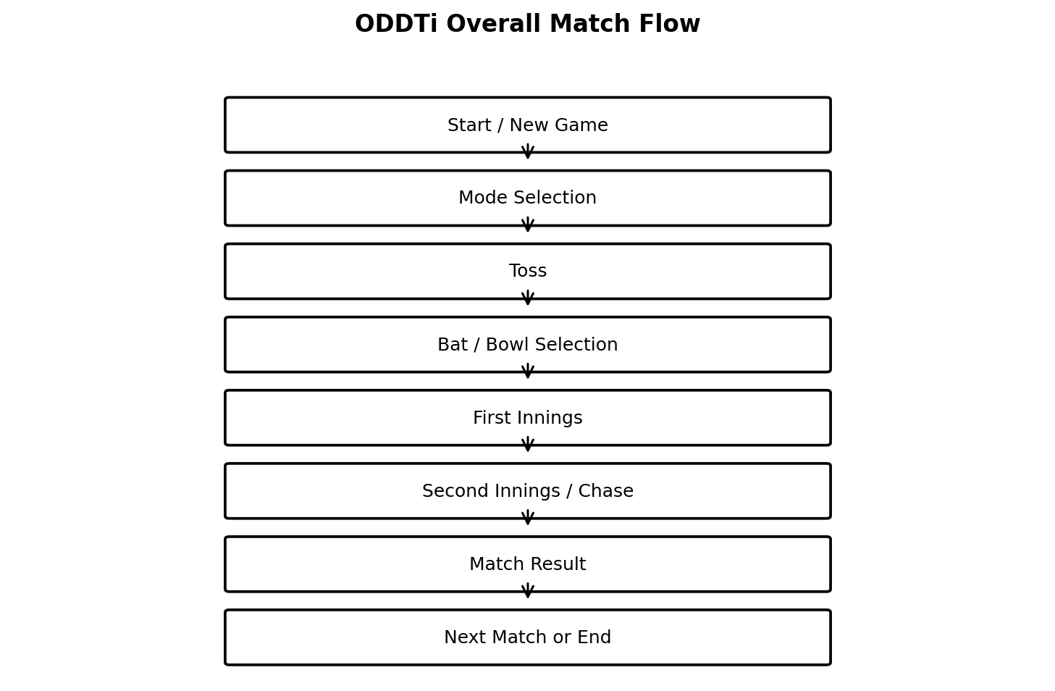
Figure 1. Overall ODDTi match and series flow.

6.2 Use Case Diagram
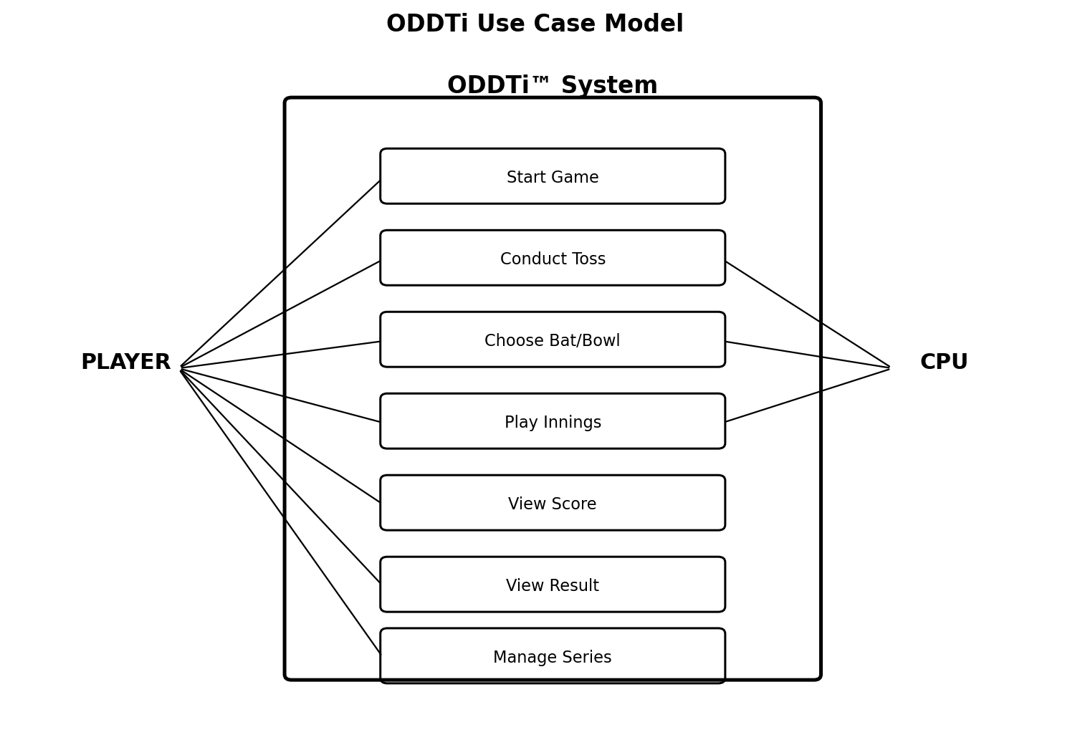
Figure 2. Major player and CPU interactions with ODDTi.

6.3 State Diagram
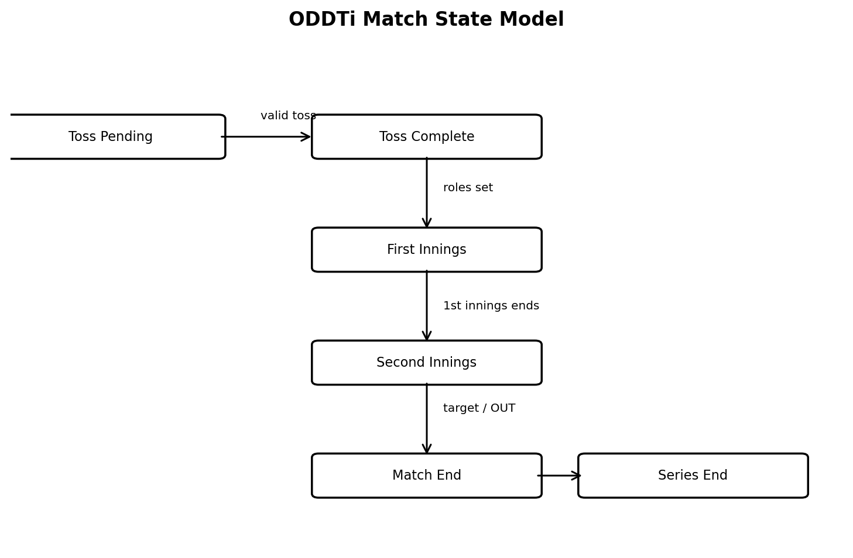
Figure 3. High-level match state transitions.

6.4 Data Flow Description
Stage | Input | Processing | Output
Toss | Call + player number + CPU number | Sum and parity determine winner | Toss winner
Innings | Batting number + bowling number | Compare numbers; add runs or OUT | Score / OUT
Chase | Target + current score + next turn | Update score and runs required | Win or continue
Result | Final scores / ending condition | Compare scores and calculate margin | Match result
Series | Match result | Increment series win count | Series status

7. DETAILED USE CASES

UC-01 — Start New Match
Item | Description
Primary Actor | Player
Goal | Start a clean game session.
Precondition | Application is running and the relevant control is available.
Main Flow | Player selects New Game.; System clears current match variables.; System displays selected mode and enables toss.
Postcondition | Fresh match ready for toss.

UC-02 — Conduct Toss
Item | Description
Primary Actor | Player / CPU
Goal | Determine innings choice rights.
Precondition | Application is running and the relevant control is available.
Main Flow | Caller selects Odd/Even.; Caller provides 0–6 number if player is caller.; CPU generates 0–6.; System calculates sum and parity.; System announces winner and locks toss.
Postcondition | Toss winner recorded.

UC-03 — Choose Bat or Bowl
Item | Description
Primary Actor | Player / CPU
Goal | Determine first innings.
Precondition | Application is running and the relevant control is available.
Main Flow | Toss winner selects Bat First or Bowl First; CPU decides automatically if it won.; System assigns roles.; System starts first innings.
Postcondition | First innings active.

UC-04 — Play Ball
Item | Description
Primary Actor | Batting side
Goal | Execute one batting/bowling turn.
Precondition | Application is running and the relevant control is available.
Main Flow | Batting number and opponent number are obtained.; Numbers are displayed.; If different, batting number is scored.; If equal, batsman is OUT.; Score Log and Last Ball update.
Postcondition | Updated score or OUT.

UC-05 — Complete Chase
Item | Description
Primary Actor | Chasing side
Goal | Win by reaching target or lose by getting OUT.
Precondition | Application is running and the relevant control is available.
Main Flow | System calculates Runs Required.; Chasing side continues turns.; Target reached triggers immediate win.; OUT before target triggers opponent win.
Postcondition | Match-ending condition.

UC-06 — Complete Match
Item | Description
Primary Actor | System
Goal | Declare final result.
Precondition | Application is running and the relevant control is available.
Main Flow | System compares scores.; System calculates run margin when applicable.; System updates Match Result Panel.; Series record is updated if required.
Postcondition | Winner/tie and margin.

UC-07 — Continue Series
Item | Description
Primary Actor | Player
Goal | Start next match in Best-of-3.
Precondition | Application is running and the relevant control is available.
Main Flow | System checks series score.; If neither side has two wins, Next Match is enabled.; New match state is initialized.; Toss begins.
Postcondition | Next match ready.

UC-08 — Reset All
Item | Description
Primary Actor | Player
Goal | Clear match and series state.
Precondition | Application is running and the relevant control is available.
Main Flow | Player selects Reset All.; System clears scores, logs and series results.; System returns to initial state.
Postcondition | Clean application state.

8. USER INTERFACE REQUIREMENTS

8.1 Main Game Screen
UI Area | Required Elements | Purpose
Header / Mode | ODDTi title, Single Match / Best of 3 selector | Identifies game and mode.
Toss Panel | Odd/Even selector, number 0–6, Do Toss, CPU Toss | Runs the match toss.
Innings Controls | Bat First, Bowl First, Submit Number, Force End | Controls match progression.
Scoreboard | Player Score, Player Balls, CPU Score, CPU Balls | Shows live match statistics.
Chase Panel | Target, Runs Required, Innings Label | Explains chase state.
Last Ball | Latest player/CPU numbers | Shows immediate previous play.
Status | Toss pending, batting, OUT, win, etc. | Communicates current system state.
Result Panel | Winner, margin, tie, series result | Shows final outcome.
Logs | Score Log, Series Log | Provides history and audit of gameplay.
Navigation | New Match, Next Match, Show Scorecard, Reset All | Controls match/series lifecycle.

8.2 Input Validation
- Number input must accept only 0, 1, 2, 3, 4, 5 or 6.
- Submit must not execute without a valid number.
- Toss controls must become disabled after the toss.
- Bat/Bowl controls must be disabled after innings starts.
- Result and series controls must reflect the current match state.

8.3 Accessibility and Usability
- Controls should have descriptive labels.
- Status messages should clearly state what the player must do next.
- Important score information should not depend only on color.
- Touch targets should be large enough for tablet/mobile use.
- The interface should remain readable in landscape orientation.

9. BUSINESS / GAME RULES
Rule ID | Rule
BR-01 | A match begins with a toss.
BR-02 | The toss caller chooses Odd or Even and uses a number from 0–6.
BR-03 | The CPU selects a random number from 0–6.
BR-04 | Odd sum means the Odd call wins; even sum means the Even call wins.
BR-05 | Only one toss is permitted per match.
BR-06 | The toss winner chooses Bat First or Bowl First; if CPU wins, CPU decides.
BR-07 | The batting side selects a number from 0–6 on each turn.
BR-08 | If batting and bowling numbers differ, the batting number is added as runs.
BR-09 | If batting and bowling numbers match, the batsman is OUT.
BR-10 | The second innings begins after the first innings ends.
BR-11 | Target is based on the first-innings score.
BR-12 | Runs Required = (Target + 1) − current chasing score.
BR-13 | Reaching or exceeding the target gives the chasing side an immediate win.
BR-14 | Getting OUT before reaching the target gives the opponent the win.
BR-15 | The match result includes winner and run margin where applicable.
BR-16 | Best-of-3 is won by the first side to reach two match wins.
BR-17 | A completed match in a series is recorded in the Series Log.
BR-18 | Match score and toss data do not carry into the next series match.

9.1 Margin Calculation
For a result requiring a run margin, the system calculates the difference between the winning side's final score and the losing side's final score. When the chasing side wins by reaching the target, the margin may be expressed according to the game's final-score convention. A tie is displayed when the final scores are equal and the game-ending condition permits a tie.

9.2 Example Turn
Scenario | Player/Batter | CPU/Bowler | Result
Normal scoring | 4 | 2 | Numbers differ; batter scores 4.
OUT | 5 | 5 | Numbers match; batter is OUT.
Zero run | 0 | 3 | Numbers differ; batter scores 0.

10. TESTING REQUIREMENTS
Testing shall verify that each functional requirement works correctly, that invalid actions are prevented, and that match/series state transitions occur in the expected order.
Test ID | Area | Test Action | Expected Result | Status
TC-01 | New Game | Select New Game | Fresh match with toss pending | Pass if correct
TC-02 | Mode | Select Single Match | Single-match mode active | Pass if correct
TC-03 | Mode | Select Best of 3 | Series mode active | Pass if correct
TC-04 | Toss | Odd call + valid number | Correct toss winner from parity | Pass if correct
TC-05 | Toss Lock | Attempt second toss | Second toss prevented | Pass if prevented
TC-06 | Input Boundary | Enter 0 | Accepted | Pass if accepted
TC-07 | Input Boundary | Enter 6 | Accepted | Pass if accepted
TC-08 | Input Validation | Enter 7 / invalid value | Rejected or prevented | Pass if prevented
TC-09 | Scoring | Batter 4, bowler 2 | Score increases by 4 | Pass if correct
TC-10 | OUT | Batter 5, bowler 5 | OUT and innings ends | Pass if correct
TC-11 | Target | Reach/exceed target | Immediate chase win | Pass if correct
TC-12 | Chase OUT | Get OUT below target | Opponent wins | Pass if correct
TC-13 | Last Ball | Complete a turn | Latest numbers shown | Pass if correct
TC-14 | Score Log | Complete multiple turns | Entries recorded in order | Pass if correct
TC-15 | Series | Win two matches | Series ends 2–0 or 2–1 | Pass if correct
TC-16 | Next Match | Start next series game | Fresh toss and scores | Pass if correct
TC-17 | Reset All | Select Reset All | Match/series data cleared | Pass if correct
TC-18 | Auto-CPU | Enable Auto-CPU | CPU actions automate correctly | Pass if correct

10.1 Boundary and Negative Tests
- Try number values below 0 and above 6.
- Try submitting with no number selected.
- Try conducting a second toss.
- Try changing Bat/Bowl choice after innings begins.
- Try submitting a turn after OUT.
- Try starting another match after a completed Best-of-3 without the appropriate reset/next action.
- Verify Reset All removes series and match history as specified.

11. FUTURE ENHANCEMENTS
- Persistent local storage for match and series history.
- Online multiplayer support.
- Multiple CPU difficulty levels and strategy profiles.
- Expanded statistics such as strike rate, scoring distribution and win percentage.
- Sound effects, animations and haptic feedback on supported devices.
- Improved responsive mobile UI.
- Exportable scorecards.
- Custom match lengths or rule variants.
- Tournament mode.
- Dedicated native mobile or desktop application.
- Accessibility improvements including keyboard-only navigation and screen-reader optimization.
These are proposed enhancements and are not part of the mandatory v2.2 requirements.

12. APPENDICES

Appendix A — Quick Reference Controls
Control | Function
New Game | Start a new match.
Do Toss | Player conducts the toss.
CPU Toss | CPU conducts the toss.
Bat First / Bowl First | Choose innings order after winning toss.
Submit Number | Submit batting/bowling number.
Force End | End the current innings manually.
Next Match | Start next game in Best-of-3.
New Match | Reset for a fresh single match.
Toggle Auto-CPU | Enable/disable automatic CPU turns.
Show Scorecard | Show match/series summary.
Reset All | Clear all match and series data.

Appendix B — Scoreboard Fields
Field | Description
Player Score | Total runs made by player.
Player Balls | Balls/turns faced by player.
CPU Score | Total runs made by CPU.
CPU Balls | Balls/turns bowled by CPU.
Target | Score to beat in the chase.
Runs Required | Remaining runs needed to win.
Innings Label | First or Second innings.
Last Ball | Latest player and CPU numbers.
Match Status | Current state of the match.

Appendix C — Glossary
- Batter: The side currently scoring runs.
- Bowler: The opposing side selecting a number to challenge the batter.
- Chase: The second innings in which a side attempts to exceed the first-innings score.
- Series Log: Match-by-match record in Best-of-3 mode.
- Score Log: Turn-by-turn history of the current match.
- Force End: Manual termination of the current innings.

Appendix D — Credits
Role | Contributor
Concept & Design | Ganesh P. Nair (GPN)
Programming Logic & Flow | Ganesh P. Nair
Implementation & Optimization | ChatGPT (OpenAI)
Testing & QA | Ganesh P. Nair (GPN)
Build / Development | macOS Safari / PyCharm / TI Connect CE
Version | ODDTi™ v2.2 — Next-Match + Last Ball + Margin Fix Build

“From schoolyard chalk lines to silicon logic —
The spirit of odd/even lives on.”
— ⚡GPN⚡ © 2025

