SOP of HMS installation in Ubuntu

To check os version - cat /etc/ SOP of HMS installation in Ubuntu

To check os version - cat /etc/*release
Step 1
-> Check SELinux Status
If Enable, Disable it.
Steps to disable SELinux – extra security
1. Check Current Mood and change it to = permissive [ by cmd = setenforce 0 ]
2. Edit the Conf. file /etc/selinux/config
and set the SELINUX to disabled
3. reboot the server
4. check the sestatus [disabled]
Output :
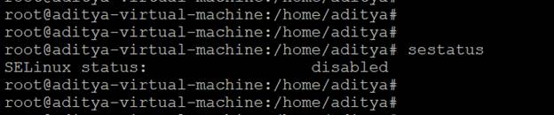

Step 2
-> Check Status of Firewall ( systemctl status ufw )
** if Active
1. All the port by cmd =[ufw allow proto tcp from any to any port 10050,10051 ]
Output :
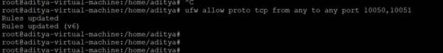

Or Directly stop the firewall by [ systemctl stop ufw]
STEP 3
Install Zabbix Repository :
We will install repository for HMS
1.repo.zabbix.com [chrome]
then select
zabbix - version(6.0)- machine distribution(ubuntu)
- then copy the link of zabbix-release
#cmd1 = wget https://repo.zabbix.com/zabbix/6.0/ubuntu/pool/main/z/zabbix-release/zabbix-release_6.0-1+ubuntu20.04_all.deb
#cmd2 = dpkg -i zabbix-release_6.0-1+ubuntu20.04_all.deb
#cmd3 = apt update
All we run successfully!

Step 4
Install Zabbix server, frontend, agent :
#cmd = apt install zabbix-server-mysql zabbix-frontend-php zabbix-apache-conf zabbix-sql-scripts zabbix-agent
Now, Check the package of Zabbix :
#cmd = dpkg -l zabbix\*
Output :
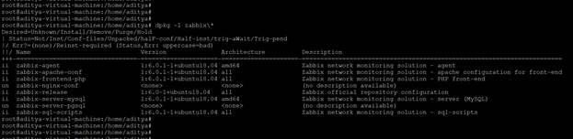

Step 5
Create initial database :
Check the mysql version = mysql -V (If not updated [8.0] , Update it .)
Step 1. Add MySQL APT repository [repo.mysql.com]
#cmd1 = wget https://repo.mysql.com/mysql-apt-config_0.8.22-1_all.deb
#cmd 2 = dpkg -i mysql-apt-config_0.8.22-1_all.deb
dpkg -i mysql-apt-config_0.8.22-1_all.deb

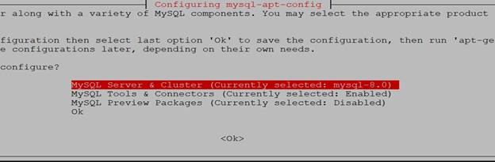
Now , Select the MYSQL Server & Cluster
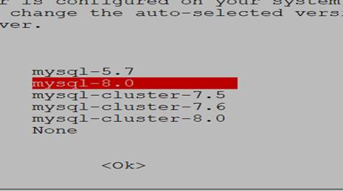
Now , Select mysql -8.0

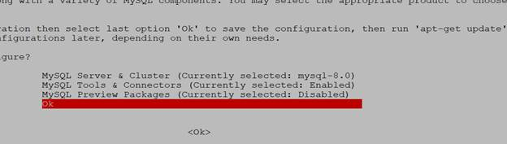
Now , Select the Ok
Output:
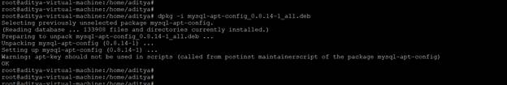
Step 2. Update APT index and install MySQL server
#cmd3 = apt update
#cmd4 = apt install mysql-server
Select , Strong Password [row]
For Ubuntu 22.04 = Link à https://www.digitalocean.com/community/tutorials/how-to-install-mysql-on-ubuntu-22-04
Now , Confirm installation:
#cmd4 = mysql -V
Output :

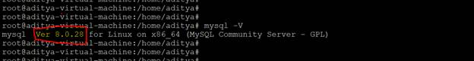

Now , Login by user and password:
- mysql -u root -p or mysql
password = <Admin@123>

Step 6
- Additional Step or cmd for 6.0 = set global log_bin_trust_function_creators=1;
-> After successful login , Now create a user for HMS and grant all privileges to it:
1. create database HMS_DB character set utf8 collate utf8_bin;
[HMS_DB - name of database] Query OK
2. create user HMS@localhost identified by 'Hitachi@12345';
['HMS'@'localhost' is user & 'Hms@123' is password for user ] Query OK
- grant all privileges on HMS_DB.* to HMS@localhost; (with grant option)
[ priviliges to database : HMS_DB for user HMS@localhost] Query OK
4. flush privileges;
5. quit;
Output :

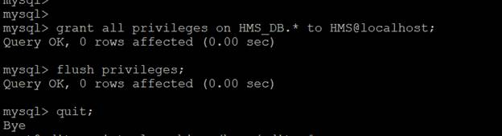

Step 7
-> After the above command ,use zcat command to install the schema of Zabbix:
#new cmd = zcat /usr/share/zabbix-sql-scripts/mysql/server.sql.gz | mysql -uHMS -p HMS_DB (main command)

zcat /usr/share/zabbix/sql-scripts/mysql/server.sql.gz | mysql --default-character-set=utf8mb4 -uHMS -p HMS_DB

[ HMS_DB is database , -p is for password for user -u(HMS) ]
OR
zcat /usr/share/zabbix-sql-scripts/mysql/server.sql.gz | mysql --default-character-set=utf8mb4 -Uhms -p HMS_DB
OR
zcat /usr/share/zabbix/sql-scripts/mysql/server.sql.gz | mysql --default-character-set=utf8mb4 -uHMS -p HMS_DB
Step 8
-> Configure the database for Zabbix server
1. cd /etc/zabbix/ -> vim zabbix_server.conf
2. changes in configuration (search by (/DB)press enter and then scroll down by (n) and make changes
a. DBName = HMS_DB
b. DBUser= HMS
c. DBPassword= Hitachi@12345 [ Uncomment]
d. Timeout=30
and save the conf. = :wq! [after pressing (esc)]
Step 9
->Start Zabbix server and agent processes and make it start at system boot using the given commands:
1.systemctl restart zabbix-server.service
systemctl restart Zabbix-agent
2.systemctl restart zabbix-agent apache2
3.systemctl enable zabbix-server zabbix-agent apache2
Output:
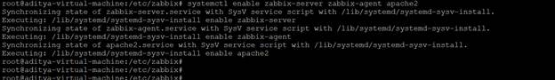
4.systemctl status zabbix-server.service
Output:
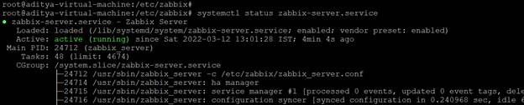
5.systemctl status apache2
Output:
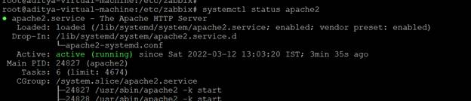

Step 10
->Open Browser
=> http:/10.247.2.188/zabbix [10.83.152.221]
now complete the http:/172.31.95.92/zabbix
172.31.95.92

From <https://us-east-1.console.aws.amazon.com/ec2/home?region=us-east-1>

on browser.
1. Default language= English (en_GB)
2.Check = OK move to next
3.Configure DB connection = with DB {name , user , password} move to next
4.Zabbix server details = next
5.Default time zone = (UTC+05:30) Asia/Kolkata [Scroll n see] next
6.Pre-installation summary = Install

Congratulations! You have successfully installed Zabbix frontend.
[ Configuration file "conf/zabbix.conf.php" created. ] Now, Finish.
# LOGIN
user = Admin
password = zabbix

######## Do GUI Changes [from the backend (/usr/share/zabbix)] ##########

*release
Step 1
-> Check SELinux Status
If Enable, Disable it.
Steps to disable SELinux – extra security
1. Check Current Mood and change it to = permissive [ by cmd = setenforce 0 ]
2. Edit the Conf. file /etc/selinux/config
and set the SELINUX to disabled
3. reboot the server
4. check the sestatus [disabled]
Output :


Step 2
-> Check Status of Firewall ( systemctl status ufw )
** if Active
1. All the port by cmd =[ufw allow proto tcp from any to any port 10050,10051 ]
Output :


Or Directly stop the firewall by [ systemctl stop ufw]
STEP 3
Install Zabbix Repository :
We will install repository for HMS
1.repo.zabbix.com [chrome]
then select
zabbix - version(6.0)- machine distribution(ubuntu)
- then copy the link of zabbix-release
#cmd1 = wget https://repo.zabbix.com/zabbix/6.0/ubuntu/pool/main/z/zabbix-release/zabbix-release_6.0-1+ubuntu20.04_all.deb
#cmd2 = dpkg -i zabbix-release_6.0-1+ubuntu20.04_all.deb
#cmd3 = apt update
All we run successfully!

Step 4
Install Zabbix server, frontend, agent :
#cmd = apt install zabbix-server-mysql zabbix-frontend-php zabbix-apache-conf zabbix-sql-scripts zabbix-agent
Now, Check the package of Zabbix :
#cmd = dpkg -l zabbix\*
Output :


Step 5
Create initial database :
Check the mysql version = mysql -V (If not updated [8.0] , Update it .)
Step 1. Add MySQL APT repository [repo.mysql.com]
#cmd1 = wget https://repo.mysql.com/mysql-apt-config_0.8.22-1_all.deb
#cmd 2 = dpkg -i mysql-apt-config_0.8.22-1_all.deb
dpkg -i mysql-apt-config_0.8.22-1_all.deb


Now , Select the MYSQL Server & Cluster

Now , Select mysql -8.0


Now , Select the Ok
Output:

Step 2. Update APT index and install MySQL server
#cmd3 = apt update
#cmd4 = apt install mysql-server
Select , Strong Password [row]
For Ubuntu 22.04 = Link à https://www.digitalocean.com/community/tutorials/how-to-install-mysql-on-ubuntu-22-04
Now , Confirm installation:
#cmd4 = mysql -V
Output :



Now , Login by user and password:
- mysql -u root -p or mysql
password = <Admin@123>

Step 6
- Additional Step or cmd for 6.0 = set global log_bin_trust_function_creators=1;
-> After successful login , Now create a user for HMS and grant all privileges to it:
1. create database HMS_DB character set utf8 collate utf8_bin;
[HMS_DB - name of database] Query OK
2. create user HMS@localhost identified by 'Hitachi@12345';
['HMS'@'localhost' is user & 'Hms@123' is password for user ] Query OK
- grant all privileges on HMS_DB.* to HMS@localhost; (with grant option)
[ priviliges to database : HMS_DB for user HMS@localhost] Query OK
4. flush privileges;
5. quit;
Output :



Step 7
-> After the above command ,use zcat command to install the schema of Zabbix:
#new cmd = zcat /usr/share/zabbix-sql-scripts/mysql/server.sql.gz | mysql -uHMS -p HMS_DB (main command)

zcat /usr/share/zabbix/sql-scripts/mysql/server.sql.gz | mysql --default-character-set=utf8mb4 -uHMS -p HMS_DB

[ HMS_DB is database , -p is for password for user -u(HMS) ]
OR
zcat /usr/share/zabbix-sql-scripts/mysql/server.sql.gz | mysql --default-character-set=utf8mb4 -Uhms -p HMS_DB
OR
zcat /usr/share/zabbix/sql-scripts/mysql/server.sql.gz | mysql --default-character-set=utf8mb4 -uHMS -p HMS_DB
Step 8
-> Configure the database for Zabbix server
1. cd /etc/zabbix/ -> vim zabbix_server.conf
2. changes in configuration (search by (/DB)press enter and then scroll down by (n) and make changes
a. DBName = HMS_DB
b. DBUser= HMS
c. DBPassword= Hitachi@12345 [ Uncomment]
d. Timeout=30
and save the conf. = :wq! [after pressing (esc)]
Step 9
->Start Zabbix server and agent processes and make it start at system boot using the given commands:
1.systemctl restart zabbix-server.service
systemctl restart Zabbix-agent
2.systemctl restart zabbix-agent apache2
3.systemctl enable zabbix-server zabbix-agent apache2
Output:

4.systemctl status zabbix-server.service
Output:

5.systemctl status apache2
Output:


Step 10
->Open Browser
=> http:/10.247.2.188/zabbix [10.83.152.221]
now complete the http:/172.31.95.92/zabbix
172.31.95.92

From <https://us-east-1.console.aws.amazon.com/ec2/home?region=us-east-1>

on browser.
1. Default language= English (en_GB)
2.Check = OK move to next
3.Configure DB connection = with DB {name , user , password} move to next
4.Zabbix server details = next
5.Default time zone = (UTC+05:30) Asia/Kolkata [Scroll n see] next
6.Pre-installation summary = Install

Congratulations! You have successfully installed Zabbix frontend.
[ Configuration file "conf/zabbix.conf.php" created. ] Now, Finish.
# LOGIN
user = Admin
password = zabbix

######## Do GUI Changes [from the backend (/usr/share/zabbix)] ##########

