2 - marks
1. State the primary goal of the Naïve Bayes classifier and what is the difference between Classification and Regression.
The primary goal of the Naïve Bayes classifier is to predict the probability of a data point belonging to a specific class based on Bayes' Theorem, assuming features are independent.
Differences: Classification vs. Regression
- Output Type: Classification predicts discrete, distinct, or categorical labels (e.g., Yes/No, Spam/Ham). Regression predicts continuous numeric values (e.g., prices, temperature).
- Goal: Classification draws decision boundaries between classes. Regression fits a best-fit line or curve through data points.
- Example: Predicting if a house is "Expensive" or "Cheap" is Classification; predicting the exact price of the house is Regression.
2.Define Multi-Layer Perceptrons (MLPs)
Multi-Layer Perceptron (MLP) consists of fully connected dense layers that transform input data from one dimension to another. It is called multi-layer because it contains an input layer, one or more hidden layers and an output layer. The purpose of an MLP is to model complex relationships between inputs and outputs.
3.Backpropagation for training an MLP.
Backpropagation is a supervised learning algorithm for Multilayer Perceptrons (MLPs) that calculates gradients of a loss function with respect to weights using the chain rule. It works by performing a forward pass to predict output, calculating the error, and propagating it backward to update weights, minimizing errors iteratively via gradient descent.
4.What is Clustering and how is Partitioning of Data done.
Clustering is the process of partitioning a set of data objects into subsets called clusters, where similarity is maximized within a cluster and minimized between clusters.
Partitioning methods are a family of clustering algorithms that divide a dataset into a predefined number (K) of clusters. They construct partitions, where each partition represents a cluster, and iteratively refine them.
5.What is K-Means clustering, Soft Partitioning, and Hard Partitioning.
K-Means clustering is an unsupervised learning algorithm that partitions a dataset into a pre-defined number () of distinct, non-overlapping subgroups (clusters) by minimizing the distance between data points and their cluster centroid. It is a centroid-based technique that aims to create compact, spherical clusters, typically using Euclidean distance.
Hard Partitioning (or Hard Clustering) refers to clustering methods where each data point is assigned exclusively to one cluster. K-Means is a prime example of hard partitioning, as it assigns a point to the nearest cluster centroid with 100% certainty, allowing no overlap between clusters.

Soft Partitioning (or Soft/Fuzzy Clustering) allows data points to belong to multiple clusters simultaneously with varying degrees of membership, usually expressed as probabilities. A common example is Fuzzy C-Means (FCM) or Gaussian Mixture Models (GMM), which can indicate, for example, that a data point is 70% in Cluster A and 30% in Cluster B.
5 – marks
1.Explain Decision Tree classification and regression algorithms in detail.
Decision Tree in Machine Learning
A decision tree is a supervised learning algorithm used for both classification and regression tasks. It has a hierarchical tree structure which consists of a root node, branches, internal nodes and leaf nodes. It works like a flowchart that helps in making step by step decision, where:
- Internal nodes represent attribute tests
- Branches represent attribute values
- Leaf nodes represent final decisions or predictions.

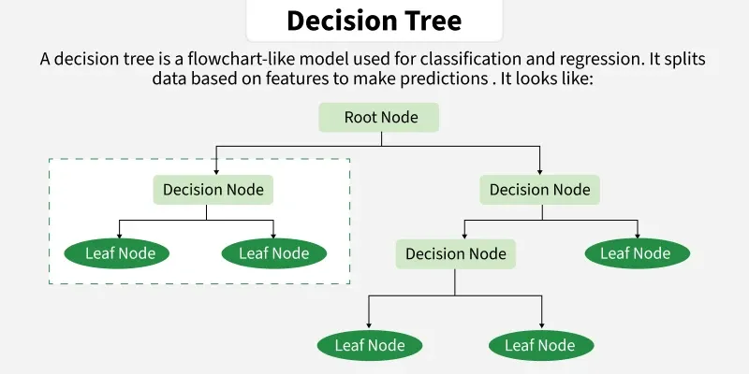

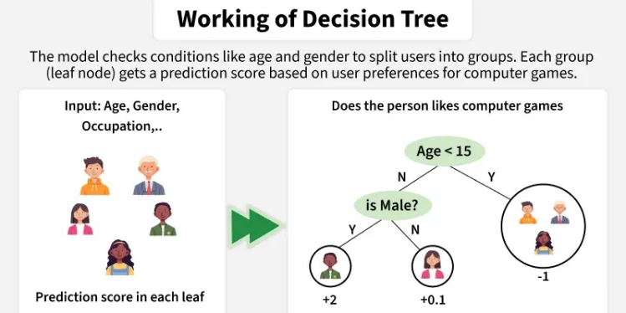

For classification:
The algorithm's steps are:
Training Phase: Building the Tree
1)Start at the Root Node: The entire dataset is considered the initial node.
2)Evaluate All Possible Splits:
For each feature and every possible split point (e.g., the midpoint between adjacent values for continuous data), the algorithm divides the dataset into two child nodes.
For each split, it calculates a chosen error metric (typically Mean Squared Error (MSE) or Residual Sum of Squares (RSS)) for both child nodes.
The goal is to find the split that results in the lowest weighted average of the MSE in the resulting child nodes, which maximizes the variance reduction.
3)Select the Best Split: The feature and split point that yield the greatest reduction in error are chosen to form the first decision node.
4)Recursive Partitioning: The process (steps 2-3) is applied recursively to each child node. This continues to split the data into smaller, more homogeneous subsets.
5)Stop Splitting: The recursion stops when a predefined stopping condition is met. Common conditions include:
For Regression:
Start at the Root: The entire dataset begins at the root node.
Select the Best Feature: The algorithm evaluates all available features using an Attribute Selection Measure (like Information Gain or Gini Index) to determine which feature best splits the data into the most homogeneous (pure) subsets.
Split the Data: The dataset is split into child nodes based on the values or a threshold of the selected feature.
Repeat Recursively: Steps 2 and 3 are repeated for each new child node with the remaining attributes.
Stop: The recursion stops when a stopping criterion is met, such as all samples in a node belonging to the same class (a pure leaf node), a maximum tree depth is reached, or the number of samples in a node is too small for further splitting.
3.Explain Linear Discriminants for Classification in detail.
Linear Discriminant Analysis (LDA) also known as Normal Discriminant Analysis is supervised classification problem that helps separate two or more classes by converting higher-dimensional data space into a lower-dimensional space. It is used to identify a linear combination of features that best separates classes within a dataset.
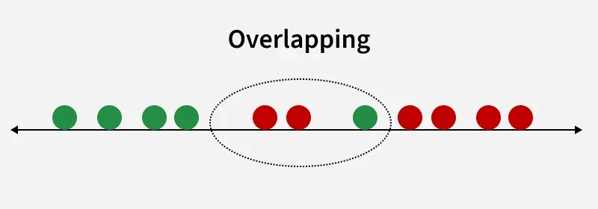
How LDA work
LDA works by finding directions in the feature space that best separate the classes. It does this by maximizing the difference between the class means while minimizing the spread within each class.
Let’s assume we have two classes with d-dimensional samples such as $x_{1},x_{2},...x_{n}$ where:
- $n_{1}$ samples belong to class $c_{1}$
- $n_{2}$​ samples belong to class $c_{2}$​.
If $x_{i}$​ represents a data point its projection onto the line represented by the unit vector $v$ is $v^{T}x_{i}$​. Let the means of class $c_{1}$ and class $c_{2}$​ before projection be $μ_{1}$​ and $μ_{2}$ respectively. After projection the new means are ${\hat{μ}}_{1}=v^{T}μ_{1}$ and ${\hat{μ}}_{2}=v^{T}μ_{2}$​.
Our aim to normalize the difference $∣{\hat{μ}}_{1}-{\hat{μ}}_{2}∣$ to maximize the class separation. The scatter for samples of class $c_{1}$​ is calculated as:
$$s_{1}^{2}=\sum_{x_{i}∈c_{1}}{(}x_{i}-μ_{1})^{2}$$
Similarly for class $c_{2}$​:
$$s_{2}^{2}=\sum_{x_{i}∈c_{2}}{(}x_{i}-μ_{2})^{2}$$
The goal is to maximize the ratio of the between-class scatter to the within-class scatter, which leads us to the following criteria:
$$J(v)=\frac{∣{\hat{μ}}_{1}-{\hat{μ}}_{2}∣}{s_{1}^{2}+s_{2}^{2}}$$
For the best separation we calculate the eigenvector corresponding to the highest eigenvalue of the scatter matrices $s_{w}^{-1}s_{b}$.
5.Define Divisive Clustering, Agglomerative Clustering, Partitional Clustering, and K-Means Clustering.
Divisive Clustering :
Divisive Clustering is a type of hierarchical clustering that follows a top-down approach. It starts by placing all data points into one large cluster and then recursively splits that cluster into smaller ones based on differences or distances between the points. This process continues until each cluster contains only similar data points or meets a stopping condition. It is the opposite of agglomerative clustering, which builds clusters from the bottom up. It is is useful when we want to break down a broad category into smaller, meaningful groups.
Agglomerative Clustering :
Agglomerative clustering is a "bottom-up" hierarchical, unsupervised machine learning algorithm that groups data points by merging the closest pairs iteratively, starting with each point as its own cluster. It creates a dendrogram to visualize hierarchies, making it ideal for finding nested structures, customer segmentation, and image segmentation without predefining the number of clusters.

Partitional Clustering :
Partitioning clustering is an unsupervised machine learning technique that divides a dataset into distinct, non-overlapping subsets (clusters) based on feature similarity. It requires defining the number of clusters (K) beforehand and works iteratively to optimize centroids, assigning each data point to the nearest cluster, commonly used for customer segmentation and anomaly detection.
K-Means Clustering :
K-means clustering is a popular unsupervised machine learning algorithm used to group unlabeled data points into a predefined number of clusters, K, based on the similarity of their features. The goal is to partition the dataset such that data points within the same cluster are similar to each other, and different from those in other clusters.

