.

**Department of Computer Science and Engineering** | **Rajalakshmi Engineering College**

164

10 - Searching & Sorting

**Ex. No. : 10.1 Date:25/5/24**

.

**Department of Computer Science and Engineering** | **Rajalakshmi Engineering College**

165

**Register No.: 231501046 Name: Ganesh S**

# Merge Sort

Write a Python program to sort a list of elements using the merge sort algorithm.

## For example:

|  |  |
| --- | --- |
| **Input** | **Result** |
| 5  6 5 4 3 8 | 3 4 5 6 8 |

**Program:**

a = int(input())

b = list(input().split(" ")) b.sort()

for i in b: print(i,end=" ")

**Output:**

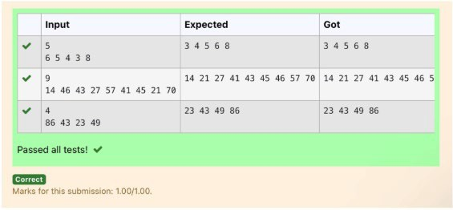

**Ex. No. : 10.2 Date:25/5/24**

**Register No.: 231501046 Name: Ganesh S**

# Bubble Sort

Given an listof integers, sort the array in ascending order using the *Bubble Sort* algorithm above. Once sorted, print the following three lines:

1. List is sorted in numSwaps swaps., where numSwaps is the number of swaps that took place.
2. First Element: firstElement, the *first* element in the sorted list.
3. Last Element: lastElement, the *last* element in the sorted list.

For example, given a worst-case but small array to sort: a=[6,4,1]. It took 3 swaps to sort the array. Output would be

Array is sorted in 3 swaps. First Element: 1

Last Element: 6

## Input Format

The first line contains an integer,n , the size of the list a . The second line contains n, space-separated integers a[i].

## Constraints

· 2<=n<=600

· 1<=a[i]<=2x106.

## Output Format

You must print the following three lines of output:

1. List is sorted in numSwaps swaps., where numSwaps is the number of swaps that took place.
2. First Element: firstElement, the *first* element in the sorted list.
3. Last Element: lastElement, the *last* element in the sorted list.

## Sample Input 0

3

1 2 3

## Sample Output 0

List is sorted in 0 swaps. First Element: 1

Last Element: 3

.

**Department of Computer Science and Engineering** | **Rajalakshmi Engineering College**

166

## For example:

.

**Department of Computer Science and Engineering** | **Rajalakshmi Engineering College**

167

|  |  |
| --- | --- |
| **Input** | **Result** |
| 3 | List is sorted in 3 swaps. |
| 3 2 1 | First Element: 1 |
|  | Last Element: 3 |
| 5 | List is sorted in 4 swaps. |
| 1 9 2 8 4 | First Element: 1 |
|  | Last Element: 9 |

**Program:**

n=input() arr=input().split() arr1=[]

for i in arr: arr1.append(int(i))

l = len(arr1) nswaps = 0

for i in range(l):

for j in range(0, l-i-1): if arr1[j] > arr1[j+1]:

arr1[j], arr1[j+1] = arr1[j+1], arr1[j] nswaps +=1

print("List is sorted in {} swaps.".format(nswaps)) print("First Element: {}".format(arr1[0])) print("Last Element: {}".format(arr1[-1]))

**Output:**

.

**Department of Computer Science and Engineering** | **Rajalakshmi Engineering College**

168

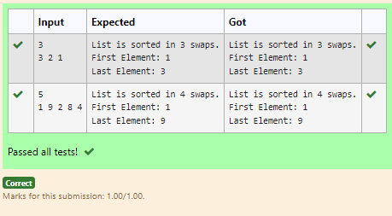

**Ex. No. : 10.3 Date:25/5/24**

**Register No.: 231501046 Name: Ganesh S**

# Peak Element

Given an list, find peak element in it. A peak element is an element that is greater than its neighbors.

An element a[i] is a peak element if

A[i-1] <= A[i] >=a[i+1] for middle elements. [0<i<n-1] A[i-1] <= A[i] for last element [i=n-1]

A[i]>=A[i+1] for first element [i=0]

## Input Format

The first line contains a single integer n , the length of A . The second line contains n space-separated integers,A[i].

## Output Format

**Print** peak numbers separated by space.

## Sample Input

5

8 9 10 2 6

## Sample Output

10 6

## For example:

|  |  |
| --- | --- |
| **Input** | **Result** |
| 4  12 3 6 8 | 12 8 |

**Program:**

def find_peaks(n, A): peaks = []

if n == 1 or A[0] >= A[1]:

peaks.append(A[0])

.

**Department of Computer Science and Engineering** | **Rajalakshmi Engineering College**

169

for i in range(1, n - 1):

.

**Department of Computer Science and Engineering** | **Rajalakshmi Engineering College**

170

if A[i] >= A[i - 1] and A[i] >= A[i + 1]: peaks.append(A[i])

if n > 1 and A[-1] >= A[-2]:

peaks.append(A[-1]) return peaks

n = int(input().strip())

A = list(map(int, input().strip().split())) peaks = find_peaks(n, A)

print(" ".join(map(str, peaks)))

**Output:**

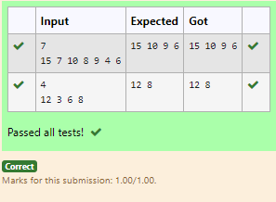

**Ex. No. : 10.4 Date:25/5/24**

**Register No.: 231501046 Name: Ganesh S**

# Binary Search

Write a Python program for binary search.

## For example:

|  |  |
| --- | --- |
| **Input** | **Result** |
| 1 2 3 5 8  6 | False |
| 3 5 9 45 42  42 | True |

**Program:**

def binary_search(arr, target): left, right = 0, len(arr) - 1 while left <= right:

mid = (left + right) // 2 if arr[mid] == target:

return True

elif arr[mid] < target: left = mid + 1

else:

right = mid - 1 return False

if name == " main ":

.

**Department of Computer Science and Engineering** | **Rajalakshmi Engineering College**

171

arr1 = list(map(int, input().strip().split(','))) target1 = int(input().strip())

.

**Department of Computer Science and Engineering** | **Rajalakshmi Engineering College**

172

result1 = binary_search(sorted(arr1), target1)

print(result1)

**Output:**

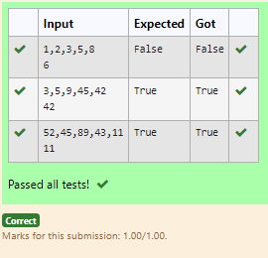

**Ex. No. : 10.5 Date:25/5/24**

**Register No.: 231501046 Name: Ganesh S**

# Frequency of Elements

To find the frequency of numbers in a list and display in sorted order.

**Constraints:** 1<=n, arr[i]<=100 **Input:**

1 68 79 4 90 68 1 4 5

## output:

1 2

4 2

5 1

68 2

79 1

90 1

## For example:

|  |  |
| --- | --- |
| **Input** | **Result** |
| 4 3 5 3 4 5 | 3 2 |
|  | 4 2 |
|  | 5 2 |

**Program:** num=input() l=num.split() nl=[]

for i in l: nl.append(int(i))

.

**Department of Computer Science and Engineering** | **Rajalakshmi Engineering College**

173

ul=[] nl.sort() for i in nl:

.

**Department of Computer Science and Engineering** | **Rajalakshmi Engineering College**

174

if i not in ul: ul.append(i)

for i in ul:

print("{} {}".format(i,nl.count(i)))

**Output:**

