.

11 - Exceptions

**Department of Computer Science and Engineering** | **Rajalakshmi Engineering College**

175

**Ex. No. : 11.1 Date: 1/6/24**

**Register No.: 231501046 Name: Ganesh S**

Problem Description:

# Safe Square Root

Develop a Python program that safely calculates the square root of a number provided by the user. Handle exceptions for negative inputs and non-numeric inputs.

Input Format:

User inputs a number. Output Format:

Print the square root of the number or an error message if an exception occurs.

## For example:

|  |  |
| --- | --- |
| **Input** | **Result** |
| 16 | The square root of 16.0 is 4.00 |
| -4 | Error: Cannot calculate the square root of a negative number. |
| rec | Error: could not convert string to float |

**PROGRAM**

import math def safe_sqrt():

try:

num = float(input()) if num < 0:

print("Error: Cannot calculate the square root of a negative number.") else:

result = math.sqrt(num)

.

**Department of Computer Science and Engineering** | **Rajalakshmi Engineering College**

176

print("The square root of", num, "is", "{:.2f}".format(result)) except ValueError:

.

print("Error: could not convert string to float") safe_sqrt()

**Output:**

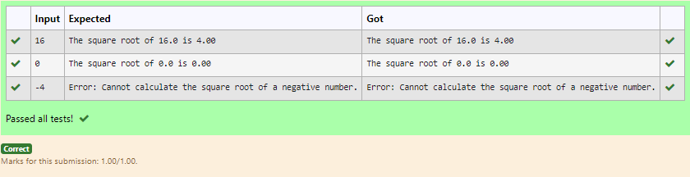

**Department of Computer Science and Engineering** | **Rajalakshmi Engineering College**

177

**Ex. No. : 11.2 Date: 1/6/24**

**Register No.: 231501046 Name: Ganesh S**

Problem Description:

# Valid Age

Write a Python program that asks the user for their age and prints a message based on the age. Ensure that the program handles cases where the input is not a valid integer.

.

Input Format:

A single line input representing the user's age. Output Format:

Print a message based on the age or an error if the input is invalid.

## For example:

|  |  |
| --- | --- |
| **Input** | **Result** |
| 25 | You are 25 years old. |
| rec | Error: Please enter a valid age. |
| -5 | Error: Please enter a valid age. |

**Program:**

def age(): try:

ag=int(input()) if ag<0:

raise ValueError("Error: Please enter a valid age.") print("You are {} years old.".format(ag))

except Exception as e:

print("Error: Please enter a valid age.") age()

**Department of Computer Science and Engineering** | **Rajalakshmi Engineering College**

178

**Output:**

.

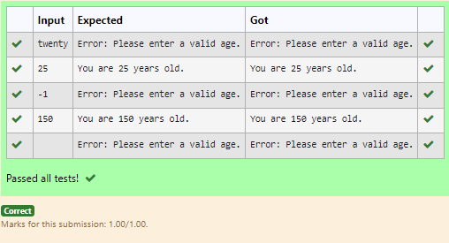

**Department of Computer Science and Engineering** | **Rajalakshmi Engineering College**

179

**Ex. No. : 11.3 Date: 1/6/24**

**Register No.: 231501046 Name: Ganesh S**

# Safe Division

Develop a Python program that safely performs division between two numbers provided by the user. Handle exceptions like division by zero and non-numeric inputs.

**Input Format:** Two lines of input, each containing a number.

**Output Format:** Print the result of the division or an error message if an exception occurs.

## For example:

|  |  |
| --- | --- |
| **Input** | **Result** |
| 10  2 | 5.0 |
| 10  0 | Error: Cannot divide or modulo by zero. |
| ten 5 | Error: Non-numeric input provided. |

**Program:**

def div(): try:

n1=input() n2=input() n1=float(n1) n2=float(n2) quo=n1/n2 print(quo)

.

**Department of Computer Science and Engineering** | **Rajalakshmi Engineering College**

180

except ValueError:

.

print("Error: Non-numeric input provided.") except ZeroDivisionError:

print("Error: Cannot divide or modulo by zero.")

div()

**Output:**

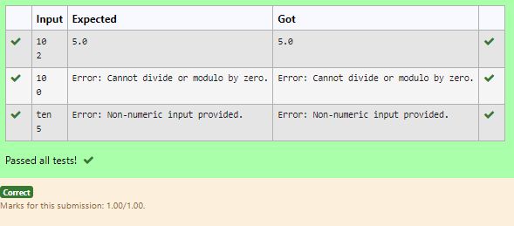

**Department of Computer Science and Engineering** | **Rajalakshmi Engineering College**

181

**Ex. No. : 11.4 Date: 1/6/24**

**Register No.: 231501046 Name: Ganesh S**

# Safe Division and Modulo

Write a Python program that performs division and modulo operations on two numbers provided by the user. Handle division by zero and non-numeric inputs.

**Input Format:** Two lines of input, each containing a number.

**Output Format:** Print the result of the division or an error message if an exception occurs.

## For example:

|  |  |
| --- | --- |
| **Input** | **Result** |
| 10  2 | Division result: 5.0  Modulo result: 0 |
| 7  3 | Division result: 2.3333333333333335  Modulo result: 1 |
| 8  0 | Error: Cannot divide or modulo by zero. |

**Program:**

def operations(): try:

num1=int(input()) num2=int(input()) div=num1/num2 mod=num1%num2 print("Division result:", div) print("Modulo result:", mod)

except ValueError:

print("Error: Non-numeric input provided.") except ZeroDivisionError:

.

**Department of Computer Science and Engineering** | **Rajalakshmi Engineering College**

182

print("Error: Cannot divide or modulo by zero.") operations()

.

## Output:

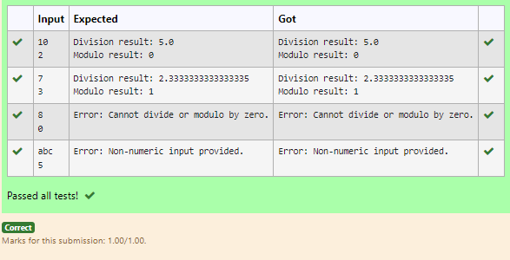

**Department of Computer Science and Engineering** | **Rajalakshmi Engineering College**

183

**weekEx. No. : 11.5 Date: 1/6/24 Register No.: 231501046 Name: Ganesh S**

Problem Description:

# Valid Integer

Write a Python script that asks the user to enter a number within a specified range (e.g., 1 to 100). Handle exceptions for invalid inputs and out-of-range numbers.

.

Input Format:

User inputs a number. Output Format:

Confirm the input or print an error message if it's invalid or out of range

## For example:

|  |  |
| --- | --- |
| **Input** | **Result** |
| 1 | Valid input. |
| 101 | Error: Number out of allowed range |
| rec | Error: invalid literal for int() |

**PROGRAM**

try:

n=int(input()) if n>=1:

print("You are",n,"years old.") else:

print("Error: Please enter a valid age.") except:

print("Error: Please enter a valid age.")

**Department of Computer Science and Engineering** | **Rajalakshmi Engineering College**

184

.

**Output:**

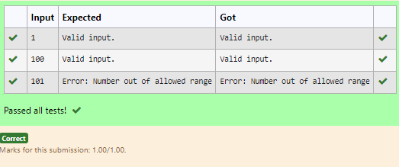

**Department of Computer Science and Engineering** | **Rajalakshmi Engineering College**

185