**Project Report**

**on**

**“BookMyAppointment”**





**School of Computer Science Engineering and Applications**

**Program: Masters of Computer Applications**

**2021 Batch**

Submitted by:

|  |  |  |
| --- | --- | --- |
| PRN: 20210804001 | : | Ganesh Towar |
|  | : |  |
|  | : |  |
|  | : |  |

**CERTIFICATE**

Certified that the Project Report entitled “**BookMyAppointment”,** submitted by Ganesh S Towar, of MCA-II Sem, is their own work and has been carried out under my supervision. It is recommended that the candidates may now be evaluated for their work by the University.

Name1: Ganesh S Towar PRN1: 202100804001

Name2: PRN2:

Date:

Guide Name

Miss Maya

**ACKNOWLEDGEMENT**

We feel immense pleasure to introduce **“BookMyAppointment”** as our major project.

We express our foremost and sincere gratitude to Miss Maya

(Give Acknowledgements and thanks to all who supported you in making this project design)

Miss Heena Bhatia who has been a constant source of knowledge and inspiration to us. Apart from the subject, we have learnt a lot from them, which we are sure, will be useful in different stages of our life.

We would like to express our gratitude to Miss Richa Purohit for her review and many helpful comments and enlightening us and guiding us throughout the project work is appreciable.

Last but not the least, the one who have given us that much strength to keep moving on forward every time, we are greatly thankful to them and have no words to express our gratitude to them.

**ABSTRACT**

A very brief introduction of project in 3 or 4 small paragraphs.

An online marketplace is a site that connects sellers with buyers. It's often known as an electronic marketplace and all transactions are managed by the website owner. Companies use online marketplaces to reach customers who want to purchase their products and services.

Example of online marketplace are Amazon, Flipcart ,Ebay , BookMyShow

BookMyAppointment is an online market place for services, where service providers can list their services on the site and clients can book appointment for the service from site. BookMyAppointment accounts for the services like Psychologist, Consultant, Salon, Dentist, etc,( evey service that requires booking an appointment )

**Table of Content**

**1 : PROBLEM STATEMENT:**

* Explanation of problem
* Current available solutions

**2: Solution:**

* Solution the Project Provides
* Django and how it interacts with database and frontend

**3 : Architecture And Design of Application:**

* MINIMUM SYSTEM REQUIREMENT
* DFD
* ERD

**4: Screen Shots :**

**5:REFRENCES:**

**Explanation of problem**

There is no existing platform that can book appointments and aggregate the services under one platform so that users can explore the services nearby and book appointment at one click.

A person needs to find out the service provider in the area then find the way to contact them and book an appointment through call. He needs to call every service provider just to know about rates and available timing.

You can’t book an appointment in non-working hours and there is no legit conformation of the booked appointment.

Current available solutions

There are many application and websites and available to help user manage their appointments, but none of the applications or websites are aggregating the services and service providers under one online marketplace.

The current applications and website provide appointment booking feature to individual user his client base.

Solution this application provides

BookMyAppointment website creates a marketplace for the service providers to list their services on the website and the user can explore the services and select the service and service provider that suits them best without making multiple call to compare the service providers. The app will provide the Address, Email, Name, Visiting fees of the service provider to the user. You would receive an verification code to confirm your Appointment.

Requirements

For developing a website, we need front end backend and database.

Programing language: Python.

Front end: HTML, Css, Bootstrap, javascript.

Backend: Django python framework.

Database: DBsqlite.

Memory: 2gb ram 2gb rom.

IDE: pycharm. (recommended).

Processor: intel i5 core 250 GHz 64 bit operating system (recommended).

Browser: google Chrome(recommended)

**What is Django? How Django interacts with frontend and database?**

Django is a high-level Python web framework that encourages rapid development and clean, pragmatic design. Built by experienced developers, it takes care of much of the hassle of web development, so you can focus on writing your app without needing to reinvent the wheel. It’s free and open source.

Django works on model view template architecture (MVT) as show below

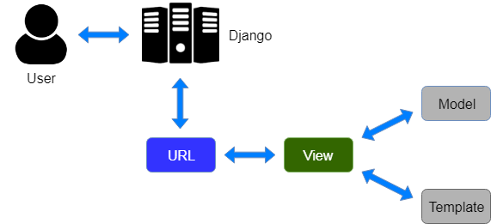

Architecture And Design of Application

(DFD ,ER Diagram)

References:

Python official documentation

Bootstrap

Geeks for geeks

Tutorial points

Screen shots