**Exception handling in Java**

**Rules:**

**Can we use try block alone without Catch or finally? the answer is no**

Try block alone should not work when there is try block there must be a catch or finally should be present

When there is a catch it should contact one keyword as Exception with an identifier as e catch (Exception e) i.e., there is nothing the identifier should be only as e we can give any character or string pfb., rules and definitions of identifier

**What is an identifier in java?**

**Identifiers** are the names of variables, methods, classes, packages and interfaces. Unlike literals they are not the things themselves, just ways of referring to them. In the HelloWorld program, HelloWorld , String , args , main and println are **identifiers**.

**Example 1: try block with finally**

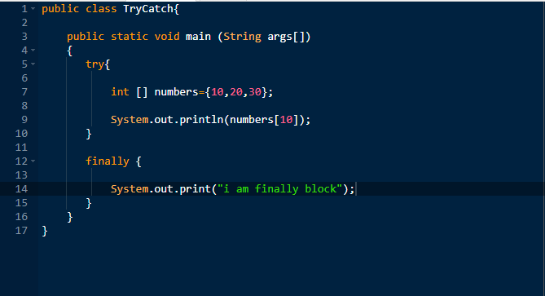

**Result**

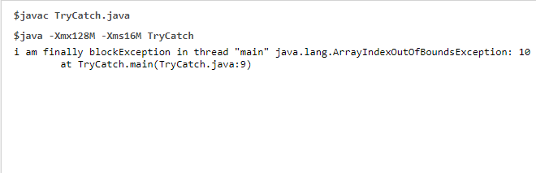

**Example 2: try with catch block**

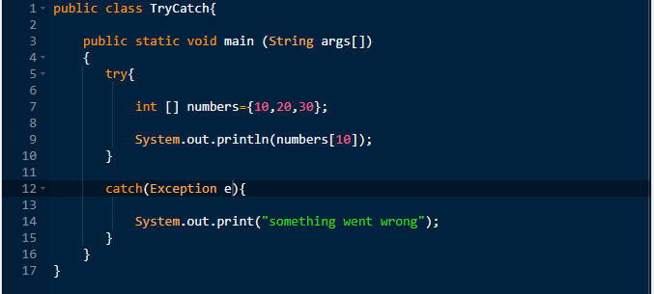

**Result**

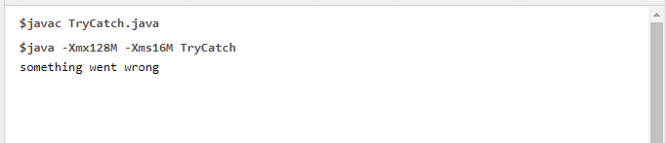

**Example 3: Try catch with finally block**

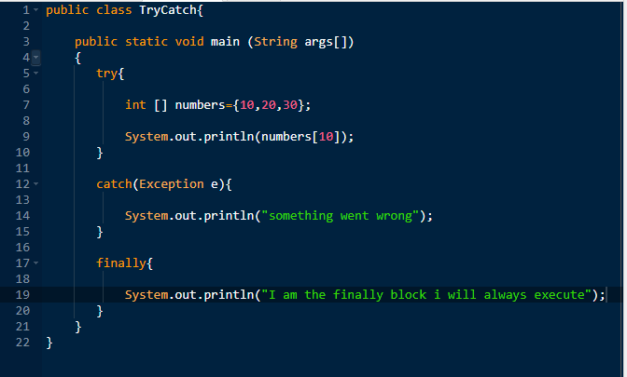

**Result:**

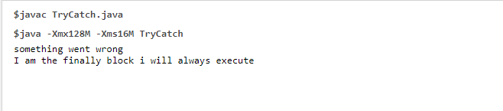

Why throw keyword is present is exception handling concept, to display custom error we are using throw keyword

**Example 4: throw keyword in Exception handling**

When the person is beyond 75 kgs he is eligible for military selection

**Created the below snippet to get an intentional error:** by seeing description throw is used for custom error I gave my own exception name as AgelimitException but it will not work why because in java libraries they mentioned few general exception type by create our own custom exception we should use any one of these

ArithmeticException, FileNotFoundException, ArrayIndexOutOfBoundsException, SecurityException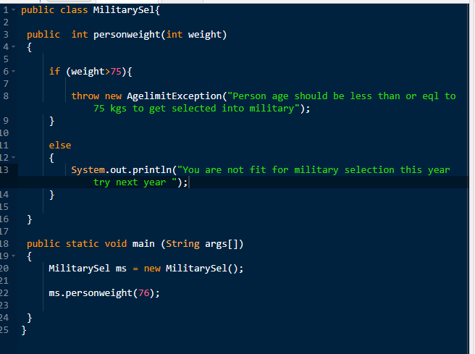

**Result:**

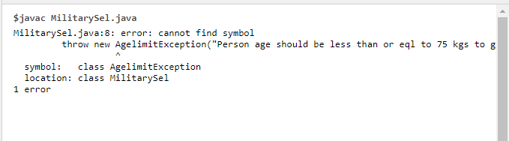

I am going to replace the exception name as Arithmetic Exception by removing AgelimitException in the above program

**Happy path scenario**

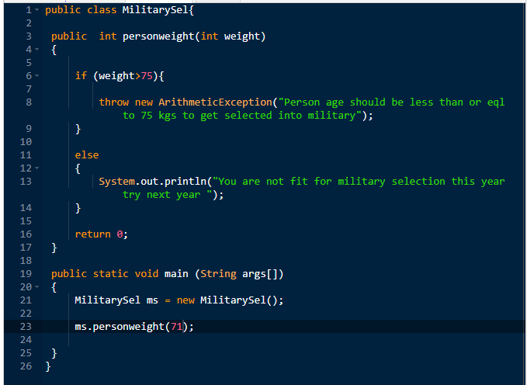

**Result:**

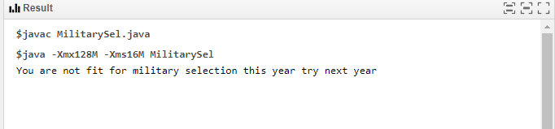

**Negative Scenario**

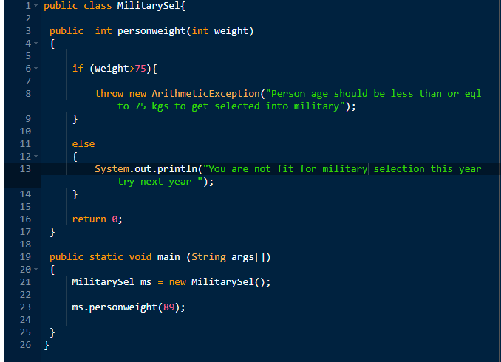

**Result**

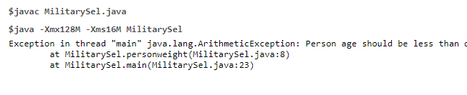

**MilitarySel**  
Exception in thread "main" java.lang.ArithmeticException: Person age should be less than or eql to 75 kgs to get selected into military

at MilitarySel.personweight(MilitarySel.java:8)

at MilitarySel.main(MilitarySel.java:23)