Full Page Screenshot using ashot in Selenium:

The full-page screenshot can be taken in numerous ways using here is one way to take the full-page screenshot using Ashot in Selenium. The Single Page or One Page website is more popular in modern web development for increasing scalability. We can use this method to capture a full-page snapshot in selenium automation.

Maven Dependency details

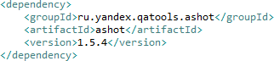

Code snippet

url: <https://ganeshkokku.wordpress.com/author/ganeshkokku/>

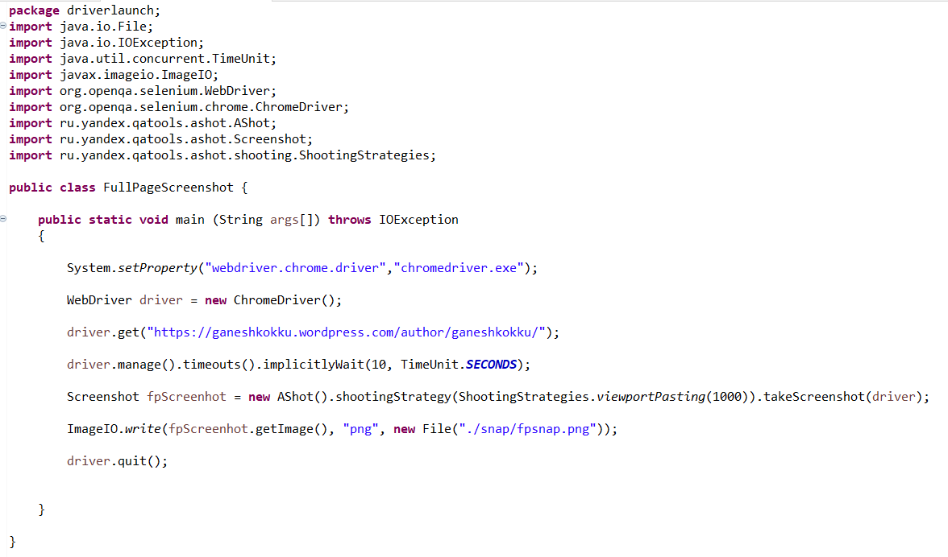

Captured Full screenshot stored in Project Folder path

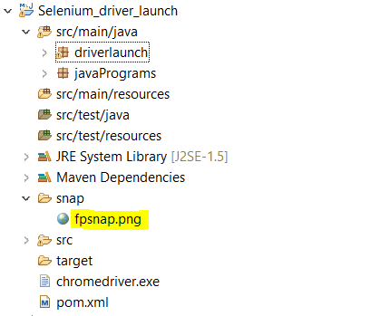

Full Screenshot view:

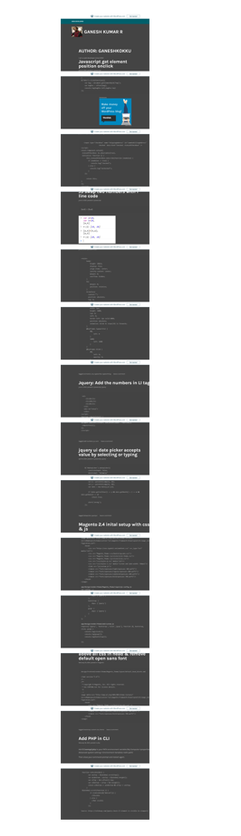

Webpage Home screen

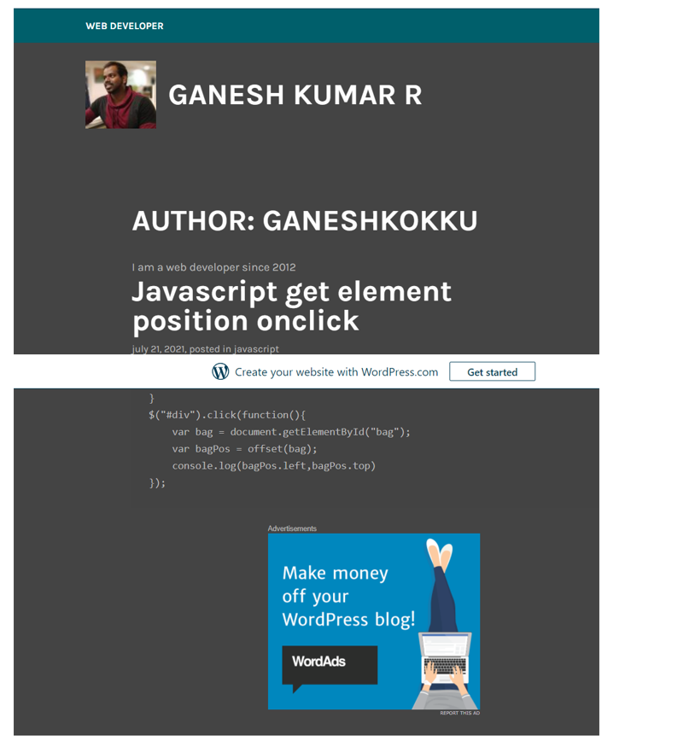

Bottom of the Webpage:

