**Run_Postman_Collection_via_Jenkins_for_Every_Two_Minutes_SCM_Github**

**Pre-Requisites:**

1. Working Postman collection that needs to be added in Github Repository

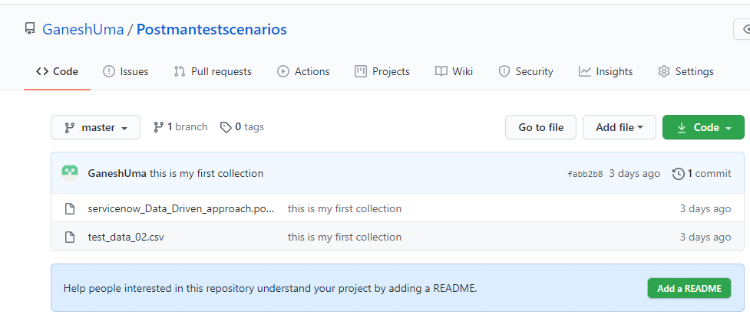

1. Download Jenkins war file from this following link <https://www.jenkins.io/download/> and place it in any of your local folder

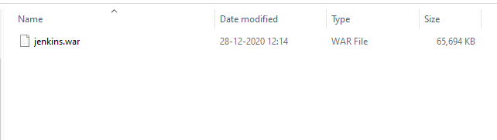

**Steps to Run Postman Collections Periodically (for every 2 minutes)**

1. Navigate to that folder in type cmd from address bar then you will land in cmd prompt and then type the following cmd : java -jar Jenkins.war

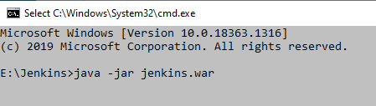

1. Open any browser then type the below local host address, if the port 8080 is taken by any other source then use this command (java -jar jenkins.war --httpPort=9090)

<http://localhost:8080>

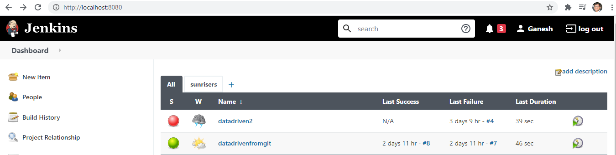

1. Click New Item -> Freestyle project -> (give some valid name) -> Click ok

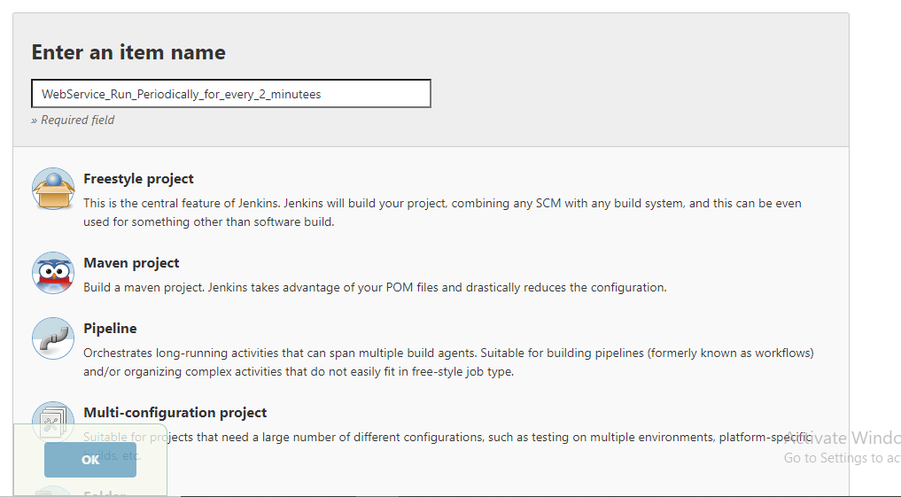

1. Separate project will get open with the above project name like below then click configure button

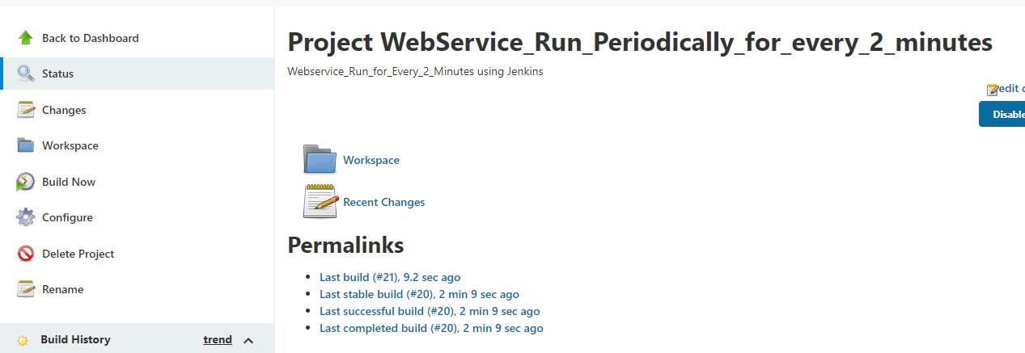

1. Configure project with the below steps

1. Valid description in General section

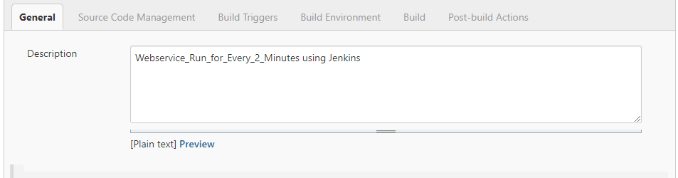

1. Select Source Code Management (SCM) as git ( provide git up URL and credentials is not a mandated option because Jenkins will clone the project from git we can leave it blank )

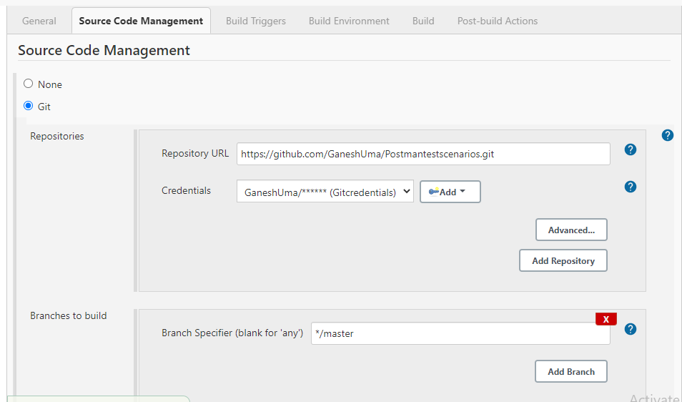

1. Select Build periodically enter the below expression it is again based on our needs click the? icon we will get the detailed expression info

H/2 * * * * ( my goal is to run for every 2 minutes)

**Note: H/15 * * * * to run periodically for every 15 mins**

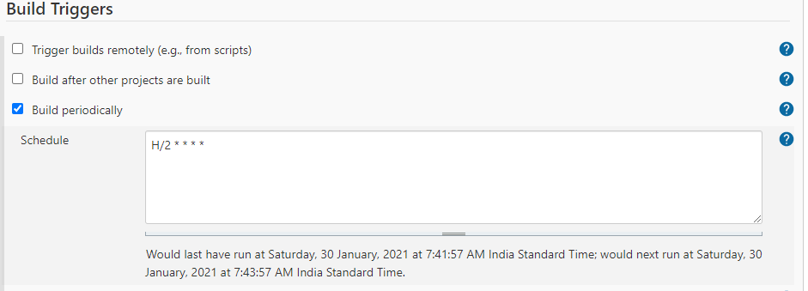

1. Build section select Execute Windows batch command and give the valid command line steps based on your collection name, environment file , data file and report details

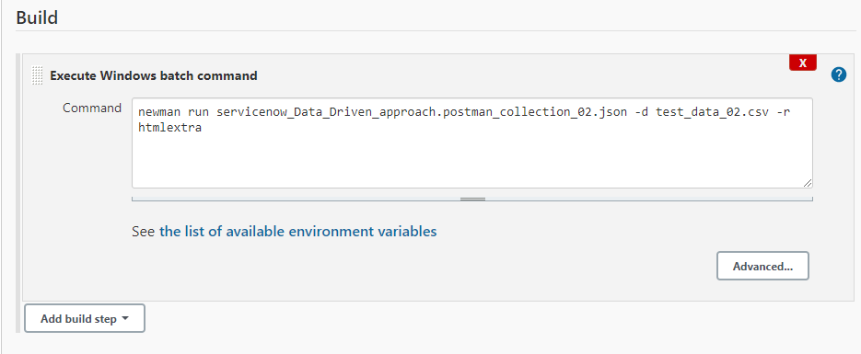

1. Click Apply and Save button

**Jenkins will clone project from git and it will run for every two minutes**

**Note**: To stop the run click Disable project button from right side of the project area

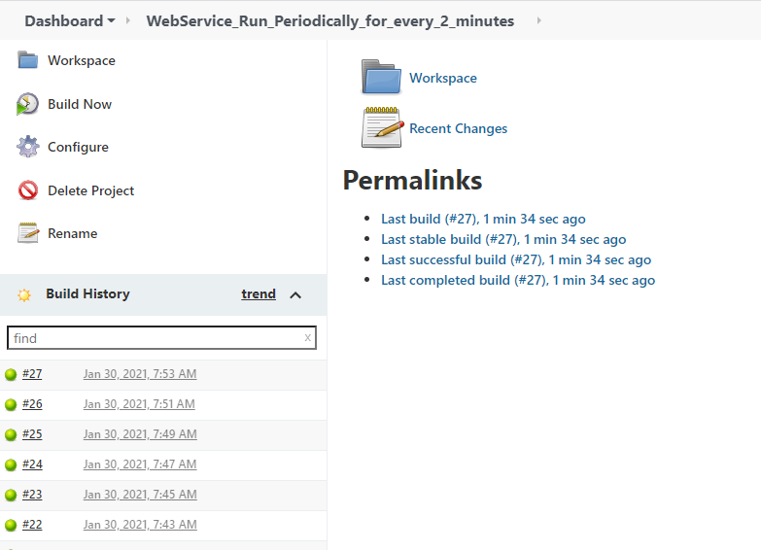

**Reports**

