**Steps to reset Jenkins Password when you forgotten**

1. Go to this path (C:\Users\Admin\.jenkins)
2. Open config.xml
3. Right click config.xml and open with notepad++
4. Find this <useSecurity>true</useSecurity> and change it to <useSecurity>false</useSecurity>
5. Start again Jenkins java -jar Jenkins.war
6. Type the following url in browser <http://localhost:8080/>
7. It will launch Jenkins dashboard directly

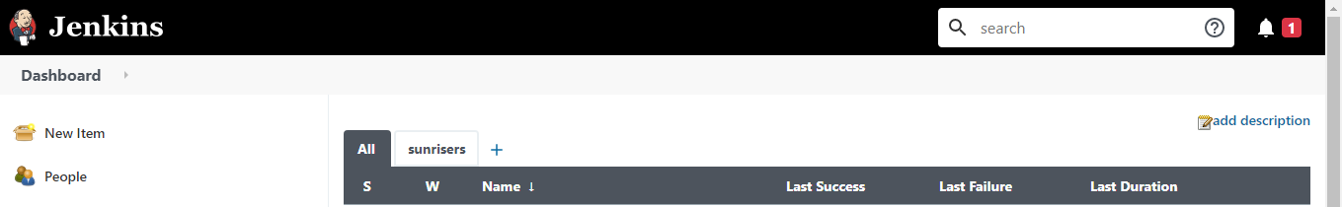

1. Click Manage Jenkins

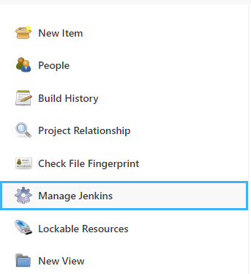

Viii) Click configure Global security

1. in Security Realm select Jenkins own user data base and uncheck Allow users to sign up

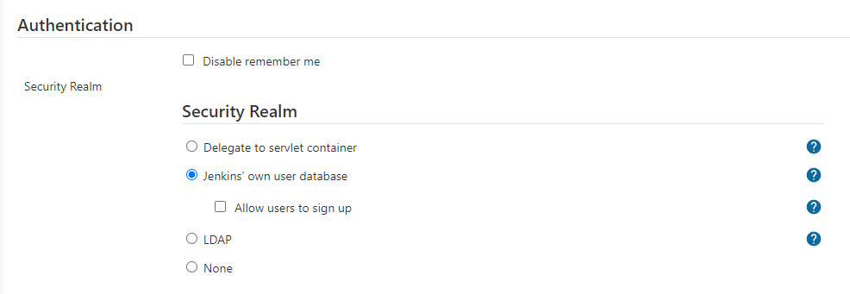

x) In Authorization check the logged in user can do anything and unselect allow anonymous read access

