**DR. BABASAHEB AMBEDAR MARATHWADA**

**UNIVERSITY CHATTRAPATI**

**SAMBHAJINAGAR.**



# “Form Login”

# 

**Presented by**

**Mr. Sanjay Ghamaji Tagad**

**Mr. Gokul Jujgar**

**Guided by**

**Mr. Ravi sir**

**Submitted to: Department of Computer**

**Science (BCS)**



**SHRI MUKTANAND COLLEGE,**

**GANGAPUR**

**(2023-2024)**

# “TEMPERATURE IN DIFFERENT

# UNITS”



***Project Submitted to***

**SHRI MUKTANAND COLLAGE, GANGAPUR CHATTRAPATI SAMBHAJINAGAR**

***For the Award Degree of***

**Bachelor of Computer Science**

***In***

**Department of Computer Science and Management**

***Student`s Name:***

**Mr. Sanjay Ghamaji Tagad**

**Mr. Gokul Jujgar**

***Under the Guidance of***

**Mr. Ravi sir**

**Shri Muktanand College, Gangapur**

**Chhatrapati Sambhajinagar**



# CERTIFICATE

This is to certify that, the major project report entitled **“**Form Login**”** has been Successfully completed and submitted by

Mr. Sanjay Ghamaji Tagad AND Mr. Gokul Jujgar. as per requirement Shree Muktanand Collage, Gangapur Chh Sambhajinagar, in Fulfillment of B.Sc. (Computer Science) 2nd Year for the Academic Year 2023-2024.

**Mr. Ravi sir Dr. V. P. Pagore**  ***(Project Guided By)* *(Head of Department)***

# ACKNOWLWDGEMENT

I take this opportunity to express my deep sense of gratitude, thanks and regards towards all of those who have directly or indirectly helped me successful completion of this project.

I present my sincere thanks to Dr. C. S. PATIL, Principal of Shri Muktanand College and Staff for their wonderful support and inspirable guiding.

I also thank Dr. V.P. Pagore ( Head of Dept.) and and who have sincerely supported me with valuable insights into the completion of this project.

I am grateful to all faculty members of BCS Staff and my friends who have helped me in the successful completion of this project.

Last but not least I am indebted to my PARENTS who provided me their time, support and inspiration needed to prepare this project.

Date:

Place: Gangapur

Signature:

1) Mr. Rushi Sir

2)Mr. Asad Sir

3)Mr. Ravi Sir

4)Miss. Manal Mam

## ***DECLARATION***

I undersigned Mr. Sanjay Ghamaji Tagad AND Gokul Jujgar student of BCS 4th semester declare that I have developed project on

“Syllabus notes”

has been personally done by me under the guidance of Mr. Ravi Sir In partial fulfillment of BCS (SY) during academic year 2023 – 2024.

All the data represented in this project is true & correct to the best of My knowledge & belief.

I also declare that this project report is my own preparation and not copied from anywhere else.

Signature

Sanjay Tagad

Gokul Jujgar

**Index:-**

|  |  |  |
| --- | --- | --- |
| **Sr.no** | **Contents** | **Page No** |
| **01** | **Program Coding** | **01** |
| **02** | **Digram** |  |
| **03** | **Vote of Thanks** |  |

**Program Coding:-**

<!DOCTYPE html>

<html lang="en">

<head>

<meta charset="UTF-8">

<link rel="stylesheet" href="css/style.css">

<title>Form</title>

<style>

body {

/* background-image: url(/images/bg1.jpg);*/

/* background-image: url(/images/bg2.jpg);*/

background-image: url(../images/bg3.jpg);

background-attachment: fixed;

background-repeat: repeat;

background-color: cadetblue;

}

.layout {

width: 1050px;

margin: 33px auto;

/* padding: 10px;*/

padding-left: 75px;

overflow: hidden;

background-color: #3e4444;

/*

display: flex;

flex-direction: column;

*/

display: block;

}

h2 {

color: #AAAAAA;

}

h1 {

color: #AAAAAA;

text-align: center;

margin-bottom: 40px;

}

input[type="text"],

input[type="email"],

input[type="tel"],

textarea {

width: 70%;

padding: 11px;

border: 3.5px solid #f18973;

background-color: #e0e2e4;

font-size: 18px;

color: #454140;

font-weight: bold;

}

input[type="text"]:focus,

input[type="email"]:focus,

input[type="tel"]:focus,

textarea:focus {

outline: none;

border-color: #6ebe44;

}

input[type="text"]:placeholder-shown,

input[type="email"]:placeholder-shown,

input[type="tel"]:placeholder-shown,

textarea {

/* color: #b14236;*/

/* caret-color: blue;*/

font-size: 16px;

font-weight: bold;

color: #454140;

}

.btn {

margin-left: 40%;

margin-top: 50px;

}

input[type="button"] {

background: #3d85c6;

background: -webkit-linear-gradient(#3d85c6, #073763);

background: linear-gradient(#3d85c6, #073763);

border-radius: 5px;

padding: 9px 20px;

color: #ffffff;

display: inline-block;

font: normal 700 24px/1 "Calibri", sans-serif;

text-align: center;

text-shadow: 1px 1px grey;

}

select {

width: 150px;

font-weight: bold;

font-size: 20px;

color: #36486b;

border: 3px solid #36486b;

padding: 4px;

}

.container {

display: block;

position: relative;

}

.container ul {

list-style: none;

overflow: auto;

}

.container ul li {

color: #AAAAAA;

display: block;

position: relative;

float: left;

width: 100%;

height: 100%;

border-bottom: 1px solid #333;

}

.container ul li input[type="radio"] {

position: absolute;

visibility: hidden;

}

.container ul li label {

display: block;

position: relative;

font-weight: 300;

font-size: 22px;

padding: 5px 5px 5px 60px;

margin: 5px auto;

height: 30px;

z-index: 5;

cursor: pointer;

-webkit-transition: all 0.25s linear;

}

.container ul li:hover label {

color: white;

}

ul li .check {

display: block;

position: absolute;

border: 4px solid #AAAAAA;

border-radius: 100%;

height: 20px;

width: 20px;

top: 10px;

left: 20px;

z-index: 5;

transition: border .25s linear;

-webkit-transition: border .25s linear;

}

ul li:hover .check {

border: 5px solid #FFFFFF;

}

ul li .check::before {

display: block;

position: absolute;

content: '';

border-radius: 100%;

height: 10px;

width: 10px;

top: 5px;

left: 5px;

margin: auto;

transition: background 0.25s linear;

-webkit-transition: background 0.25s linear;

}

input[type=radio]:checked~.check {

border: 5px solid #0DFF92;

}

input[type=radio]:checked~.check::before {

background: #0DFF92;

}

input[type=radio]:checked~label {

color: #0DFF92;

}

footer {

color: #AAAAAA;

font-size: 17px;

margin-left: 38%;

margin-top: 60px;

display: inline-block;

overflow: hidden;

font-family: sans-serif;

color: aliceblue;

}</style>

</head>

<body>

<div class="layout">

<h1>Sample Form</h1>

<h2>Name </h2>

<input type="text" name="name" placeholder="Name">

<div class="container">

<h2>Gender :: </h2>

<ul>

<li>

<input type="radio" id="f-option" name="selector">

<label for="f-option">Male</label>

<div class="check"></div>

</li>

<li>

<input type="radio" id="s-option" name="selector">

<label for="s-option">Female</label>

<div class="check">

<div class="inside"></div>

</div>

</li>

</div>

<h2>Division</h2>

<select name="selectoptions">

<option >Aurangabad</option>

<option >beed</option>

<option >jalna</option>

<option >dharashiv</option>

<option >nanded</option>

<option >latur</option>

<option >parbhani</option>

</select>

<h2>Email Address</h2>

<input type="email" name="email" placeholder="example@mail.com">

<h2>Phone Number</h2>

<input type="tel" name="PhoneNO" placeholder="+88012345678910">

<h2>Message</h2>

<textarea name="message" id="" cols="50" rows="10" placeholder="Type your message"></textarea>

<br> <br>

<div class="btn"><input type="button" name="button" value="Submit"></div>

<!-- <textarea name="messages" placeholder="Write to me"></textarea>-->

<footer>

created by: gokul laxman jujgar <br> services by ip </footer>

</div>

</body>

</html>

**Login Form:-**

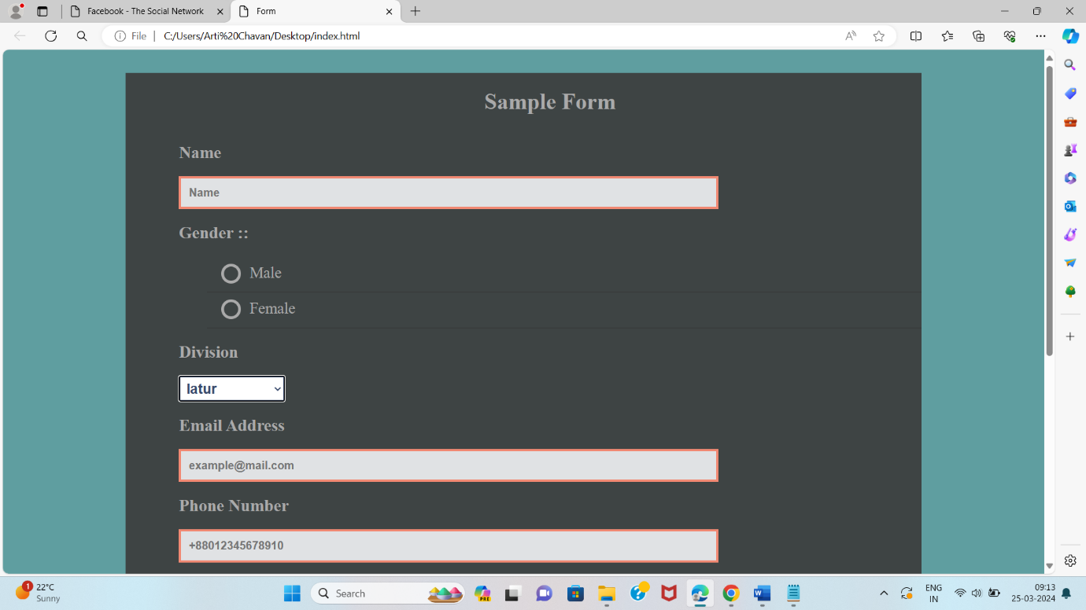

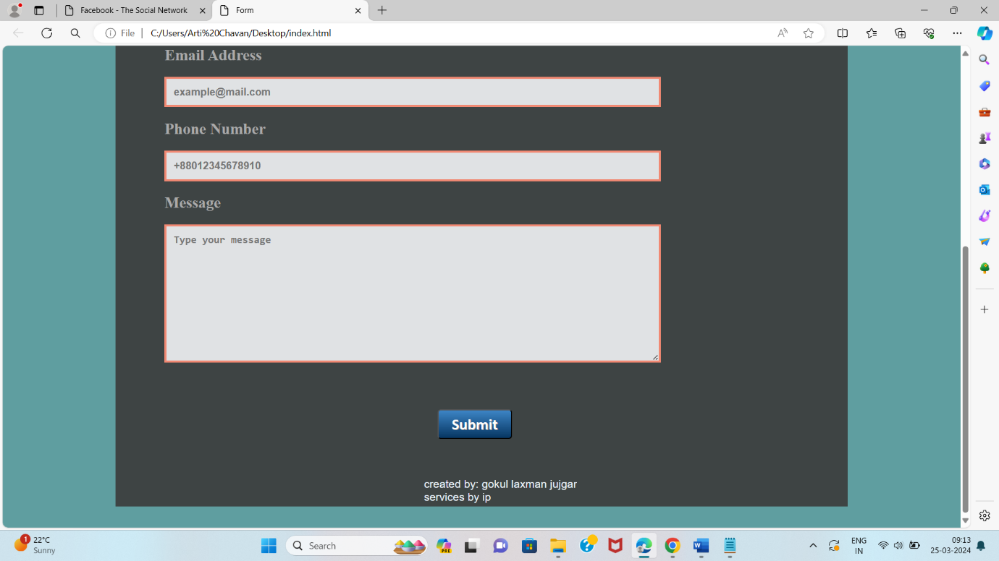

**Thank You….!**

**To All Teachers Staffs And My Best Friends To Help Us to My Mini Project….!**

