**Create all the below tables and insert data:**

**Table name: Bank (bname Primary key)**

+--------------------+-----------+

| bname              | bcity     |

| AJNI Bank          | NAGPUR    |

| ANDHERI Bank       | MUMBAI    |

| CHANDANI Bank      | DELHI     |

| DHARAMPETH Bank    | NAGPUR    |

| M.G. ROAD Bank     | BANGALORE |

| NEHERU PALACE Bank | DELHI     |

| POWAIBank          | MUMBAI    |

| VIRAR Bank         | MUMBAI    |

| VRCE Bank          | NAGPUR    |

+--------------------+-----------+

**Table name: customer (cname primary key)**

+---------+---------+

| cname   | city    |

+---------+---------+

| ANIL    | KOLKATA |

| KRANTI  | MUMBAI  |

| MADHURI | NAGPUR  |

| MANDAR  | PATANA  |

| MEHUL   | BARODA  |

| NAREN   | MUMBAI  |

| PRAMOD  | NAGPUR  |

| SANDIP  | SURAT   |

| SHIVANI | MUMBAI  |

| SUNIL   | DELHI   |

**Table name: deposit**

| actno(pk) | cname(fk)   | bname (fk)             | amount      | adate      |

| 100   | ANIL    | VRCE BANK          | 1000.00 | 1995-03-01 |

| 101   | SUNIL   | AJNI BANK          | 5000.00 | 1996-01-04 |

| 102   | MEHUL   | CHANDANI BANK    | 3500.00 | 1995-11-17 |

| 103   | PRAMOD  | M.G. ROAD BANK    | 1200.00 | 1995-11-17 |

| 104   | SANDIP  | ANDHERI BANK       | 3000.00 | 1995-03-27 |

| 105   | SHIVANI | VIRAR BANK         | 1000.00 | 0000-00-00 |

| 106   | MADHURI | AJNI BANK          | 2000.00 | 1995-12-05 |

| 107   | KRANTI  | NEHERU PALACE BANK | 5000.00 | 1995-07-02 |

| 108   | NAREN   | POWAIBANK          | 7000.00 | 1995-08-02 |

**Table name: borrow**

| loanno | cname(fk)   | bname (fk)             | amount |

| 201    | ANIL    | VRCE BANK          |   5000 |

| 206    | MEHUL   | AJNI BANK          |   1000 |

| 311    | SUNIL   | DHARAMPETH BANK    |   3000 |

| 321    | MADHURI | ANDHERI BANK       |   2000 |

| 375    | PRAMOD  | VIRAR BANK         |   8000 |

| 481    | KRANTI  | NEHERU PALACE BANK |   3000 |

Questions:

1. List Name of Customer Having Living City MUMBAI and Branch City DELHI.
2. List Names of Customers who are Depositors and have Same Branch City as that of SUNIL.

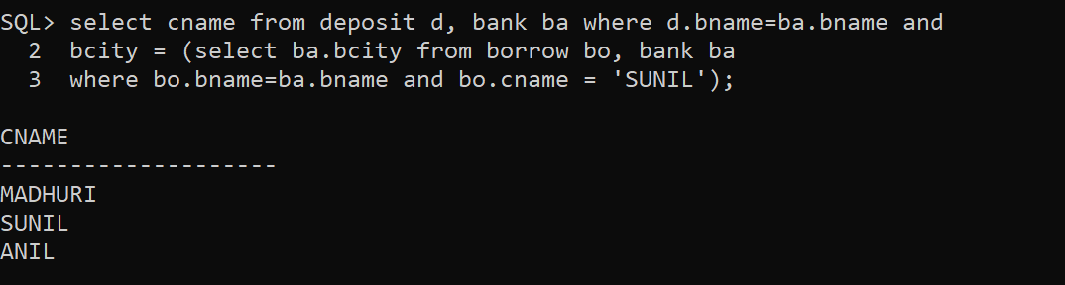

1. List LoanNO and Loan City of Borrowers Having the Same Branch as that of Depositors SUNIL.

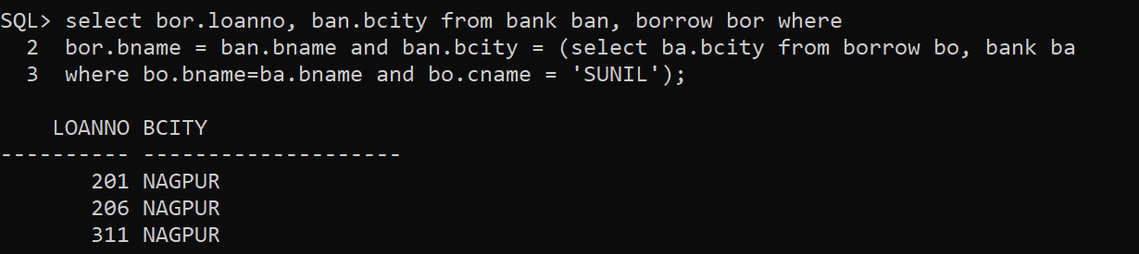

1. List LoanNO,Loan City,Account NO and Deposit City of Customers Living in NAGPUR.
2. List Deposit Details and Loan details of Customers in the City where Pramod is Living.

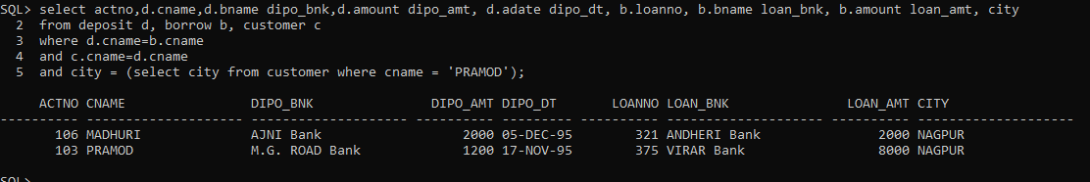

1. List Names of Customers who are Depositors and have Same Branch City as that of SUNIL.

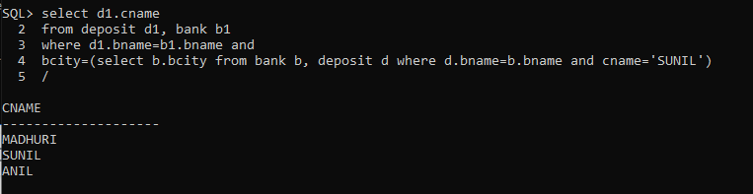

1. List Names of Depositors Having Same Living City as that of SHIVANI and Having Deposit Amount Greater than 2000.

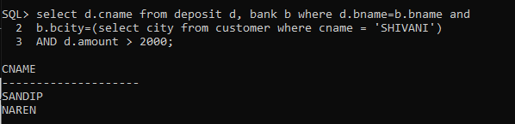

1. List Names of Borrowers Having Deposit Amount Greater than 1000 and Loan Amount Greater than 2000.

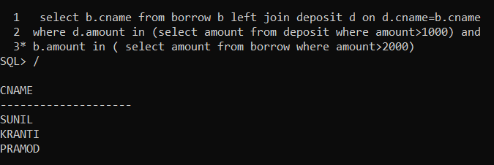

1. List Names of Depositors Having the Same Branch as the Branch of SUNIL.
2. List Names of Borrowers Having Loan Amount Greater than the Loan Amount of ANIL.

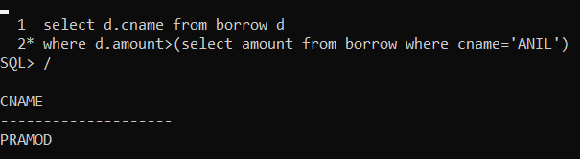

1. List LoanNO,Loan City,Account NO and Deposit City of Customers Having Deposit Branch Located in DELHI.
2. List LoanNO,Loan City,Account NO,Deposit City,Branch Name,Branch City and Living City of Pramod.
3. List Deposit Details and Loan details of Customers in the City where Pramod is Living.
4. List Names of Depositors Having balance Greater than 1000 and group by branch name

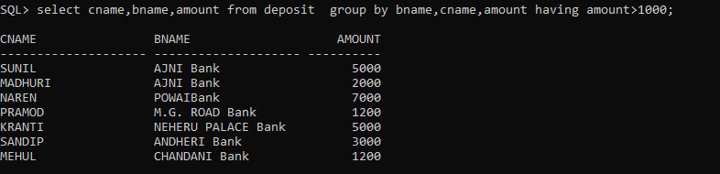

1. List LoanNO,Loan City,Account NO,Deposit City,Branch Name,Branch City and Living City of Pramod