**Test Case : TC020 Add Nationality**

Login Page - Orange HRM Login Page



______________________________________

Login Page - credentials

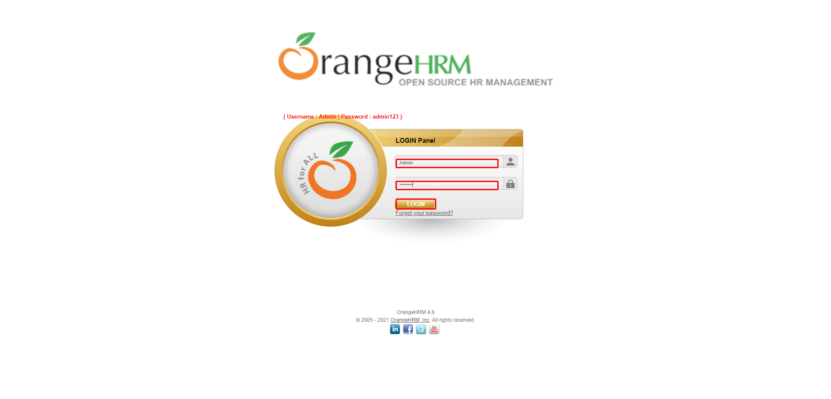

______________________________________

Nationality Page - Nationality Entered

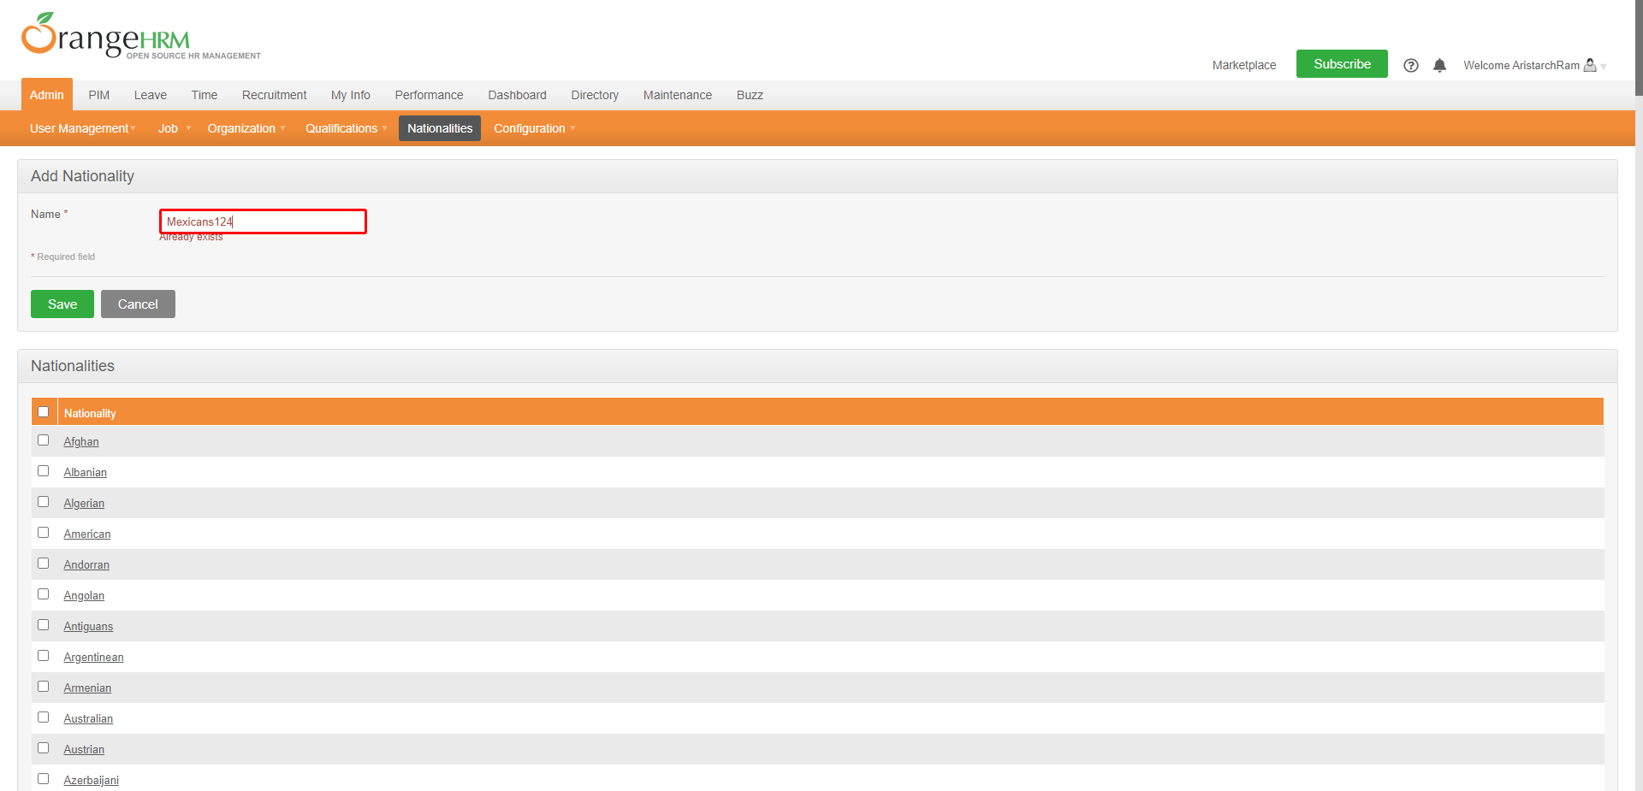

______________________________________

Nationality Page - Scroll and verify the record details

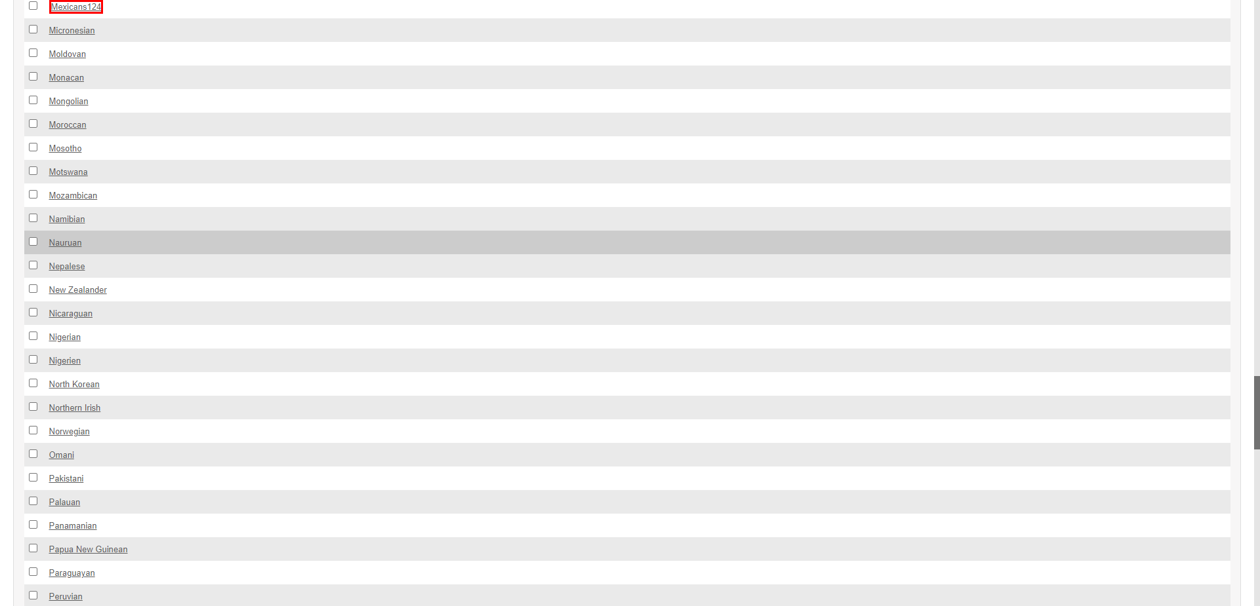

______________________________________

HomePage - Logout

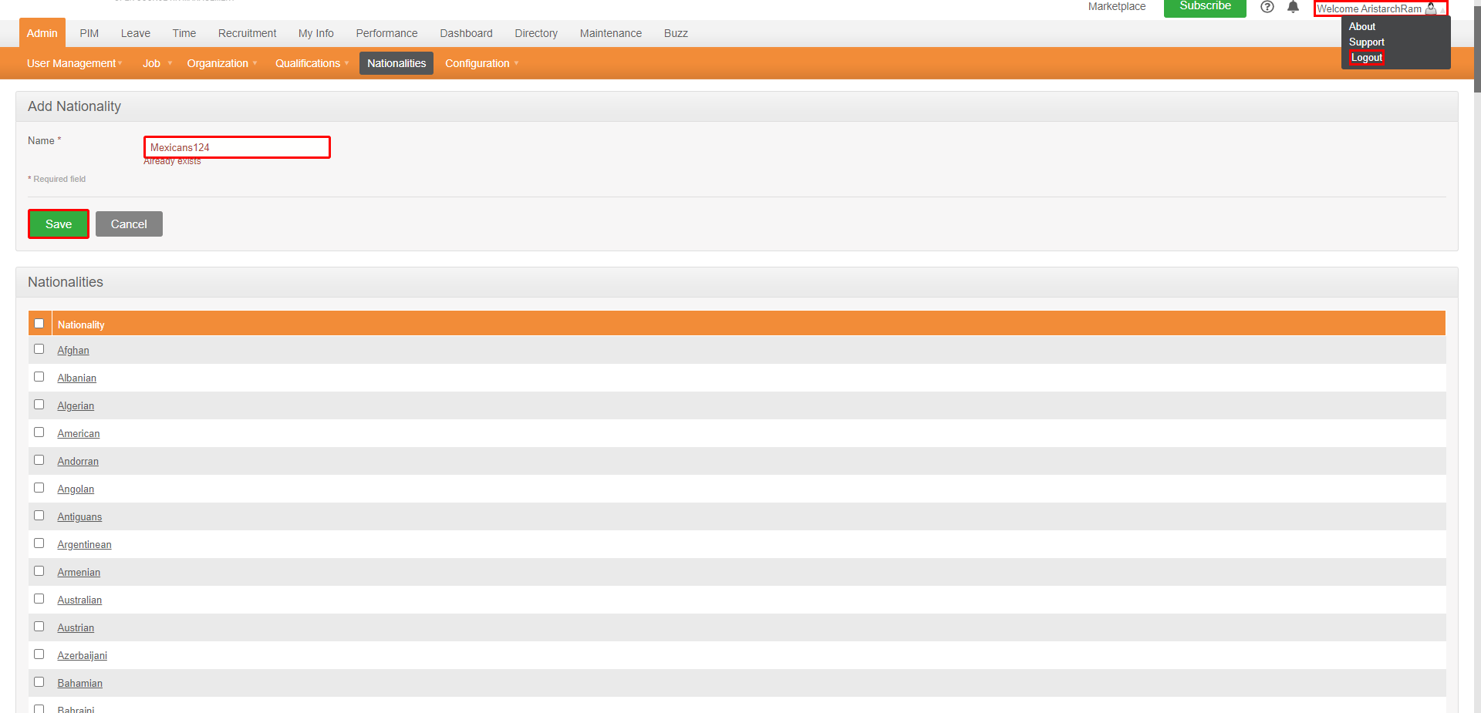

______________________________________

HomePage - after Logout



______________________________________