**Installation And Configuration Of OwnCloud And Only Office Using Docker Compose :**

prerequisites:

* CPU: dual core 2 GHz or better.
* RAM: 2 GB or more
* HDD: at least 50 GB of free space
* At least 2 GB of swap

1: yum update:

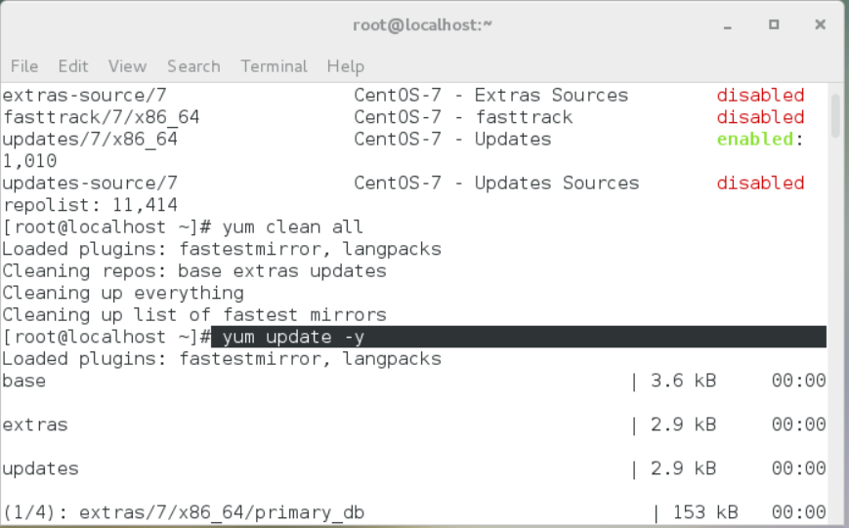

2: installation of docker:

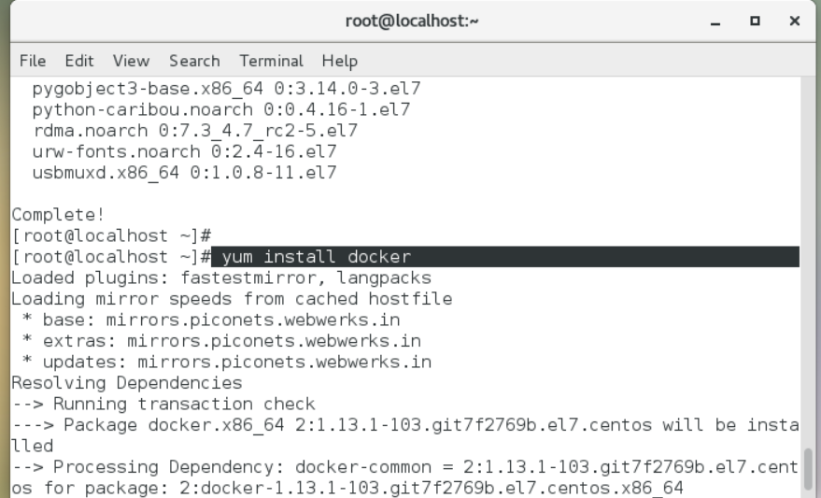

3. Disable SELINUX  by going in file /etc/sysconfig/selinux and changing enforcing to disabled.



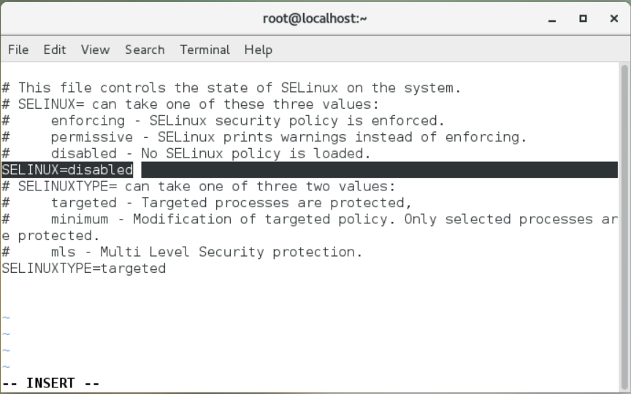

4: After this make the directory owncloud-docker-server and go in that directory for further process.

#mkdir owncloud-docker-server

#cd /owncloud-docker-server

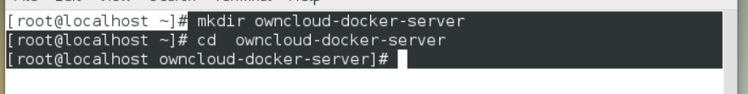

5:Installation of wget

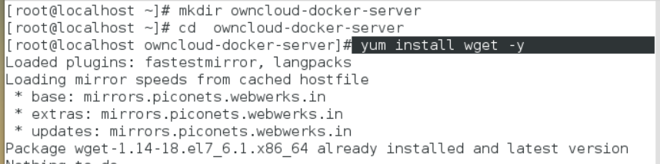

6: Now copy docker-compose.yml from GitHub repository by using wget command in that present directory.

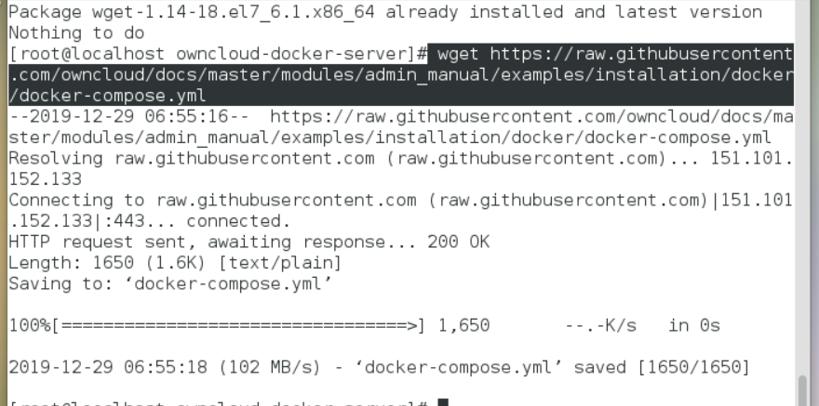

7.Create An Environment Configuration File Now.

cat << EOF > .env

OWNCLOUD_VERSION=10.3

OWNCLOUD_DOMAIN=localhost

ADMIN_USERNAME=admin

ADMIN_PASSWORD=admin

HTTP_PORT=8080

EOF

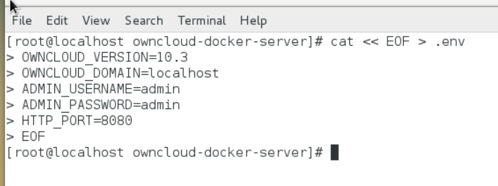

8: Installation of docker compose by using following command: curl -L

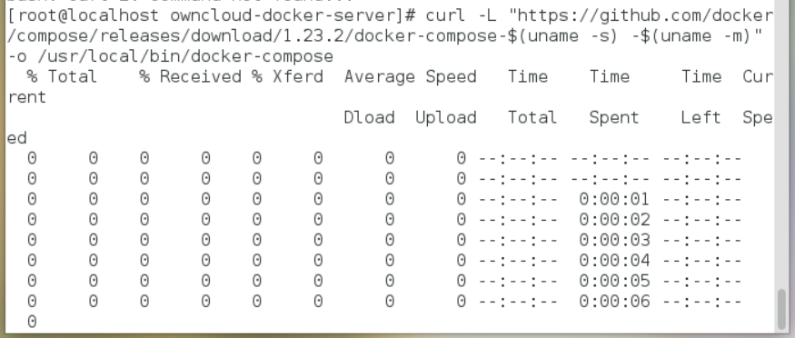

9:And after installing it, give it appropriate permissions

# chmod +x /usr/local/bin/docker-compose

You can check version by using following command:

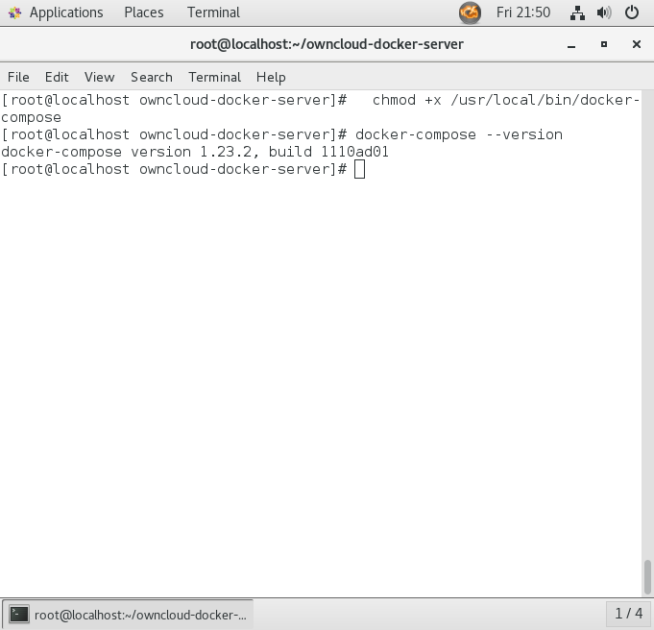# docker-compose –version

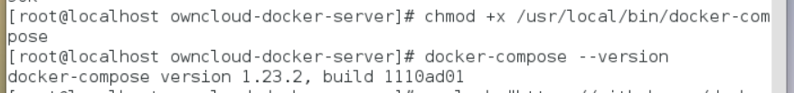

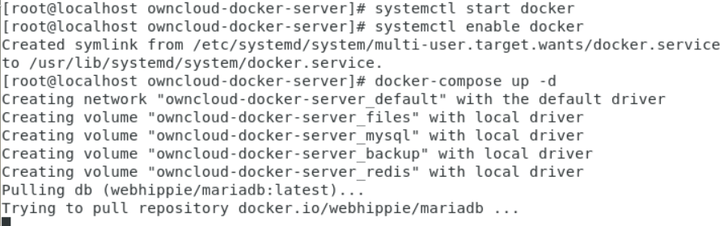

10: Now Build And Start Container By Using Following Command.

#Docker-compose up –d

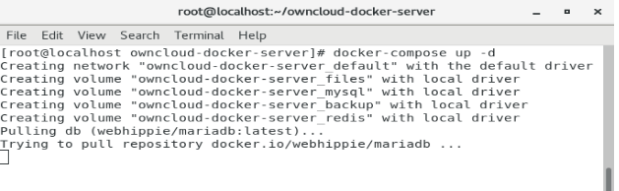

11: Browse in your browser ‘localhost:8080’, you will observe following screen.

Login using the credentials provided in EOF file.

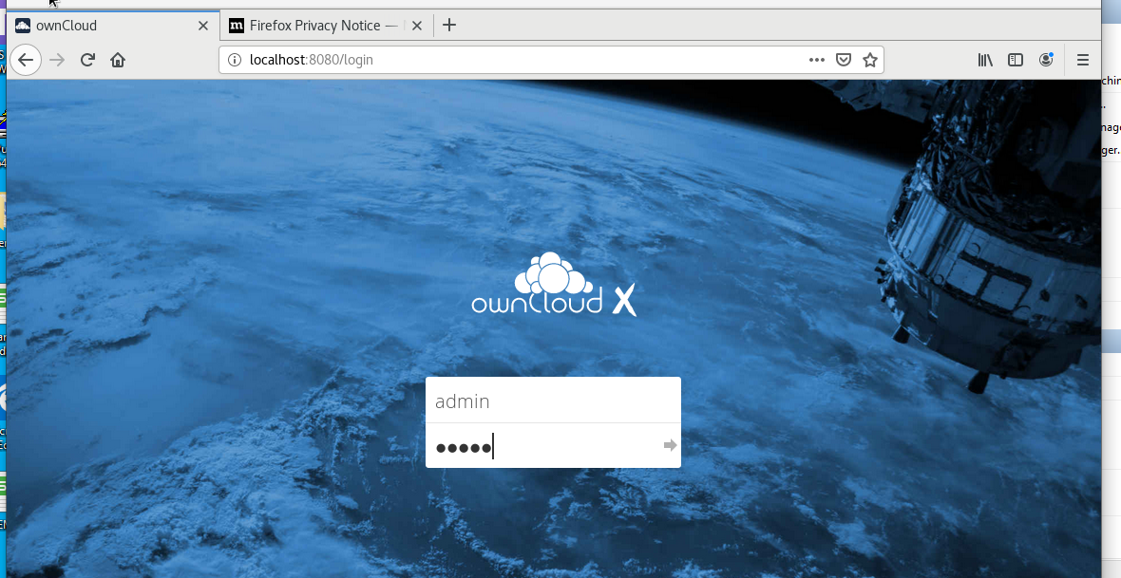

Now here we don,t see ONLYOFFICE option:

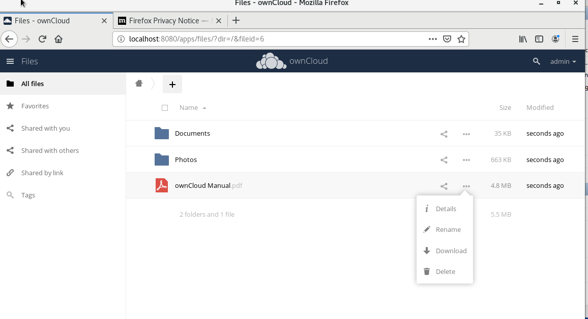

**Configuration of ONLYOFFICE ON OWNCLOUD**

11: INSTALL GIT PACKAGE IF YOU DON’T HAVE IT:

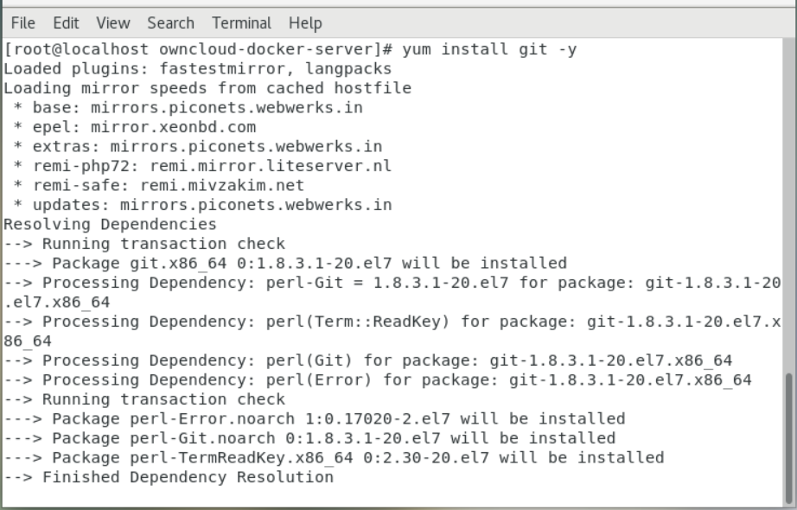

12; clone the onlyoffice’s repo in file docker-onlyoffice-owncloud.

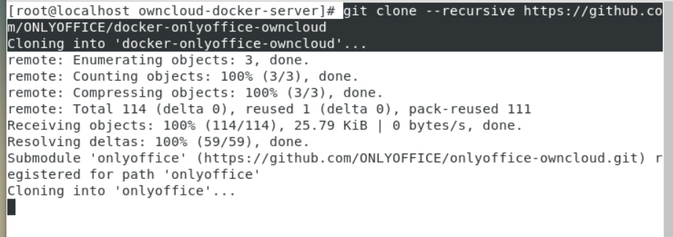

13. Now go in docker-onlyoffice-owncloud directory and again run docker compose command in that directory.

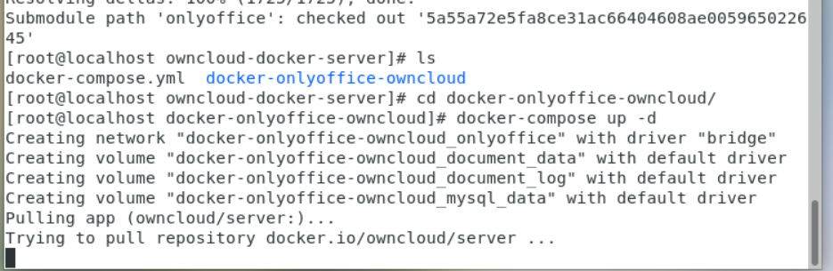

14: write set_configuration.sh script:

Vi set_configuration.sh

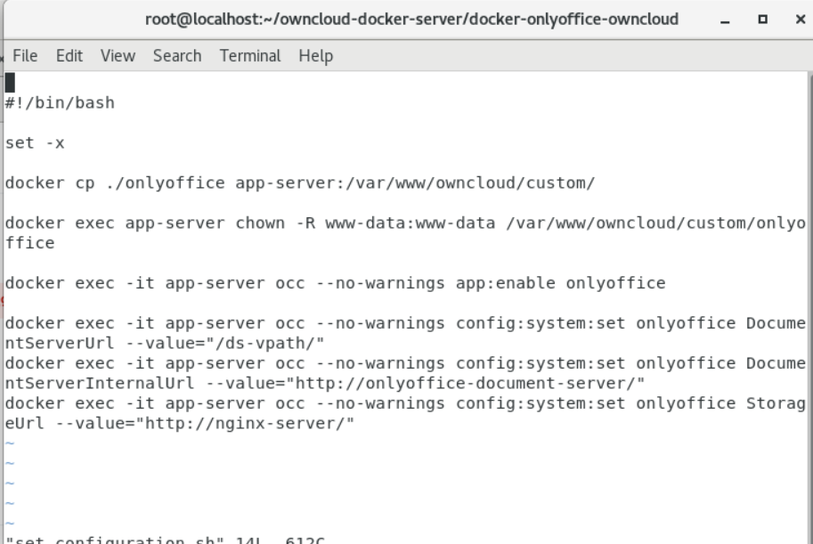

15: Run that script by command:

#git submodule update --remte

#bash set_configuration.sh command

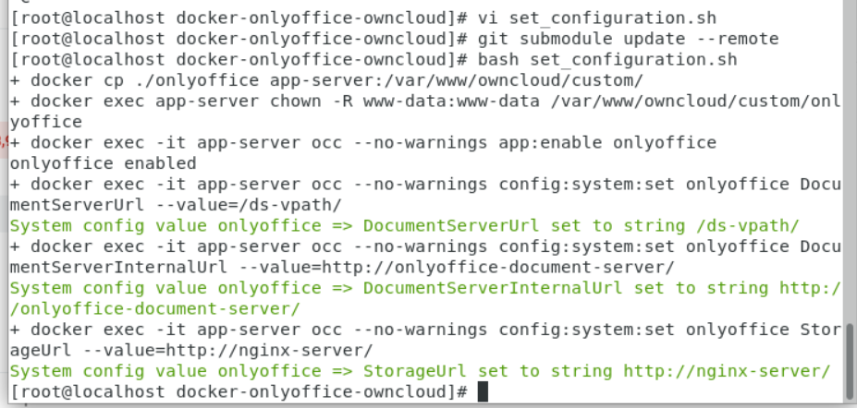

16: then go to your browser and browse localhost in it, if everything is correct then you will be redirected to the same login page ,login using the same credentials.

After you login you will onlyoffice option as seen in the following scree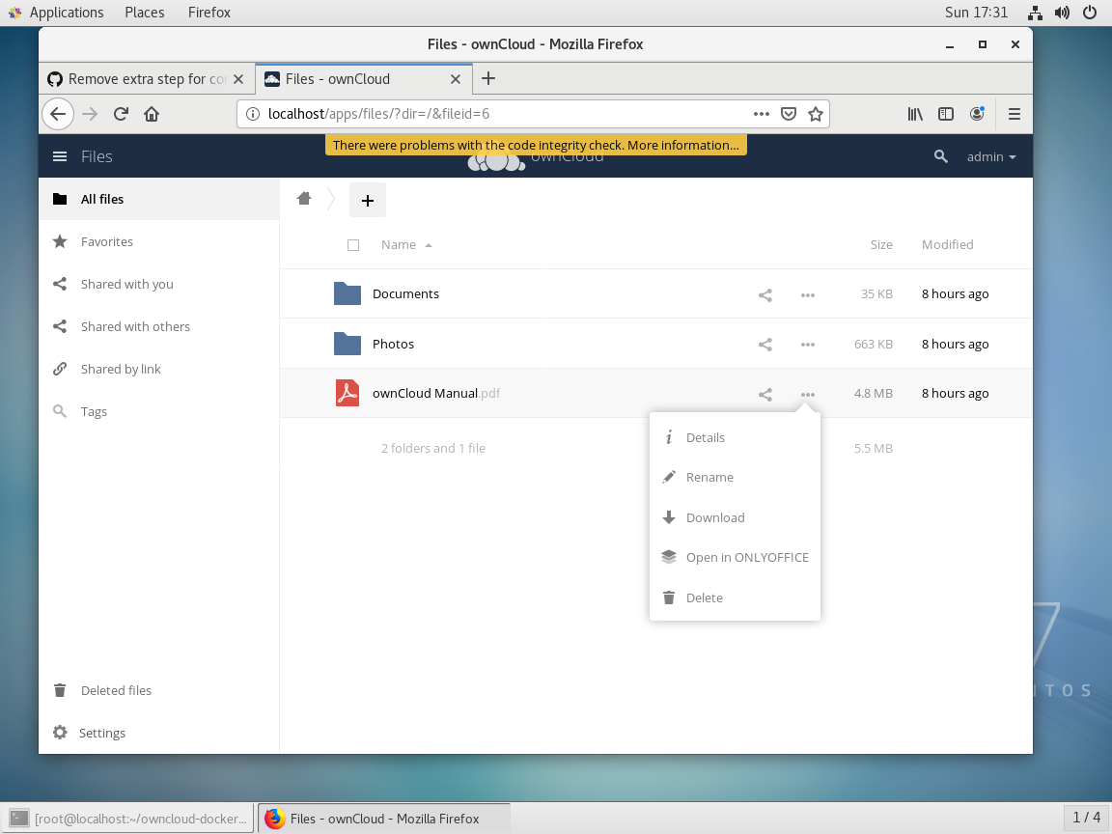

17: if onlyoffice not enabled,

click on admin in right corner and in that click on settings >Apps.

Check weather the onlyoffice is enabled or not,if not then click on disabled apps and find the onlyoffice and enable it. After enabling it you will see following output.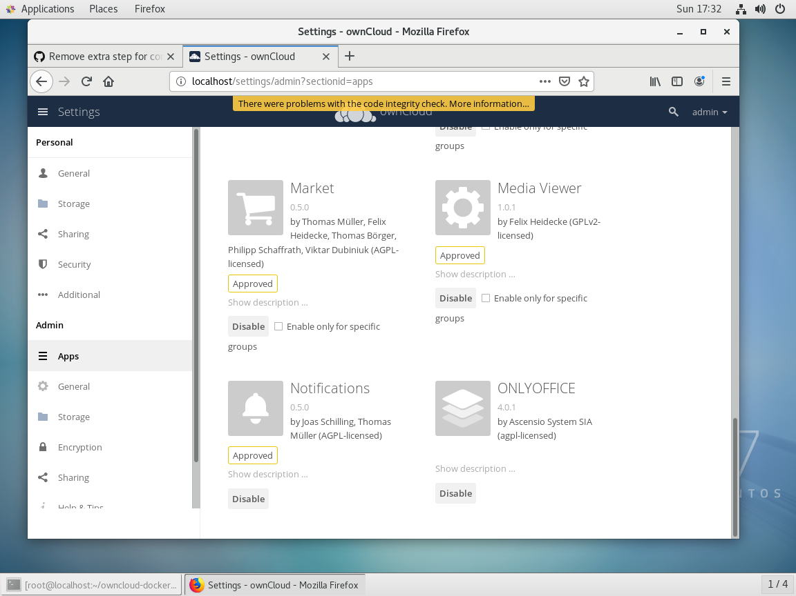

Now you Upload document and give edit writes to users:

