WEEK 4 — FINAL CAPSTONE
Predictive Modeling & Optimization in Logistics Systems
Predicting delivery time • Evaluating models • Turning predictions into operational decisions

1. Executive Summary
This final-week capstone develops a predictive analytics workflow for logistics delivery-time forecasting. A synthetic dataset of 800 shipments was created with operational features including zone, transport mode, shipment volume, distance, traffic level and delivery time. Three regression approaches—Linear Regression, Decision Tree Regression and Random Forest Regression—were trained and evaluated. The best baseline model was selected using hold-out test performance, followed by cross-validation and hyperparameter tuning. The final model achieved an MAE of 0.46 hours, RMSE of 0.71 hours and R² of 0.461 on the test set. Predictions were then translated into optimization strategies for route prioritization, capacity allocation and delay-risk management. Because the dataset is hypothetical, the numerical results demonstrate methodology rather than real company performance.

2. Problem Definition
The logistics problem addressed is: Can delivery time be predicted before or during shipment execution using operational characteristics? Accurate predictions can help teams identify potentially late shipments, prioritize interventions, allocate capacity and compare alternative operational plans.
Target variable: Delivery_Time_hr. Candidate predictors: Zone, Transport_Mode, Shipment_Volume_kg, Distance_km and Traffic_Level.

3. Data Simulation
The synthetic dataset contains 800 shipment records. Numeric variables were generated with realistic variation and categorical variables represent common logistics conditions. Additional delay events were introduced to make the modeling problem more representative of operational exceptions.
Feature | Type | Role
Zone | Categorical | Geographical operating segment
Transport_Mode | Categorical | Vehicle/transport choice
Shipment_Volume_kg | Numeric | Shipment size
Distance_km | Numeric | Route length
Traffic_Level | Categorical | Traffic condition
Delivery_Time_hr | Numeric | Prediction target

4. Analytical Workflow
Business problem → Data simulation → Validation → Feature preparation → Train/test split → Baseline modeling → Evaluation → Cross-validation → Hyperparameter tuning → Prediction → Risk prioritization → Optimization recommendation → KPI monitoring.

5. Model Selection
Linear Regression: Provides a simple, interpretable baseline and establishes whether a largely linear relationship can explain delivery time.
Decision Tree Regression: Captures nonlinear thresholds and interactions and is easy to interpret through tree structure.
Random Forest Regression: Combines multiple decision trees to capture nonlinear relationships while reducing the instability of a single tree.

6. Model Preparation
Categorical variables were one-hot encoded and numerical variables were retained in their numeric form. A scikit-learn Pipeline keeps preprocessing and model training together, reducing the risk of applying inconsistent transformations between training and testing data.

7. Model Performance
Model | MAE (hr) | RMSE (hr) | R²
Linear Regression | 0.44 | 0.67 | 0.521
Random Forest | 0.46 | 0.72 | 0.458
Decision Tree | 0.55 | 0.81 | 0.307
The strongest baseline model by test RMSE was Linear Regression. After 3-fold cross-validation and grid-search tuning of the Random Forest, the tuned model produced MAE=0.46 hr, RMSE=0.71 hr and R²=0.461 on the held-out test set.

8. Evaluation Metrics
- MAE (Mean Absolute Error): average absolute prediction error in hours; easy for operations teams to interpret.
- RMSE (Root Mean Squared Error): penalizes larger errors more strongly and is useful when major delays are especially costly.
- R² (Coefficient of Determination): indicates how much variation in the target is explained by the model relative to a baseline.

9. Validation & Hyperparameter Tuning
A hold-out test set of 20% was kept separate from model fitting. Model selection was compared on the same test framework, while the Random Forest was tuned using 3-fold cross-validation over tree count, maximum depth and minimum leaf size. In a production forecasting system, chronological validation should be preferred when predicting future shipments to prevent temporal leakage.

10. Actual vs Predicted Performance
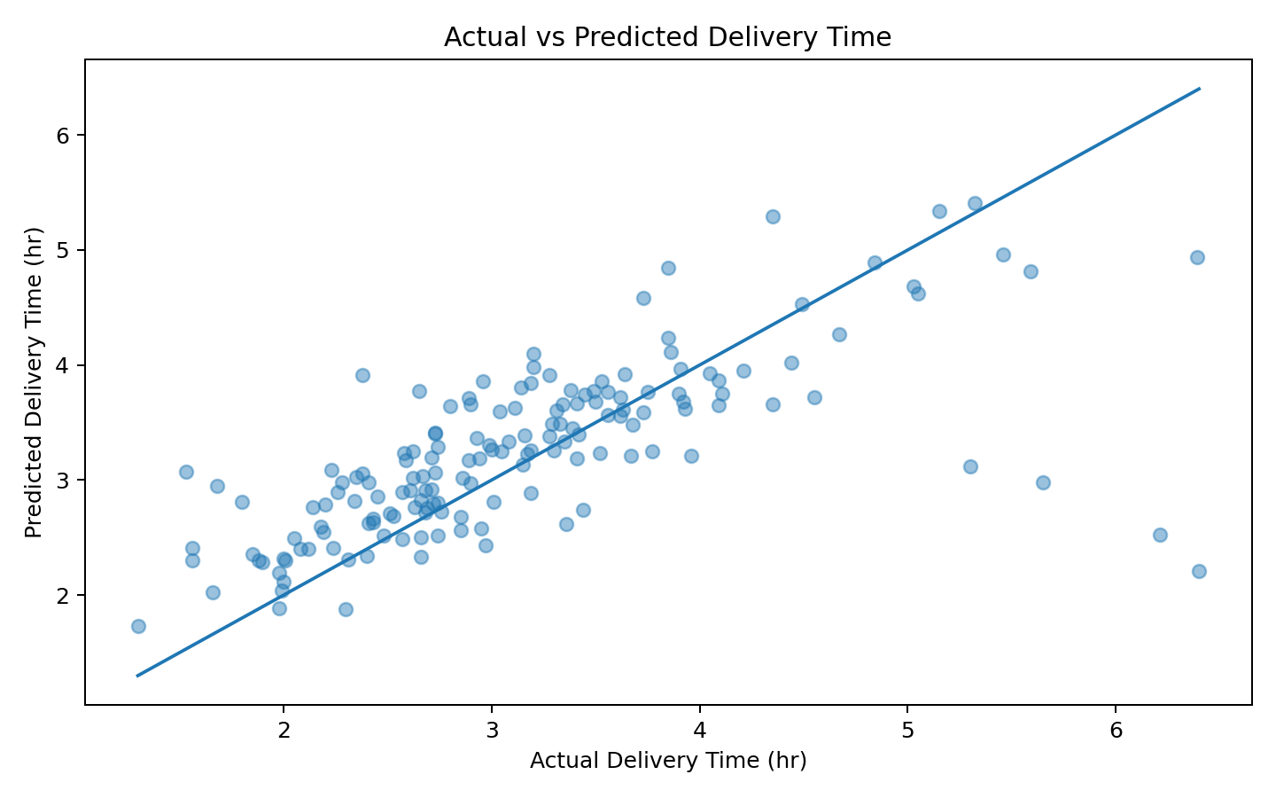
Interpretation: Points close to the diagonal represent accurate predictions. Larger vertical deviations identify shipments where the model under- or over-estimates delivery duration. These cases are valuable for error analysis and operational investigation.

11. Feature Importance
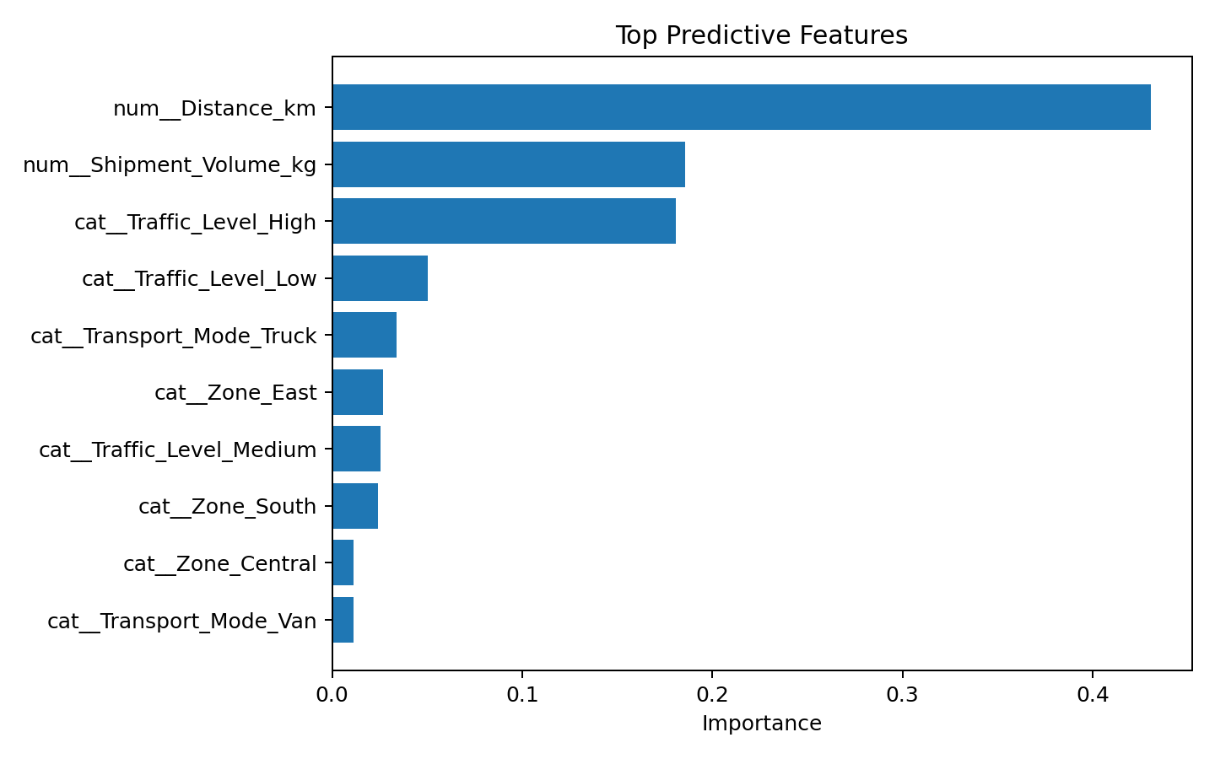
Interpretation: Feature importance highlights which inputs contribute most to Random Forest predictions. Distance, shipment volume, traffic and categorical operating conditions can reveal where additional data or operational controls may improve forecasting.

12. Optimization Strategies
- Delay-risk prioritization: score shipments using predicted delivery time and route conditions, then escalate high-risk shipments before service failure.
- Capacity allocation: reserve appropriate vehicle capacity for high-volume or high-distance shipments and avoid avoidable under-utilization.
- Route planning: use predicted delivery duration as an input to compare route alternatives alongside distance, cost and service constraints.
- Transport-mode selection: select modes using a multi-objective view of cost, predicted time and service reliability rather than cost alone.
- Dynamic dispatch: use updated traffic and operational data to re-score shipments and prioritize interventions.
- Scenario analysis: test alternative allocation plans before deployment and compare expected cost and service KPIs.

13. Optimization Decision Framework
Prediction → Risk score → Prioritize → Allocate resources → Execute intervention → Measure KPI → Retrain/recalibrate.
A useful optimization objective is to minimize total logistics cost while maintaining a required service level. A production formulation could include vehicle capacity, route distance, delivery windows, driver availability and zone constraints.

14. Python Implementation
from sklearn.model_selection import train_test_split, GridSearchCV
from sklearn.ensemble import RandomForestRegressor
from sklearn.pipeline import Pipeline
X = df.drop(columns="Delivery_Time_hr")
y = df["Delivery_Time_hr"]
X_train, X_test, y_train, y_test = train_test_split(
X, y, test_size=0.20, random_state=42
)
model = Pipeline([
("preprocessing", preprocessor),
("model", RandomForestRegressor(random_state=42))
])
params = {
"model__n_estimators": [100, 200],
"model__max_depth": [8, 12, None],
"model__min_samples_leaf": [2, 4]
}
search = GridSearchCV(
model, params, cv=3,
scoring="neg_root_mean_squared_error"
)
search.fit(X_train, y_train)
predictions = search.predict(X_test)
mae = mean_absolute_error(y_test, predictions)
rmse = mean_squared_error(y_test, predictions) ** 0.5
r2 = r2_score(y_test, predictions)

15. Monitoring KPIs
KPI | Purpose | Recommended use
MAE / RMSE | Model accuracy | Monitor drift and error magnitude
On-Time Delivery Rate | Service level | Measure operational outcome
Average Delivery Time | Speed | Track changes after interventions
Cost per Shipment | Cost | Evaluate optimization trade-offs
High-Risk Shipment Rate | Risk | Monitor predicted operational exposure

16. Limitations & Ethical/Operational Considerations
The dataset is synthetic, so model performance cannot be generalized to a real logistics organization. Production deployment would require validated historical data, consistent timestamps, route information, vehicle capacity, weather/traffic signals where appropriate, and monitoring for data drift. Predictions should support human decision-making rather than automatically penalize drivers or customers. Model explanations and audit trails should be retained for high-impact operational decisions.

17. Final Recommendations
- Deploy the model first as a decision-support pilot rather than an automated controller.
- Capture actual promised-versus-delivered timestamps to improve the target definition.
- Add route, weather, traffic, capacity and dispatch-time features where legally and operationally appropriate.
- Evaluate interventions using controlled KPI comparisons and monitor model drift.
- Combine predictive outputs with a route/capacity optimization layer for measurable cost-service trade-offs.
- Review the model periodically and retrain when operational patterns materially change.

18. Final Conclusion
Week 4 completes the four-stage logistics analytics journey by connecting strategic planning, data preparation, exploratory analysis and predictive decision support. The modeling exercise shows how delivery-time predictions can become actionable through risk prioritization, capacity planning and route strategy. The most important outcome is not a single model score, but a repeatable analytical framework in which predictions are evaluated rigorously, translated into operational decisions and measured against business KPIs. With real operational data, the same architecture can be extended to demand forecasting, late-delivery classification, cost prediction and vehicle-routing optimization.

Appendix — Reproducibility
Random seed: 42 | Records: 800 | Test size: 20% | Cross-validation: 3-fold | Primary target: Delivery_Time_hr | Evaluation: MAE, RMSE and R² | Models: Linear Regression, Decision Tree, Random Forest.

