WEEK 3
Advanced Data Analysis & Visualization in Logistics
Exploratory Data Analysis • Visualization • Operational Insights • Python

Prepared as part of the Logistics Data Analyst Internship | Week 3

1. Executive Summary
This report presents an advanced exploratory data analysis (EDA) and visualization workflow for a hypothetical logistics operation. A synthetic shipment dataset containing 600 records was created to simulate common logistics variables such as shipment volume, transport mode, delivery distance, delivery time, transport cost, operating zone, and on-time performance. The purpose is to demonstrate how Python can transform operational records into visual evidence and actionable business insights. The analysis examines central tendencies, distributions, relationships, and zone-level performance. The results indicate that distance is a major cost driver, while selected zones show higher delivery times and weaker service performance. These findings demonstrate how visual analytics can help logistics managers prioritize bottlenecks, review transportation costs, and allocate resources more effectively.

2. Dataset Simulation
The dataset was designed specifically for this academic exercise and does not represent real customer or company data. Each record represents one shipment. The synthetic values were generated with realistic variation and a small number of operationally unusual observations to demonstrate how EDA can identify bottlenecks and potential outliers.
Variable | Type | Purpose
Shipment_ID | Categorical | Unique shipment reference
Zone | Categorical | Operating/service region
Transport_Mode | Categorical | Truck, Van or Two-Wheeler
Shipment_Volume_kg | Numeric | Shipment size
Distance_km | Numeric | Delivery distance
Delivery_Time_hr | Numeric | End-to-end delivery time
Transport_Cost_INR | Numeric | Estimated transportation cost
On_Time | Boolean | Whether shipment met target time

3. Exploratory Data Analysis

3.1 Descriptive Statistics
The simulated dataset contains 600 shipments. Average shipment volume is 55.3 kg, average delivery time is 2.55 hours, and average transport cost is approximately ₹916. The overall simulated on-time delivery rate is 78.5%. Median values are considered alongside means because logistics data can contain unusually large shipments, long distances, or delayed deliveries.
Metric | Count | Mean | Median | Std Dev | Min | Max
Shipment_Volume_kg | 600 | 55.30 | 49.00 | 30.94 | 4.00 | 172.00
Distance_km | 600 | 30.08 | 26.65 | 19.18 | 2.00 | 175.30
Delivery_Time_hr | 600 | 2.55 | 2.42 | 0.98 | 0.50 | 9.92
Transport_Cost_INR | 600 | 915.72 | 874.00 | 381.70 | 150.00 | 3509.00

3.2 Visualization 1 — Delivery-Time Distribution
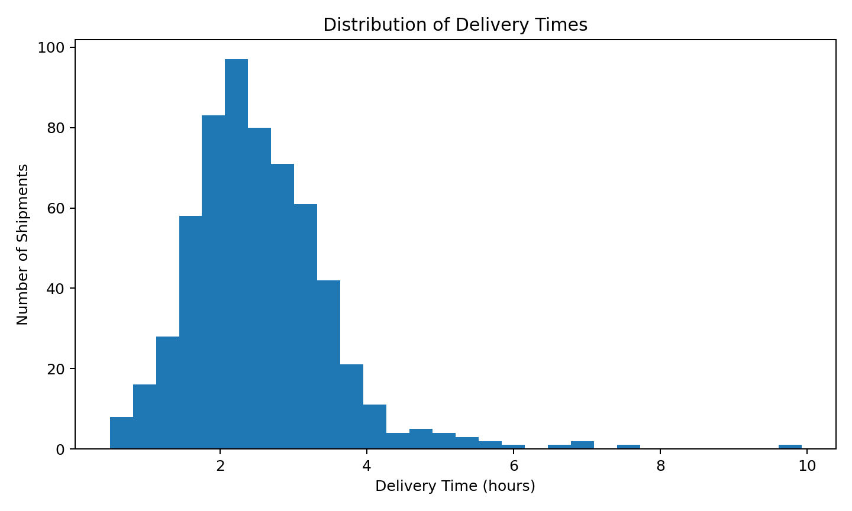
Interpretation: The histogram shows how delivery times are distributed. Most shipments cluster around the normal operating range, while a smaller tail represents unusually slow deliveries. These extreme observations can indicate congestion, handling delays, route issues, or capacity constraints and should be investigated before being treated as errors.

3.3 Visualization 2 — Distance vs Transport Cost
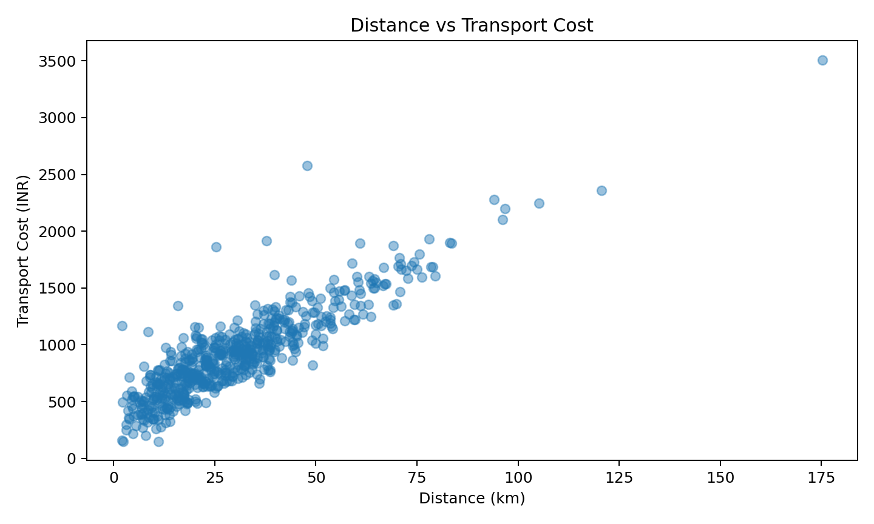
Interpretation: The scatter plot helps identify the relationship between route distance and transportation cost. The upward pattern indicates that longer journeys generally require higher transportation expenditure. The spread around the relationship suggests that shipment volume, transport mode, and operational variation also contribute to cost differences.

3.4 Visualization 3 — Zone-Level Delivery Performance
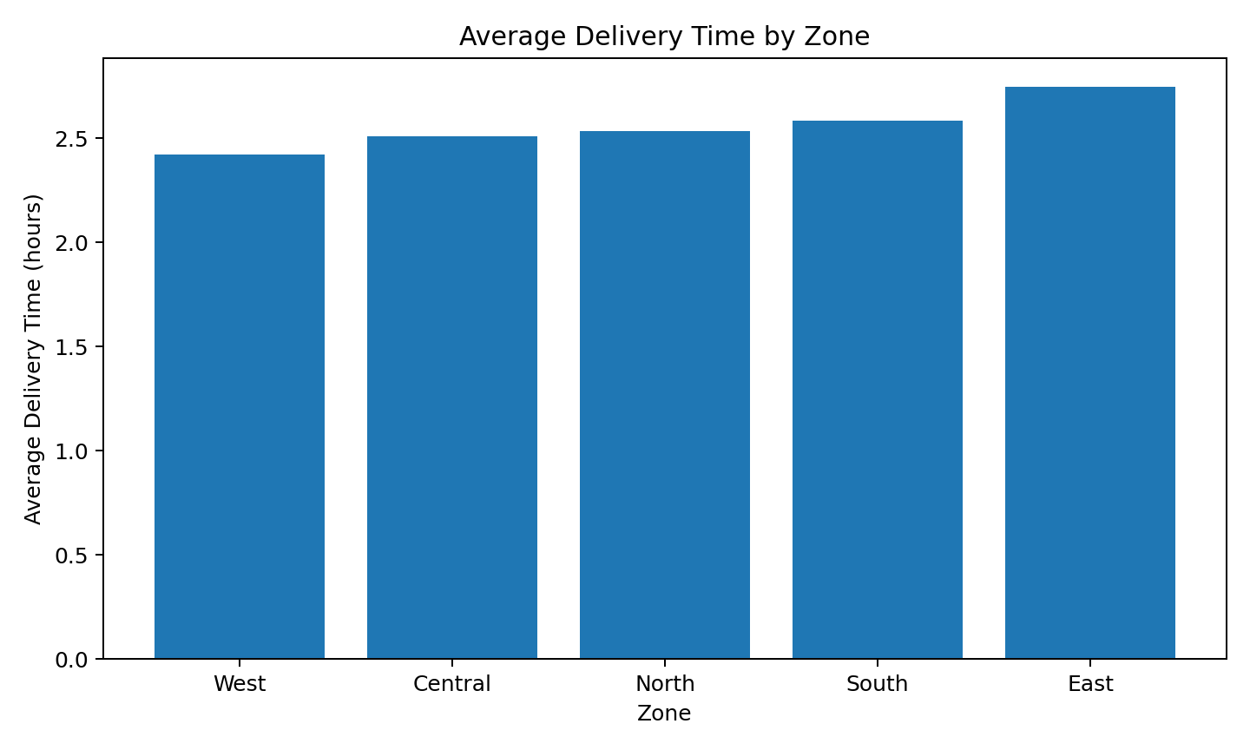
Interpretation: Comparing average delivery time by zone makes geographical bottlenecks easier to identify than looking at individual shipment records. The slowest zone should be investigated for route design, traffic exposure, dispatch timing, distance mix, or resource availability before operational changes are made.

3.5 Visualization 4 — Correlation Analysis
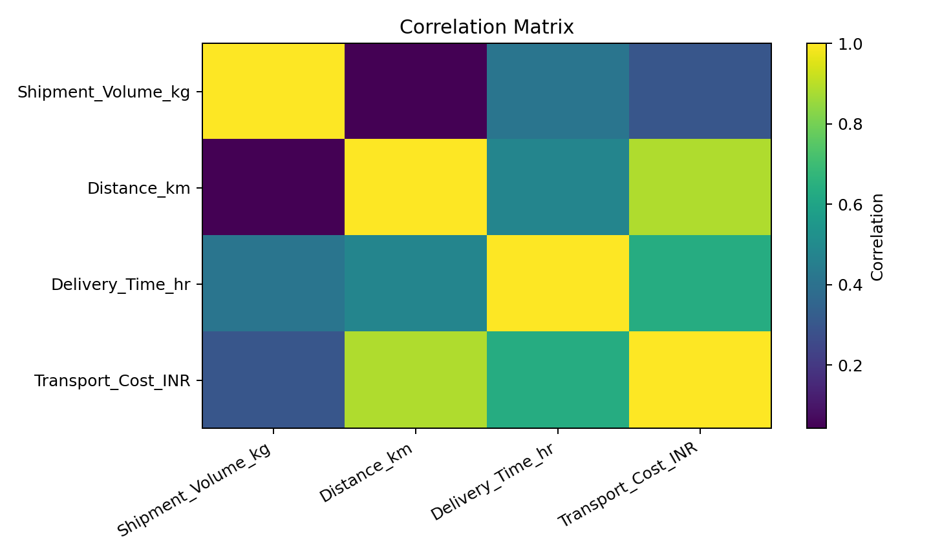
Interpretation: The correlation matrix provides a compact view of linear relationships between numerical variables. A strong positive relationship between distance and cost would support the use of distance as a cost-planning feature. Correlation is not proof of causation, so operational conclusions should also consider shipment mix and transport mode.

4. Operational Insights
1. **Geographical bottleneck:** East has the highest simulated average delivery time. This makes it a priority area for route and dispatch investigation.
2. **Cost driver:** Distance is positively associated with transport cost in the simulated data, indicating that route length should be included in cost forecasting and route-planning decisions.
3. **Mode comparison:** Two-Wheeler has the highest average simulated cost among the transport modes. Managers should compare its capacity and service advantages against its higher cost rather than evaluating cost in isolation.
4. **Performance variation:** The difference between zones demonstrates why aggregate KPIs can hide local bottlenecks. Zone-level dashboards can support targeted interventions.
5. **Outlier investigation:** Extremely long delivery times and unusually high costs should be reviewed as potential operational exceptions. Removing them automatically could hide genuine service failures.

5. Recommendations
- Create zone-level monitoring for delivery time and on-time performance.
- Use distance, shipment volume, and transport mode as features in future cost-prediction models.
- Investigate repeated long-duration shipments instead of treating every outlier as a data error.
- Compare route alternatives for high-delay zones and measure improvement against baseline KPIs.
- Build a recurring logistics dashboard with delivery time, cost per shipment, volume, and on-time rate.
- Use chronological validation for future forecasting tasks to avoid information leakage.

6. Python Code Illustration
import pandas as pd
import matplotlib.pyplot as plt
# Load and inspect data
df = pd.read_csv("logistics_shipments.csv")
print(df.info())
print(df.describe())
# Central tendency
print(df[["Shipment_Volume_kg",
"Delivery_Time_hr",
"Transport_Cost_INR"]].agg(["mean", "median"]))
# Correlation
corr = df.select_dtypes("number").corr()
print(corr)
# Distribution
plt.hist(df["Delivery_Time_hr"], bins=30)
plt.xlabel("Delivery Time (hours)")
plt.ylabel("Shipments")
plt.title("Delivery-Time Distribution")
plt.show()
# Relationship
plt.scatter(df["Distance_km"], df["Transport_Cost_INR"], alpha=0.45)
plt.xlabel("Distance (km)")
plt.ylabel("Transport Cost (INR)")
plt.title("Distance vs Transport Cost")
plt.show()
# Group comparison
zone_summary = df.groupby("Zone")["Delivery_Time_hr"].mean()
zone_summary.sort_values().plot(kind="bar")
plt.ylabel("Average Delivery Time (hours)")
plt.title("Average Delivery Time by Zone")
plt.show()

7. Visualization Selection Rationale
Histogram: Best for understanding distribution, concentration and long-tail delivery delays.
Scatter Plot: Useful for investigating relationships between distance and cost and spotting unusual observations.
Bar Chart: Effective for comparing operational KPIs across discrete zones or transport modes.
Correlation Matrix: Provides a compact overview of relationships among numerical variables and supports feature selection.

8. Conclusion
The Week 3 analysis demonstrates how exploratory data analysis and visualization can convert shipment records into operational insight. Descriptive statistics establish the baseline, distributions reveal normal behavior and exceptions, group comparisons expose geographical differences, and relationship plots help identify potential cost drivers. The analysis also shows that visualizations are most valuable when they answer a specific logistics question rather than simply presenting charts. The next analytical stage can build on these findings through demand forecasting, delivery-risk prediction, segmentation, and route optimization. Together, these methods can help logistics teams reduce avoidable delays, control transport costs, allocate resources more effectively, and make decisions using measurable evidence.

Appendix — Key Results Snapshot
Shipments analyzed: 600
Average shipment volume: 55.3 kg
Average delivery time: 2.55 hours
Average transport cost: ₹916
On-time delivery rate: 78.5%

